|  |  |
| --- | --- |
|  |  |

Contents

Scala 3

Introduction 3

SBT by Example 17

Essential SBT 28

Scala & Fun Prog Essentials | Rock the JVM | Beginners 32

The Absolute Scala Basics 32

Values, Variables and Types 35

Expressions 40

Functions 47

Type Inference – What the compiler knows 51

Stack and Tail Recursion 52

Call-by-Name and Call-by-Value 58

Default and Named Arguments 61

Smart Operations on Strings 64

Object Oriented Basics in Scala 67

Basics 67

Exercises 73

Method Notations 79

Objects 93

Inheritance 98

Inhertiance Contd: Abstract Classes & Traits 109

Inheritance Exercises: Implementing our own Collection 115

Generics 122

Anonymous Classes 135

Object-Oriented Exercises: Expanding Our Collection 138

Case Classes 153

Enums 160

Exceptions 164

Packaging and Imports 173

Functional Programming with Scala 182

Whats a Function really? 182

Anonymous Functions 195

Higher Order Functions and Curries 201

HOFs and Curries – Exercises 207

map, flatMap, filter and for-comprehensions 232

Collections Overview 244

Sequences, List, Array and Vector 246

# Scala

## Introduction

Mainly, we need to install three things. The first one is the JDK, the Java Development Kit, which is a random environment where java programs are executed. We strongly recommend Java 8 instead of java 7 and 6. The second one, is Scala which we will use for writing our programs. There are other options though you have Eclipse and Inside.

**Installing sbt on Windows**

Install JDK - Follow the link to install [JDK 8 or 11](https://adoptopenjdk.net/).

Installing from a universal package - Download [ZIP](https://github.com/sbt/sbt/releases/download/v1.5.5/sbt-1.5.5.zip) or [TGZ](https://github.com/sbt/sbt/releases/download/v1.5.5/sbt-1.5.5.tgz) package and expand it.

Windows installer - Download [msi installer](https://github.com/sbt/sbt/releases/download/v1.5.5/sbt-1.5.5.msi) and install it.

Installing from a third-party package - **Note:** Third-party packages may not provide the latest version. Please make sure to report any issues with these packages to the relevant maintainers.

[Scoop](https://scoop.sh/) - $ scoop install sbt

[Chocolatey](https://chocolatey.org/) - $ choco install sbt

**Install IntelliJ**

Install the Scala Plugin in IntelliJ

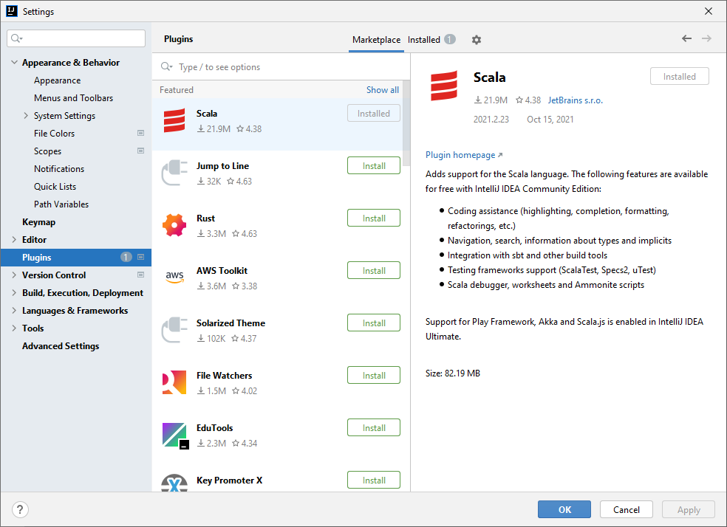

Create a new Scala Project

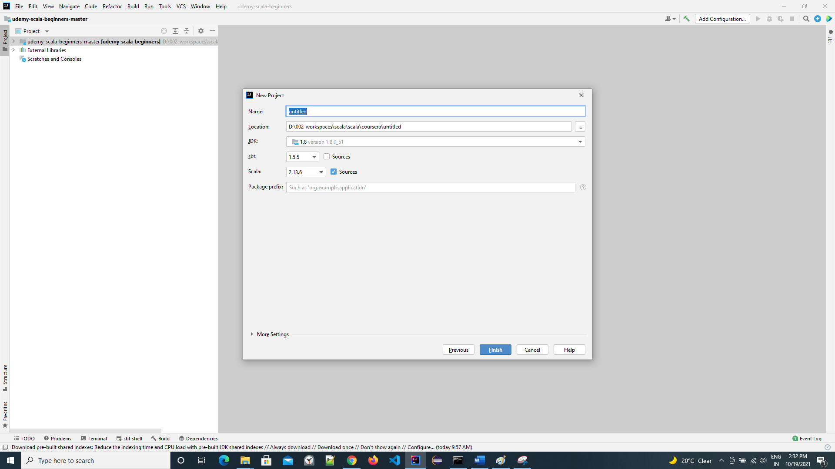

Create a new project, provide it a name and select the Java version that we are going to use

Right click on the scala package > New > Scala Worksheet

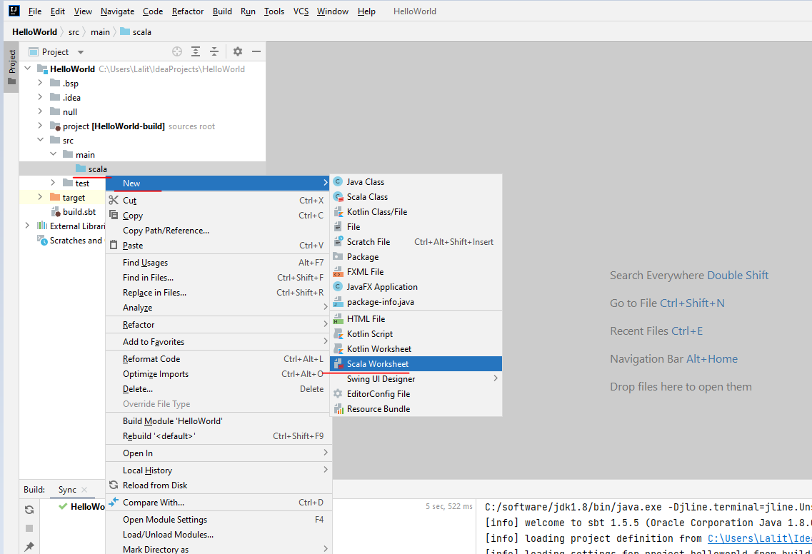

Anything we type here now is going to be compiled by IntelliJ

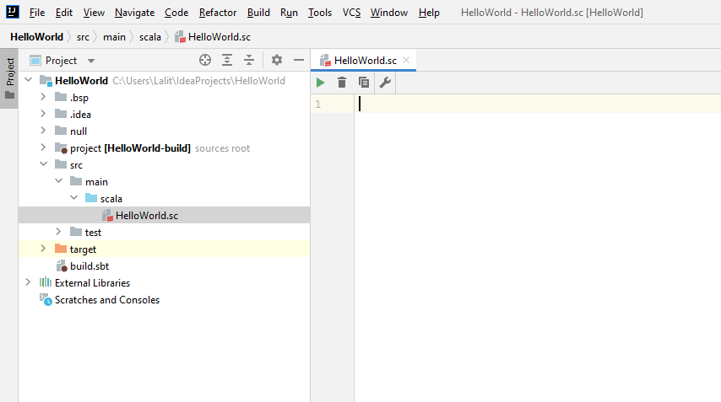

IntelliJ has automatically executed the below “Hello World” that we wrote here

It can be seen on the right side REPL screen

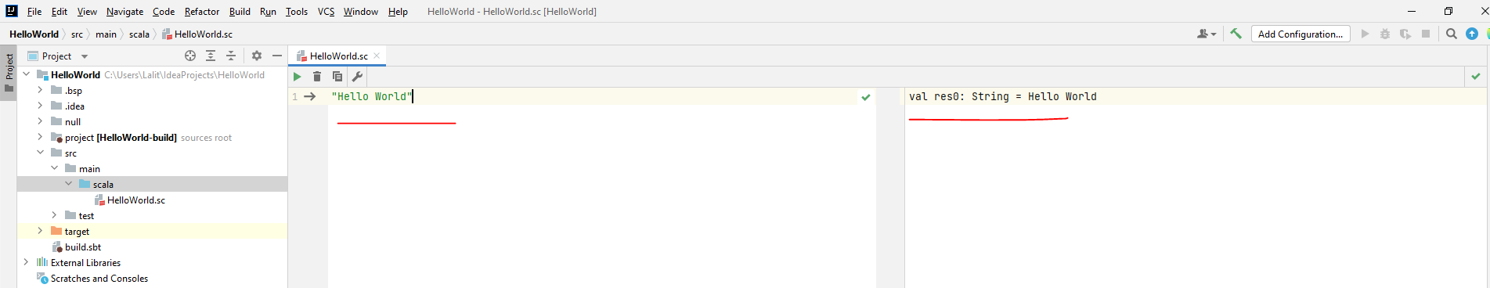

If it does not then just right click on the code Window and click on "Evaluate Worksheet"

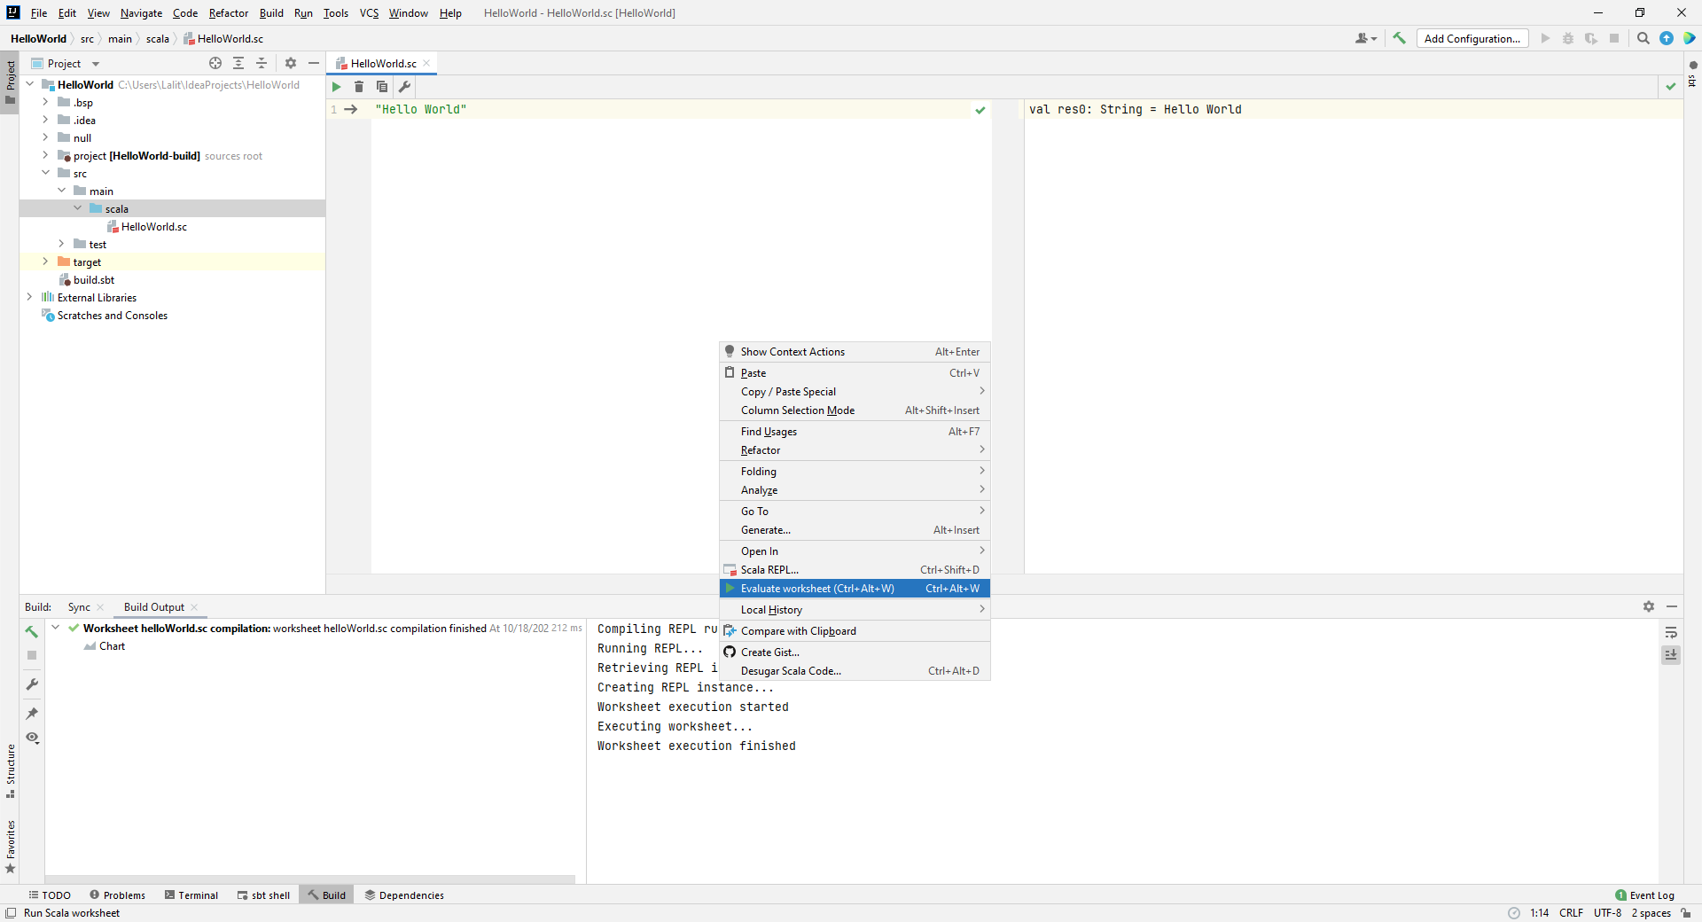

Lets create our first main scala program now

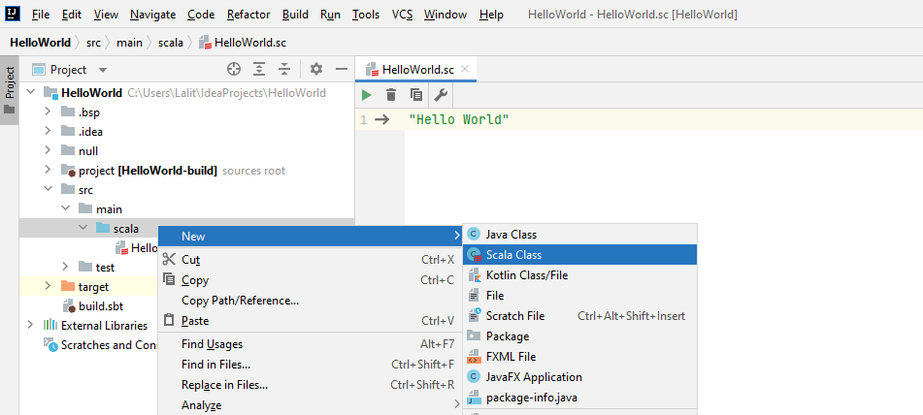

|  |  |
| --- | --- |
| We need to create our Example scala class in a example package and then we need to select Object here.  We selected Object here because it is a Singleton object. |  |

And it created the package for us and the class inside of it

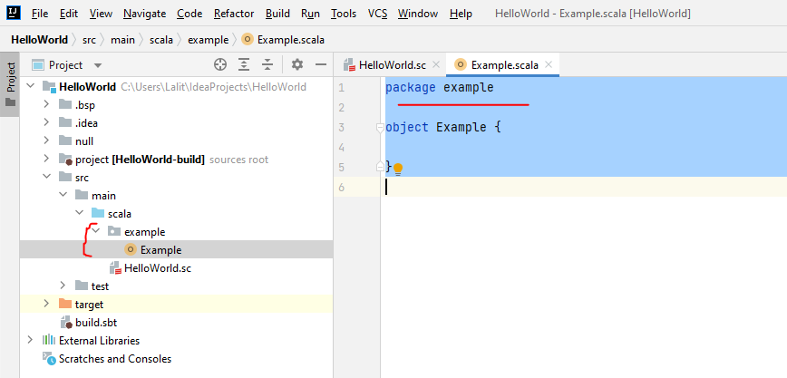

To allow IntelliJ and Scala to combine this as your main program extend Application

package example  
  
object Example extends App {  
 *println*("Hello World")  
}

To run this now, right click and click on "Run Example"

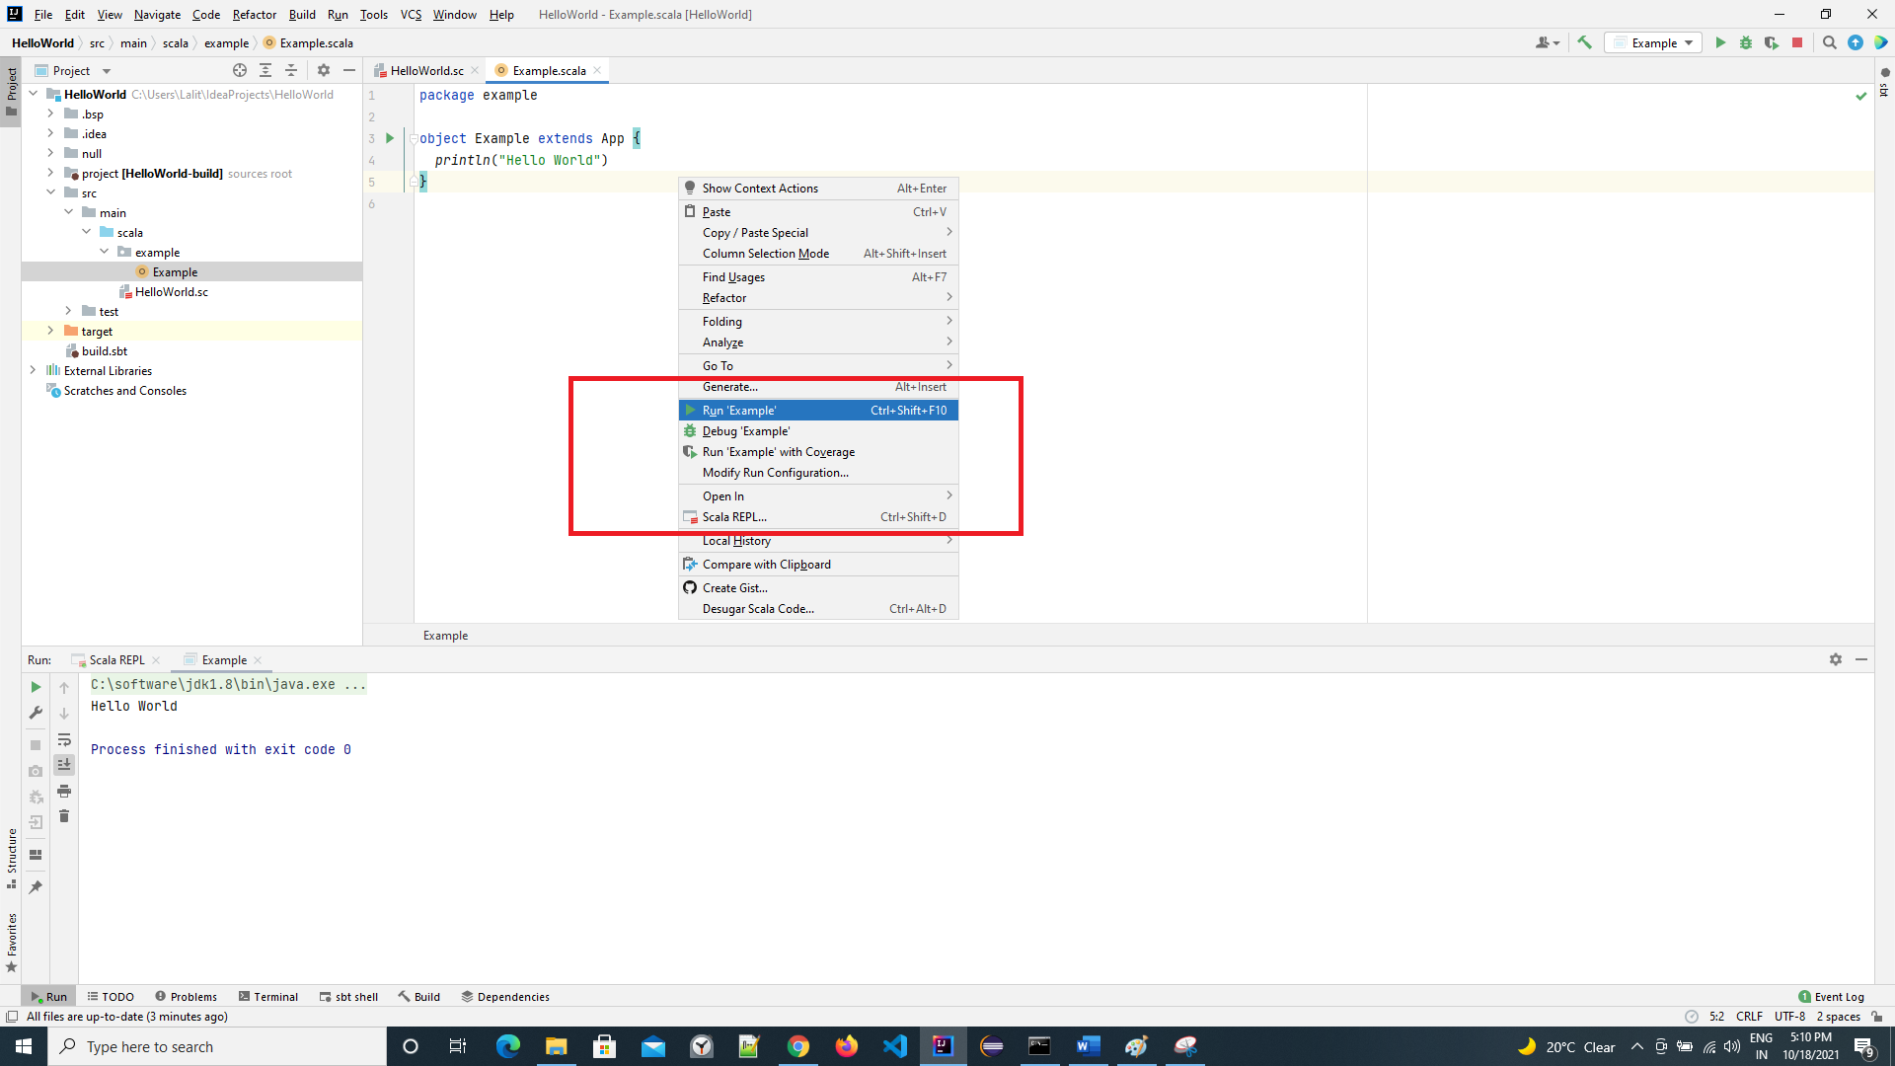

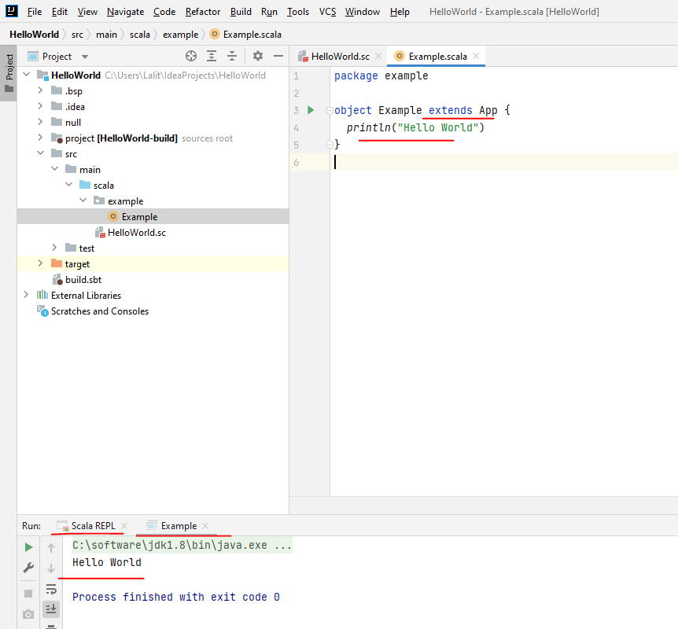

To start the Scala REPL, right click and click on "Scala REPL"

Close the project now using File > Close Project

Open the project again and now we are going to modify the build.sbt file

|  |  |
| --- | --- |
|  | Open from the path ( selecting the build.sbt file here )  Choose "Open as Project" and the open as trusted project  C:\Users\Lalit\IdeaProjects\HelloWorld\build.sbt  Make sure that we are using Java 8 |

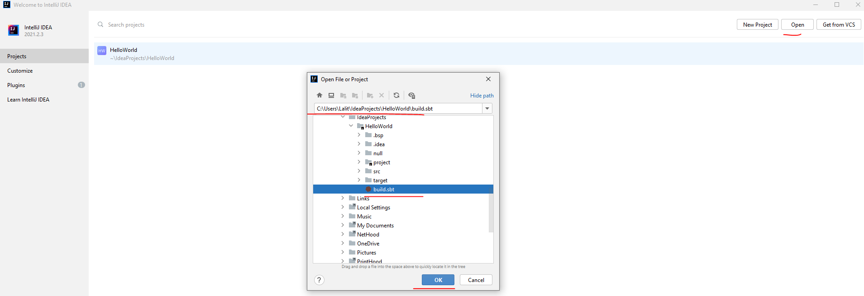

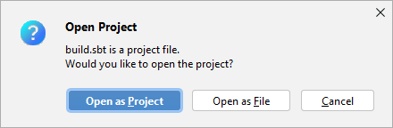

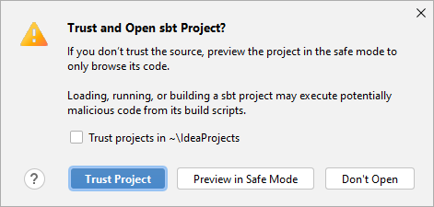

We will provide a dependency to Scala test here now

Copy from here –

<https://github.com/ladamalina/coursera-progfun1/blob/master/week-1-lesson-1/IntelliJ%20IDEA%20Tutorial%20_%20Coursera.pdf>

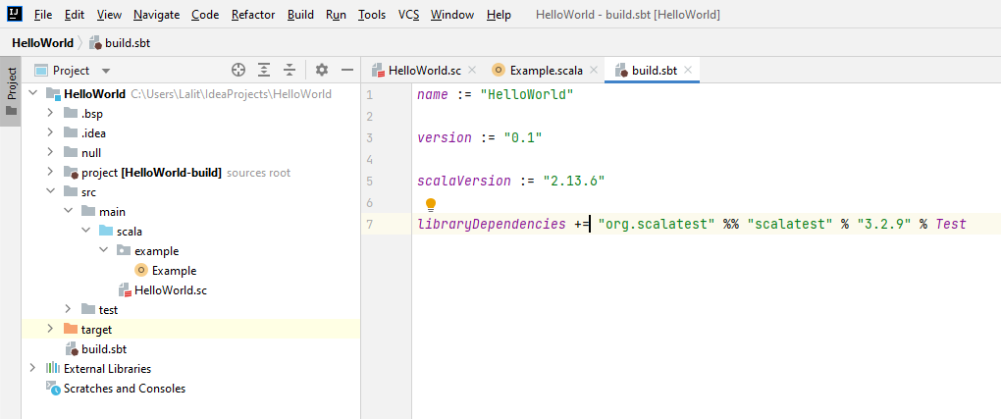

**build.sbt**

name:= "HelloWorld"  
  
version:= "0.1"  
  
scalaVersion:= "2.13.6"  
  
libraryDependencies+= "org.scalatest" %% "scalatest" % "3.2.9" % *Test*

SBT will now fetch our dependency and add it to our project

Alt + F12 will give you a terminal window for this project

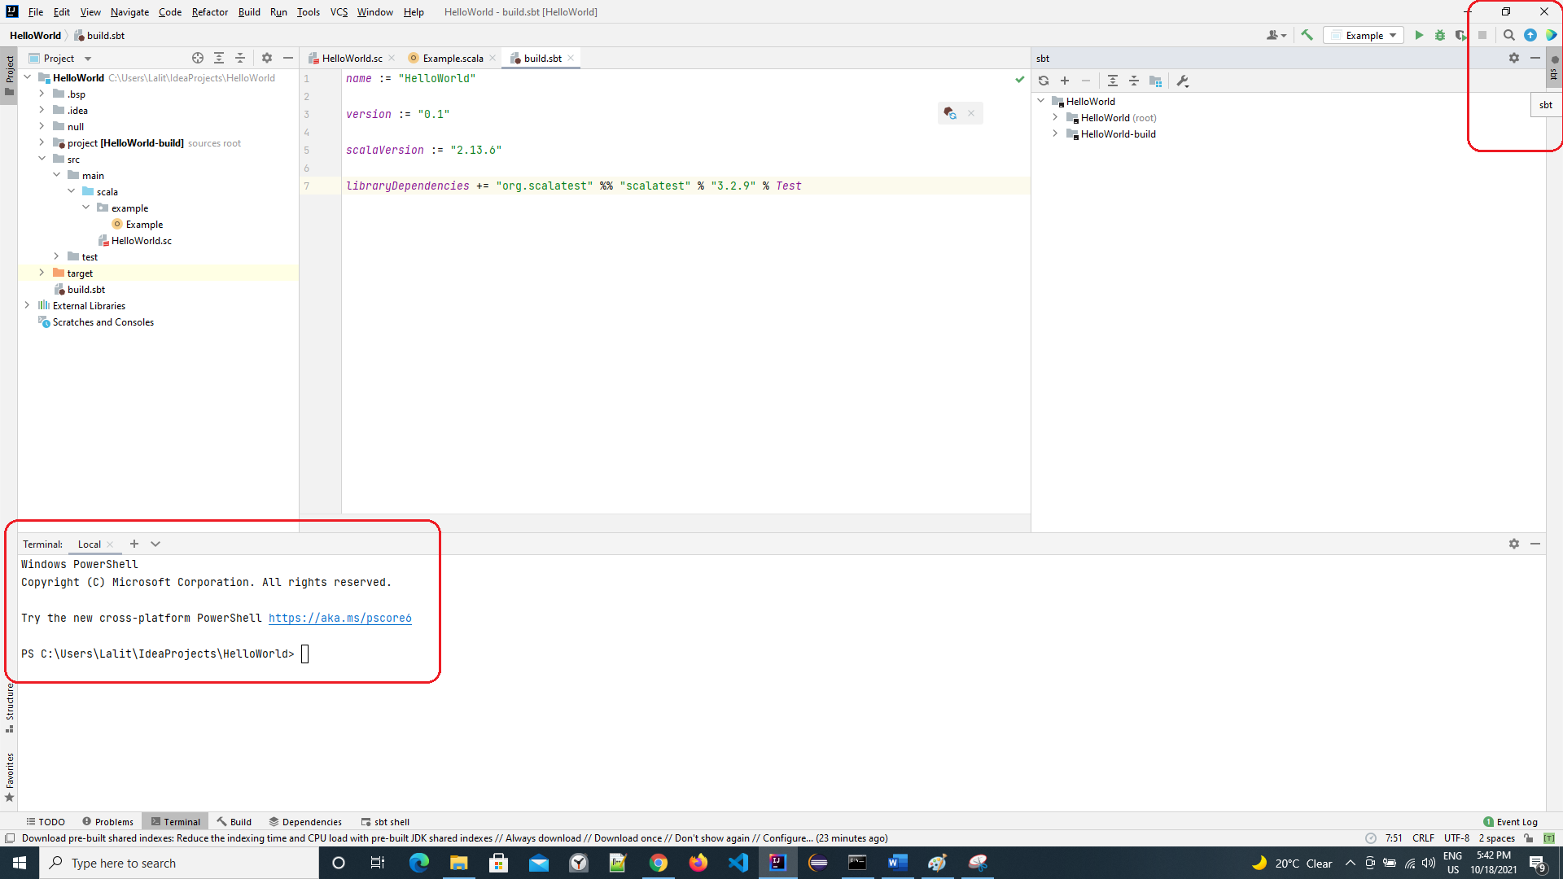

Also see that clicking on the sbt to the right side top – shows you the projects that IntelliJ recognizes – two projects are listed.

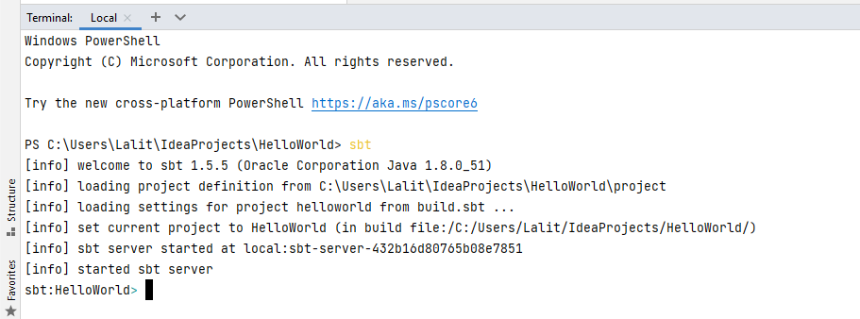

Lets run the program after we are on the command line

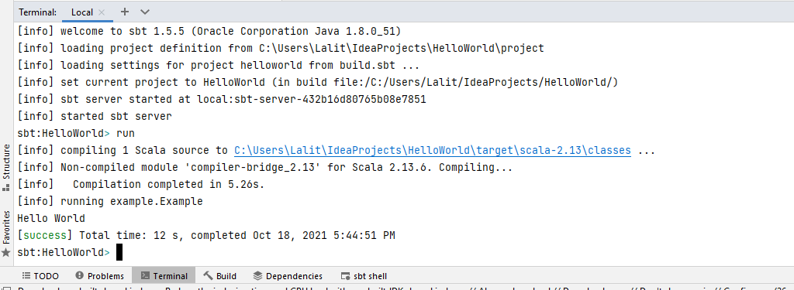

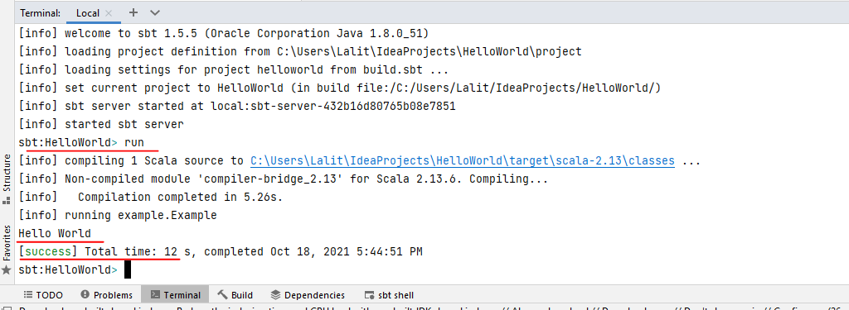

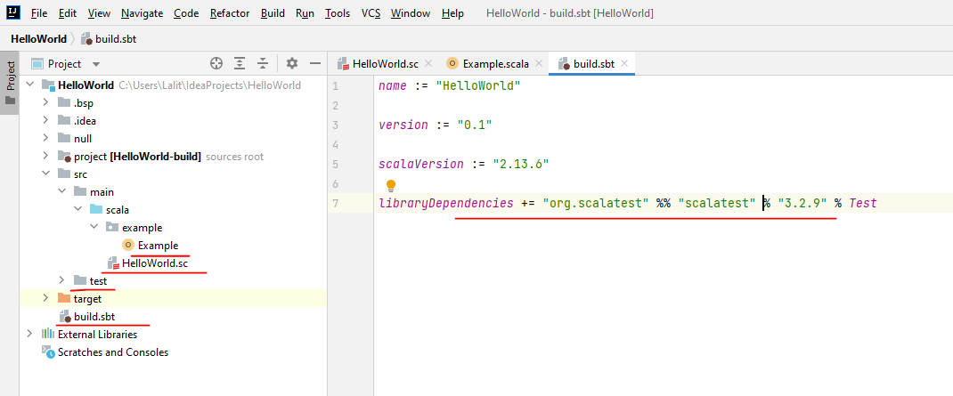

## SBT by Example

<https://www.scala-sbt.org/1.x/docs/sbt-by-example.html>

This page assumes you’ve [installed sbt 1](https://www.scala-sbt.org/1.x/docs/Setup.html).

Let’s start with examples rather than explaining how sbt works or why.

Create a minimum sbt build

$ mkdir foo-build

$ cd foo-build

$ touch build.sbt

**Start sbt shell**

$ sbt

[info] Updated file /tmp/foo-build/project/build.properties: set sbt.version to 1.1.4

[info] Loading project definition from /tmp/foo-build/project

[info] Loading settings from build.sbt ...

[info] Set current project to foo-build (in build file:/tmp/foo-build/)

[info] sbt server started at local:///Users/eed3si9n/.sbt/1.0/server/abc4fb6c89985a00fd95/sock

sbt:foo-build>

Exit sbt shell

To leave sbt shell, type exit or use Ctrl+D (Unix) or Ctrl+Z (Windows).

sbt:foo-build> exit

**Compile a project**

As a convention, we will use the sbt:...> or > prompt to mean that we’re in the sbt interactive shell.

$ sbt

sbt:foo-build> compile

**Recompile on code change**

Prefixing the compile command (or any other command) with ~ causes the command to be automatically re-executed whenever one of the source files within the project is modified. For example:

sbt:foo-build> ~compile

[success] Total time: 0 s, completed May 6, 2018 3:52:08 PM

1. Waiting for source changes... (press enter to interrupt)

**Create a source file**

Leave the previous command running. From a different shell or in your file manager create in the foo-build directory the following nested directories: src/main/scala/example. Then, create Hello.scala in the example directory using your favorite editor as follows:

**package** example  
  
object **Hello** extends App **{**  
 println**(**"Hello"**)**  
**}**

This new file should be picked up by the running command:

[info] Compiling 1 Scala source to /tmp/foo-build/target/scala-2.12/classes ...

[info] Done compiling.

[success] Total time: 2 s, completed May 6, 2018 3:53:42 PM

2. Waiting for source changes... (press enter to interrupt)

Press Enter to exit ~compile.

**Run a previous command**

From sbt shell, press up-arrow twice to find the compile command that you executed at the beginning.

sbt:foo-build> compile

**Getting help**

Use the help command to get basic help about the available commands.

sbt:foo-build> help

about Displays basic information about sbt and the build.

tasks Lists the tasks defined for the current project.

settings Lists the settings defined for the current project.

reload (Re)loads the current project or changes to plugins project or returns from it.

new Creates a new sbt build.

projects Lists the names of available projects or temporarily adds/removes extra builds to the session.

project Displays the current project or changes to the provided `project`.

....

Display the description of a specific task:

sbt:foo-build> help run

Runs a main class, passing along arguments provided on the command line.

**Run your app**

sbt:foo-build> run

[info] Packaging /tmp/foo-build/target/scala-2.12/foo-build_2.12-0.1.0-SNAPSHOT.jar ...

[info] Done packaging.

[info] Running example.Hello

Hello

[success] Total time: 1 s, completed May 6, 2018 4:10:44 PM

Set ThisBuild / scalaVersion from sbt shell

sbt:foo-build> set ThisBuild / scalaVersion := "2.13.6"

[info] Defining ThisBuild / scalaVersion

Check the scalaVersion setting:

sbt:foo-build> scalaVersion

[info] 2.13.6

**Save the session to build.sbt**

We can save the ad-hoc settings using session save.

sbt:foo-build> session save

[info] Reapplying settings...

build.sbt file should now contain:

ThisBuild / scalaVersion := "2.13.6"

Name your project

Using an editor, change build.sbt as follows:

**ThisBuild** **/** scalaVersion **:=** "2.13.6"  
**ThisBuild** **/** organization := "com.example"  
  
lazy val hello = (project in file("."))  
 .settings(  
 name := "Hello"  
 )

**Reload the build**

Use the reload command to reload the build. The command causes the build.sbt file to be re-read, and its settings applied.

sbt:foo-build> reload

[info] Loading project definition from /tmp/foo-build/project

[info] Loading settings from build.sbt ...

[info] Set current project to Hello (in build file:/tmp/foo-build/)

sbt:Hello>

Note that the prompt has now changed to sbt:Hello>.

**Add ScalaTest to libraryDependencies**

Using an editor, change build.sbt as follows:

**ThisBuild** **/** scalaVersion **:=** "2.13.6"  
**ThisBuild** **/** organization **:=** "com.example"  
  
**lazy** **val** hello **=** **(**project in file**(**"."**))**  
 **.**settings**(**  
 name **:=** "Hello"**,**  
 libraryDependencies **+=** "org.scalatest" **%%** "scalatest" **%** "3.2.7" **%** **Test,**  
 **)**

Use the reload command to reflect the change in build.sbt.

sbt:Hello> reload

**Run tests**

sbt:Hello> test

Run incremental tests continuously

sbt:Hello> ~testQuick

**Write a test**

Leaving the previous command running, create a file named src/test/scala/HelloSpec.scala using an editor:

**import** org**.**scalatest**.**funsuite**.**_  
  
**class** **HelloSpec** **extends** **AnyFunSuite** **{**  
 test**(**"Hello should start with H"**)** **{**  
 **assert("**hello"**.**startsWith**(**"H"**))**  
 **}**  
**}**

~testQuick should pick up the change:

2. Waiting for source changes... (press enter to interrupt)

[info] Compiling 1 Scala source to /tmp/foo-build/target/scala-2.12/test-classes ...

[info] Done compiling.

[info] HelloSpec:

[info] - Hello should start with H *** FAILED ***

[info] assert("hello".startsWith("H"))

[info] | | |

[info] "hello" false "H" (HelloSpec.scala:5)

[info] Run completed in 135 milliseconds.

[info] Total number of tests run: 1

[info] Suites: completed 1, aborted 0

[info] Tests: succeeded 0, failed 1, canceled 0, ignored 0, pending 0

[info] *** 1 TEST FAILED ***

[error] Failed tests:

[error] HelloSpec

[error] (Test / testQuick) sbt.TestsFailedException: Tests unsuccessful

**Make the test pass**

Using an editor, change src/test/scala/HelloSpec.scala to:

**import** org**.**scalatest**.**funsuite**.**_  
  
**class** **HelloSpec** **extends** **AnyFunSuite** **{**  
 **test(**"Hello should start with H"**)** **{**  
 *// Hello, as opposed to hello*  
 **assert(**"Hello"**.**startsWith**(**"H"**))**  
 **}**  
**}**

Confirm that the test passes, then press Enter to exit the continuous test.

**Add a library dependency**

Using an editor, change build.sbt as follows:

**ThisBuild** **/** **scalaVersion** **:=** "2.13.6"  
**ThisBuild** **/** **organization** **:=** "com.example"  
  
**lazy** **val** hello **=** **(**project in file**(**"."**))**  
 **.**settings**(**  
 name **:=** "Hello"**,**  
 **libraryDependencies** **+=** "**com**.**typesafe**.**play**" **%%** "**play**-**json**" **%** "2.9.2"**,**  
 **libraryDependencies** **+=** "**com**.**eed3si9n**" **%%** "**gigahorse**-**okhttp**" **%** "0.5.0"**,**  
 **libraryDependencies** **+=** "**org**.**scalatest**" **%%** "**scalatest**" **%** "3.2.7" **%** **Test,**  
 **)**

Use the reload command to reflect the change in build.sbt.

**Use Scala REPL**

We can find out the current weather in New York.

sbt**:Hello>** console  
**[**info**]** **Starting** scala interpreter**...**  
**Welcome** to **Scala** 2.12**.**7 **(Java** **HotSpot(**TM**)** 64**-Bit** **Server** VM**,** **Java** 1.8**.**0_171**).**  
**Type** in expressions **for** evaluation**.** **Or** **try** **:**help**.**  
  
scala**>** **:**paste  
*// Entering paste mode (ctrl-D to finish)*  
  
**import** scala**.**concurrent**.**_**,** duration**.**_  
**import** gigahorse**.**_**,** support**.**okhttp**.Gigahorse**  
**import** play**.**api**.**libs**.**json**.**_  
  
**Gigahorse.**withHttp**(Gigahorse.**config**)** **{** http **=>**  
 **val** baseUrl **=** "https://www.metaweather.com/api/location"  
 **val** rLoc **=** **Gigahorse.**url**(**baseUrl **+** "/search/"**).**get**.**  
 addQueryString**(**"query" **->** "New York"**)**  
 **val** fLoc **=** http**.**run**(**rLoc**,** **Gigahorse.**asString**)**  
 **val** loc **=** **Await.**result**(**fLoc**,** 10**.**seconds**)**  
 **val** woeid **=** **(Json.**parse**(**loc**)** **\** 0 **\** "woeid"**).**get  
 **val** rWeather **=** **Gigahorse.**url**(**baseUrl **+** s"/$woeid/"**).**get  
 **val** fWeather **=** http**.**run**(**rWeather**,** **Gigahorse.**asString**)**  
 **val** weather **=** **Await.**result**(**fWeather**,** 10**.**seconds**)**  
 **({Json.**parse**(**_**:** **String)}** andThen **Json.**prettyPrint**)(**weather**)**  
**}**  
  
*// press Ctrl+D*  
  
*// Exiting paste mode, now interpreting.*  
  
**import** scala**.**concurrent**.**_  
**import** duration**.**_  
**import** gigahorse**.**_  
**import** support**.**okhttp**.Gigahorse**  
**import** play**.**api**.**libs**.**json**.**_  
res0**:** **String** **=**  
**{**  
 "consolidated_weather" **:** **[** **{**  
 "id" **:** 6446939314847744**,**  
 "weather_state_name" **:** "Light Rain"**,**  
 "weather_state_abbr" **:** "lr"**,**  
 "wind_direction_compass" **:** "WNW"**,**  
 "created" **:** "2019-02-21T04:39:47.747805Z"**,**  
 "applicable_date" **:** "2019-02-21"**,**  
 "min_temp" **:** 0.48000000000000004**,**  
 "max_temp" **:** 7.84**,**  
 "the_temp" **:** 2.1700000000000004**,**  
 "wind_speed" **:** 5.996333145703094**,**  
 "wind_direction" **:** 293.12257757287307**,**  
 "air_pressure" **:** 1033.115**,**  
 "humidity" **:** 77**,**  
 "visibility" **:** 14.890539250775472**,**  
 "predictability" **:** 75  
 **},** **{**  
 "id" **:** 5806299509948416**,**  
 "weather_state_name" **:** "Heavy Cloud"**,**  
**...**  
  
scala**>** **:**q *// to quit*

**Make a subproject**

Change build.sbt as follows:

**ThisBuild** **/** scalaVersion **:=** "2.13.6"  
**ThisBuild** **/** organization **:=** "com.example"  
  
**lazy** **val** hello **=** **(**project in file**(**"."**))**  
 **.**settings**(**  
 name **:=** "Hello"**,**  
 libraryDependencies **+=** "com.eed3si9n" **%%** "gigahorse-okhttp" **%** "0.5.0"**,**  
 libraryDependencies **+=** "org.scalatest" **%%** "scalatest" **%** "3.2.7" **%** **Test,**  
 **)**  
  
**lazy** **val** helloCore **=** **(**project in file**(**"core"**))**  
 **.**settings**(**  
 name **:=** "Hello Core"**,**  
 **)**

Use the reload command to reflect the change in build.sbt.

**List all subprojects**

sbt:Hello> projects

[info] In file:/tmp/foo-build/

[info] * hello

[info] helloCore

**Compile the subproject**

sbt:Hello> helloCore/compile

**Add ScalaTest to the subproject**

Change build.sbt as follows:

**ThisBuild** **/** scalaVersion **:=** "2.13.6"  
**ThisBuild** **/** organization **:=** "com.example"  
  
**val** scalaTest **=** "org.scalatest" **%%** "scalatest" **%** "3.2.7"  
  
**lazy** **val** hello **=** **(**project in file**(**"."**))**  
 **.**settings**(**  
 name **:=** "Hello"**,**  
 libraryDependencies **+=** "com.eed3si9n" **%%** "gigahorse-okhttp" **%** "0.5.0"**,**  
 libraryDependencies **+=** scalaTest **%** **Test,**  
 **)**  
  
**lazy** **val** helloCore **=** **(**project in file**(**"core"**))**  
 **.**settings**(**  
 name **:=** "Hello Core"**,**  
 libraryDependencies **+=** scalaTest **%** **Test,**  
 **)**

**Broadcast commands**

Set aggregate so that the command sent to hello is broadcast to helloCore too:

**ThisBuild** **/** scalaVersion **:=** "2.13.6"  
**ThisBuild** **/** organization **:=** "com.example"  
  
**val** scalaTest **=** "org.scalatest" **%%** "scalatest" **%** "3.2.7"  
  
**lazy** **val** hello **=** **(**project in file**(**"."**))**  
 **.**aggregate**(**helloCore**)**  
 **.**settings**(**  
 name **:=** "Hello"**,**  
 libraryDependencies **+=** "com.eed3si9n" **%%** "gigahorse-okhttp" **%** "0.5.0"**,**  
 libraryDependencies **+=** scalaTest **%** **Test,**  
 **)**  
  
**lazy** **val** helloCore **=** **(**project in file**(**"core"**))**  
 **.**settings**(**  
 name **:=** "Hello Core"**,**  
 libraryDependencies **+=** scalaTest **%** **Test,**  
 **)**

After reload, ~testQuick now runs on both subprojects:

sbt**:Hello>** **~**testQuick

Press Enter to exit the continuous test.

**Make hello depend on helloCore**

Use .dependsOn(...) to add a dependency on other subprojects. Also let’s move the Gigahorse dependency to helloCore.

**ThisBuild** **/** scalaVersion **:=** "2.13.6"  
**ThisBuild** **/** organization **:=** "com.example"  
  
**val** scalaTest **=** "org.scalatest" **%%** "scalatest" **%** "3.2.7"  
  
**lazy** **val** hello **=** **(**project in file**(**"."**))**  
 **.**aggregate**(**helloCore**)**  
 **.**dependsOn**(**helloCore**)**  
 **.**settings**(**  
 name **:=** "Hello"**,**  
 libraryDependencies **+=** scalaTest **%** **Test,**  
 **)**  
  
**lazy** **val** helloCore **=** **(**project in file**(**"core"**))**  
 **.**settings**(**  
 name **:=** "Hello Core"**,**  
 libraryDependencies **+=** "com.eed3si9n" **%%** "gigahorse-okhttp" **%** "0.5.0"**,**  
 libraryDependencies **+=** scalaTest **%** **Test,**  
 **)**

**Parse JSON using Play JSON**

Let’s add Play JSON to helloCore.

**ThisBuild** **/** scalaVersion **:=** "2.13.6"  
**ThisBuild** **/** organization **:=** "com.example"  
  
**val** scalaTest **=** "org.scalatest" **%%** "scalatest" **%** "3.2.7"  
**val** gigahorse **=** "com.eed3si9n" **%%** "gigahorse-okhttp" **%** "0.5.0"  
**val** playJson **=** "com.typesafe.play" **%%** "play-json" **%** "2.9.2"  
  
**lazy** **val** hello **=** **(**project in file**(**"."**))**  
 **.**aggregate**(**helloCore**)**  
 **.**dependsOn**(**helloCore**)**  
 **.**settings**(**  
 name **:=** "Hello"**,**  
 libraryDependencies **+=** scalaTest **%** **Test,**  
 **)**  
  
**lazy** **val** helloCore **=** **(**project in file**(**"core"**))**  
 **.**settings**(**  
 name **:=** "Hello Core"**,**  
 libraryDependencies **++=** **Seq(**gigahorse**,** playJson**),**  
 libraryDependencies **+=** scalaTest **%** **Test,**  
 **)**

After reload, add core/src/main/scala/example/core/Weather.scala:

**package** example**.**core  
  
**import** gigahorse**.**_**,** support**.**okhttp**.Gigahorse**  
**import** scala**.**concurrent**.**_**,** duration**.**_  
**import** play**.**api**.**libs**.**json**.**_  
  
**object** **Weather** **{**  
 **lazy** **val** http **=** **Gigahorse.**http**(Gigahorse.**config**)**  
  
 **def** weather**:** **Future[String]** **=** **{**  
 **val** baseUrl **=** "https://www.metaweather.com/api/location"  
 **val** locUrl **=** baseUrl **+** "/search/"  
 **val** weatherUrl **=** baseUrl **+** "/%s/"  
 **val** rLoc **=** **Gigahorse.**url**(**locUrl**).**get**.**  
 addQueryString**(**"query" **->** "New York"**)**  
 **import** **ExecutionContext.Implicits.**global  
 **for** **{**  
 loc **<-** http**.**run**(**rLoc**,** parse**)**  
 woeid **=** **(**loc **\** 0 **\** "woeid"**).**get  
 rWeather **=** **Gigahorse.**url**(**weatherUrl format woeid**).**get  
 weather **<-** http**.**run**(**rWeather**,** parse**)**  
 **}** **yield** **(**weather **\\** "weather_state_name"**)(**0**).**as**[String].**toLowerCase  
 **}**  
  
 **private** **def** parse **=** **Gigahorse.**asString andThen **Json.**parse  
**}**

Next, change src/main/scala/example/Hello.scala as follows:

**package** example  
  
**import** scala**.**concurrent**.**_**,** duration**.**_  
**import** core**.Weather**  
  
**object** **Hello** **extends** **App** **{**  
 **val** w **=** **Await.**result**(Weather.**weather**,** 10**.**seconds**)**  
 println**(**s"Hello! The weather in New York is $w."**)**  
 **Weather.**http**.**close**()**  
**}**

**Let’s run the app to see if it worked:**

sbt:Hello> run

[info] Compiling 1 Scala source to /tmp/foo-build/core/target/scala-2.12/classes ...

[info] Done compiling.

[info] Compiling 1 Scala source to /tmp/foo-build/target/scala-2.12/classes ...

[info] Packaging /tmp/foo-build/core/target/scala-2.12/hello-core_2.12-0.1.0-SNAPSHOT.jar ...

[info] Done packaging.

[info] Done compiling.

[info] Packaging /tmp/foo-build/target/scala-2.12/hello_2.12-0.1.0-SNAPSHOT.jar ...

[info] Done packaging.

[info] Running example.Hello

Hello! The weather in New York is mostly cloudy.

**Add sbt-native-packager plugin**

Using an editor, create project/plugins.sbt:

addSbtPlugin**(**"com.typesafe.sbt" **%** "sbt-native-packager" **%** "1.3.4"**)**

Next change build.sbt as follows to add JavaAppPackaging:

**ThisBuild** **/** scalaVersion **:=** "2.13.6"  
**ThisBuild** **/** organization **:=** "com.example"  
  
**val** scalaTest **=** "org.scalatest" **%%** "scalatest" **%** "3.2.7"  
**val** gigahorse **=** "com.eed3si9n" **%%** "gigahorse-okhttp" **%** "0.5.0"  
**val** playJson **=** "com.typesafe.play" **%%** "play-json" **%** "2.9.2"  
  
**lazy** **val** hello **=** **(**project in file**(**"."**))**  
 **.**aggregate**(**helloCore**)**  
 **.**dependsOn**(**helloCore**)**  
 **.**enablePlugins**(JavaAppPackaging)**  
 **.**settings**(**  
 name **:=** "Hello"**,**  
 libraryDependencies **+=** scalaTest **%** **Test,**  
 **)**  
  
**lazy** **val** helloCore **=** **(**project in file**(**"core"**))**  
 **.**settings**(**  
 name **:=** "Hello Core"**,**  
 libraryDependencies **++=** **Seq(**gigahorse**,** playJson**),**  
 libraryDependencies **+=** scalaTest **%** **Test,**  
 **)**

**Reload and create a .zip distribution**

sbt:Hello> reload

...

sbt:Hello> dist

[info] Wrote /tmp/foo-build/target/scala-2.12/hello_2.12-0.1.0-SNAPSHOT.pom

[info] Wrote /tmp/foo-build/core/target/scala-2.12/hello-core_2.12-0.1.0-SNAPSHOT.pom

[info] Your package is ready in /tmp/foo-build/target/universal/hello-0.1.0-SNAPSHOT.zip

Here’s how you can run the packaged app:

$ /tmp/someother

$ cd /tmp/someother

$ unzip -o -d /tmp/someother /tmp/foo-build/target/universal/hello-0.1.0-SNAPSHOT.zip

$ ./hello-0.1.0-SNAPSHOT/bin/hello

Hello! The weather in New York is mostly cloudy.

**Dockerize your app**

sbt:Hello> Docker/publishLocal

....

[info] Successfully built b6ce1b6ab2c0

[info] Successfully tagged hello:0.1.0-SNAPSHOT

[info] Built image hello:0.1.0-SNAPSHOT

Here’s how to run the Dockerized app:

$ docker run hello:0.1.0-SNAPSHOT

Hello! The weather in New York is mostly cloudy

**Set the version**

Change build.sbt as follows:

**ThisBuild** **/** version **:=** "0.1.0"  
**ThisBuild** **/** scalaVersion **:=** "2.13.6"  
**ThisBuild** **/** organization **:=** "com.example"  
  
**val** scalaTest **=** "org.scalatest" **%%** "scalatest" **%** "3.2.7"  
**val** gigahorse **=** "com.eed3si9n" **%%** "gigahorse-okhttp" **%** "0.5.0"  
**val** playJson **=** "com.typesafe.play" **%%** "play-json" **%** "2.9.2"  
  
**lazy** **val** hello **=** **(**project in file**(**"."**))**  
 **.**aggregate**(**helloCore**)**  
 **.**dependsOn**(**helloCore**)**  
 **.**enablePlugins**(JavaAppPackaging)**  
 **.**settings**(**  
 name **:=** "Hello"**,**  
 libraryDependencies **+=** scalaTest **%** **Test,**  
 **)**  
  
**lazy** **val** helloCore **=** **(**project in file**(**"core"**))**  
 **.**settings**(**  
 name **:=** "Hello Core"**,**  
 libraryDependencies **++=** **Seq(**gigahorse**,** playJson**),**  
 libraryDependencies **+=** scalaTest **%** **Test,**  
 **)**

**Switch scalaVersion temporarily**

sbt:Hello> ++2.12.14!

[info] Forcing Scala version to 2.12.14 on all projects.

[info] Reapplying settings...

[info] Set current project to Hello (in build file:/tmp/foo-build/)

Check the scalaVersion setting:

sbt:Hello> scalaVersion

[info] helloCore / scalaVersion

[info] 2.12.14

[info] scalaVersion

[info] 2.12.14

This setting will go away after reload.

**Inspect the dist task**

To find out more about dist, try help and inspect.

sbt**:Hello>** help dist  
**Creates** the distribution packages**.**  
sbt**:Hello>** inspect dist

To call inspect recursively on the dependency tasks use inspect tree.

sbt**:Hello>** inspect tree dist  
**[**info**]** dist **=** **Task[**java**.**io**.File]**  
**[**info**]** **+-Universal** **/** dist **=** **Task[**java**.**io**.File]**  
**....**

**Batch mode**

You can also run sbt in batch mode, passing sbt commands directly from the terminal.

$ sbt clean "testOnly HelloSpec"

**Note**: Running in batch mode requires JVM spinup and JIT each time, so **your build will run much slower**. For day-to-day coding, we recommend using the sbt shell or a continuous test like ~testQuick.

**sbt new command**

You can use the sbt new command to quickly setup a simple “Hello world” build.

$ sbt new scala/scala-seed.g8

....

A minimal Scala project.

name [My Something Project]: hello

Template applied in ./hello

When prompted for the project name, type hello.

This will create a new project under a directory named hello.

## Essential SBT

**The essential Scala build tool tutorial**

***Make a production app in Scala with TDD unit tests, modules, Java interop, and run it on Docker. Less than 30 minutes.***

*Published December 2016, last updated March 2021.*

* **What**: This is a Scala tutorial that teaches you the essentials of how to use SBT for a modern, modular and test-driven Scala project.
* **Why**: People tell me SBT is difficult to use, even hopeless.

Let's get straight into the meat, because I assure you it is not hopeless; SBT is the most powerful build tool I had ever used.  
This tutorial is aimed to somebody who comes, say, from a Python, Java or PHP background and wants to see immediate results, such as creating and running unit tests, and creating a deployable package from your code and using SBT modules, and how to inter-operate with a Java library to scrape the web. *And you can get all that done in less than 30 minutes!*

* **How**: I provide a sequence of snippets with a Copy button, which you can paste into a command line shell. This means that you can get a project working from scratch without having to go to the documentation, install complex IDEs, text editors, that are not always straightforward.
* **Shell**: To run these commands you will need a Linux type shell. On Windows, use the [Windows Subsystem for Linux](https://docs.microsoft.com/en-us/learn/modules/get-started-with-windows-subsystem-for-linux/) and Ubuntu instructions.
* **Prerequisite**: [Download and install Java](https://adoptopenjdk.net/).
* **Prerequisite**: Install SBT:
  + **Windows**: install with [Chocolatey](https://chocolatey.org/packages/sbt): choco install sbt or [download the MSI installer](https://github.com/sbt/sbt/releases/download/v1.4.8/sbt-1.4.8.msi).
  + **macOS**: install [with Homebrew](https://formulae.brew.sh/formula/sbt): brew install sbt.
  + **Linux**: follow instructions here: [Installing SBT on Linux](https://www.scala-sbt.org/1.x/docs/Installing-sbt-on-Linux.html).

Once you've set up the prerequisites and have, simply follow the instructions below and let me know of any feedback in the [feedback form](https://www.scalawilliam.com/essential-sbt/#feedback)! And if you'd like more content like this, [subscribe](https://www.scalawilliam.com/essential-sbt/#subscribe).

[**CREATE A BASIC EMPTY SBT PROJECT**](https://www.scalawilliam.com/essential-sbt/#create-a-basic-empty-sbt-project)

mkdir -p new-project

cd new-project

mkdir -p project

echo 'sbt.version=1.4.9' > project/build.properties

[**COMPILE THE PROJECT**](https://www.scalawilliam.com/essential-sbt/#compile-the-project)

sbt compile

[**RECOMPILE ON CODE CHANGE**](https://www.scalawilliam.com/essential-sbt/#recompile-on-code-change)

sbt '~compile'

~ watches for code changes. Press Enter to exit.

[**CREATE A SOURCE FILE**](https://www.scalawilliam.com/essential-sbt/#create-source-file)

Run this command in another terminal window.

mkdir -p src/main/scala/

cat > src/main/scala/SimpleApp.scala << EOF

object SimpleApp extends App {

println("It works")

}

EOF

[**RUN CONTINUOUSLY**](https://www.scalawilliam.com/essential-sbt/#run-continuously)

Exit the ~compile command by pressing Enter

sbt '~run'

Copy

[**CHANGE SOURCE TO VERIFY IT WORKS**](https://www.scalawilliam.com/essential-sbt/#change-source-to-verify-it-works)

sed -i -e 's/works/definitely works/' \

src/main/scala/SimpleApp.scala

Copy

[**ADD SCALATEST**](https://www.scalawilliam.com/essential-sbt/#add-scalatest)

echo 'libraryDependencies += "org.scalatest" %%' \

'"scalatest" % "3.2.6" % Test' >> build.sbt

Copy

[**CREATE A TEST**](https://www.scalawilliam.com/essential-sbt/#create-a-test)

mkdir -p src/test/scala/

cat > src/test/scala/SimpleTest.scala << EOF

import org.scalatest.funsuite._

final class SimpleTest extends AnyFunSuite {

def sum(a: Int, b: Int): Int = ???

test("sum works for 1 + 2 = 3") {

assert(sum(1, 2) == 3)

}

}

EOF

[**TEST CONTINUOUSLY**](https://www.scalawilliam.com/essential-sbt/#test-continuously)

Exit previous ~run command by pressing Enter

sbt '~test'

[**MAKE IT PASS**](https://www.scalawilliam.com/essential-sbt/#make-it-pass)

sed -i -e 's/???/a + b/' src/test/scala/SimpleTest.scala

[**USE SCALA 2.13**](https://www.scalawilliam.com/essential-sbt/#use-scala-)

echo 'scalaVersion in ThisBuild := "2.13.5"' >> build.sbt

[**ADD THE SBT-NATIVE-PACKAGER PLUGIN**](https://www.scalawilliam.com/essential-sbt/#add-the-sbt-native-packager-plugin)

echo 'addSbtPlugin("com.typesafe.sbt" % '\

'"sbt-native-packager" % "1.8.1")' \

> project/plugins.sbt

[**ENABLE SBT-NATIVE-PACKAGER**](https://www.scalawilliam.com/essential-sbt/#enable-sbt-native-packager)

echo 'enablePlugins(JavaAppPackaging)' >> build.sbt

[**PACKAGE THE APP**](https://www.scalawilliam.com/essential-sbt/#package-the-app)

sbt 'show dist'

[**RUN PACKAGED APP**](https://www.scalawilliam.com/essential-sbt/#run-packaged-app)

unzip -o -d /tmp/my-project \

./target/universal/new-project-0.1.0-SNAPSHOT.zip

/tmp/my-project/new-project-0.1.0-SNAPSHOT/bin/new-project

[**DOCKERIZE YOUR APP**](https://www.scalawilliam.com/essential-sbt/#dockerize-your-app)

sbt docker:publishLocal

[**RUN THE DOCKER IMAGE**](https://www.scalawilliam.com/essential-sbt/#run-the-docker-image)

docker run new-project:0.1.0-SNAPSHOT

[**CREATE A SUBMODULE**](https://www.scalawilliam.com/essential-sbt/#create-a-submodule)

echo 'lazy val fizzbuzz = project' >> build.sbt

[**COMPILE THE SUBMODULE**](https://www.scalawilliam.com/essential-sbt/#compile-the-submodule)

sbt fizzbuzz/compile

[**ADD SCALATEST TO SUBMODULE**](https://www.scalawilliam.com/essential-sbt/#add-scalatest-to-submodule)

echo ' .settings(libraryDependencies += "org.scalatest"' \

'%% "scalatest" % "3.2.6" % Test)' >> build.sbt

[**CONTINUALLY TEST THE SUBMODULE**](https://www.scalawilliam.com/essential-sbt/#continually-test-the-submodule)

sbt '~fizzbuzz/test'

[**CREATE A METHOD IN THE SUBMODULE**](https://www.scalawilliam.com/essential-sbt/#create-a-method-in-the-submodule)

mkdir -p fizzbuzz/src/main/scala/

cat > fizzbuzz/src/main/scala/Fizz.scala << EOF

object Fizz {

def buzz(n: Int): String = ???

}

EOF

[**CREATE A TEST IN THE SUBMODULE**](https://www.scalawilliam.com/essential-sbt/#create-a-test-in-the-submodule)

mkdir -p fizzbuzz/src/test/scala/

cat > fizzbuzz/src/test/scala/FizzTest.scala << EOF

import org.scalatest.funsuite._

final class FizzTest extends AnyFunSuite {

test("fizzBuzz for 4 is 4") {

assert(Fizz.buzz(4) == "4")

}

}

EOF

[**PASS THE TEST**](https://www.scalawilliam.com/essential-sbt/#pass-the-test)

sed -i -e 's/???/s"$n"/' \

fizzbuzz/src/main/scala/Fizz.scala

[**MAKE THE APP DEPEND ON THE SUBMODULE**](https://www.scalawilliam.com/essential-sbt/#make-the-app-depend-on-the-submodule)

echo 'dependsOn(fizzbuzz)' >> build.sbt

[**USE THE SUBMODULE IN THE APP**](https://www.scalawilliam.com/essential-sbt/#use-the-submodule-in-the-app)

sed -i -e 's/".*"/Fizz.buzz(args.last.toInt)/'\

src/main/scala/SimpleApp.scala

[**RUN THE APP WITH ARGUMENTS**](https://www.scalawilliam.com/essential-sbt/#run-the-app-with-arguments)

sbt "run --- 123"

[**EXPLICITLY NAME THE PROJECT**](https://www.scalawilliam.com/essential-sbt/#explicitly-name-the-project)

echo 'name := "new-project"' >> build.sbt

[**EXPLICITLY VERSION THE PROJECT**](https://www.scalawilliam.com/essential-sbt/#explicitly-version-the-project)

echo 'version := "0.2"' >> build.sbt

[**ADD JSOUP JAVA LIBRARY TO MAIN PROJECT**](https://www.scalawilliam.com/essential-sbt/#add-jsoup-java-library-to-main-project)

echo 'libraryDependencies += "org.jsoup" % "jsoup"' \

'% "1.13.1"' >> build.sbt

[**PRINT ALL BBC NEWS HEADLINES**](https://www.scalawilliam.com/essential-sbt/#print-all-bbc-news-headlines)

mkdir -p src/main/scala/

cat > src/main/scala/SimpleApp.scala << EOF

import org.jsoup.Jsoup

import scala.jdk.CollectionConverters._

object SimpleApp extends App {

val doc = Jsoup.connect("http://www.bbc.com/news").get()

val newsHeadlines = doc

.select(".gs-c-promo-heading__title")

.asScala

.map(_.text().trim)

.filter(_.nonEmpty)

newsHeadlines.foreach(println)

}

EOF

sbt run

For feedback, or to subscribe, go to the [Feedback form](https://www.scalawilliam.com/essential-sbt/#feedback) or the [Subscription form](https://www.scalawilliam.com/essential-sbt/#subscribe).

# Scala & Fun Prog Essentials | Rock the JVM | Beginners

## The Absolute Scala Basics

The SBT version you can leave it as it is, and the Scala version is super important because this course supports both Scala version 2 and Scala of version 3. So depending on which version you will need for your project or for your job, you'll pick either the latest Scala out to version. At the moment of this recording, it's 2.13.6 or a Scala 3 version. Now, Scala 3 supports all the features that Scala two has, plus a bunch of others. So I will use Scala 3 for this course.

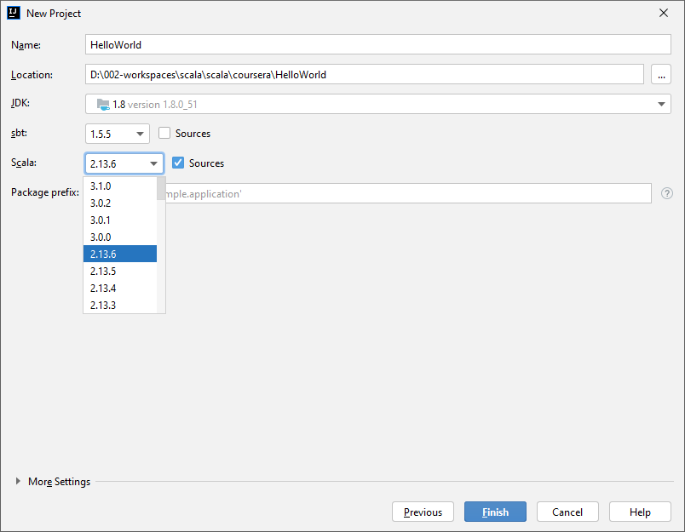

We have created the project with 3.0.2 version of Scala

Create a new Scala Package named playground now

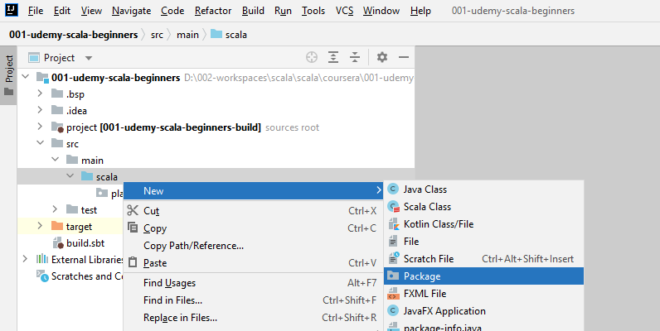

Create a new Scala class now

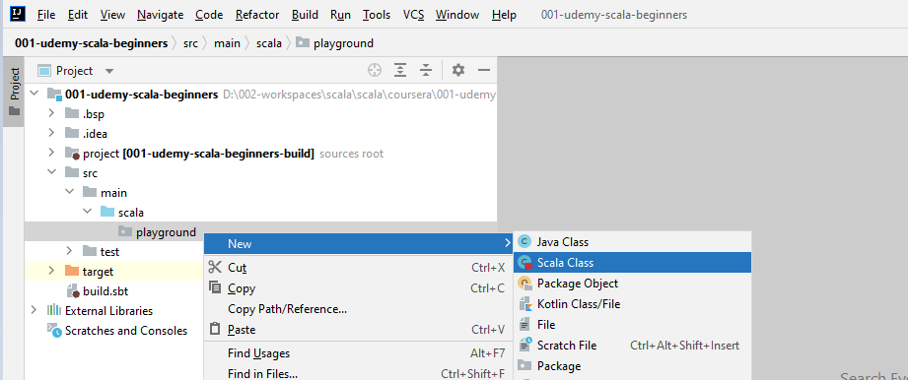

And we will select Object here as this is a Singleton class

|  |  |
| --- | --- |
|  | **Playground.scala**  package playground  object Playground {  } |

Type in main and hit enter and IntelliJ will expand that to the main method for this class

This is similar to public static void main in Java

package playground  
  
object Playground {  
  
 def main(args: Array[String]): Unit = {  
 println("I am ready to learn Scala!");  
 }  
}

This file is now a executable application, Right click and Run and it will print "I am ready to learn Scala!"

### Values, Variables and Types

Create a package for this named part1.basics and in that package create a Scala class called ValuesVariablesTypes

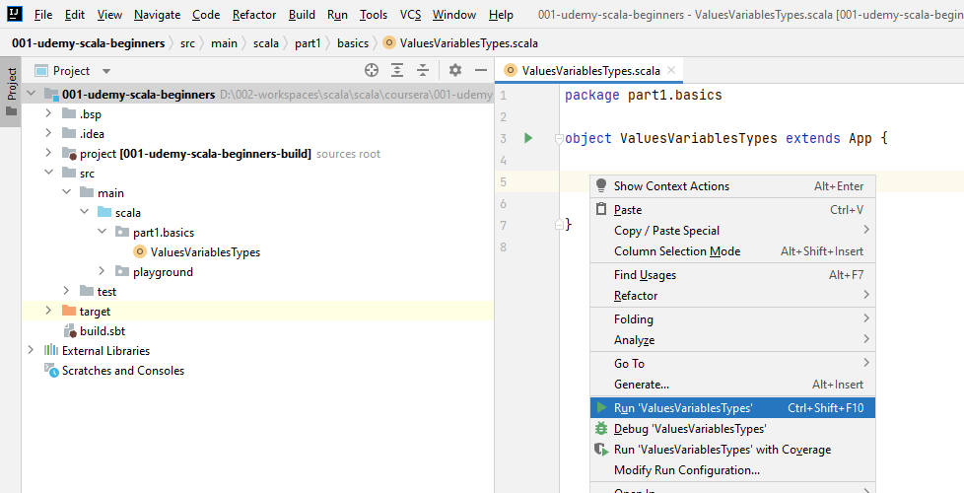

Right clicking now would show the option of Run for this file.

Lets create a value now

Syntax is

package part1.basics  
  
object ValuesVariablesTypes extends App {  
  
 val *x*: Int = 42  
 println("Value of x is " + *x*)  
  
}

* If we try to give a new value to x, this will upset the computer

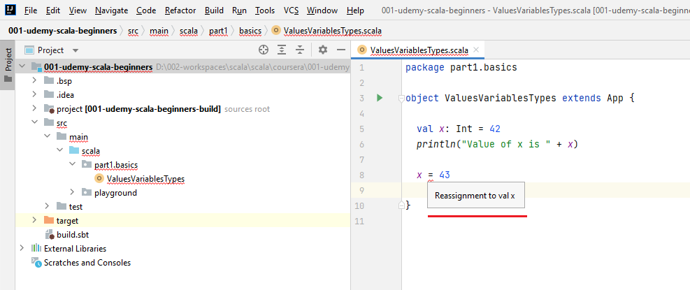

It says if I hover, it says reassignment to Val. So this is the first take away from the this lecture. The things that you declare with your Val cannot be reassigned. Once they have a value, they're set in stone. Vals are immutable. Vals act in a similar way to constants or finals in Java or C, although they serve a different purpose.

vals aren't really regarded as constants to be used in various parts of the code, but more like intermediate computations to later use in computations.

Now the Scala way and the functional programming way of thinking in general involves working with such vals. You'll get more familiar with this style as we go through the course. OK, so let's delete this little token here because it's not allowed.

So keep in mind that vals are immutable.

Now, next lesson. Watch what I'm doing. So I'm selecting the type of Y, like we said, call an end and I'm going to delete it. So as you see, nobody seems to complain. And if I. Right click and run, the code will run and still print forty two. OK, so another piece of news.

The types of Vals are optional. That's because the compiler can infer the type of in this case X from the right hand side.

It looks at the value of 43 and the compiler figures out that forty three is an it. So Y must be an Int. If I hover over it you will see that Y is an Int.

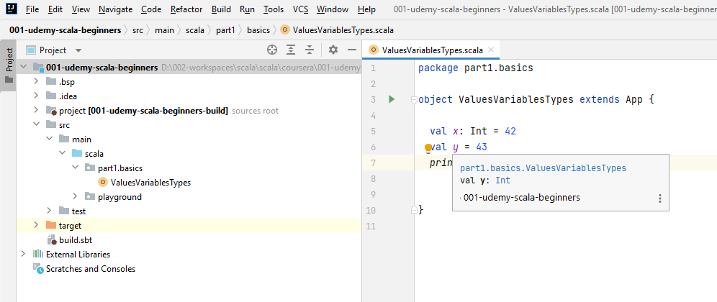

And that was inferred by the compiler already without needing me to specify explicitly. So keep in mind that compiler can infer types. Now in practice we don't usually mention type's explicitly for values and later variables as the compiler is smart enough to figure types for us.

Now, if you do mention the type and if you say call it a Int, make sure the right hand side conforms to that type because otherwise the compiler will complain.

For example, if I use a string, which is a piece of text in between double codes and says Hello Scala, now the compiler complains because it says expression of type string does not conform to expected type in.

* Vals are Immutable
* Compiler can Infer types from the right hand side

Compiler will complain when we assign the wrong types

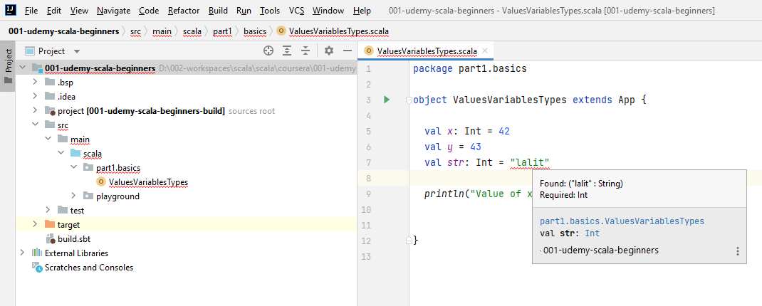

Just so you know that semicolons are allowed in Scala like you've probably seen in Java or C or C++, but they're not really necessary in Scala as we write each expression on its own line. So semi colons are unnecessary, they are required if you write multiple expressions on the same line. But this is usually bad style. So if I say Val, another string, which is good, goodbye. Now the semicolon is mandatory because it separates the expression. Again, this is discouraged.

package part1.basics  
  
object ValuesVariablesTypes extends App {  
  
 val *x*: Int = 42  
 val *y* = 43  
 val *aString*: String = "lalit"**;** val *aDouble*: Double = 10.0  
   
 println("Value of x is " + *x*)  
  
}

Lets look at some more data types now

**ValuesVariablesTypes.scala**

**package** part1.basics  
  
**object** ValuesVariablesTypes **extends** **App** {  
  
 val x: Int = 42  
  
 // inferred as integer  
 val y = 43  
  
 // inferred as String  
 val someString = "lalit"  
  
 // Semicolons are required if writing multiple lines on same line - bad practise however  
 val aString: String = "lalit"; val aDouble: Double = 10.0  
  
 println("Value of x is " + x)  
  
 // Boolean  
 val aBoolean: Boolean = **false**  
  
 // inferred as Boolean  
 val someBoolean = true  
  
 // Char  
 val aChar: Char = 'a'  
  
 // Float  
 val aFloat: Float = 1.1  
  
 // inferred as Double and not Float  
 val aNumber = 1.1  
  
 // Inferred as Float  
 val aInferredFloat = 1.1F  
  
 // Inferred as Double  
 val aInferredDouble = 1.1D  
  
 // Longs  
 val aLong: Long = 1  
  
 // Inferred as Long  
 val aInferredLong = 1L  
  
 // Short  
 val aShort: Short = 1  
  
 // Inferred Short  
 // ??  
  
 // Will complain of reassignment in statement below, hence commented  
 // aShort = 2

// Variables

var aVariable: Int = 4

// Variables can be reassigned, compiler will not complain

// In functional programming this is called as side effects - reassigning values

aVariable = 5

println("Value of aVariable is " + aVariable)

}

Programs without side effects are easier to understand, as we will see in this course, because there are no variables and logic to keep track of. However, we cannot really eliminate side effects completely because we need our programs to do something to the world. We'll just need to be mindful of side effects from now on, and I'll discuss more cases of side effects, of dangers of side effects as we go through the course.

We have learned about values and how to declare them, as in Val, name calling type equals something on the right hand side. You've learned that values cannot be reassigned. That is, they are immutable. By contrast, variables can be reassigned. We see that they are mutable now. Functional programming involves working less with variables. So we'll start thinking more in terms of values rather than VARs, and you'll learn the style of thinking along the way.

We have also seen that val and var have types and the types can be inferred by the compiler, which is pretty cool. From now on, we'll use the compiler to determine the type of things you've also learned, the basic types in Scala and how to use them. You've seen booleans, you've seen numerical values, and you've also seen characters and strings.

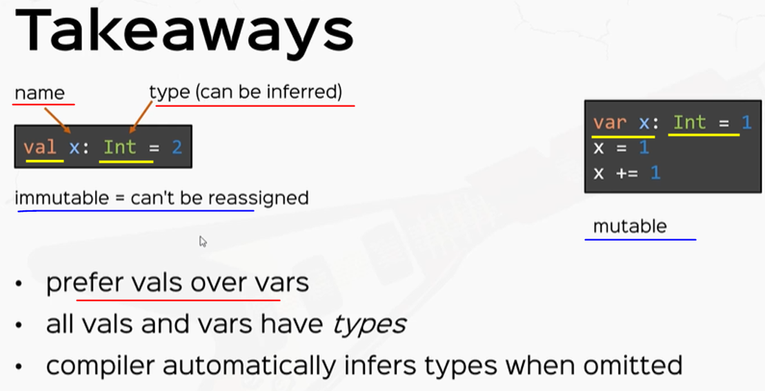

### Expressions

We're going to create a new application just for this lecture.

**Expressions.scala**

package part1.basics  
  
object Expressions extendsApp {  
  
   
}

In Scala we call this an expression – see the x statement

Most basic expressions are Math expressions, see the println statement above

package part1.basics  
  
object Expressions extends App {  
  
 // Expression  
**val *x* = 1 + 2**

println( 2 * 3 + 4 )

// + - * / & | ^ << >> >>> ( right shift with zero extension )

}

Math operators are of course, plus minus, multiply, divide and then bitwise operators you've probably use in other languages like 'bitwise and', 'bitwise or', bitwise, 'exclusive or' in bitwise 'left shift' and 'right shift' along with this little particular right shifting operation, which is only specific to Scala and this is right shift with zero extension, this is a little bit more rarely used, but I just wanted you to know it exists.

Of course, there are many, many types of expressions, say, for example, relational operations which test equality and non equality. So, for example, if I print line, the expression one equals equals X this test for equality between the number one and the number X. This thing is an expression and it evaluates to a boolean. In this case, it will evaluate to false because X is three, so it will print false to the console. Other relational operations are so you've seen equals equals already this test for equality. We have not equality, which is the not equal sign this being equals. We have relational operations between numbers. We have greater then greater than or equal less then and less than or equal.

println(1 == x)  
// == != > >= < <=  
  
println(!(1 == x))  
// ! && ||

Next we have boolean operators for logic. You've also likely seen this. So if I print line, the negation of one equals X, we say not this little bang and inside parentheses we can have a condition, so one equals X.. This is the logical negation. Logical negation is a unary operator. You can have logical and in logical or operators which are binary and these act on two booleans and return a boolean. You've also likely seen this before. Also, you might have used operators for changing variables from other languages. So if I declare var a variable, which has the value to for example and I say a variable plus equals three, that means a variable turns out to be five because I'm adding three to it. This also works with minus equals, multiply equals and divided by equals. So just to prove that this works, if I print this to the console, I'm going to see the value five. Note that this these operators and the plus equals only work with variables, like I mentioned in the previous video, changing a variable is called a side effect. So these are all side effects.

var aVariable = 2

aVariable += 3 // also works with -= *= /= ..... side effects

println( aVariable )

Which brings me to the next very important topic that I want to talk about, which is the distinction between statements or instructions versus expressions. So instructions versus expressions. I want to make this distinction very, very clearly from the start, because understanding this will clear a lot of confusions in the future. All right.

Instruction. Something that you tell the computer to do, for example, change a variable, print to the console, do this or do that in imperative languages like Java or Python, you work with instructions. So you're basically always to tell the computer, do this, do that, compute this compute that showed this to the console, print this to the console, send this to the server and so on and so forth. All right. So instructions are doing something.

**// Instructions (DO) vs Expressions (VALUE)**

// IF expression

val aCondition = true

val aConditionedValue = if(aCondition) 5 else 3 // IF EXPRESSION

println(aConditionedValue)

println( if(aCondition) 5 else 3 )

println(1 + 3)

var i = 0

val aWhile = while (i < 10) {

println(i)

i += 1

}

// NEVER WRITE THIS AGAIN.

By contrast, an expression is something that has a value or and or a type right. In Scala and in functional programming in general we'll think in terms of expressions, that is every single bit of your code will compute a value. Now, let me show you what I mean with a new Scala syntax example, so a good example of this is the if expression in Scala, which acts in a very, very different way than in most other languages. So if I say, val aCondition, which is something that you compute, right, let's just say it's true for the sake of it, we don't really care about the actual value of a condition. Now, if we want a computer value in terms of this condition, so lets say val aConditioned value, we will say in Scala if a condition and let's just say that if a condition is true, will have the value five otherwise will have the value of three. In Scala we say if a condition five else three and let's print a conditioned value.

// IF expression  
val aCondition = true  
val aConditionedValue = if(aCondition) 5 else 3 // IF EXPRESSION  
println(aConditionedValue)

All right, so we have the value five here because a condition is true. Now, let me break this down for you. So what this could says is a condition value here is either five, if a condition is true or three otherwise known is that unlike other languages where you would say if a condition do something that is set the value of five, otherwise, that the value of three, the if expression gives back a value. That's why it's called an if expression, not an if instruction. All right. So to prove this further, you can actually use this if expression as is, so if I print this to the console.

Notice that the compiler doesn't complain and I'm going to see another five here. So just as you would say, println, I don't know, one plus three, and this evaluates to 4. This thing is also something that evaluates to five. So this is super important. And we'll use if expression's a lot in the course and you will use it a lot in your code. So make sure you get this right. The if in Scala is an expression. All right. Now you know about IFS.

// IF expression  
val aCondition = true  
val aConditionedValue = if(aCondition) 5 else 3 // IF EXPRESSION  
println(aConditionedValue)

println(if(aCondition) 5 else 3)  
println(1 + 3)

You're now probably curious to know about Loop's because it's the natural progression in learning a new programming language. And I'm here to tell you that there are loops in Scala, but we discourage using them because there are rimiscents of imperative programming like Java. They don't really return anything meaningful and only execute side effects. Let me give you an example, though. So if I declare a variable, which I initialize with zero and I want to count to 10, so I'm seeing - while I is less than 10 and I'm going to create a little block of code and I'm going to print each number and I'm going to increment by one. So i += 1. This is a while loop in Scala call and if I right click and run this application, I'm going to see all the numbers from zero to nine. All right. But next, I'm going to write this in all caps. Please never write this again.

var i = 0  
val aWhile = while (i < 10) {  
 println(i)  
 i += 1  
}  
  
// NEVER WRITE THIS AGAIN.

Now, if you ask me, but how do I actually iterate, we'll learn how to approach iteration very, very shortly, I promise. But please avoid while loops like the plague. That's because while and looping in general is very specific to imperative programming, that is Java or Python or C, the single worst thing a Scala programmer can do really is write imperative code with this syntax. So please don't do this.

We're talking about instructions and expressions and the difference between them and Scala forces, everything to be an expression. So everything in Scala is an expression. Only definitions like the definition of a val or a class or package is not expressions, but everything else is. So keep that in mind. Operations, calling functions, if expressions like it's seen here, every single thing, even reassigning a variable is also an expression, it just doesn't return anything meaningful.

So watch what I'm writing. I'm going to introduce a new concept here. So if I see val, I'm going to name this aWeirdValue. And the value of aWeirdValue is I'm going to put this in between parentheses so it's more obvious for you and I'm going to say a variable equals three. So this thing has its own value and can be attributed to aWeirdValue. Now, the type of aWeirdValue is if I hover it – a Unit. Unit is a very special type in Scala, which is equivalent void in other languages, and it just means don't return anything meaningful. And the only possible value of unit is I'm going to show you. Let's print this out. So if we print this, if I run, we're going to see the value of unit, so the value of unit is this little guy parenthesis, parentheses, this is the only value the unit type can hold.

// EVERYTHING in Scala is an Expression!  
  
val aWeirdValue = (aVariable = 3) // Unit === void  
println(aWeirdValue)

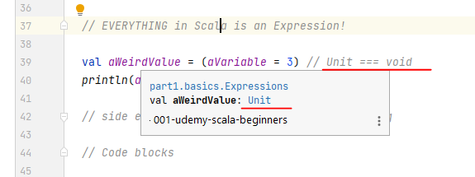

We said in last video that reassigning a variable is a side effect. Now, side effects in Scala are actually expressions returning Unit.

That's all you need to know - while Loops, for example, are side effects. And these expressions also return Unit. For example, if I declare a value, call this aWhile and if I hover over aWhile, the compiler infers it to be unit.

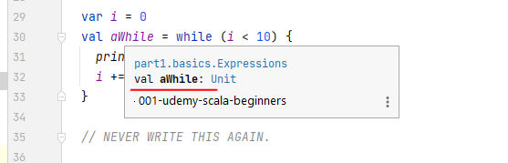

val aWeirdValue = (aVariable = 3) // Unit === void  
println(aWeirdValue)  
  
// side effects: println(), whiles, reassigning

That's because the while expression returns Unit. So examples of side effects are printing something to the console, for example. while loops and reassigning of vars, these are all side effects and there are expressions returning Unit. So make sure you get the right, Side Effects are reminiscent of imperative programming. That is, they are like instructions, but in Scala there's still expressions returning Unit.

All right. Now, final thing I'm going to talk about code blocks.

Code blocks are a special kind of expressions because they have some special properties.

So watch what I'm writing. I'm going to declare a value. I'm going to call this a code block. And this is I'm going to open some curly braces and inside I'm going to define some more values.

val aCodeBlock = {  
 val y = 2  
 val z = y + 1  
  
 if (z > 2) "hello" else "goodbye"  
}

So let's say value Y equals two and values equals I don't know why plus one. And at the end I'm going to see if z is greater than 2. I'm going to say "hello", otherwise "goodbye". This little piece of code is called a code block, it's surrounded by curly braces, and inside we can write code, we can define values, we can write expressions and so on and so forth. Now, two interesting bits about blocks.

* Number 1: code block is an expression. Even the fact that I put it on the right hand side of a value definition should tell you that this guy is an expression like everything else in Scala.
* The value of the block is the value of its last expression.

So the value of this whole block is the value of this if expression because it occurs just all right. Sure enough, if I hover over a code block, it'll the compiler will say that this is a string. That's because it's the type of the last expression which is the type of both branches. OK. Now interesting bit

* Number 2: code blocks, as you can see here, can have their own definition of values and variables and so on and so forth inside.

Everything you declare inside the code block stays visible within the code block. So if later outside the block I say, let's say I'll say val anotherValue = z + 1.

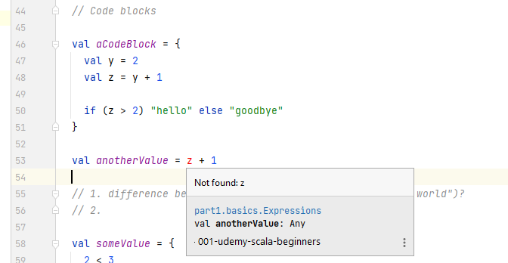

*// Code blocks*val aCodeBlock= {  
 val y = 2  
 val z = y + 1  
  
 if (z > 2) "hello" else "goodbye"  
}  
  
val *anotherValue* = **z** + 1

It says, cannot resolve symbol z, and that's because z is defined within a code block and it's not visible outside.

We have learned that, if in Scala is not an instruction, it's actually an expression and it evaluates to something. You've also learned that code blocks in Scala are also expressions and their value is given by the value of the last constituent expression, plus the fact that inside code blocks you can have auxillary definitions that are only visible inside the code block. But most importantly, you've learned to make the difference between instructions and expressions. So instructions are executed. Think imperative languages like Java, think do something versus expressions which are evaluated like in functional languages and Scala for example. So instruction means do something versus an expression, which means give me the value of something. You learn to make this subtle difference as we go through this course.

Also in Scala and in functional languages in general, we'll think more in terms of expressions and values, of course, but this style of thinking will come natural to you as we progress. Now, before we move on to exercises, I wanted to ask a little little little thing of you. Please, please do not use while loops in your scala-called code.

|  |  |
| --- | --- |
| val x = 3 + 5  val xIsEven = x % 2 == 0  val xIsOdd = x % 2 != 0  val xIsOdd = xIsEven != 0  val cond: Boolean = . . .  val i = if (cond) 42 else 0  val x = {  val cond: Boolean  if (cond): 42 else 0  } | Basic Expressions: Operators  if in scala is a Expression  Code Blocks in Scala are Expressions. The value of the Bock is the value of the last Expression  **Expressions vs Instructions**  Instructions are executed ( think Java ), expressions are evaluated ( Scala ) |

So I have a couple of questions for you. First, what is the difference between that string hello world and println("hello world"). Think about it, second question is, what's the value of this guy? I'm going to declare a value in this cause someValue equals 2 < 3. So what's the value of this? All right. Also, what's the value of this little guy? Let's call this someOtherValue, which is, again.

// 1. difference between "hello world" vs println("hello world")?  
// 2.  
  
val someValue = {  
 2 < 3  
}  
println(someValue)  
  
val someOtherValue = {  
 if(someValue) 239 else 986  
 42  
}  
println(someOtherValue)

Well, the string. "Hello, world" is a value of type String. The Hello World is a string literal.

We like to say the println("Hello world") is an expression which is a side effect.

* And if you've paid attention to side effects, they are expressions returning Unit.

So the types of these two things are different. The first is a String and this guy is Unit. This also has the side effect. That's why it's called the side effect of actually printing the string. Hello world to the console.

All right. So these these two are the main differences between the string Hello World versus print line. Hello, world. As for the second question, someValue is a value of type boolean. It's a code block and the value of the code block is the value of its last expression. Now, given that this block only has one expression, this guy is a relational operation and returns a boolean. If you hover over some value, it says it's a boolean. And in particular, the value of someValue is obviously true because two is less than three. If we print this out to the console, we'll see the value true in the console, but we'll print some other value as well to convince ourselves of the value of this guy as well. So some other value is also a code block and the value of the block is the value of the last constituent expression. Now, this might be a small trick question because the value of this code block is this little guy 42. This is the value of some other value. This the type of some other value is an end and it's value is forty to this if expression is completely irrelevant. So if I print this out, we're going to see the value True. And the value of 42. OK, so obviously the value true and the value 42, so this is the solution to the two questions.

**Expressions.scala**

package part1.basics  
  
object Expressions extends App {  
  
 // Expression  
 val x = 1 + 2  
  
 // + - * / & | ^ << >> >>> ( right shift with zero extension )  
  
 println(1 == x)  
 // == != > >= < <=  
  
 println(!(1 == x))  
 // ! && ||  
  
 var aVariable = 2  
 aVariable += 3 // also works with -= *= /= ..... side effects  
 println(aVariable)  
  
 // Instructions (DO) vs Expressions (VALUE)  
  
 // IF expression  
 val aCondition = true  
 val aConditionedValue = if(aCondition) 5 else 3 // IF EXPRESSION  
 println(aConditionedValue)  
 println(if(aCondition) 5 else 3)  
 println(1 + 3)  
  
 var i = 0  
 val aWhile = while (i < 10) {  
 println(i)  
 i += 1  
 }  
  
 // NEVER WRITE THIS AGAIN.  
  
 // EVERYTHING in Scala is an Expression!  
  
 val aWeirdValue = (aVariable = 3) // Unit === void  
 println(aWeirdValue)  
  
 // side effects: println(), whiles, reassigning  
  
 // Code blocks  
  
 val aCodeBlock = {  
 val y = 2  
 val z = y + 1  
  
 if (z > 2) "hello" else "goodbye"  
 }  
  
 // val anotherValue = z + 1  
  
 // 1. difference between "hello world" vs println("hello world")?  
 // 2.  
  
 val someValue = {  
 2 < 3  
 }  
 println(someValue)  
  
 val someOtherValue = {  
 if(someValue) 239 else 986  
 42  
 }  
 println(someOtherValue)  
  
}

### Functions

I'm going to call this a function, and in parentheses, I'm going to specify parameters in each parameter has a name and a type. So a: String is a parameter named a of type String. I'm going to add another parameter, say type Int, and this function will return a string. So call on string at the end is the return type of the function after the function definition or the function header or the function signature, if you will, at the end will put an equal sign and then we'll specify the implementation and after the equal sign follows a single expression, which is the implementation of the function and the implementation of the function that I want to write.

package part1.basics  
  
object Functions extends App {  
  
 def aFunction(a: String, b: Integer): String =  
 a + " - " + b  
  
 *println*( *aFunction*("Hello", 12) )  
  
}

Now, like everything else in Scala, calling a function is also an expression, right? Because we can use the call the function as is in the print line. Now one new thing to bear in mind the parameter less functions can also be called with just their name.

def aParameterlessFunction(): Int = 42

println(aParameterlessFunction())

// println( aParameterlessFunction )

// only works in Scala 2 - parameterless functions are invoked without parentheses

We can print a parameter less function like this with the parentheses parentheses () like we would call a function, or we could print a parameter less function without the paranthesis (). And the compiler will warn us that empty print method axes as parameter or less so parameter less functions can be called with just their name. So keep this in mind.

I'm talking particularly to people already exposed to functional programming, where the syntax could mislead you into thinking that this is the function itself. So you now know how to define it functions. Now let's define some more ambitious functions. This was pretty basic. Let's define another function that instead of concatenating a string and an int, now concatenate the same string n times. Now in a normal programming language for such a function, you would use loops, but I want you to get into a habit of using functions instead. So this is what I promised I would show you when thinking about loops in a functional language. So let me show you how I'm going to do it. So I'm going to define a function.

def aRepeatedFunction(aString: String, n: Int): String = {  
 if (n == 1) aString  
 else aString + aRepeatedFunction(aString, n-1)  
}  
  
println( aRepeatedFunction("hello",3) )  
  
// WHEN YOU NEED LOOPS, USE RECURSION.

So this is a recursive function because it calls itself and the IntelliJ is smart enough to figure this out for me. And it says method a repeated function is recursive. Now if I call this function and let's say, print the application of a repeated function with the string hello and the number three, I am expecting to see hello, concatenate it three times and print it to the console. So let's right click and run this and we see Hello, Hello, Hello. Of course, that is because we call this repeated function recursively, and at some point it would be a function got into the and equal one base case. So it returned a string and then the repeated calls or the recursive calls concatenate a string later on.

So what I want you to take away here is that when in a normal programming language, you would use loops but in Scala or in a functional language - you use recursive functions. So I'm going to write this in all caps when you need loops - use recursion. This is a fundamental idea of functional programming. Even if you get this one idea right out of this course, you're already ahead of half of Scala programmers.

Again, the worst thing a Scala programmer can do is use imperative code with a Scala syntax. Now, before I move on, I wanted to talk a little bit about types, about return types of functions. So as is the case that the compiler can infer the types of vals or vars. So the compiler can figure out the return types of functions if not specified. So let's go to the first function and just remove the return type of this one. So the compiler doesn't really complain if I delete the return type of a function, and indeed, if I hover over it, it says it still returns a string. And the compiler figures that out by looking at the implementation, which is the expression concatenating some strings.

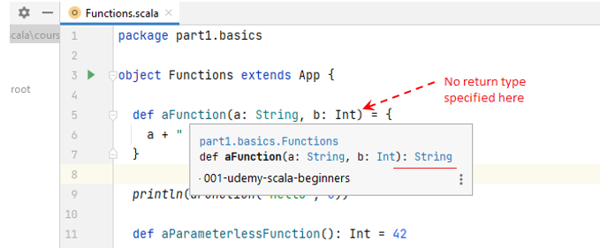

* But if we delete the return type from a recursive function then the compiler will complain.

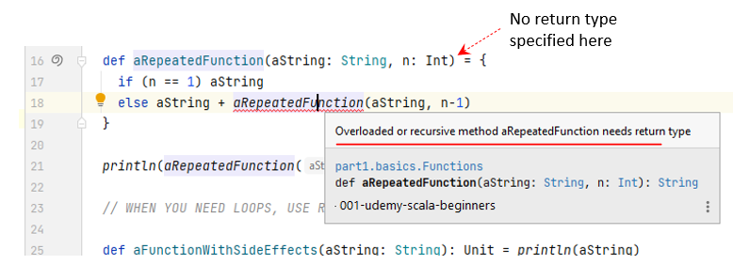

* So it says the recursive method a repeated function needs results type. All right. That's because the compiler cannot figure out the return type of a recursive function on its own. Just remember to put in return types of functions, especially if they are a recursive as best practice. Always specify the return types of functions nonetheless.

Speaking of return types, you can use Unit as a return type. That means you define a function as only executing side effects. So if I say def a function with side effects that takes, a string as a parameter, I'm going to name this parameter a string. The type will be String and the return type is Unit, and the implementation is going to be something that returns Unit. Now what is something that returns unit, for example? Print line statement.

def aFunctionWithSideEffects(aString: String): Unit = println(aString)

So print line something is still an expression returning unit. We normally need functions with side effects if we want something that has nothing to do with computation itself, for example, printing something to the console, displaying something on screen, logging something or writing to a file, etc.

Now another thing which might not be a shocker. We said that you can have code blocks as the implementation of functions. We also said in a previous video that in code blocks, you can have auxiliary definitions. Now here the short code blocks also allow you to define auxiliary functions inside. So if I define a big function with, say, a parameter and which returns and I don't really care the types of parameters or the return types of functions here, I only care that I show you that you can define auxiliary functions inside. So if I define a smaller function which receives, I don't know how many parameters you want. And it just returns an Int, say, a plus b, you can actually use the functions that you define inside the code block to determine the return type of the big function that you implement. So if I say if I call a smaller functions inside a smaller function with n and n - 1, this is the return type. ➀ The return expression sorry of the implementation of a big function.

def aBigFunction(n: Int): Int = {

def *aSmallerFunction*(a: Int, b: Int): Int = a + b

*aSmallerFunction*(n, n-1) ➀

}

* So you can use the code blocks to define auxiliary things inside like values, variables and now auxiliary functions.

So you now know about functions. Let's practice these functions with some exercises. I'm going to give you four tasks here. These are pretty simple.

/*

Exercises:

1. A greeting function (name, age) => "Hi, my name is $name and I am $age years old."

2. Factorial function 1 * 2 * 3 * .. * n

3. A Fibonacci function

f(1) = 1

f(2) = 1

f(n) = f(n - 1) + f(n - 2)

4. Tests if a number is prime.

*/

**1st assignment solution**

The first function with the greeting is very simple, but it's supposed to get you familiar with Scala syntax for defining functions.

def greetingForKids(name: String, age: Int): String =

"Hi, my name is " + name + " and I am " + age + " years old."

println(greetingForKids("David", 12))

**2nd assignment solution**

def factorial(upto: Int): Int = {

if (upto > 1)

upto * factorial( upto - 1 )

else

1

}

*print*( *factorial*(5) )

**3rd assignment solution**

Another recursive function will be a Fibonacci function. And the Fibonacci numbers are a stream of numbers. Where are the first Fibonacci number? Is one. The second Fibonacci number is also one. And Fibonacci of PN is Fibonacci of n - 1, plus Fibonacci of n - 2. All right. So this is a stream of numbers that just explodes exponentially. So I want you to implement the Fibonacci number. So Fibonacci of PN should return the absolute value of the Fibonacci number.

def fibonacci(n: Int): Int =

if (n <= 2) 1

else *fibonacci*(n-1) + *fibonacci*(n-2)

// 1 1 2 3 5 8 13 21

println(fibonacci(8))

**4th assignment solution**

Now finally, let's go with is prime, which receives a number n as parameter and returns a Boolean, which is to test whether n is a prime or not. And here I'm going to open some curly braces because isPrime needs an auxiliary function. So these two previous functions, Factorial and Fibonacci wanted you to write recursive function and isPrime needs an auxiliary function inside a code block. And here I'm going to write an auxiliary function, which tests if n is prime up to a limit. So I'm going to define an auxiliary function. This is prime until and I'm going to pass in a parameter t, which is Int, and this will return Boolean. So the significance of this function is is inPrime until T that is, does n have any devices until the number of T, right? So the implementation of this function is going to be if T is less than or equal to one, then it's going to return. True because an is prime until the number one. There are no dividers between 2 and 1 such that they divide n right. Otherwise, I'm going to call isPrimeUntil recursively because isPrime until T is basically isPrimeUntil T minus one and n should not divide T.

|  |  |
| --- | --- |
| **def** isPrime( n: **Int** ): **Boolean** = {  **def** isPrimeUntil( t: **Int** ): **Boolean** =  if ( t <= 1 ) true  else n % t != 0 && isPrimeUntil( t-1 )  isPrimeUntil(n / 2)  }  println( isPrime(37) )  println( isPrime(2003) )  println( isPrime(37 * 17) ) | So this is a one possible solution for an implementation of his prime. There are multiple equivalent implementations. And just to test if we call is prime with the no say thirty seven, which is a unknown prime number or is prime with a number of twenty three, which is a bigger number but still known to be prime. We should be seeing true in the console. But if we try saying thirty seven times 17, which is an non-prime number, we should be getting false. We should be getting two truths and one force in the console.  Oh, you should be calling as prime, of course. So let me call this guy. Of six to nine. |

And just to test if we call is prime with the no say thirty seven, which is a unknown prime number or is prime with a number of twenty three, which is a bigger number but still known to be prime. We should be seeing true in the console. But if we try saying thirty seven times 17, which is an non-prime number, we should be getting false. We should be getting two truths and one force in the console. Oh, you should be calling isPrime.

So we have true, true and then false, which means that our is prime function works well.

### Type Inference – What the compiler knows

We've seen type inference a little bit in action in our code earlier in the earlier videos. But I also want you to get a more solid understanding of it in theory. So we saw in our code then when we don't specify a type for a value or variable, the compiler will try to figure it out for us. So in this case, the value message has the value of a string. So the compiler looks at the right hand side and says, OK, this is this, this is a string. So the type of message must also be a string. Or that being said, the compiler will then write a complete value definition for us without needing us to specify the type string explicitly. This is a one step operation, but the compiler is able to do many, many steps in order to determine the correct type of our values. So in this example, we have two values, X and Y, for which we have not specified any type, but the compiler is able to progressively determine the type of each.

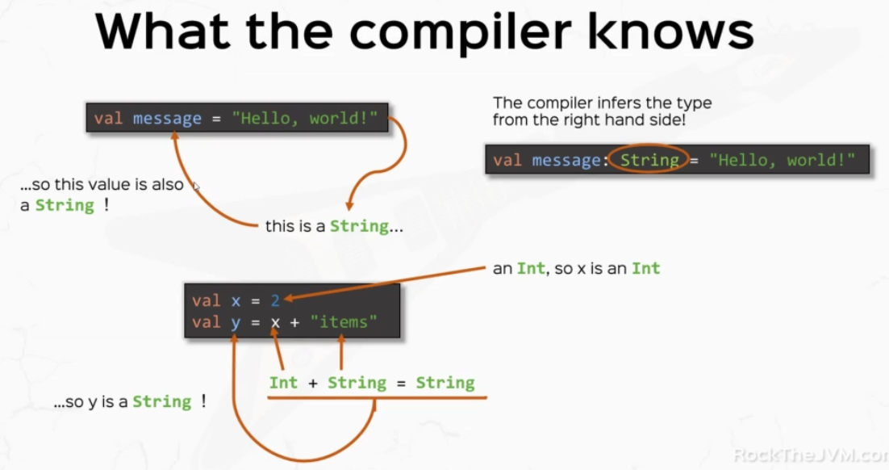

So for the value X, the compiler is able to figure out that it's an end from the right hand side and for the value y having determined the type of X first, it will look at the right hand side and will say int plus a string, well that is a string concatenation. So the result is a string. So the type of Y is also a string. But what you're seeing on screen right now is a more visual representation of what the compiler actually does behind the scenes. This is important.

The compiler is also able to figure out the return types of functions by looking at their implementations. So if I, for example, defined this little successor function which returns the next integer, the compiler is able to look at the implementation, figure out that the resulting expression returns in this case. And so it's able to figure out that the return type of this function is int. So behind the scenes, the compiler actually writes the complete function signature with the return type completely specified without me needing to write it explicitly.

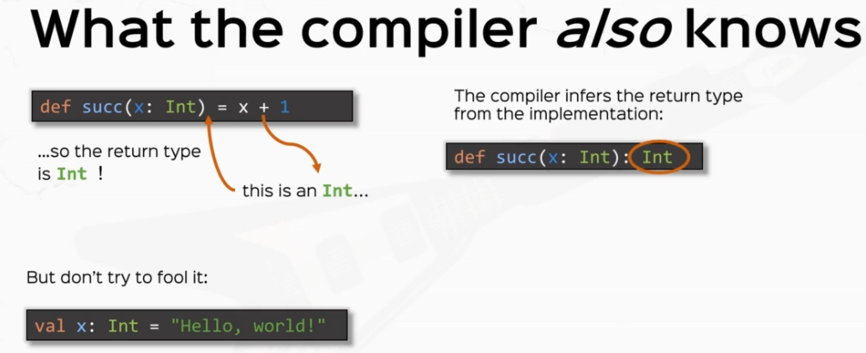

But if you do specify a type, make sure that you conform to it on the right hand side because otherwise the compiler will you with an error. In this case, I'm declaring a value of type input. Given a string on the right hand side, the compiler still does type inference behind the scenes to do a type check. So the compiler is expecting an end. But on the right hand side, the compiler figures out that the return expression is a string. So it confuses the compiler and it throws an error in your face called a type mismatch.

But sometimes the compiler is not able to figure out all the return types on its own. So with our little recursive factorial function here as an example, the compiler is not able to figure out the return type here. Let's just assume that it tries to do. So as we said before, determining the return type of the function means determining the return type of its implementation expression, which in this case isn't if expression, which has two branches. So the compiler has to analyze both the first branch returns an integer which is fine. The other branch returns a product between an int, which is also fine, and the recursive call of factorial who's type the compiler is not aware, so it will try to figure out the return type of this other factor by looking at the return type of the factorial function, which is what it was trying to find in the first place, which confuses the compiler. And the compiler will throw an error in your face when it does that.

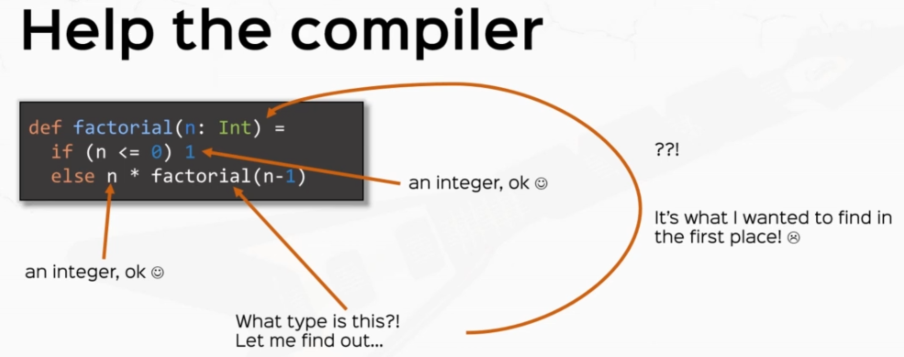

### Stack and Tail Recursion

def factorial(n: Int): Int =

if (n <= 1) 1

else {

println("Computing factorial of " + n + " - I first need factorial of " + (n-1))

val result = n * factorial(n-1)

println("Computed factorial of " + n)

result

}

println( factorial(10) )

// println(factorial(5000)) // stack overflow!

* So this function is recursive of course. OK, now the technical detail in order to run a recursive function, the Java virtual machine on top of which Scala runs, uses a call stack to keep partial results so that it can get back to computing the desired result. So each call of the recursive function uses what we call a static frame.

Now, the trouble with this approach is that the Java, the Java virtual machine keeps all the calls on its internal stack, which has limited memory. So if I tried to print factorial of five thousand. This thing will be will not be so pretty, so let's run this. And we have our first crash, this is cold, so I'm going to Scala this all the way to the top and this will be our first. Stack overflow error, stack overflow errors happen when the recursive depth is too big, so as you see the recursive calls stopped around the the number five hundred and thirty four from the number of 5000 originally.

So basically the JVM tried to call the recursive function roughly forty five hundred times before the stack blew up with memory. So we have our first stack overflow error. All right. So this is bad, particularly since recently I told you that you should use recursion when you want to loop. Now, a legitimate question would be OK, Daniel, but what if I do want to iterate five thousand times? Can I only iterate only roughly four thousand five hundred times? Isn't that a limitation?

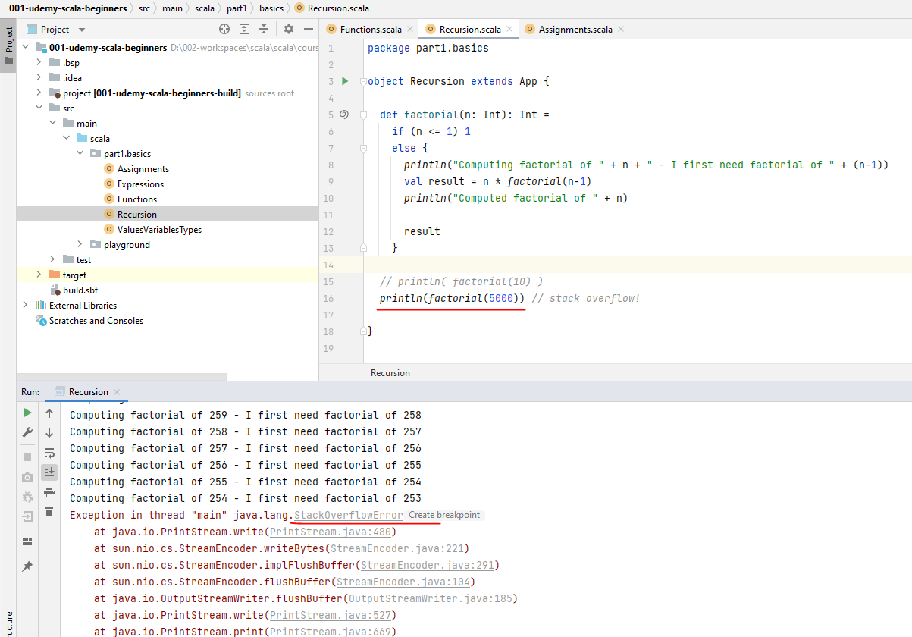

Well, the answer is yes, it is, unless we write code in a smart way. Now, let me give you another definition of the factorial function above and let us to find a new concept. All right.

So I'm going to define another factorial. I'm going to call it just like that. Another factorial, which again, receives an end as a parameter and it returns an end, of course. And inside, I'm going to define an auxiliary function. I'm going to call this factorial helper. This receives, uh, an intensive parameter. I'm going to call this X and another IND as a parameter. I'm going to call this accumulator. The return type is also going to be an end and the implementation of this one is going to be so this is basically the essence of the fact, well, if X is less than one, which is the base case for the factorial as well, instead of returning one, I'm going to return accumulator. Otherwise I'm going to call fact helper with X minus one. And the accumulator this time is going to be X times accumulator. At the end, I'm just going to call fact help her with an. And the number one at the beginning, so this guy is another definition of factorial, it runs the same. This is really not obvious.

def anotherFactorial(n: Int): BigInt = {

@tailrec

def **factHelper**(x: Int, accumulator: BigInt): BigInt =

if (x <= 1) accumulator

else **factHelper**(x - 1, x * accumulator)

*// TAIL RECURSION = use recursive call as LAST expression*

factHelper(n, 1)

}

*/\**

*Let me break it down for you.*

*Breakdown:*

*anotherFactorial(10) = factHelper(10, 1)*

*= factHelper(9, 10 * 1)*

*= factHelper(8, 9 * 10 * 1)*

*= factHelper(7, 8 * 9 * 10 * 1)*

*= ...*

*= factHelper(2, 3 * 4 * ... * 10 * 1)*

*= factHelper(1, 1 * 2 * 3 * 4 * ... * 10)*

*= 1 * 2 * 3 * 4 * ... * 10*

*\*/*

*println*( *anotherFactorial*(20000) )

*// WHEN YOU NEED LOOPS, USE _TAIL_ RECURSION.*

Let me break it down for you. All right. So another factorial of 10. Let's say we compute another factorial of 10 and let us prove that it does the same thing as factorial of ten, which is the product of all numbers, up to 10. One times. Two times, three times so on until 10. All right. So another factor of 10 is this guy factHelper of ten and one of ten and one I'm just going to copy factHelper because I'm going to use it a lot. All right. So fact helper of ten and one. What is fact helper of ten and one, is ten less than or equal to one. Well, no. Well, we're going to go on the else branch, which means that this is fact helper of ten minus one, which is nine and ten times the accumulator while the accumulator was one.

*= factHelper(9, 10 * 1)*

So ten times one. OK, now factHelper of nine and ten again is nine less than or equal to one. No. So we're going to go on the else branch again, which is fact helper this time X minus one is eight because the original parameter is nine and the accumulator is ten times one and X is equal to nine. So this guy will be nine times ten times one.

*= factHelper(8, 9 * 10 * 1)*

Again, is eight less than or equal to one will know so will go on the else branch and the parameter at this time will be seven and the accumulator will be eight times nine times ten times one.

*= factHelper(7, 8 * 9 * 10 * 1)*

Again, going through the code seven is not less than or equal to one, so fact Holper will again be called recursively and so on and so forth until we'll get to fact helper of two. And the accumulator is going to be three times, four times and so on and so forth. Times ten times one. Now two is not less than or equal to one. So we'll get one final recursive call with X minus one, which is this time one. And then two times three times. Four times ten times one.

*= factHelper(2, 3 * 4 * ... * 10 * 1)*

Now I'm just going to rearrange this a little bit so that it's easy to see. So I'm going to put this one at the beginning. So that it looks prettier, OK, and that this last call fact helper of one and the accumulator is going to go on the branch because one is less than or equal to one. So it's going to return accumulator. So this guy will return the accumulator, which is one times two times, three times four times ten, which is the definition of the factorial.

*= factHelper(1, 1 * 2 * 3 * 4 * ... * 10)*

So fact helper here actually implements the factorial definition. Now, besides being a little fancier way of computing the factorial, the most interesting thing is that this way of writing the recursive function actually works with a big number. So if I call another factorial of five thousand, you'll be surprised to see that it works. Oh, but until then, let's comment about this little thing which crashes are programmed before. So let's right click and run again. OK, so. This thing actually runs we didn't print out a number. Let's do that. We're probably going to run out of integer representation.

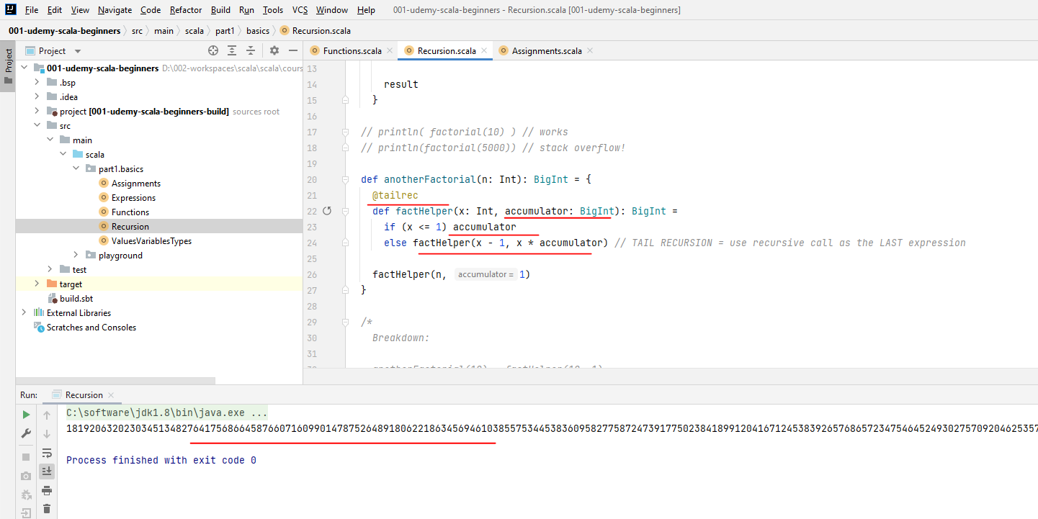

So that's why we see zero here, because the number for 5000 is absolutely astronomical and it overflows the integer representation. At some point it will be zero. So everything multiplied after that will turn to zero will solve this problem. Let's let's use BigInt instead of Int and just replace the accumulators and the return types with BigInt and lets run again just to see that this number is actually legit. So this is the actual number, which is the factorial of five thousand. Pretty, pretty big number, if you ask me. All right. So the thing is that this another factorial actually works with big numbers. It works with 5000, it works with 20000 if it's available. So it will probably take a second or two. But we have a legit number with factorial of 20000.

OK, so the question is, why doesn't this guy crash with a stack overflow even though it is also recursive? Don't let the the fact that I put it as as an auxiliary function for you, it doesn't really matter. OK, so I can actually call fact helper on its own with twenty thousand and it will still run fine. In fact, let me try that so I don't try this on your code. I'm just going to prove this to you and I run fact helper with twenty thousand and one and just print this out and comment the another factorial thing. You will see that the fact Holper can actually run on its own. OK, so this enormous number is the result of fact over. So the fact that I put it as an auxiliary function doesn't actually help. I'm going to undo my modifications.

* So the question is, why does another factorial work and why doesn't the first one work? The trick here is that we wrote Fact Helper right over here as the last expression of its code path. This allows Scala to preserve the same stack frame and not use additional stack frames for recursive calls. In the previous implementation, Scala needed a recursive call stack frame for each recursive call so that it computes the intermediate result so that it can then multiply it with a number and then pass it back from the Stack. But here it doesn't need to discard this need to save intermediate results to be used later. So when you evaluate this recursive call, the current stack frame, for example, fact helper of 10 is replaced with fact helper of something else without using extra Stack memory. This is called tail recursion and IntelliJ is smart enough to figure out that this method fact helper is tail recursive. This guy is not tail recursive because the factorial recursive code does not occur as its last expression.
* So the key ingredient of tail recursion is to use a recursive call as the last expression on each code path that it occurs.

def anotherFactorial(n: Int): BigInt = {

@tailrec

def factHelper(x: Int, accumulator: BigInt): BigInt =

if (x <= 1) accumulator

// TAIL RECURSION = use recursive call as the LAST expression

else factHelper(x - 1, x * accumulator)

factHelper(n, 1)

}

println( anotherFactorial(20000) )

// WHEN YOU NEED LOOPS, USE _TAIL_ RECURSION.

* If you're not sure if your functions are tail recursive, you can add a tiny annotation before the function definition. You can add @tailrec and this guy will tell the compiler that this function is supposed to be tail recursive. If the function is not recursive, then the compiler will issue an error for you. So if I add this annotation with the previous factorial function, then the compiler will complain because it says recursive call not a tail position that is, it's not the last expression of its code path.

All right. So the tailrec annotation will not work. From now on, will try to make a recursive methods till recursive because that's how we can actually achieve the iteration versus recursion approach that we talked about in the previous videos. So the answer to the legitimate question of "Daniel, how do I iterate when recursion is limited" is a more complete when you need loop's use tail recursion.

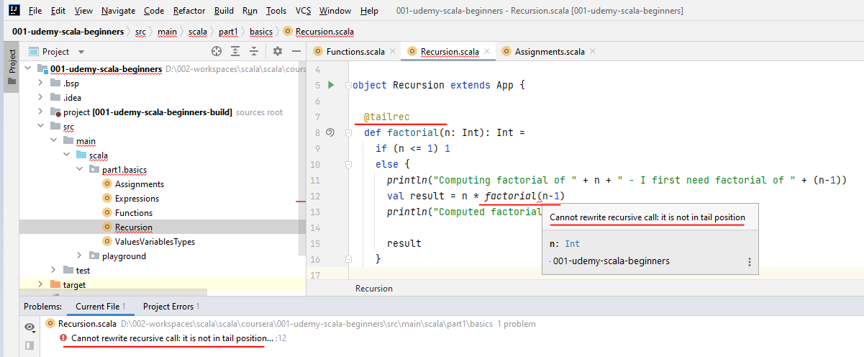

Sample code that uses @tailrec functions

package com.lalit.practise

import scala.annotation.tailrec

object Functions1 extends App {

def factorial(numb: Int): BigInt = {

@tailrec

def multiplyIt(numb: Int, accum: BigInt): BigInt = {

if (numb <= 1) accum

else multiplyIt( numb - 1, accum * numb )

}

multiplyIt(numb, 1)

}

*// println( factorial( 400 ) )*

*println*( *factorial*(400) )

def repeatStr(word: String, numOfTimes: Int): String = {

@tailrec

def repeatIt(numofTimes: Int, accum: String): String = {

if (numofTimes <= 1) accum

else repeatIt( numofTimes - 1, accum + word )

}

repeatIt(numOfTimes, "")

}

*// println(repeatStr("Hello ", 400000))*

*println*(*repeatStr*("Hello ", 400))

*// Writing without the Auxiliary Function*

@tailrec

def repeatStrTwo(word: String, numOfTimes: Int, accum: String): String = {

if (numOfTimes <= 1) accum

else *repeatStrTwo*( word, numOfTimes - 1, accum + word )

}

*println*(*repeatStrTwo*("Hey ", 100000, "" ))

*// println(repeatStrTwo("Hey ", 400, "" ))*

}

All right, so a pretty important topic, people, which requires some exercises. Right. So I want you to write the string concatenation function from the previous video. So the one the function that concatenate a string n times using tail recursion. Then I want you to create an is prime function, which is tail recursive. And three, I want you to create a Fibonacci function, which is tail recursive. Any function can be turned into a tail or recursive function. The trick here is to use these little accumulators to store intermediate results rather than call the function recursively. You need as many accumulators as you have recursive calls on your code path. Sometimes you need more than one accumulators. This is a hint. So pause the video now and think about how to solve these three functions.

/*

Exercises:

1. Concatenate a string n times

2. IsPrime function tail recursive

3. Fibonacci function, tail recursive.

*/

**1st Assignment: Concatenate a string n times using tail recursion**

@tailrec

def concatenateTailRecursive(str: String, count: Int, strAccumulator: String ): String = {

if ( count <= 0 ) strAccumulator

else *concatenateTailRecursive*(str, count - 1, strAccumulator + str )

}

*println*( *concatenateTailRecursive*("Hello ", 10, "") )

**2nd Assignment: IsPrime function tail recursive**

def isPrime(n: Int): Boolean = {

@tailrec

def isPrimeTailrec(t: Int, isStillPrime: Boolean): Boolean =

if (!isStillPrime) false

else if (t <= 1) true

else isPrimeTailrec(t - 1, n % t != 0 && isStillPrime)

isPrimeTailrec(n / 2, true)

}

println(isPrime(2003))

println(isPrime(629))

Slight modifications, if isStillPrime, is false, there's no point in calling isPrimeTailRec recursively because in the number that we originally started with is not prime. So if not isStillPrime, then we'll just have to return false. Otherwise, if it is less than or equal to one order, true, otherwise we're going to call isPrimeTailRec, recursively isPrimeTailRec, and the number two, which was the limit, is going to be t - 1 this time. And the accumulator will store the fact that and Model T is not equal to zero.

So remember, this expression was in the previous implementation outside of a recursive call. Now it's inside and it's stored in the accumulator and the old value of the accumulator isStillPrime. OK, and the main implementation of this program isPrime going to call is PrimeTailRec with T, again the limit is the half of n and isStillPrime will start with a positive assumption which is true. All right, so if we call this isPrime of 2003, that should return true and print line of isPrime of, if I remember correctly, six to nine that should return false.

This function was not simple. So take a couple of seconds to actually process. This is still prime, basically holds the intermediate result. So instead of calling the function recursively with and Martin not equal zero and the recursive call of is prime until we store that in the accumulator. All right. OK, and finally, we have the Fibonacci number with and as an input and this returns an end.

**3rd Assignment: Fibonacci function, tail recursive**

OK, and finally, we have the Fibonacci number with and as an input and this returns an end. And I'm going to use an auxiliary function here as well. This function is also not trivial and it has a little trick. So fiboTailRec and this will take 3 parameters. This will take the i number that I want to compute, OK, and then instead of one accumulator, we'll use two accumulators. That is because Fibonacci calls Fibonacci of N - 1 and Fibonacci of N - 2 in the same code path. So a general rule of thumb is, however many recursive calls you have on the same code path, that's how many accumulators you need to have in the tail recursive function version of the function that you want to implement.

def fibonacci(n: Int): Int = {

def fiboTailrec(i: Int, last: Int, nextToLast: Int): Int =

if(i >= n) last

else fiboTailrec(i + 1, last + nextToLast, last)

if (n <= 2) 1

else fiboTailrec(2, 1, 1)

}

println(fibonacci(8)) // 1 1 2 3 5 8 13, 21

So we have to accumulators to store we call that as last and nextToLast, which is the previous Fibonacci number. So this is basically Fibonacci of N - 1 and this is Fibonacci of N - 2. That's the results that we're going to store in. These accumulators, of course, will return int and the implementation is going to be well, if I >= N so we'll start from I equals two and if I grows bigger than N then I'm going to return the last number, because that's the final result that I care about. Otherwise I'm going to call fiboTailRec with i + 1. So that's the next number. And the accumulators are going to be the last number is going to be the sum of these two, because that's the property of the fibonacci stream of numbers. So last plus nextToLast and the previous Fibonacci number is going to be the last number.

OK, and as the main implementation of the Fibonacci function. I'm going to put in a if expression just to optimize so if n is less than or equal to two. I'm just going to return 1 otherwise fiboTailRec with three, so this is the starting index for the fiboTailRec. And the accumulators are 1 and 1 because these are the two first Fibonacci numbers. So if I print line fibonacci(8), I should see the number twenty one, if I remember correctly. Oh, I see the number 13. Well, why is that? Well I have 1, 1, 2, 3, 5, 8 and 13. So that is the seventh number.

Oh, silly. I did say I was going to start from two. Right. So if I run this again with the number two. Yes, I'm going to get twenty one, which is the number I care about.

This was also a tricky question. You needed to figure out that you needed to accumulators instead of one. These are hard exercises and this gives you a taste of what functional programming is about.

### Call-by-Name and Call-by-Value

I'm going to define a function called calledByValue, which takes a number x and this is a long. And this guy returns unit. I don't really care that it returns a value, just does something. So this is a function with side effects and this guy just prints by value and a colon and then X and I want to do this twice. I promise this will make sense in a second.

def calledByValue( x: Long ): Unit = {

println( "by value: " + x )

println( "by value: " + x )

}

Now, a new thing I'm going to define a method calledByName. Which takes yet another parameter named X in this time instead of long, I'm going to put in a little thing, a little arrow here Long, which is the type long and it also returns unit and the implementation is going to be identical. So print these two guys twice.

* Now this little arrow here tells the compiler that the parameter will be called by name, this is a different evaluating parameters in functions.

I'm going to explain the concept by example.

def calledByName( x: => Long ): Unit = {

println( "by name: " + x )

println( "by name: " + x )

}

calledByValue( System.nanoTime() )

calledByName( System.nanoTime() )

So I'm going to call callByValue first with the value system.nanoTime which tells me the current time of the system in nanoseconds. And I'm going to call called by name with the same expression. All right. So system.time. So normally with two functions, with the same implementation, this guy returns a value and it will be printed twice. And with a call by name, with the same implementation, with the same expression, this guy will return a different time because by the time this thing runs, the time will have changed. So a different value, but still printed twice.

Output is:

by value: 114262928996300

by value: 114262928996300

by name: 114263006037300

by name: 114263006641800

Process finished with exit code 0

So we chose the parameter to be of type long. It's really of no significance. We just want it long to be compatible with a time function. OK, now this little error over here makes all the difference in the world. And this explains the two different values here in the second by name call, which, by the way, I should really change. So we might actually make the difference. So two things by value and two things by name and the by name values are different.

* Now, let's finally introduce the concepts. So in the by value call, the exact value of this expression is computed before the function evaluates in the same value is used in the function definition. This is probably the style of calling parameters that you've used in other languages. So basically the computer evaluates system time, which is this guy, so it's as if I said system that nanoTime is this little guy with an L at the end and use this guy throughout the entire function definition. All right. So this is basically what the computer does. OK, this is what Call By Value means. It evaluates this guy and it's used inside the entire function definition.

def calledByValue(x: Long): Unit = {

println("by value: " + 1257387745764245L)

println("by value: " + 1257387745764245L)

}

* By contrast, in the Call By Name call, this expression is passed literally as is. That's why it's called Call By Name and the expression is evaluated every time. So it's as if I said system.nanoTime is the replacement of X throughout the entire function definition

def calledByName(x: => Long): Unit = {

println( "by name: " + System.nanoTime() )

println( "by name: " + System.nanoTime() )

}

and suddenly the whole thing starts to make sense. So this value is indeed printed twice. But system.nanoTime here is evaluated two times, two different times. And that is why we see two different values here in the by name instance. So this is what this little funky error does differently. It delays the evaluation of the expression passed as a parameter, and it's used literally every time it's used in the function definition. This is the byName call. This is extremely useful in lazy streams and in things that might fail. That's what we are going to study when we look at the try type. All right. But let's get some more mundane examples before that. I'm going to create a small, infinite, recursive function. I'm going to call this infinite which returns see an int and its implementation is going to be one plus infinity. This is really a dumb function, nobody would use it. But just for the sake of proving the binding concept, and I'm going to define another function called printFirst, which takes a parameter of type int and another parameter of type int, but called byName. So with this funky arrow and this guy will just print the first thing, the first parameter, not the byName one.

OK, let's try printFirst with infinite and the numbers say 34. OK, so infinite returns an int and the number 34 is well the number 34. Now we expect infinite because it's called byValue to be evaluated first. But only a fool would do that because it will crash with a stack overflow error of course.

def infinite(): Int = 1 + infinite()

def printFirst( x: Int, y: => Int ) = println(x)

// printFirst(infinite(), 34) // stack overflow

printFirst( 34, infinite() )

But let's see what happens. So let's comment this out. Let's see what happens if I try print first with the parameter swapped. So thirty for an infinite. Let's see what that happens.

**Output**

34

Process finished with exit code 0

Well, this thing runs well and it prints the number thirty four without crashing with the stack overflow with the infinite recursive call. Well, why is that? Well, as we said, the by name parameter delays, the evaluation of the expression passed here until it's used. Well, since the parameter why is not used. This guy is never actually evaluated, which is why our program seems to survive.

So quite an important topic we learned about Called by Value, which is basically the kind of call that we've been using the whole time. And if I have a function with a call by value parameter, the value passed to the function is actually used inside of the function definition. The value is computed before the function is called in. The same value is used throughout the entire function implementation, no matter how many times the parameter x in this case is used. Now, by contrast, in call by name, if I have a function with this funky error text, the parameter that I pass in is not a value. But the expression itself literally passed in to the function with a call by name in the expression is passed as is and is evaluated at every use within the function definition.

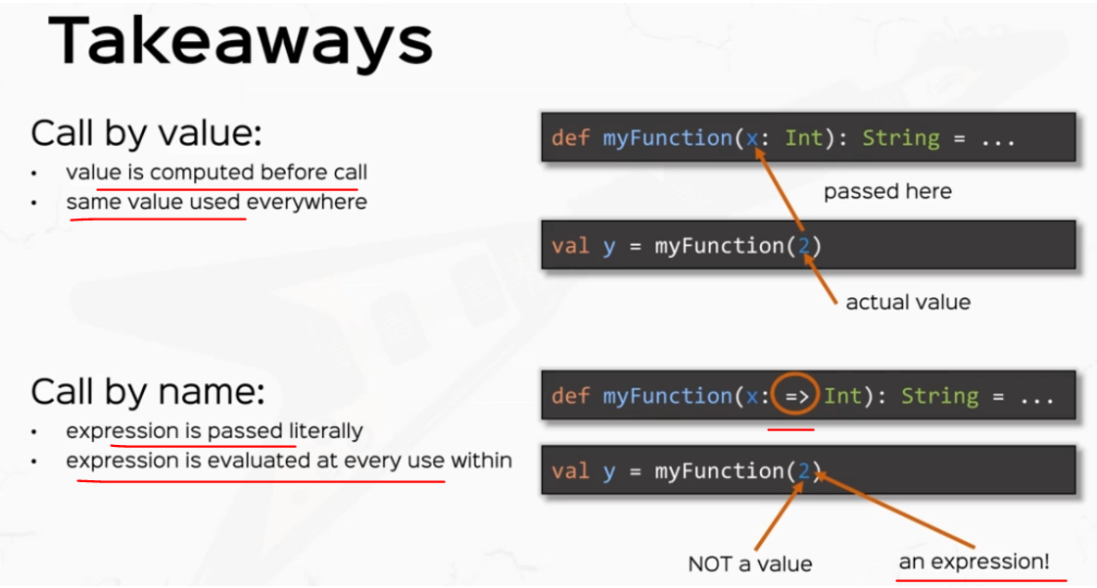

So bear in mind, all right, this was a shorter but quite powerful one. Make sure you get back to this video when you find anything confusing with call by name.

### Default and Named Arguments

Now, I'm going to start with an example that we used and we wrote in a previous video, which is the taleRecursiveFactorial. I'm going to show you what I want to prove with it. But for a start, let's just write it. So the tail recursive factorial received two parameters, both an int. One was the the number n whose factorial we want to compute and the accumulator that stores the intermediate result. So this was, if n <= 1. We return the accumulator. Otherwise the tail recursive factorial with n – 1 and n times the accumulator. All right. So this is the core of the tail recursive factorial that we wrote in a previous video.

package lectures.part1basics

object DefaultArgs extends App {

def trFact(n: Int, acc: Int): Int =

if (n <= 1) acc

else trFact(n-1, n*acc)

val fact10 = trFact(10, 2)

}

Now, the idea here with the tail recursive factorial written in this fashion is that basically the only useful use case of the tail recursive factorial function that we wrote earlier is to start with the accumulator equals one. So basically, if you want the factorial of 10, you always call tail recursive factorial with 10 and one. And in general, if you want the factorial of anything, you could call recursive factorial with that thing and one. So basically the accumulator starts up with one every single time. So in some occasions we end up creating functions which will be called with the same parameters 99 percent of the time, which is the case with our accumulator right over here. So this is one of two things. Either this accumulator pollutes the function signature because we're only interested in the end parameter. We're only interested in factorial. And really this is only a technicality that allows us to write the tail recursive version. So either the accumulator spoils our function signature or we need to wrap this up into a bigger function, which was the case of our previous implementation. Fortunately, Scala allows us to pass default values for some parameters that we don't really want to appear every single time. And the way that we do that is specifying a default value at the parameter level. So I'm going to say equals one. This basically says that if I don't pass the accumulator value, it's going to be implied as 1.

package lectures.part1basics

object DefaultArgs extends App {

def trFact(n: Int, acc: Int **= 1**): Int =

if (n <= 1) acc

else trFact(n-1, n*acc)

val fact10 = trFact(10)

val fact10 = **trFact(10, 2)**

}

So I can simply say the factorial of 10 is the tail recursive factorial with parameter 10 only and the accumulator will be implied with the value one. Now, that doesn't really stop me from passing in the accumulator if I do want to. So if I say pass it with some other parameter and say I want **two times the factorial of 10**, I can actually do that even though I have specified the default value for accumulator. So if I do pass in an actual value for the parameter with a default value, that default value will be overwritten. So this value will be passed instead.

Passing default values for arguments is a popular feature in other languages such as JavaScript or Python. But passing default values to parameters introduces its own set of challenges. So see, for example, that you are creating a photo editing app and you expose and a function in your API which saves your picture. So you define a function called save picture and it takes, let's say, 3 parameters. The format of the picture, which is a string and let's say the resolution, the width and height with width which is an int and height, which is a int. And this let's say it returns unit and it just prints something to the console. We don't really care what the implementation is. We only care about the function signature.

Now, we discussed that and default values for parameters are useful for the case where your functions are called many, many, many times with the same parameters. So say, for example, that your save picture function is called most of the time with the format JPEG and with various resolutions say like I don't know, 800 by 600. That's not a valid resolution anymore. This seems pixilated, but let's just assume that this JPEG format is called most of the time. I also forgot to enter presentation mode to show you the messages from the compiler better because there is something that I want to show you.

def savePicture(format: String = "jpg", width: Int = 1920, height: Int = 1080): Unit = println("saving picture")

savePicture(width = 800)

/*

1. pass in every leading argument

2. name the arguments

*/

savePicture(height = 600, width = 800, format = "bmp")

So now that I've defined a default value for format, now, in theory I could just simply delete this this first parameter jpeg and the compiler would still be fine. But trouble is, it isn't it says cannot resolve reference, savePicture with such signature. That is because if I do pass a parameter, the compiler will think that a hundred this number is the first parameter of savePicture and at this moment it's confused. So the leading parameters, if they are with default values, they cannot be really admitted because that would confuse the compiler.

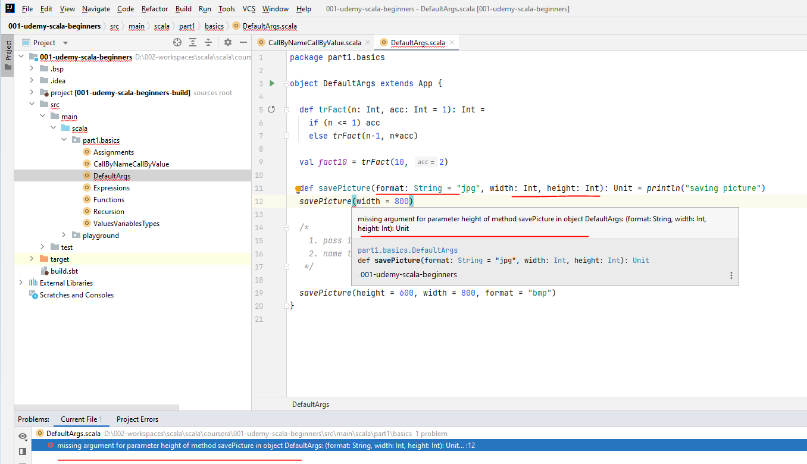

Let's try adding default values for the other parameters, say, for example, that the width and height are also cold with, say, 1920 by 1080, which is the full HD resolution most of the time. So we can simply call save picture just like that. And the compiler will imply all our parameters. But if I do pass in a value here, let's say 800 for the with the compiler will be confused because it doesn't know which parameter this value stands for. This was the case earlier as well.

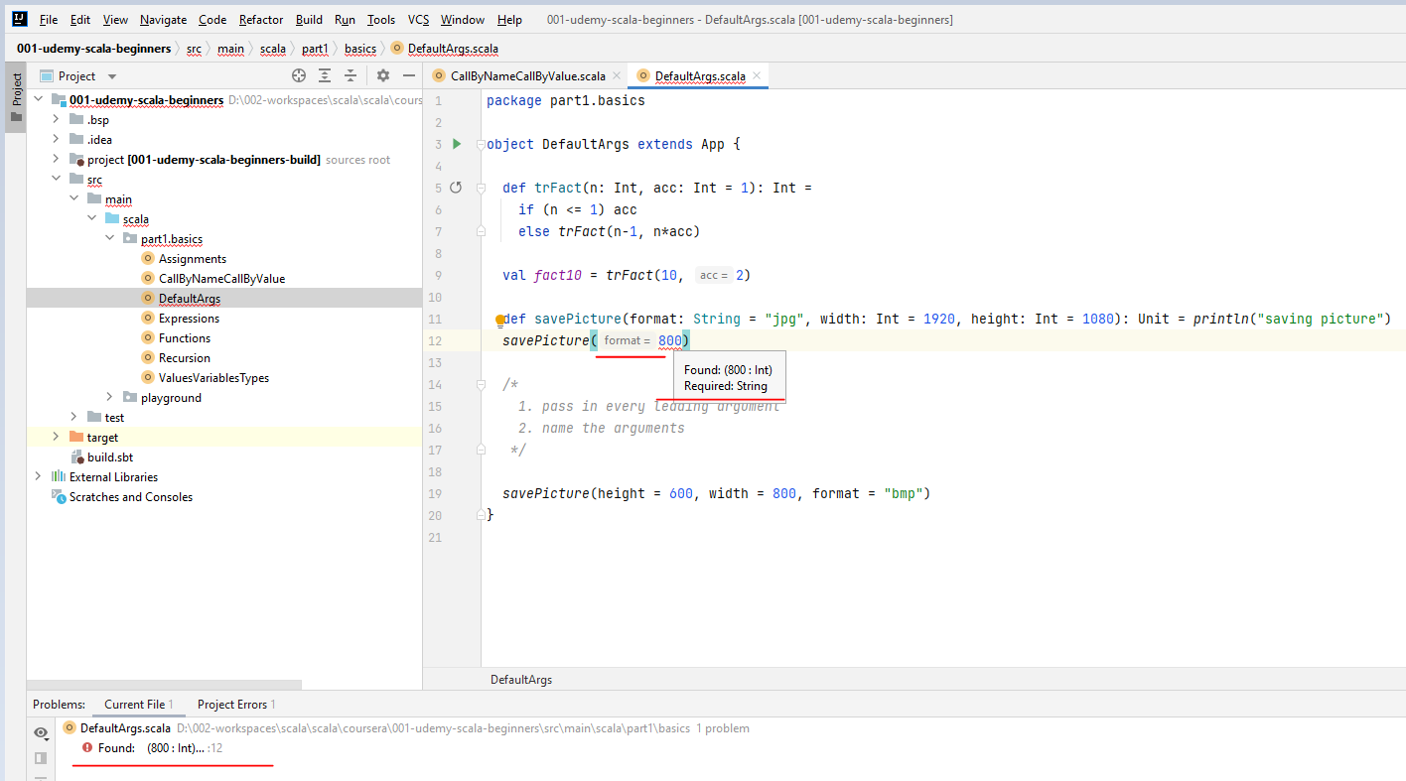

So we have two solutions to this. Either we pass in every leading argument because if I pass in, say, another format's the bitmap, then the later arguments would then be implied by the compiler. Or we can name the arguments. And this is news. So instead of the default with, say, I want the width to be eight hundred pixels. So I would say width equals 800 pixels. This is clear enough for the compiler because if the compiler sees width equals 800, the compiler will say, OK, I'm going to take default values of the other parameters.

/*

1. pass in every leading argument

2. name the arguments

*/

savePicture( format = "bmp", width = 800, height = 600 )

So this is how you solve the default aren't problems if you have either leading arguments or have too many default parameters. All right. Now, this a nice side effect of being able to name the arguments is that you can pass in the arguments in a different order if you name them. So if I say save picture with, say, height equals six hundred and with equals eight hundred and format's equals bitmap, this works because this clarifies which parameter has which value to the compiler. All right. So we're going to use the default values for parameters quite a bit in the later parts of the course. All right.

savePicture( height = 600, width = 800, format = "bmp" )

So in this video, you've learned that when 99 percent of the time you call a function with the same parameters as was the case with our table recursive factorial, you can just specify a default value for an argument and just omitted when you call it. The trouble is that we cannot omit leading default arguments. So we learned about naming our parameters. If, again, I'm having the greeting function for kids with default arguments, Superman and age 10, I can call the greed function with age equals five and the name leading argument with the default value Superman will be implied by the compiler. Also, I can name all the parameters or I can pass them in a different order. That is a side feature of being able to name our parameters.

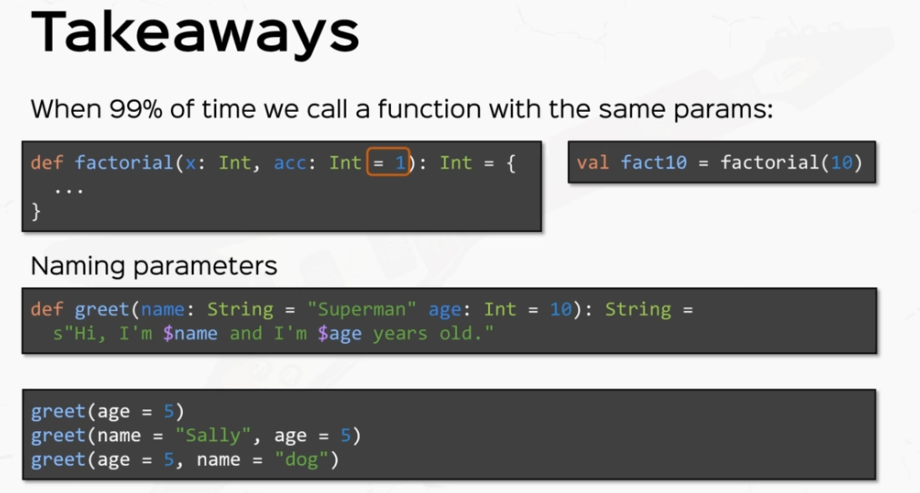

### Smart Operations on Strings

We're going to be talking about strings which are basically everywhere in Scala, in Java and basically every programming language. In this video, we're going to be learning some specific string niceties plus some standard operations on strings. So let's get right to it. Let's create a Scala class ( Object ) StringOps. Again, we're going to make this an object and make this extend app. So now our code is Runnable, right, so let's declare a string. And let's give this quite a bit of a longer text, so let's say hello, I am learning Scala. OK, so this is a decent string. Now what I want to show you is quite a few standard string operations. So strings have a number of methods if you know Java. This will come as a refresher for you. So. Notice this little dot, which is a method course of string dot ca at. Let's say index to strings are zero index. So this is character number zero, then? This is character number one. This is character number two. This is what we're going to print and so on and so forth. So Caret returns the character at that index. OK, so if I. Right. Click and run, I'm going to see the letter 'l' let me end your presentation mode so you can see this more clearly.

val str: String = "Hello, I am learning Scala"

println(str.charAt(2))

println(str.substring(7, 11))

println(str.split(" ").toList)

**Output**

l

I am

List(Hello,, I, am, learning, Scala)

Now another utility that we often use is. Substring, which takes one or two indices, this has multiple implementations, so let's say I have the substring from index seven, which is inclusive, up to index 11 exclusive. Right. So this is basically the substring "I am" so if I really can run, I'm going to see the substring "I am" here in the console. OK, this we also have split, which splits the string into multiple pieces depending on the delimiter. So if the deliverers of space are basically split returns, an array of all the sub strings which are, as we wrote this in this example, the words separated by spaces, so this will return an array which is not very printable. I'm going to use to list to print this a little bit more prettier. OK, so hello then. So this is Hello, comma, and this comes from the list representation. All right. And then I am learning Scala in different strings.

println(str.startsWith("Hello"))

println(str.replace(" ", "-"))

println(str.toLowerCase())

println(str.length)

***Output***

true

Hello,-I-am-learning-Scala

hello, i am learning scala

26

Then we have tests for strings, for example, starts with hello. And this function returns true or false, depending on whether the original string starts with the parameter, string in this case will return. True. Now we have replacement functions, so replace so as you see, we have quite a few replace implementations and versions, but. A very simple and widely used version is just the simple replace with two string parameters. So say, for example, I'm replacing all the spaces with dashes. I'm going to see quite a weird string, so "Hello,-I-am-learning-Scala" all with a dash. OK, we also have some functions toLowerCase and toUpperCase which turn every cap letter into small caps and vice versa. All right, so string to lowercase says "hello, i'm learning scala" with all lowercase and finally very useful the length function which as you see, it's called without parameters. So it's also called without parentheses. If you remember, this is alternative syntax and this will return the length of the string, which in this case will be 26.

OK, all the functions are also present in the Java language, so as you know, Scala runs on the top on top of the Java virtual machine and it has access to the string class in the Java language. So these are all Java functions that are available in Scala.

Besides that, Scala has its own utilities. So if I say, for example, if I have no string. Which is the number say, I don't know, forty five, I can actually convert this automatically to an integer by saying it, a number of string dot two isn't as simple as that.

val aNumberString = "2"

val aNumber = aNumberString.toInt

println('a' +: aNumberString :+ 'z')

println(str.reverse)

println(str.take(2))

And this converts a number to an end. So actually the number forty five also we can have. Concatenation and prepend, so pretending and upending. Let me show you what I mean. So if I see the character a watch what I'm writing, plus colon a number of string. That means I'm free pending the character A to a no strings, I will return a four or five appending is with the symmetrical operation with to colon + which is. colon plus. And let's say we have Z. So if a no string, let's say it's to the number to this guy or say 'a2z'.

***Output:***

a2z

alacS gninrael ma I ,olleH

He

Right, so the three pending and a pending operators are Scala specific. Also we have reverse, so if I say str, which is the this little text above, I say reverse, this is also a Scala specific utility function. Although not very useful in this case, also, we have lists like functions, so for example, if I want to take two characters out of the string, it will just return 'He'. All right, cool. Now let's talk about Scala specific things which are string interpolations.

First, I'm going to talk about s interpolations. Let me show you what I mean. Do you remember the little greeting function for kids that we wrote earlier? Hello, my name is David and I'm 12 years old. I'm going to write a fancier implementation of that right here. So if I say my name is David and age is 12, then the greeting will be watch. While I'm writing. I'm writing as quote, this is an S interpolated string and inside I'm going to inject the name in the age variables as the falls. So I'm going to say hello, comma. My name is $name. So this guy, this $ sign tells the compiler that name will be injected in the string. And I am $age years old. Right. So $name and $age are expanded inside this interpolated string, but they only work if you put this s inside. Otherwise the string will be taken literally.

// S-interpolators

val name = "David"

val age = 12

val greeting = s"Hello, my name is $name and I am $age years old"

val anotherGreeting = s"Hello, my name is $name and I will be turning ${age + 1} years old."

println(anotherGreeting)

***Output:***

Hello, my name is David and I will be turning 13 years old.

S interpolated strings also have the property that they can evaluate complex expressions. So if I say "hello, my name is David and I will be turning 13". Let me show you what I mean. So if I say another greeting which says "Hello, my name is David and I will be turning $ and watch the curly braces and I'm going to say {age + 1} inside the curly braces, basically I can right any expression that I want. So $age + 1 years old. OK, so if I print line another greeting, it's going to say. "Hello, my name is David and I will be turning 13 years old". So this is interpolated string works as expected. So this is a very cute way of injecting names or values or even complex expressions inside strings without actually needing to decompose the string into its proper constituents and concatenating them at the end. All right. So quite powerful.

We also have other interpolated strings available. For example, F interpolations. F interpolators act as s interpolators in the sense that they can expand values or complex expressions inside, but they can also receive printf like format's. Let me show you what I mean. So if I say, for example, that "David can eat 1.2 burgers per minute", I can write an F interpolated Mith. OK, so if I say that speed is 1.2 F, which is the amount of burgers that David can eat per minute, I can create a string which is an F interpolated string. Notice the F before the quote and I'm going to say $name can eat $speed and then watch what I'm writing. I'm writing percent to point to f this is a printf like format for displaying this value, which means 2 characters total minimum and 2 decimals precision.

// F-interpolators

val speed = 1.2f

val myth = f"$name can eat $speed%2.2f burgers per minute"

println(myth)

***Output:***

David can eat 1.20 burgers per minute

OK, and then say burgers per minute. So if I print the myth it will say. David can eat 1.20 burgers per minute, although we define speed as 1.2. The format forces, the float's be displayed at one point to zero with enough precision. So this is worth breaking down. So f interpreters, leaders are for formatted strings in a print like fashion. So if I have, Daniel can eat 1.20 burgers per minute. The F interpolated string starts with an f before the quote. So the signals to the compiler that some values may be injected in the string. The $ sign says that this will expand the value. This is the value name and the percent s is a string format from the printf standard. Again, the percentage point to F is for decimal representation, which says at least 2 characters and 2 precision decimals. This leads to the awesome fact that Daniel can 1.20 burgers per minute, which may or may not be true. Now, besides the fact that this is absolute insanity, the number 1.2 is displayed is 1.20 forced by the flawed format. Now, if Interpolate is strings also have the amazing property that they can also check for type correctness in the values that they expend. So if, for example, I have the value X, which is a float and the string representation calls for $X, which expands X, but with %3d format, which expects a integer number, this will force the compiler to evaluate the type of X which will be expanded, and if the types don't match, the compiler will issue an error.

// raw-interpolator

println(raw"This is a \n newline")

All right, now, the final interpreter that I wanted to talk about, the only one left is the raw interpolator. The raw interpolator works the same as the s interpolator. Although it has the property that can print characters literally. So if I print, for example, the raw interpolated string, this is a backslash n nearline, backslash n are usually escaped and printed as a new line. This will be printed literally. So if I run this guy. It will be printed literally, so backlashes will not be escaped. This is the property of the raw interpolating.

***Output:***

This is a \n newline

However, if I have a value which says, I don't know, let's call this escaped, which has the same value. This is a new line. If I print line the raw interpolated string with this escaped string injected instead. Escaped, the backlash ends will be escaped. OK, so this is a and the new line is escaped and the text is printed on two lines, so the raw interpolated strings ignores escaped characters inside raw characters in the string.

val escaped = "This is a \n newline"

println(raw"$escaped")

***Output:***

This is a

newline

Otherwise injected variables do get escaped. All right. So pretty cool things and also pretty powerful. We'll use string operations quite a lot in this course, but by now you should be well equipped.

## Object Oriented Basics in Scala

### Basics

Create a class of type Object and extend App

package part2.oop

object OOBasics extends App {

}

I'm going to write a class here outside the object implementation because class definitions can sit on the top level code. So here it is class and I'm going to create a class called person. And this is it, folks. You've created a class to instantiate this class person.

package part2.oop

object OOBasics extends App {

}

class Person

You've created a class to instantiate this class person, we're just going to assign it to a val, let's say we create a val called person and the instantiation of a class is with the operator new and then the name of the class. So congrats, folks. You have instantiated a class. And if I print line the person, well, I'm going to see something very weird in the console. But let me switch to my presentation mode so they can see more clearly. So. Right. Click and run.

package part2.oop

object OOBasics extends App {

val *p* = new Person

*println*(*p*)

}

class Person

*Output:*

part2.oop.Person@c39f790

Process finished with exit code 0

And we have this very weird string representation, we're going to learn about string representations a little bit later, don't worry about it. This is how the JVM naturally represents things. And we are going to learn pretty strong representations very, very shortly.

The short story is that a class organizes data and behavior that is code and instantiation means concrete realizations and memory, that is actual memory spaces, that conform to the code and the data structure that the class describes. Now, that being said, let's move on and let's create a little more complex class than this simple person class. Let's see, the person actually has a name and an age. So the way that I'm going to write is I'm going to pass in parameters to this class person. I'm going to say name, string and age. And this is how we pass parameters to a class. This resembles the way that we pass parameters to functions. But in this case, this syntax has a different meaning. This right over here is called a constructor.

class Person(name: String, age: Int) *// constructor*

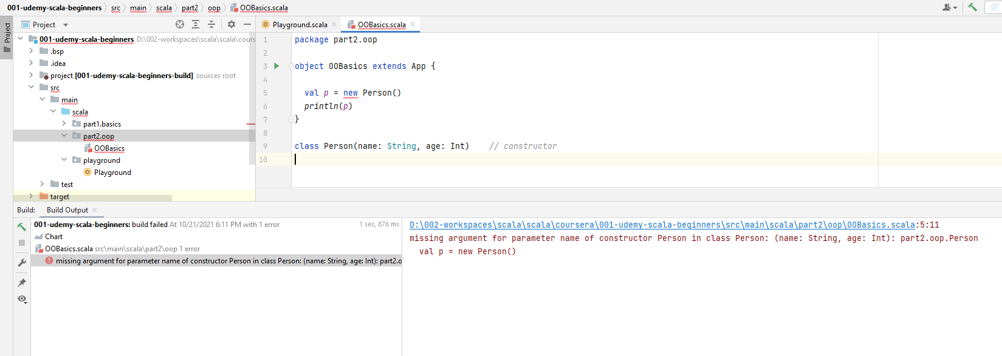

A constructor says basically that every single instance of person must be constructed by passing in a name and an age, and the compiler is so eager to tell us that and says unspecified value parameters, name and age. So let's pass some values to it. And let's say John and age twenty six. And now the compiler is happy because this person is correctly constructed. Now let's say I want to print to the console this person's age. Now, the way that you would do that in other languages would be just to write something like person.age. But in Scala, the compiler will complain and it will say cannot resolve symbol age. And this is the first lesson that I want you to take away, and that is the fact that age is a class parameter, but it's not a class member that you can access with the dot operator. So basically class parameters are not fields. So class parameters from the constructor and class feels that you can access are two different things.

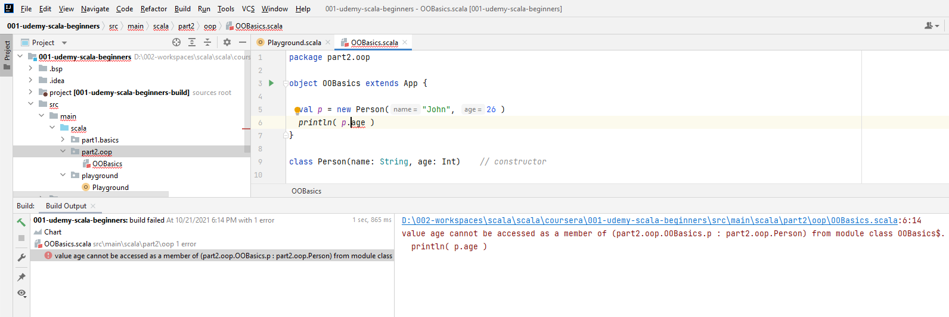

Now, the way that you would convert a class parameter to a field would be to add the val or var keyword for the parameter. And now you see the compiler is happy and the person age can be printed out to the console. And if I run this, I'm probably going to see the value 26, of course.

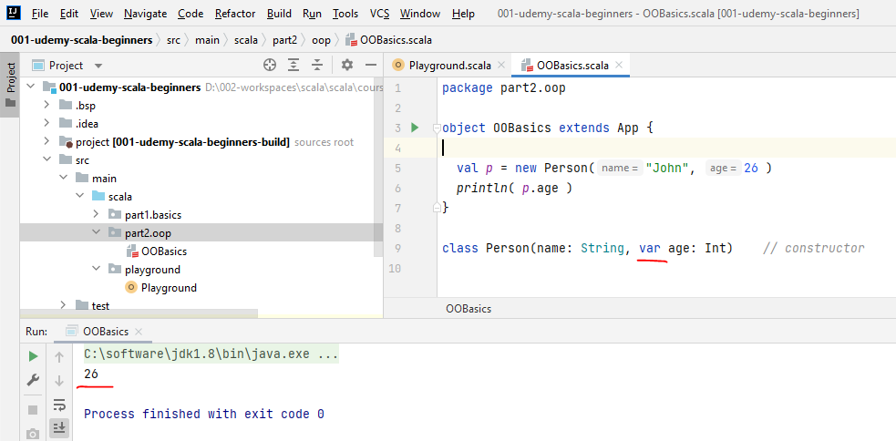

So remember, class parameters and class fields are two different things in the way that you convert parameters to fields is to add the keyword value or var to the class parameters. Now it's not always the case that you would want to convert all class parameters to fields, of course. So make sure you get this right.

Now, we know that classes are basically blueprints that describe the way that things look like that is data and the way things work and that is functionality or we call it behavior. So we've talked about class data with parameters and fields. Let's add some actual functionality.

So let's expand this person class by actually going to move this comment above. And I'm going to open and close curly braces. The curly braces over here are the delimiters to the class is body. Now, the body here is not an expression persay, but it defines the implementation of this class. And the block of code inside can have basically everything, including val and var definitions. If I say val x = they can have function definitions, we call them methods, we're going to talk about them very, very shortly. They can have expressions, we can have other definitions, for example, packages and other classes and more complex stuff. So we don't need to worry about that for now and the value of the code block. This guy is ignored because this guy is only the implementation of this class, but remember that you can do anything inside this block that you can do in a block expression.

package part2.oop

object OOBasics extends App {

val *p* = new Person("John", 26 )

*println*( *p*.*x* )

}

class Person(name: String, var age: Int) {

*// body*

val *x* = 2

*println*(1 + 3)

}

*Output:*

4

2

Process finished with exit code 0

Now, before we move on, I want to tell you a couple of things. So, first of all, the value definitions or the VA definitions inside the class implementations or fields. So, for example, I declared a value X equals two. I can actually use that as a field. So if I right. Click and run this, I'm going to see the value to print it to the console. But also notice that before the value to here, the value for was printed before. So this guy was also evaluated and that is because at every instantiation of the class person, this whole block of code will be evaluated. That is every single expression within and all side effects. For example, this print line will be executed. OK, so you've learned quite a bit about what you can do inside a block implementation of a class. You've learned that you can create values and values and that you can evaluate expressions. Now, I promised you that we would dive into defining functions.

package lectures.part2oop

object OOBasics extends App {

// constructor

class Person(name: String, val age: Int = 0) {

// body

val x = 2

println(1 + 3)

}

}

So let's do that. So let's define a function that greets someone else. So I'm going to greet somebody with a name and this guy will return units as I don't want a too fancy implementation. I'm just going to print line and I'm going to use an S interpolated string. And I'm going to say the name says hi name. This function because it's defined inside a class definition is called a method. But you know this already. And if I actually call this method, I would use the dot notation that we used for accessing fields as well. So we can say person dot great. And then I'm going to pass in a parameter, say Daniel. Right.

object OOBasics extends App {

*// constructor*

class Person(name: String, val age: Int = 0) {

*// body*

val *x* = 2

*println*(1 + 3)

*// method*

def greet(name: String): Unit = *println*(s"$name says: Hi, $name")

}

val *person* = new Person("John", 26 )

*println*( *person*.*x* )

*person*.greet("Daniel" )

}

Output:

4

2

Daniel says: Hi, Daniel

So if I can run this and see what happens, Daniel says, Hi, Daniel. Well, this is kind of wrong because we wanted John to say hi, Daniel. And it makes total sense because name and name are two different names and they all resolve to the name parameter for the method. But we want the name to be this person's name. So, of course, the way that we would do that is to use this.name.

object OOBasics extends App {

*// constructor*

class Person(name: String, val age: Int = 0) {

*// body*

val *x* = 2

*println*(1 + 3)

*// method*

def greet(name: String): Unit = *println*(s"${this.name} says: Hi, $name")

*// overloading*

def greet(): Unit = *println*(s"Hi, I am **$**name")

}

val *person* = new Person("John", 26 )

*println*( *person*.*x* )

*person*.greet( "Daniel" )

}

Output:

4

2

John says: Hi, Daniel

You've probably seen the keyword, this or the implied use of either self or this or some other form of accessing this instances field. **But notice that the name is not a class field, but it's still available within the class definition.** So this.name will refer to the name parameter of class person, whether the name is an actual field or not. So if I right click and run this. I'm going to see John says, hi, Daniel, which is the implementation that I want. You've also likely seen this in other languages, but whenever you did not need the keyword, this to kill ambiguity, the use of fields and parameters actually implies the use of this. So if I say a method greet with no parameters and that returns unit and just println an s interpolated string which says "hi, I am the $name", what it actually says is hi, I am this dot name. But this is implied, so whether I say name or this does name, this is. Not really relevant, because if I say $name, it's always implied to be this person's either perimeter or field. But if I have a method with a parameter with the same name, then the $name here or any use of the name word will refer to the parameter instead of the classes, field or parameter.

But right now, I've just gotten us into a new topic, which is the topic of overloading. Overloading means defining methods with the same name but different signatures. Overloading is allowed in most languages, including Scala. The compiler is not confused if you say person.greet("Daniel") or person.greet(), the compiler will then know how to create a program that knows which method to call later. The only time the compiler is confused is if you supplied two methods with the same parameter lists but returning different things. So if I say def greet, that returns an int for example, and returns the value 42, then the compiler will complain.

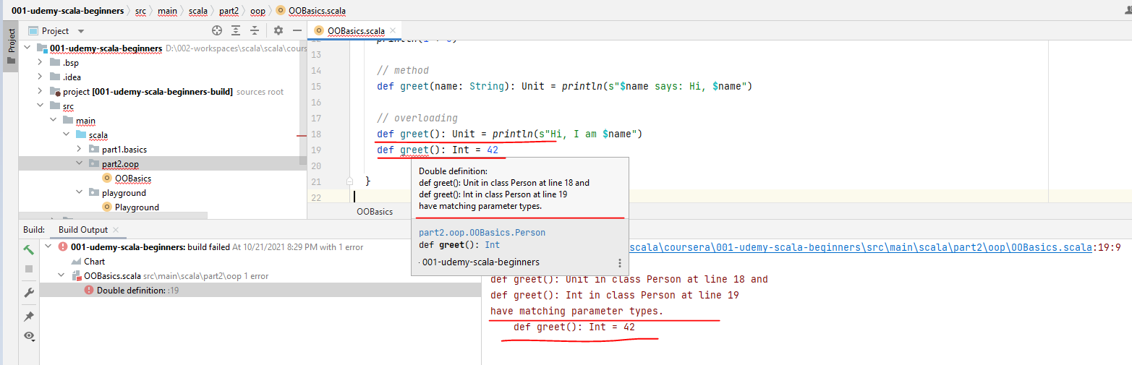

Because if you call the method greet, the compiler will not know which method you actually want to call. Do you want to call this one or this one. And the compiler says greet is already defined in the scope. So this is not overloading.

Overloading means applying the methods with the same name, but different signatures. Different signatures means different numbers of parameters or parameters of different types, coupled with possibly different return types here at the end. But this alone is not subject to overloading.

All right. So we've discussed classes, parameters, fields, methods, construction and overloading. Let's talk about multiple constructors. Or overloading constructor's, now we said at the beginning that this class's definition right over here is called a constructor because it allows the construction of instances right over here. Now, in many languages, for the same class, we can supply many constructors. And in Scala we allow that to by using def this.

package lectures.part2oop

object OOBasics extends App {

// constructor

class Person(name: String, val age: Int = 0) {

// body

val x = 2

println(1 + 3)

// method

def greet(name: String): Unit = println(s"${this.name} says: Hi, $name")

// overloading

def greet(): Unit = println(s"Hi, I am $name")

// multiple constructors

def this(name: String) = this(name, 0)

def this() = this("John Doe")

}

val person = new Person("John", 26)

println(person.x)

person.greet("Daniel")

person.greet()

So say, for example, I have an auxiliary constructor that initializes the age with zero, so it only takes the name as a parameter and it calls the primary constructor with this with name and zero. So the implementation of the auxiliary constructor with only the name parameter actually calls the primary constructor. With also the keyword, this with two parameters now, although this is pretty cool, the frustration with auxillary constructors is that the implementation of a secondary constructor has to be another constructor and nothing else.

def this() = this("John Doe")

So if, for example, I define a another constructor with no parameters and I initialize this with, say, John, do right. This is the only implementation that an auxiliary constructor can have, which is to call another constructor a primary or secondary. Now, this limitation makes the auxiliary constructor is quite impractical because they're only used in practice for default parameters. For example, I declared the subsidiary constructor just to omit the age parameter so this could be more easily solved by supplying a default parameter to the actual class definition.

def this(name: String) = this(name, 0)

So we won't actually need this new auxiliary constructor. So notice that default parameters actually work for constructors as well.

### Exercises

Lets implement a novel and a writer class. A novel means a book, and the writer is the one writing the novels. The writer should have, should have, let's say, first name, a surname and the year of birth and a method called Full Name, which returns the concatenation of first name and surname. Now, the novel would have, let's say, a name, of course, and the year of release and of course, an author, which is an instance of typewriter.

/*

Novel and a Writer

Writer: first name, surname, year

- method fullname

Novel: name, year of release, author

- authorAge

- isWrittenBy(author)

- copy (new year of release) = new instance of Novel

*/

Now the methods for your Novel, let's say we have an authorAge which returns the age of the author at the year of release. OK, now another method would be isWrittenBy( author ) and a method called copy which receives a new year of release and this thing, let's say, returns a new instance of novel, with a new year of release, say the author actually expanded or revised the edition. All right. So these are very, very basic. But I want you to do these because I want you to get accustomed to the Scala rules.

/*

Counter class

- receives an int value

- method current count

- method to increment/decrement => new Counter

- overload inc/dec to receive an amount

*/

Next, I want you to create a little counter class which returned, which receives an entire value. So this guy receives an int and has a method which returns the current count. And the method to increment and decrement the counter by one, but these guys will return a new Counter. I also want you to overload the int and different methods to actually receive a parameter, which is the amount by which you are increment or decrement the counter, and the result will be a new counter every single time.

/*

Novel and a Writer

Writer: first name, surname, year

- method fullname

Novel: name, year of release, author

- authorAge

- isWrittenBy(author)

- copy (new year of release) = new instance of Novel

*/

**Solution to this**

class Writer(firstName: String, surname: String, **val** year: Int) {

def fullName: String = firstName + " " + surname

}

class Novel(**name**: String, year: Int, **author**: Writer) {

def authorAge = year - **author.year**

def isWrittenBy(author: Writer) = author == this.author

def copy(**newYear**: Int): Novel = new Novel(**name**, newYear, **author**)

}

So let's define the class Novel, actually class Writer first because it has a first name just string and a surname which also string and int as year, which is end the year of birth and the full name method, which is string. It will return first name, plus a space plus a space plus its surname. All right. So this is basically it.

You can also use an S interpolated String if you want. All right. Now the class Novel has a name, which is a string, the year of release, which is an int and the author, which is a Writer. Right. So you can use these types for parameters. The authorAge method will be the year minus the author's year. But year is not a field, so we need to declare it a field. So the year parameter has to be made a field so that it's accessible in the novel class now is written by some author, which is a writer, basically tests that the author that I receive as a parameter is equal to this author. This is an interesting conversation. We're going to get to that very shortly and the copy, which gets a new year of release. And this is going to be an int and returns. A novel is going to be a new novel with the same name with the New Year and the same author. Right. So the name and author are implied to be this instance is name an author and the New Year is going to be the parameter. Right.

So let's quickly test our code and create some instances. So let's say I'm going to create an author, which is a new writer. I'm going to name him "Charles Dickens", and I think we need a year of birth. Oh, so we have Charles first name, Dickens and the Year of birth as 1812, if Wikipedia is to be believed and the novel to be a new novel by the name "Great Expectations". The year of release is 1861 and the author is author. Right. So if we print what other age, so novel.authorAge we're going to see the difference. 1861 versus 1812. Throwing 49 of course, and most importantly, novel is written by author, and this will print true because the novel has the author as of course its author. So we're going to see the value true here. But notice what I'm writing if I duplicate this and if I say "Imposter". And. I print line novels written by "Imposture".

package part2.oop

import scala.annotation.tailrec

object OOBasics extends App {

*// constructor*

class Person(name: String, val age: Int = 0) {

*// body*

val *x* = 2

*println*(1 + 3)

*// method*

def greet(name: String): Unit = *println*(s"**$**name says: Hi, **$**name")

*// overloading*

def greet(): Unit = *println*(s"Hi, I am **$**name")

}

val *person* = new Person("John", 26 )

*println*( *person*.*x* )

*person*.greet("Daniel" )

val *author* = new Writer( "Charles", "Dickens", 1812 )

val *imposter* = new Writer( "Charles", "Dickens", 1812 )

val *novel* = new Novel( "Great Expectations", 1861, *author* )

*println*( *novel*.authorAge )

*println*( *novel*.isWrittenBy( *imposter* ) )

}

*/\**

*Novel and a Writer*

*Writer: first name, surname, year*

*- method fullname*

*Novel: name, year of release, author*

*- authorAge*

*- isWrittenBy(author)*

*- copy (new year of release) = new instance of Novel*

*\*/*

class Writer(firstName: String, surname: String, val year: Int) {

def fullName: String = firstName + " " + surname

}

class Novel(name: String, year: Int, author: Writer) {

def authorAge = year - author.year

def isWrittenBy(author: Writer) = author == this.author

def copy(newYear: Int): Novel = new Novel(name, newYear, author)

}

***Output:***

*49*

*false*

Although Imposture and author have the same names and the same year of birth, this guy will return false. Now there is a question whether this is actually what we want, because if I have two instances of the same class with actually the same data, I would expect to have equality between them. So basically, author, an Imposture should be equal. Equality is an important problem in object oriented languages. And we're going to talk about equality and how Scala deals with it very shortly in this section. But this, in short, is the implementation that we wanted. Notice that I didn't really specify return types for all my methods here because the compiler infers them for me. We're going to take the compiler for granted in this course.

Now, let's go to the counter class. This is more interesting, even though it doesn't do a very interesting thing. The actual class is very interesting. Let me show you how I'm or what I mean by that. So let's create a counter class which receives a value as a parameter. So let's say it has an int as an initial parameter. OK, and if I define a method called count that will return the current count for this instance. All right, so this is a method that returns the current count that is being held in this Counter. Now, notice that n here is a parameter, not a field.

class Counter(n: Int) {

def count = n

}

In practice, the way that we reunite a field with a method that just returns that field, basically a getter is to define a val, let me call this as count and be done with it. Right. So this has the same effect as defining a method that actually gets that field.

class Counter(val count: Int) {

}

Now, the methods to increment and decrement are very similar. So let's define the inc() method. And this returns a new counter with count plus one. This is very important. The fact that we were returning a new counter rather than modifying the current count in this instance is called **immutability** and is the same principle with declaring vals for primitive types but extended to objects and to classes. This is extremely important in functional programming.

class Counter(val count: Int) {

def inc = new Counter(count + 1) // **immutability**

}

This basically says that instances are fixed. They cannot be modified inside. Whenever you need to modify the contents of an instance, you actually need to return a new instance. This is an incredibly important concept and we're going to use that a lot in this course and you're going to need it a lot in your Scala code in the future. Now, very much the same fashion. The decrement method is a new counter with decremental count.

class Counter(val count: Int) {

def inc = new Counter(count + 1) // **immutability**

def dec = new Counter(count - 1) // **immutability**

def inc(n: Int) = new Counter(count + n) // **immutability**

def dec(n: Int) = new Counter(count - n) // **immutability**

}

And the overloads to increment and decrement will be something like inc which returns a new Counter, which is an int and returns a new counter with count + n and and of course the decrement method because returns a new Counter with count – 1 . And now an interesting thing happens if you want to use this counter to actually log something whenever it's incremented or decrypted. So instead of incremental decremental being something with a side effect, like println incrementing, and the decrements should be println decrementing. For example, if you want to log something, if something happens, if an event occurs, then these definitions for inc and dec do not hold anymore because you're jumping off and n times and you want to print incrementing and decrementing n times instead.

**Solution to this**

class Counter(val count: Int = 0) {

def inc = {

println("incrementing")

new Counter(count + 1) // immutability

}

def dec = {

println("decrementing")

new Counter(count - 1) // immutability

}

def inc(n: Int): **Counter** = {

if (n <= 0) this

else **inc.inc(n-1)**

}

def dec(n: Int): **Counter** =

if (n <= 0) this

else **dec.dec(n-1)**

def print = println(count)

}

// class parameters are NOT FIELDS

So let's assume that inc and dec are our source of logging. So in order to not repeat ourselves, we want to actually call it back from the overloaded counterparts. So for example, if I want to increment n times, remember, instead of looping, we want recursion. So we're going to say if n is less than or equal to zero, just to be extra safe, I'm going to return this same instance because it doesn't need any incrementing. Otherwise I'm going to call the ink method and then recursively call this method within minus one times.

So inc and notice that inc without any parameters actually returns the result of the method applications or the calling of this method. So this calls the inc method and then I want to do a dot inc and n - 1. But the compiler this time complains because recursive method needs result type. So I'm going to use the counter type. All right. So ink dot ink and n - 1 and the same thing for decrement. All right. So this guy returns a Counter as well. And I'm going to say if n <= 0, I'm going to return this otherwise dec.dec n - 1. All right, let's add a little method called print and this prints to the console the current account.

All right, let's test our code, so let me create in this app, on the top level OOBasics extends App, I'm going to create a little Counter so val Counter is going to be in new counter with a value zero, which, by the way, we can pass in as a default value in the counter constructor. So you can see equals zero here. And that means I don't need to supply it explicitly. All right. So this creates a new Counter and the default value is implied to be zero. All right.

package part2.oop

import scala.annotation.tailrec

object OOBasics extends App {

*. . .*

val *counter* = new Counter

*counter*.inc.print

*counter*.inc.inc.inc.print

*counter*.inc(10).print

}

. . .

class Counter(val count: Int = 0) {

def inc = {

*println*("incrementing")

new Counter(count + 1) *// immutability*

}

def dec = {

*println*("decrementing")

new Counter(count - 1)

}

def inc(n: Int): **Counter** = {

if (n <= 0) this

else **inc.inc(n-1)**

}

def dec(n: Int): **Counter** =

if (n <= 0) this

else **dec.dec(n-1)**

def print = *println*(count)

}

*// class parameters are NOT FIELDS*

Now, if I say counter.Inc and then print. This will actually print 1 and the inc method will print incrementing, which in practice might be some other kind of event, like logging something in a file or triggering an event to something else. All right. So let's right click and run this. And it says incrementing, which is the effect of the inc method and then print, which is 1. All right, we can, of course, say counter.inc.inc.inc and increments the counter three times. And if we call the print method, we are going to see incrementing printed three times and then the value 3. And also we can use counter.inc with a value, say 10, and then a print which will print incrementing ten times and then the value 10. So let's right click and run and test all of these.

***Output:***

49

false

incrementing

1

incrementing

incrementing

incrementing

3

incrementing

incrementing

incrementing

incrementing

incrementing

incrementing

incrementing

incrementing

incrementing

incrementing

10

All right, so we have everything here, we have incrementing one and then three times incrementing in the value three and then 10 times incrementing and the value ten, which leads us to the conclusion that we've implemented our little counter correctly.

All right. Let's quickly sum up the basics. So you've learned about classes, about how to define them and how to instantiate them with a keyword new. You've also learned about class parameters and class fields that they are different things. And the way that you convert a parameter to field is to just use the keyword Val or Var. You've also learned how to define methods inside the class definitions. You've also learned how to call methods, although this was probably familiar to you from other languages. Now, just as a reminder, this syntax without parentheses for calling methods is allowed for methods without parameters. All right. You've also learned about overloading methods and you've also learned to use the keyword 'this' both to access the current instance being operated on and define and call other constructors right people. So in 30 minutes, you've basically gone through object orientation in court, which is pretty -- cool.

If we run this with, this wil die with a stack overflow error, so use @tailrec

*counter*.inc(10000).print

Another change required is to cover for the error after adding the @tailrec annotation, compiler complains for

TailRec optimisation not applicable, method inc is neither private nor final so can be overridden

def inc(n: Int): Counter = {

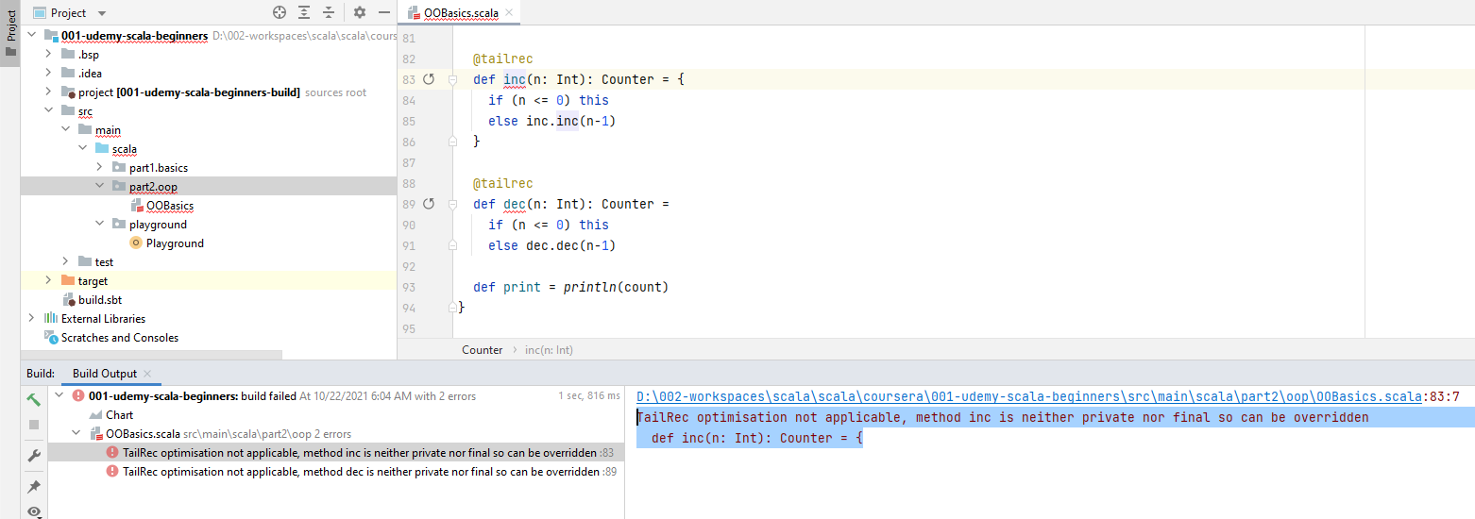

@tailrec

**final** def inc(n: Int): Counter = {

if (n <= 0) this

else inc.inc(n-1)

}

@tailrec

**final** def dec(n: Int): Counter =

if (n <= 0) this

else dec.dec(n-1)

}

Works now with 10000 passed to inc and dec

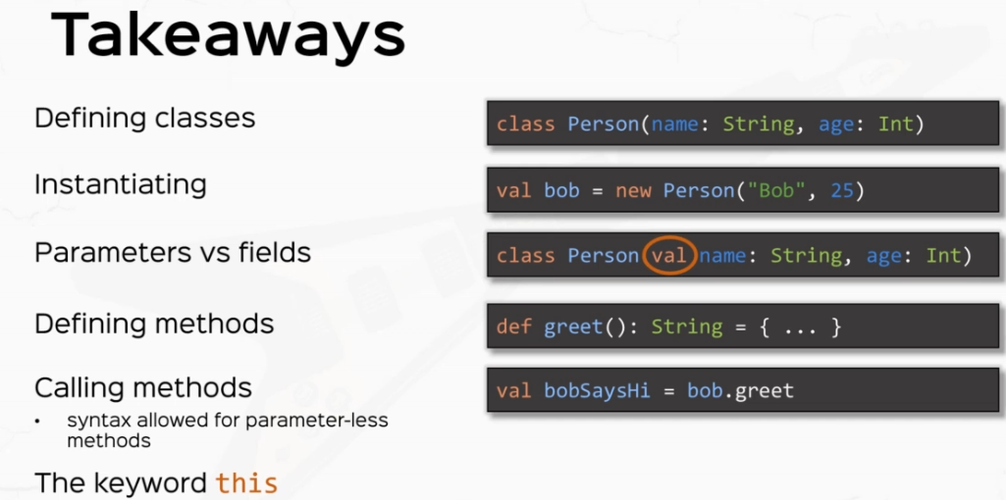

### Method Notations

package part2.oop

object MethodNotations extends App {

class Person(val name: String, favoriteMovie: String) {

def likes(movie: String): Boolean = movie == favoriteMovie

}

val *mary* = new Person( "Mary", "Inception" )

*println*( *mary*.likes("Inception") )

}

Now, in this little object that we created right here, I'm going to create a new class person in the same style as we did in the last video, but now I'm creating the class person inside the object because otherwise it would conflict with the other class person that we wrote in the previous video. We're going to talk about conflicting and packaging later on in this section. But for now, just declare the class person inside the method notations object. All right. So I'm going to create a new class person with two parameters with a name which is a string. I'm going to make this a member. That is a field, that is I'm going to add the keyword val here and I'm going to add a favorite movie parameter, which is also a string.

I created this little class person, as you see it here, because I want to show you some really cool Scala features that make Scala resemble natural language, much more so than other programming languages. So bear with me here. I'm going to define a method inside the person class here called likes(), and I'm going to pass it a movie which is a string, and this guy will return a boolean. And its implementation is going to be very simple, and we're just going to say that this person likes the movie if the movie equals favorite movie, OK. Otherwise, this person will not like the movie. The implementation itself doesn't matter all that much because I want to show you something. So let's define value here. Let's call this Mary and we're going to instantiate the person class that we wrote here in person. And let's give Mary the name Mary with a capital and as the favorite movie we're going to pass in, say, "Inception". And let's print the statement that were the expression that mary.likes("Inception"). Of course, this will evaluate to true, so let's right click and run. And as we expected, the value is printed at the console. But here's what I'm about to write. So instead of mary.likes("Inception"), I'm going to supply a different way of calling the likes method. Here's how it goes mary space likes space inception. These two expressions. mary.likes("Inception") and mary space like space "Inception" are equivalent. But how cool is that? mary likes "Inception". This is so, so natural language. This is called infix notation or operator notation. And it only works with methods which have only one parameter. So object.method with the single parameter can be replaced with the expression object method parameter just like that. So first takeaway is that methods with a single parameter can be called in this infix notation style.

package part2.oop

object MethodNotations extends App {

class Person(val name: String, favoriteMovie: String) {

def likes(movie: String): Boolean = movie == favoriteMovie

}

val *mary* = new Person( "Mary", "Inception" )

*println*( *mary*.likes("Inception") )

print( "Infix notation or Operator Notation result: " )

println( mary likes "Inception" )

}

Now the term infix or operator notation is actually pretty intentional because what I'm about to talk right now is operators in Scala.

Now I put operators in between quotes and you understand what this means in a second. But before that, let's just create another fun method in the class person saying, for example, that this person is hanging out with another person. So let's just define a method called hangOutWith and this method will receive another person as a parameter. And it just returns a string and let's just say that the implementation is pretty simple and essential, play the string saying that this name is hanging out with the other person's name, not other, but person Danny.

object MethodNotations extends App {

class Person(val name: String, favoriteMovie: String) {

def likes(movie: String): Boolean = movie == favoriteMovie

def hangOutWith(person: Person): String = s"**$**{this.name} is hanging out with **$**{person.name}"

}

val *mary* = new Person("Mary", "Inception")

*println*(*mary*.likes("Inception"))

*print*( "Infix notation or Operator Notation result: " )

*println*( *mary* likes "Inception" )

*// "operators" in Scala*

}

So because I define this method with a single parameter now, this method can be used in an infix notation as well. So if I define a new person, let's say Tom, which is a new person with the name Tom, and let's just say that Tom likes Fight Club, amazing movie. Of course, we can actually print line that Mary hang out with Tom. This is actually a valid expression.

object MethodNotations extends App {

class Person(val name: String, favoriteMovie: String) {

def likes(movie: String): Boolean = movie == favoriteMovie

def hangOutWith(person: Person): String = s"**$**{this.name} is hanging out with **$**{person.name}"

}

val *mary* = new Person("Mary", "Inception")

*println*(*mary*.likes("Inception"))

*print*( "Infix notation or Operator Notation result: " )

*println*( *mary* likes "Inception" )

*// "operators" in Scala*

val *tom* = new Person("Tom", "Fight Club")

*println*( *mary* hangOutWith *tom*)

}

And as you've learned, this method can be used in an antique style because it receives a single parameter. So if I can run this, we're just going to see Mary's hanging out with Tom. Now, I use the term operator earlier because in this case, the method hangOutSith acts like an operator between Mary and Tom, which yields a string. In this case, the string Mary is hanging out with Tom. So this guy acts like an operator between two things, yielding a third thing. Now, the term operator is actually reminiscent from math. Right? So if you think of a of an operator example, you think of these math operators like plus minus and so on and so forth. Now, the thing is, the Scala actually has an extremely permissive method naming scheme. So if I actually rename this method to have the name and or plus, that's actually a valid method. So if I say marry plus Tom, that's actually calling the method called plus in the class person, this is super cool and this is what makes call extremely enjoyable to work with because it gives you such freedom to name your methods as you want. Where in other languages the characters like plus or hash or dollar or ampersand are actually reserved in Scollard. They're not at least four methods. So if I define a method called plus, that's actually a valid method and the expression mary + tom is a valid expression, which actually calls mary.+ with a parameter Tom, let's just write it so it's clear. Mary plus with parameter Tom, that's actually a valid expression. Now at this point you probably are wondering and I'm here to dispel any mystery that the plus operator is between numbers are actually methods as well. So if I say print line one plus two, that's the same as printing. One dot plus with parameter two, so mathematical operators are actually acting in the exact same way as methods because they are. So the takeaway here is and I'm going to write this in all caps, all operators are methods.

object MethodNotations extends App {

class Person(val name: String, favoriteMovie: String) {

def likes(movie: String): Boolean = movie == favoriteMovie

def **+**(person: Person): String = s"**$**{this.name} is hanging out with **$**{person.name}"

}

val *mary* = new Person("Mary", "Inception")

*println*(*mary*.likes("Inception"))

*print*( "Infix notation or Operator Notation result: " )

*println*( *mary* likes "Inception" )

*// "operators" in Scala*

val *tom* = new Person("Tom", "Fight Club")

*println*( *mary* **+** *tom*)

*println*( 1 + 2 )

}

*Output:*

*Mary is hanging out with Tom*

*3*

If you're curious, you can actually control space after you put in the dot after a number. So if I'm going here and I'm hit control space, the ID will actually give me all the available methods and will give me all the proper operators.

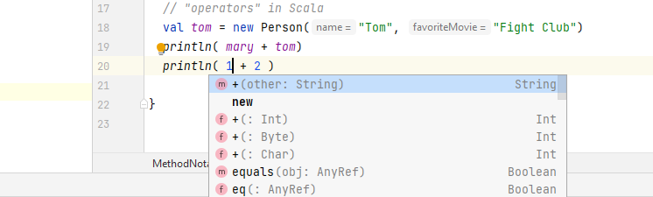

Like Bang equals like mod, multiply, plus, minus, divide, greater then and all the operators that you've gotten used to from major languages. But all operators are methods in Scala.

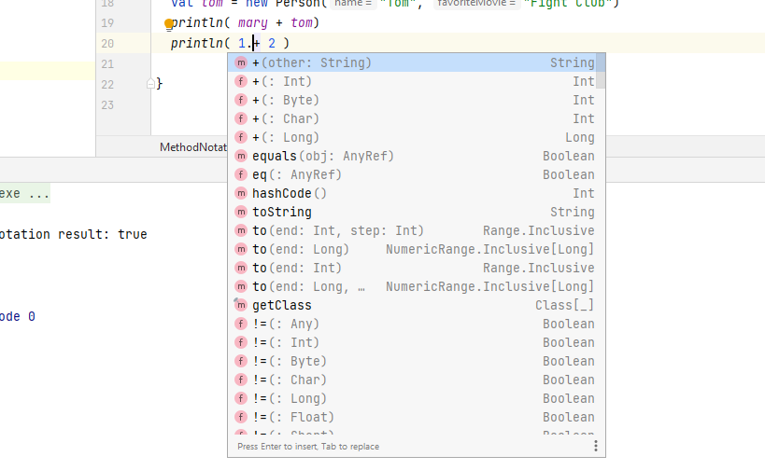

And now that you have complete freedom, you can name your methods as you want, you can name them ? or bang or however you want. For example, all AKKA actors have operators like Bang or question mark, these are the ask patterns or the tail patterns between asynchronous actors. All right. So at this point, you've learned about infix notation and operators. Now you understand why put them in between quotes? Because they're not operators, persay their methods.

println( mary + tom)

println( mary.+(tom))

println( 1 + 2 )

*Output:*

*Mary is hanging out with Tom*

*Mary is hanging out with Tom*

Now, the next thing that I want to talk about is prefix notation. By the way, this style of writing methods of calling methods in infix notation is called syntactic sugar. An example of syntactic sugar. Syntactic sugars are nicer ways of writing code that are equivalent to more complex or more cumbersome ways of writing code. So the syntactic sugar is more resemblance of natural language, and Scala offers this kind of syntactic sugar for methods with single parameters. But there's more. So right now I'm going to talk about prefix notation, which is another form of syntactic sugar. Now, prefix notation is all about unary operators. So if I say val X is negative one, this negative sign over here is unary operator. Now what I'm here to tell you is that unary operators are also methods. So if I say that val y equals 1.unary_-, that will be the same thing. So negative one is actually equivalent to one.unary_-. So unary operators are actually methods with unary underscore prefixed. So negative one here is equivalent with one.unary_-. Now the unary_ prefix. I'm going to write it here so that you have time to write it yourself. So the unary_ prefix only works with a few operators, so it works with -, +, ~ and the bang ! operator.

// ALL OPERATORS ARE METHODS.

// Akka actors have ! ?

// prefix notation

val x = -1 // equivalent with 1.unary_-

val y = 1.unary_-

// unary_ prefix only works with - + ~ !

So let's give an example and write a unary operator for persons. So say for example, I write a unary_! operator for persons that actually let's say it returns a string and says an exclamation or something like that. The implementation is not really important. So I define a method called unary_!, this naming is very important and I'm going to put a space here and I'm going to say it returns a string. Now, the reason I put in a space before the calling of the return type is that if I don't put in a space, then the compiler will think that this column will be part of the method name. So be very careful right over here and put in a space between the name of the method and the calling for the return.

def unary_! : String = s"$name, what the heck?!"

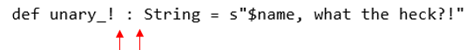

So let's say that this unit bank ! operator says an S interpolated string with a "$name what the heck". Like an ! or something like that, we don't really care about the implementation, but we only care that this method returns something. So if we print to the console, not Mary, that means this is equivalent with print lining mary.unary_!. So because these two expressions are equivalent, if I go ahead and run this, I'm going to see the same strings printed to the console, which is exactly what happens.

package part2.oop

object MethodNotations extends App {

class Person(val name: String, favoriteMovie: String) {

def likes(movie: String): Boolean = movie == favoriteMovie

def +(person: Person): String = s"**$**{this.name} is hanging out with **$**{person.name}"

def unary_! : String = s"**$**name, what the heck?!"

}

val *mary* = new Person("Mary", "Inception")

*println*(*mary*.likes("Inception"))

*print*( "Infix notation or Operator Notation result: " )

*println*( *mary* likes "Inception" )

*// "operators" in Scala*

val *tom* = new Person("Tom", "Fight Club")

*println*( *mary* + *tom*)

*println*( *mary*.+(*tom*))

*println*( 1 + 2 )

*println*( 1.+(2) )

*// ALL OPERATORS ARE METHODS.*

*// Akka actors have ! ?*

*// prefix notation*

val *x* = -1 *// equivalent with 1.unary_-*

val *y* = 1.unary_-

*// unary_ prefix only works with - + ~ !*

*println*(!*mary*)

*println*(*mary*.unary_!)

}

All right, so you've learned another form of syntactic sugar with prefix notation. This is pretty cool. Note again that this unary underscore a scheme only works with these four operators, plus minus tilde and bang. All right. Now, next thing I want to talk to you about is you've probably have the intuition already postfix notation. We've talked about infix. We've talked about prefix. Let's talk about postfix. This one is pretty simple. I'm going to go ahead in the class person and add a little method called isAlive, a very simple method that returns a boolean. And let's just consider the implementation to be true. We don't really care about the actual implementation. We only care about this function signature. That is, the function does not receive any parameters. The functions that do not receive any parameters have the property that they can be used in a postfix notation.

object MethodNotations extends App {

class Person(val name: String, favoriteMovie: String, val age: Int = 0) {

def likes(movie: String): Boolean = movie == favoriteMovie

def +(person: Person): String = s"${this.name} is hanging out with ${person.name}"

def +(nickname: String): Person = new Person(s"$name ($nickname)", favoriteMovie)

def unary_! : String = s"$name, what the heck?!"

def isAlive: Boolean = true

}

. . .

}

Now, what does that mean? If I print line, mary.isAlive. Now, this is going to call the method, which is something that you already know about from the object oriented basics lecture. But an equivalent way of writing this again in a syntactic sugary way would be to say, mary isAlive. This syntactic sugar is called a postfix notation. And again, like the infix notation, has the purpose of getting closer to natural language. But this is rarely used in practice because the only difference is the difference between a dot and a space. And in practice, we often use the DOT notation, this one because the space notation, the postfix notation can introduce potential ambiguities when reading the code, not to the compiler, but to us as humans.

// postfix notation

println( mary.isAlive )

println( mary isAlive ) // only available with scala.language.postfixOps import - discouraged

If you do want to use it. Postfix operator notation is only available to methods without parameters. All right, so you've learned about postfix notation, which is something very simple. The final thing before we move on to exercises is a special method name called apply(). apply() has a special property in Scala and I'm going to show you how that is. So I'm going to go to the person class and I'm going to define a method called apply with parentheses. Parentheses are important and this is going to return a string. And let's say the implementation is going to be a greeting in the same style that we wrote so many times now. So I'm going to say an S interpolated string with "Hi, my name is $name and I like $favoriteMovie", something very simple. Again, the implementation is not that important, but the method signature. So the method signature is very important, not so much that it was a return type, but the method name and the method parameters, because here's what I'm about to write.

package lectures.part2oop

import scala.language.postfixOps

object MethodNotations extends App {

class Person(val name: String, favoriteMovie: String, val age: Int = 0) {

def likes(movie: String): Boolean = movie == favoriteMovie

def +(person: Person): String = s"${this.name} is hanging out with ${person.name}"

def +(nickname: String): Person = new Person(s"$name ($nickname)", favoriteMovie)

def unary_! : String = s"$name, what the heck?!"

def unary_+ : Person = new Person(name, favoriteMovie, age + 1)

def isAlive: Boolean = true

def apply(): String = s"Hi, my name is $name and I like $favoriteMovie"

. . .

}

// apply

println( mary.apply() )

println( mary() ) // equivalent

}

So if I print line mary.apply, then of course this will call the apply method from the mary object and it will say, hi, my name is mary and I like what it was an inception. Right, but the trick, if I say mary, parenthesis, parentheses, this has the same effect.

// apply

println( mary.apply() )

println( mary() ) // equivalent

So notice how the compiler does not complain, I can basically, quote unquote, call Mary as if it were a function, and that is because I've defined an apply method in the person class. So whenever you see whenever the compiler actually whenever the compiler sees an object being called like a function, it actually looks for a definition of apply in that particular class. So in this case, we have appli defined with no parameters. So the compiler does not really complain that I've called Mary like a function with no parameters because the compiler will actually delegate to the apply method. So these two print line statements are equivalent.

Now, if you want to prove to yourself that these are equivalent, you can simply right click and run this. And of course, the program will print the same thing twice. This is extremely cool because it breaks the barrier between object oriented programming and functional programming, as we will see at the beginning of Section three when we talk about what functions actually are. But for now, remember that apply is extremely special in Scala and we're going to make heavy use of it throughout the entire course. So make sure you get this right. Right. So quite a bunch of new and important concepts. I'm waiting for you in the next video where we get to practice all the stuff.

Lets do 4 exercises now

/*

1. Overload the + operator

mary + "the rockstar" => new person "Mary (the rockstar)"

2. Add an age to the Person class

Add a unary + operator => new person with the age + 1

+mary => mary with the age incrementer

3. Add a "learns" method in the Person class => "Mary learns Scala"

Add a learnsScala method, calls learns method with "Scala".

Use it in postfix notation.

4. Overload the apply method

mary.apply(2) => "Mary watched Inception 2 times"

*/

First, I want you to overload the plus operator that we defined here. I want you to add another plus operator which receives a string and it will return a new person with a nickname. So, for example, if I say "Mary plus the Rockstar". Which all guys are, this will return another person with the name Mary, with the parentheses, the Rockstar as a nickname and the same favorite movie. All right. So overloading on infix operator. Now, second exercise is to add an age to the person class. With default zero value, if you will, if you want, and add unary plus operator, which basically increments the value of the age and returns a new person with the H plus one. So if I say plus Mary, that will return Mary with the age incremented. This resembles the prefix plus plus operators that you've probably seen in Java or C++. All right. So this is good for an analogy, OK? Third exercise I want you to add learns method in the person class. This receives a string parameter and returns a sentence which says "Mary learns" whatever you pass into it, say "Scala". All right, so this will operate like that then after you do that, I want you to add a learnsScalla method which doesn't receive any parameters and cause the learns method with Scala as a parameter, and I want you to use it in post fix notation, all right. And finally, I want you to add another apply method, so overload the apply method to receive a number and returns a string and it will basically say mary.apply with a number says say for example, mary watched her favorite movie, Inception, 2 times. All right, so I want you to overload the apply method to receive a number and it will say the person's name watched their favorite movie and times so positive video while you work through the exercises.

1. Overload the + operator

mary + "the rockstar" => new person "Mary (the rockstar)"

1st Exercise Solution:

def +(nickname: String): Person = new Person(s"$name ($nickname)", favoriteMovie)

println( ( mary + "the Rockstar").apply() )

.apply method call after the ( mary + "the Rockstar") will call the following method and print

def apply(): String = s"Hi, my name is $name and I like $favoriteMovie"

We could also call like this, as it will search for the method apply then

println( ( mary + "the Rockstar")() )

*Output:*

*Hi, my name is Mary (the Rockstar) and I like Inception*

2. Add an age to the Person class

Add a unary + operator => new person with the age + 1

+mary => mary with the age incrementer

2nd Exercise Solution

Now we add an age to the person class and I give you a hint to give it a default value of zero. So let's just add, um, I'm going to add an age here as an end and give it the full value of zero so that it doesn't break the persons that we instantiate later in the code.

class Person(val name: String, favoriteMovie: String, age: Int = 0) {

. . .

}

All right. And we said we wanted to add a unary plus operator that actually increments the age by one and returns a new person. All right. So let's add it at the unary group here. So def unary underscore plus and this returns a person again, bear in mind the space between the unary plus method name and the colon, which we will introduce for the return type for this method. If you don't place in a space, the compiler will wrongly assume that the colon is part of the method name. Of course you can, you can define method's called unary that unary_+:, but that will be just a method like any other. All right. So if you want to define a unary operator, it has to have the name unary_and then the operator that you want. All right. So this will return a person and say this will return a new person with the same name, with the same favorite movie and age plus one. The implementation is very simple. All right.

package part2.oop

object MethodNotations extends App {

class Person(val name: String, favoriteMovie: String, age: Int = 0) {

def likes(movie: String): Boolean = movie == favoriteMovie

def +(person: Person): String = s"**$**{this.name} is hanging out with **$**{person.name}"

def +(nickName: String): Person = new Person(s"**$**name (**$**nickName)", favoriteMovie, 10 )

def unary_! : String = s"**$**name, what the heck?!"

def unary_+ : Person = new Person(name, favoriteMovie, age + 1 )

def apply(): String = s"Hi, my name is **$**name and I like **$**favoriteMovie"

}

Let's modify the apply method to actually let's just test this unary plus operator by calling in or accessing the age field, which, by the way, we need to make it a field by adding a val. All right. So if we print line, +mary so +mary means mary.unary_+ that we've just defined and that is a new person. OK, and if I say +mary.age, then this will return one because mary was constructed as a new person with the age zero. If you remember, mary was a new person with mary in Inception, not supplying the perimeter and means that the age is 10 and plus Mary will make a new person with the age equals to 11. So if I print this out, I'm going to see the value one in the console. Of course, so this is the approach that you would take when defining a unary operator.

println( (+mary).age )

This gives a error saying

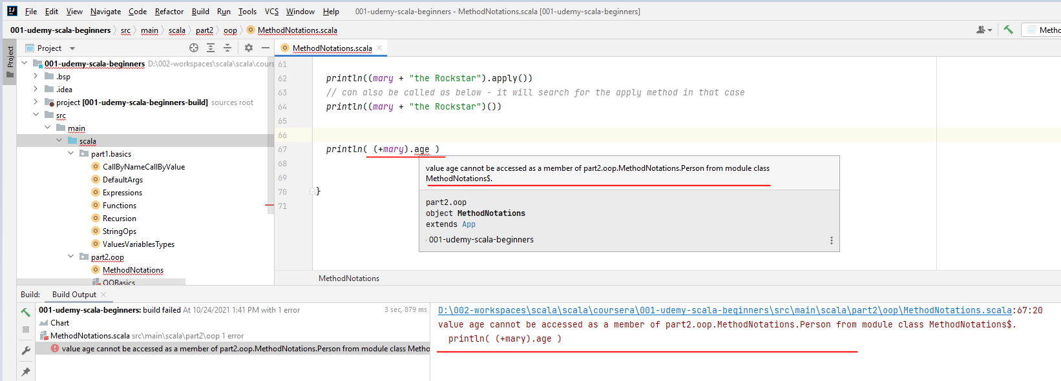

So lets make the age as a val

package part2.oop

object MethodNotations extends App {

class Person(val name: String, favoriteMovie: String, val age: Int = 0) {

def likes(movie: String): Boolean = movie == favoriteMovie

def +(person: Person): String = s"**$**{this.name} is hanging out with **$**{person.name}"

def +(nickName: String): Person = new Person(s"**$**name (**$**nickName)", favoriteMovie, 10 )

def unary_! : String = s"**$**name, what the heck?!"

def unary_+ : Person = new Person(name, favoriteMovie, age + 1 )

def apply(): String = s"Hi, my name is **$**name and I like **$**favoriteMovie and age is

**$**{this.age}"

}

val *mary* = new Person("Mary", "Inception", 10)

*println*(*mary*.likes("Inception"))

*print*( "Infix notation or Operator Notation result: " )

*println*( *mary* likes "Inception" )

*// "operators" in Scala*

val *tom* = new Person("Tom", "Fight Club", 10)

*println*( *mary* + *tom*)

*println*( *mary*.+(*tom*))

*println*( 1 + 2 )

*println*( 1.+(2) )

*// ALL OPERATORS ARE METHODS.*

*// Akka actors have ! ?*

*// prefix notation*

val *x* = -1 *// equivalent with 1.unary_-*

val *y* = 1.unary_-

*// unary_ prefix only works with - + ~ !*

*println*(!*mary*)

*println*(*mary*.unary_!)

*// apply*

*println*( *mary*.apply() )

*println*( *mary*() ) *// equivalent*

*println*((*mary* + "the Rockstar").apply())

*// can also be called as below - it will search for the apply method in that case*

*println*((*mary* + "the Rockstar")())

*println*( (+*mary*).age )

*println*( (+*mary*).apply() )

}

Output is:

true

Infix notation or Operator Notation result: true

Mary is hanging out with Tom

Mary is hanging out with Tom

3

3

Mary, what the heck?!

Mary, what the heck?!

Hi, my name is Mary and I like Inception and my age is 10

Hi, my name is Mary and I like Inception and my age is 10

Hi, my name is Mary (the Rockstar) and I like Inception and my age is 10

Hi, my name is Mary (the Rockstar) and I like Inception and my age is 10

11

Hi, my name is Mary and I like Inception and my age is 11

Number three says add a learns method and then learnsScala method. So lets add a learning method, which gives us a thing that we want to learn, which is a string for simplicity.

*3. Add a "learns" method in the Person class => "Mary learns Scala"*

*Add a learnsScala method, calls learns method with "Scala".*

*Use it in postfix notation.*

And let's just say that this returns a string and it's an as interpolated String says, $name is learning $language, right? Then we have the learnsScala method, which doesn't receive anything. And the implementation is going to be this learnsScala. So if I go back and I print line, Mary learns Scala , this is the postfix notation that I told you about in the previous video, and that means mary.learnsScala, which in turn calls the learns method with the caller parameter. So I should be expected to see what is it. Mary is learning Scala in the console. Right. So let's click and run. And of course, we see Mary's learning Scala to the console as expected.

My implementation:

def learns(language: String): String = s"**$**name learns **$**language"

def learnsScala(): String = learns("Scala")

and calling the methods as

*println*( *mary* learns "Scala")

*println*( *mary*.learnsScala() )

I am not able to call the 2nd println as

println( mary learnsScala )

**Solution**

object MethodNotations extends App {

class Person(val name: String, favoriteMovie: String, val age: Int = 0) {

def learns(thing: String) = s"**$**name is learning **$**thing"

def learnsScala = this learns "Scala"

. . .

}

}

invoking the methods

println( mary learns "Scala")

println( mary learnsScala )

***Output:***

*Mary learns Scala*

*Mary learns Scala*

All right, now, the fourth exercise is also pretty simple. So we need to overload the apply method to take an int parameter and return a string saying name watched favorite movie n times. This is very simple.

package part2.oop

import scala.language.*postfixOps*

object MethodNotations extends App {

class Person(val name: String, favoriteMovie: String, val age: Int = 0) {

def apply(n: Int): String = s"**$**name watched **$**favoriteMovie **$**n times"

. . .

Invoking it then would be like

println( mary(10) )

*Output:*

*Mary watched Inception 10 times*

**The full code is below**

package lectures.part2oop

import scala.language.*postfixOps*

object MethodNotations extends App {

class Person(val name: String, favoriteMovie: String, val age: Int = 0) {

def likes(movie: String): Boolean = movie == favoriteMovie

def +(person: Person): String = s"**$**{this.name} is hanging out with **$**{person.name}"

def +(nickname: String): Person = new Person(s"**$**name (**$**nickname)", favoriteMovie)

def unary_! : String = s"**$**name, what the heck?!"

def unary_+ : Person = new Person(name, favoriteMovie, age + 1)

def isAlive: Boolean = true

def apply(): String = s"Hi, my name is **$**name and I like **$**favoriteMovie"

def apply(n: Int): String = s"**$**name watched **$**favoriteMovie **$**n times"

def learns(thing: String) = s"**$**name is learning **$**thing"

def learnsScala = this learns "Scala"

}

val *mary* = new Person("Mary", "Inception")

*println*(*mary*.likes("Inception"))

*println*(*mary* likes "Inception") *// equivalent*

*// infix notation = operator notation (syntactic sugar)*

*// "operators" in Scala*

val *tom* = new Person("Tom", "Fight Club")

*println*(*mary* + *tom*)

*println*(*mary*.+(*tom*))

*println*(1 + 2)

*println*(1.+(2))

*// ALL OPERATORS ARE METHODS.*

*// Akka actors have ! ?*

*// prefix notation*

val *x* = -1 *// equivalent with 1.unary_-*

val *y* = 1.unary_-

*// unary_ prefix only works with - + ~ !*

*println*(!*mary*)

*println*(*mary*.unary_!)

*// postfix notation*

*println*(*mary*.isAlive)

*println*(*mary* isAlive) *// only available with scala.language.postfixOps import – discouraged*

*// apply*

*println*(*mary*.apply())

*println*(*mary*()) *// equivalent*

*/\**

*1. Overload the + operator*

*mary + "the rockstar" => new person "Mary (the rockstar)"*

*2. Add an age to the Person class*

*Add a unary + operator => new person with the age + 1*

*+mary => mary with the age incrementer*

*3. Add a "learns" method in the Person class => "Mary learns Scala"*

*Add a learnsScala method, calls learns method with "Scala".*

*Use it in postfix notation.*

*4. Overload the apply method*

*mary.apply(2) => "Mary watched Inception 2 times"*

*\*/*

*println*((*mary* + "the Rockstar").apply())

*println*((+*mary*).age)

*println*(*mary* learnsScala)

*println*(*mary*(10))

}

All right, people, let's wrap this up with some takeaways. So if we define a person class, which on the screen looks very similar to what we wrote in the code, we learned about method notation. So for methods that only receive one parameter, we can actually call them like object method, parameter with spaces in between them. This makes Scala very similar to natural language. This is called infix notation and only works for methods with one parameter.

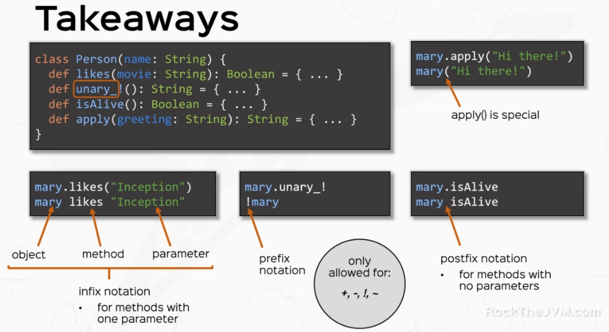

You've also learned about unary operators. So if you call this guy with Bang ! and then the object being called, this is called a prefix notation and actually delegates to the unary_! operator. In this case, this is only allowed for a number of operators, plus, minus tilde and bang. We've also learned about postfix notation that is four methods that do not have parameters. We can actually call them with a space in between. The postfix notation is a little bit rarely used in practice because it can cause confusion when reading code. Again, this is only available for methods with no parameters.

And last, you've learned that apply methods are special because they allow you to call your objects like they were functions. How right. This is Daniel. We're wrapping up this very important topic that we're going to make use of throughout the entire course. And you're surely going to use this in your call, a code.

### Objects

Now, if you've paid attention so far, I've avoided the term object when referring to instances of classes, and that is because objects in Scala are a dedicated concept. Now, one of the fundamental aspects of object oriented programming is something that we call class level functionality. That means functionality that does not depend on an instance of a class. If you've noticed everything that we have written so far had connection to an instance of some class at any given point. Now there are cases where we really shouldn't need to do that. For example, universal constants or universal functionality that we should be able to access without relying on an instance of some class. All right.

So here's how we would do that in a conventional language. So I'm going to go to a playground and I'm going to go to a playground and actually show you how we used to do it. So in Java, we would write a class because all the code resides in classes. And let's say I have some constants relating to the class person. I'm actually going to delete the public modifier so that the code can actually compile. And if all the persons have, for example, two eyes, this is universal to the class person, we would write public static final int so that it's a constant and not modifiable and call this as N_EYES and equals two. So this is how we define a constant that does not rely on an instance of person to access it. And if we wanted to print this, the value of this constant, we would use person.eyes. So we would access N_EYES field from the class person, not from an instance of person. This is called class level functionality and it's one of the fundamental aspects of object oriented programming. Now, I'm going to go back to Scala and I'm going to begin by saying in all caps that Scala does not have class level functionality. So Scala does not know the concept of static. It actually has something even better, and it's called objects, so an object can actually have this kind of static like functionality.

Here's what I mean. So the equivalent in Scala for that little Java code that we wrote earlier would be in. Let me switch to my presentation mode object person. So I'm going to open the curly braces like I would define a class and I'm going to say val and N_EYES equals two. This is how Scala defines "class level of functionality". And the way that we would access it would be just a print line person.N_EYES just like we did in Java. There are a number of important conceptual differences between this approach and the Java approach that I'm going to explain and go through them one by one. But before that, just note that an object can have values or vars and can also have method definitions. So if I define a method canFly which returns of boolean and I suppose the implementation is false, then this is a valid method definition. So objects can be defined in a similar way that classes can, with the exception that objects do not receive parameters. So you can define the values, vars and methods inside objects and you can access them as you would in a class level setting. So if I say person.canFly, then I should receive the number two and the string falls at the console.

package lectures.part2oop

object Objects extends App {

// SCALA DOES NOT HAVE CLASS-LEVEL FUNCTIONALITY ("static")

object Person { // type + its only instance

// "static"/"class" - level functionality

val N_EYES = 2

def canFly: Boolean = false

}

println(Person.N_EYES)

println(Person.canFly)

. . .

}

So the starting point is that to use class level definition in Scala, we use objects. Now let's start with explaining the differences. In Scala, we use an object as a singleton instance. So Scala object is a singleton instance. What do I mean by that? What I mean is that when I define the object person, I basically define its type, but I also define its only instance. So the object is its own type person, plus it is its only instance. That is, if I create a value, let's say mary and I attribute the value person with a capital P to mary. This thing is an instance, this is the instance of the person type, which is the only instance that this person type can have, if I have another value called John, which is also a person, if I print line the fact that mary and john are equal in the sense that they point to the same instance, I'm going to see the value true here in the console. All right, that is because Mary and John point to the same instance, which is the object called person, so another advantage of Scala objects is that they are Singleton instances by definition, without any other code needed from you. So this is pretty cool.

Now, a pattern that's often used in practice is that we write objects and classes with the same name. So class person. In the same file or even the same scope for practical reasons, this is to separate instance level functionality. From, "static" or "class level" functionality, so we split the functionality between classes and objects. This pattern of writing classes and objects with the same name in the same scope is called "companions". So the class person and the object person are companions because they reside in the same scope and have the same name. So what we achieve here in this design with companions is that the whole code that will ever write will reside in either a class and we can access it from an instance or it will reside in the inside of a singleton object. And we can access that by accessing the Singleton object, which means that all the code that will ever going to access will be accessed from some kind of instance, either a regular instance or the Singleton instance. That means Scala is actually a truly object oriented language. So Scala is actually more object oriented than most object oriented languages, including Java, which is kind of funny because it was designed as a functional language and it's actually very successful at it, as you'll see in the functional programming section.

package lectures.part2oop

**object** Objects **extends App** {

// SCALA DOES NOT HAVE CLASS-LEVEL FUNCTIONALITY ("static")

**object** Person { // type + its only instance

// "static"/"class" - level functionality

val N_EYES = 2

def canFly: Boolean = false

// factory method

def apply(mother: Person, father: Person): Person = new Person("Bobbie")

}

**class** Person(val name: String) {

// instance-level functionality

}

// COMPANIONS

println(Person.N_EYES) // prints 2

println(Person.canFly) // prints false

// Scala object = SINGLETON INSTANCE

val mary = new Person("Mary")

val john = new Person("John")

println(mary == john) // prints false

val person1 = Person

val person2 = Person

println(person1 == person2) // prints true

}

**Output:**

*2*

*false*

*false*

*true*

But I digress. Now, let's clarify some things with this companion's design pattern in Scala so that we don't get confused later on. So what I mentioned at the beginning was that if you define an object called in this case person, then this guy is the only instance of its type. Now, if you also declare a companion class for this a class person, then this statement is not entirely true. Let me show you what I mean. So if I declare a class person, then I can actually instantiate it. So if I say val mary is a new person involved, John is also a new person, then Mary and John are not going to be equal because they refer to different instances. So this time will print false to the console. So basically I can instantiate two different instances of the class person. What I meant when I said that the object person is a singleton is that you cannot say val person 1 equals person and val person 2 equals also a person. And these two are different. So if you println(person1 == person2) then we're going to see true to the console. All right, so when I say that this is a singleton object, what I mean by that is that there is a single instance that can be referred to with the name person. So keep this subtle distinction in mind. Cool.

val person1 = Person

val person2 = Person

println(person1 == person2) // prints true

Let's expand now this design pattern. Often in practice, we have factory methods in the Singleton objects. So see, for example, the person has a valid name as class field, right? Of course, this code will not compile now because Mary and John need to have some names. So let's give this Mary and John. OK. Now, in the person object we have in practice, usually we have factory methods that can build persons. So in this case, I'm going to define a from method which takes a mother and a father and result in a new person that is a child. So if I get a mother, which is a person and a father, which is also a person and the return type is person and the implementation is not really relevant, let's say it's called it's a new Person with a name Bobby. Bobby, then this from Method is called a factory method, because its sole purpose is to build a person's given some parameters. So the way that we use that in practice is to say, well, Bobby equals person.from(mary, john). But often in practice, these factory methods are called in a very convenient way apply instead of some other name. So instead of from we can simply apply with mary, john or we can actually delete apply() altogether and make the person Singleton object callable like a function, which is pretty darn cool. So this actually looks like a constructor with a small difference that this is actually the appli method in the person Singleton object. So this pattern is widely used in practice. Cool.

package lectures.part2oop

object Objects extends App {

// SCALA DOES NOT HAVE CLASS-LEVEL FUNCTIONALITY ("static")

object Person { // type + its only instance

// "static"/"class" - level functionality

val N_EYES = 2

def canFly: Boolean = false

// factory method

def apply(mother: Person, father: Person): Person = new Person("Bobbie")

}

class Person(val name: String) {

// instance-level functionality

}

// COMPANIONS

println(Person.N_EYES)

println(Person.canFly)

// Scala object = SINGLETON INSTANCE

val mary = new Person("Mary")

val john = new Person("John")

println(mary == john)

val person1 = Person

val person2 = Person

println(person1 == person2)

val bobbie = Person(mary, john)

}

Now, the final thing that I want to show you, which is new, is Scala Applications. This is the point where you actually understand why this code is Runnable. So I want to start by saying that that Scala application is only Scala object with a very, very important and very particular method, it's called def main(args: Array(String)), which receives an array of string as a parameter. Now, the method needs to have this exact definition with returning unit at the end, because Scala applications are turned into Java virtual machine applications whose entry points have to be static, public static void main with an array of string as a parameter. Now we've seen that the void return type in scale is unit and the static in Java is translated into a single applying method in Scala objects. So Scala applications have to be SQL objects with this method.

So if I delete, for example, the extends appling right over here, then if I right click here, the IDE will not run my code anymore.

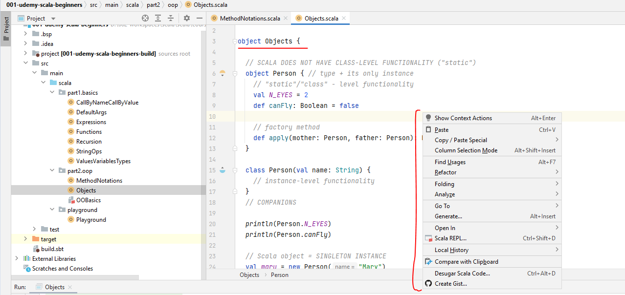

But if I define this method with this exact signature. And I put my code inside. OK. Just indent to good. Then suddenly this application is Runnable again, right, so I can actually right click and run and the code will run as expected. So Scala application is a small object with this exact method implemented. Either that or if you want a shorter way, you can delete this main method and actually say at the beginning extends app, which already has a def main method. All right.

package lectures.part2oop

object Objects {

// SCALA DOES NOT HAVE CLASS-LEVEL FUNCTIONALITY ("static")

object Person { // type + its only instance

// "static"/"class" - level functionality

val N_EYES = 2

def canFly: Boolean = false

// factory method

def apply(mother: Person, father: Person): Person = new Person("Bobbie")

}

class Person(val name: String) {

// instance-level functionality

}

// COMPANIONS

def main(args: Array[String]): Unit = {

println (Person.N_EYES)

println (Person.canFly)

// Scala object = SINGLETON INSTANCE

val mary = new Person ("Mary")

val john = new Person ("John")

println (mary == john)

val person1 = Person

val person2 = Person

println (person1 == person2)

val bobbie = Person (mary, john)

// Scala Applications = Scala object with

// def main(args: Array[String]): Unit

val k = 6.67e-11

}

}

So we started with the fact that Scala does not have static values or methods in the way that other languages do for creating class level functionality, if you will. Scala has something even better. And this is called Scala Objects. So object in the context of Scala is a separate concept. A Scala object is in its own type and is the only instance of that type in the sense that if two things point to a Scala object, then they are equal. A major advantage of scale objects is that they can implement the singleton pattern in one line of code or without any other boilerplate or any other code whatsoever needed from you. And we've seen one in practice.

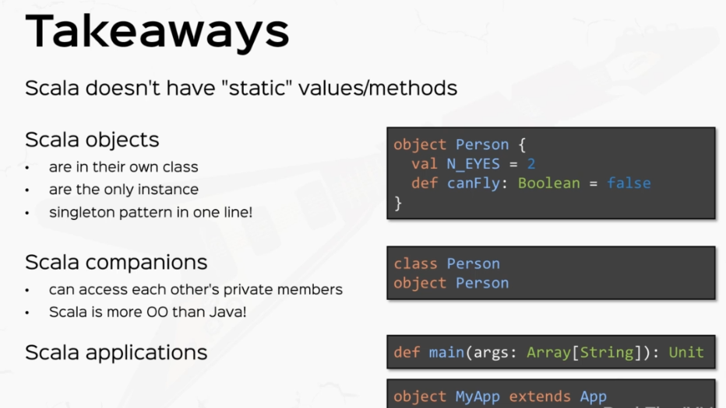

We've also discussed that Scala, objects and small classes can stay in the same scope and these are called Companions. Companions can e access each other's private members, as we will see later in the section. And we've found out that all the code that we write can only be accessed in an instance of something which makes Scala more object oriented than most object oriented languages in existence. And we've seen an example. We've also discussed about Scala applications, which are either Scala objects with this method def main with an array of string as an argument and returning unit or something which extends App. A Scala object extending the app type.

### Inheritance

Scala has single class inheritance, much like other languages. So if I declare, for example, a class called animal with a small little method called eat, which just prints something like nomnom? The implementation is not really important. If I define a class cat which say, extends animal known as the syntax extends animal. This is very similar to Java. Then if I define a new cat, then I can call the method eat on this instance of cat because extending a class means inheriting all the non private fields and methods. So if I say cat dog eat, then that is a valid expression. And if I right click and run this will print no no no. OK, let me switch to presentation mode so you can see this more clearly. Now in this context we call Cat a subclass of Animal and Animal we call a super class of Cat.

package lectures.part2oop

object Inheritance extends App {

// single class inheritance

class Animal {

val creatureType = "wild"

def eat = println("nomnom")

}

class Cat extends Animal {

def crunch = {

eat **➀**

println("crunch crunch")

}

}

val cat = new Cat

}

*Output*

*nomnom*

*crunch crunch*

OK, so much like the inheritance model of most other languages, Scala offers single class inheritance. That is, you can only extend one class at a time, of course, Scala offers much more intricate inheritance models when we talk about traits later, but patience. So we said a subclass only inherits non private members of the Superclass. Speaking of which, if I make this as private with the keyword private, then calling the method eat on the instance of cat is not possible anymore because symbol eat is inaccessible from this place. So private will mark this method only accessible within this class only. Now the other axis modifier that you can actually have here is protected instead of private, which marks this method only usable within this class only and within subclasses. So if I extend or if I spend the class cat here and I create a new method called, say, Krunch, which inside calls it and let's say prints something else to the console, like crunch, crunch, right.

**➀** Calling the method it actually calls the method it inherited from class animal. So if I control click here, it will take me to the method that I inherited from the class animal. So the protected modifier actually allows the use of the method eat inside the subclass as well, but it's not accessible outside the subclass. So I still can't call the method eat, I can only call the public methods krunch in this case. So the access modifier that you can have in Scala are private protected and no modifier, which by default means public. That means anyone can access this method once this class is accessible. Right. All right. So this was pretty basic. You've probably dealt with inheritance before in other languages, so I'm not going to stress it too much.

Now, I'm going to talk about constructor's because they act in a very particular way when dealing with inheritance. So let's say I define the class person that in a similar way that we used earlier. So if I say this person has a name and an age and the let's say subclass this person with a class Adult, again with a name and age, and let's say this guy has an ID card, which just for the sake of the scenario here, is only issued to Adults and it's a string and we say extents person. Now, this code will not compile and the compiler will complain that we have unspecified value parameters, name and age.

package part2.oop

object InheritanceAndTraits extends App {

*// single class inheritance*

class Animal {

val *creatureType* = "wild"

def eat = *println*("nomnom")

}

class Cat extends Animal {

def crunch = {

eat

*println*("crunch crunch")

}

}

val *cat* = new Cat

cat.crunch

// constructors

class Person(name: String, age: Int)

class Adult(name: String, age: Int, idCard: String) extends Person

}

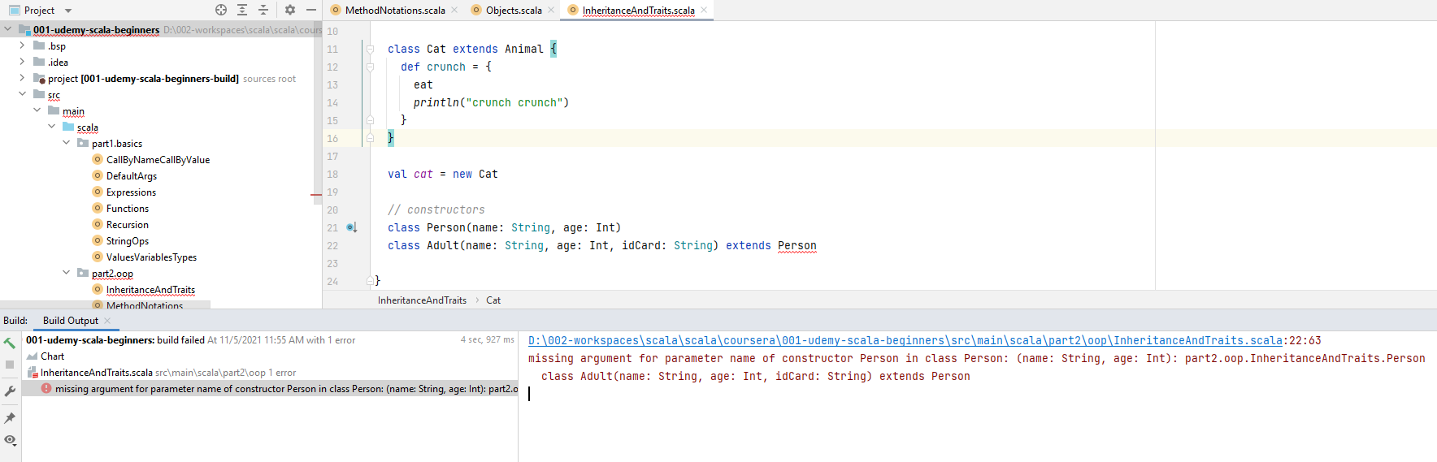

*D:\002-workspaces\scala\scala\coursera\001-udemy-scala-beginners\src\main\scala\part2\oop\InheritanceAndTraits.scala:22:63*

*missing argument for parameter name of constructor Person in class Person: (name: String, age: Int): part2.oop.InheritanceAndTraits.Person*

*class Adult(name: String, age: Int, idCard: String) extends Person*

Now, if you remember, defining class like this with a class signature also defines its constructor. Now, this code does not compile because when you instantiate a derived class, in this case adult, the JVM will need to call a constructor from a parent class first. That's a JVM rule. So it needs to call a constructor of person before you call the constructor of adult. This happens in the internals of JVM. Now, this caller compiler forces you to guarantee that there is a correct super constructed code when using such a derived class. So you must pass in the correct arguments. Otherwise the compiler will look for and in this case fail to find a constructor that looks like this, like the one you provided. So in this example, the constructor person with no parameters does not exist. So you need to pass in the correct parameters like name and age. So this is the correct way of extending a class with parameters.

*// constructors*

class Person(name: String, age: Int)

class Adult(name: String, age: Int) extends Person(name, age)

Now, if you happen to be one of those people who define auxillary constructors, for example, if I define an auxiliary constructor for person with def this if you remember.

// constructors

class Person(name: String, age: Int) {

def this(name: String) = this(name, 0)

}

class Adult(name: String, age: Int) extends Person(name)

With the implementation that, for example, this class calls the constructor with name and the H0, then you can also specify that constructor here in the EXTENDS clause. So if you say extends person name, this is also valid because the compiler found a constructor with just the name for the superclass. Cool. So we have basic inheritance, we have access modifiers and we have constructor's.

Let's talk about overriding. Now, let's say define a class dog, which a dog, not duck, extends animal, and I want to supply a different implementation for the protected def eat method. So the way I would do that would be to use the key word override. So override def eat, which let's say prints Crunch Crunch. So now if I instantiate a dog, say val dog equals a new dog, I can actually call dog.eat because this time the eat method is public. See that it has no other privacy modifier. So if I call the dog eat, I'm going to see crunch crunch in the console. All right, so I'm seeing crunch, crunch, I'm also seeing these two guys from the from the cat above. So overriding works for method's as it works for values and vars.

package part2.oop

object InheritanceAndTraits extends App {

*// single class inheritance*

class Animal {

val *creatureType* = "wild"

def eat = *println*("nomnom")

}

class Cat extends Animal {

def crunch = {

eat

*println*("crunch crunch")

}

}

val *cat* = new Cat

*cat*.crunch

*// constructors*

class Person(name: String, age: Int) {

def this(name: String) = this(name, 0)

}

class Adult(name: String, age: Int) extends Person(name, age)

class Dog extends Animal {

override def eat = *println*("Crunch Crunch")

}

val *dog* = new Dog

*dog*.eat

}

*Output*

*nomnom*

*crunch crunch*

*Crunch Crunch*

So if I, for example, define a val say a creatureType which say it's wild, so wild creature and dog can actually override that, so override the val creatureType and we can give it another value, say domestic, right, and we can actually use it so we can print line, dog.creatureType, so of course if I right click and run this, I'm actually going to see the string domestic because I have overridden the value creature type in the dog. If I hadn't I would have seen the wild string to the console. Let's just comment this out and prove this.

package part2.oop

object InheritanceAndTraits extends App {

*// single class inheritance*

class Animal {

val *creatureType* = "wild"

def eat = *println*("nomnom")

}

class Cat extends Animal {

def crunch = {

eat

*println*("crunch crunch")

}

}

val *cat* = new Cat

*cat*.crunch

*// constructors*

class Person(name: String, age: Int) {

def this(name: String) = this(name, 0)

}

class Adult(name: String, age: Int) extends Person(name, age)

class Dog extends Animal {

override def eat = *println*("Crunch Crunch")

}

val *dog* = new Dog

*dog*.eat

*println*(*dog*.*creatureType*)

}

*Output:*

*nomnom*

*crunch crunch*

*Crunch Crunch*

*wild*

package part2.oop

object InheritanceAndTraits extends App {

*// single class inheritance*

class Animal {

val *creatureType* = "wild"

protected def eat = *println*("nomnom")

}

class Cat extends Animal {

def crunch = {

eat

*println*("crunch crunch")

}

}

val *cat* = new Cat

*cat*.crunch

*// constructors*

class Person(name: String, age: Int) {

def this(name: String) = this(name, 0)

}

class Adult(name: String, age: Int) extends Person(name, age)

class Dog extends Animal {

override def eat = *println*("Crunch Crunch")

override val *creatureType* = "Domestic"

}

val *dog* = new Dog

*dog*.eat

*println*(*dog*.*creatureType*)

}

Output:

*nomnom*

*crunch crunch*

*Crunch Crunch*

*Domestic*

Now, fields, as opposed to methods, have the special property that they can be overridden directly in the constructor as well. So if I copy this definition, let's copy it, not cut it and actually pass this. As a parameter, this actually overrides the value creature type. So if I pass in the new dog code, I'd say canine, something like that. Of course, I need to supply a perimeter type then this is a valid definition of the class dog with the creature type field directly overridden in the constructor as a class parameter. It's as if I said, and let's come into the class dog here. It's as if I said class dog with some kind of dog type as a string parameter extents animal. And I'm overriding the creature type field inside and the implementation is going to be dog type here. OK, so overriding the value directly in the constructor or overriding the value creature type inside the class, but using the class parameter as the implementation is exactly the same thing.

package part2.oop

object InheritanceAndTraits extends App {

*// single class inheritance*

class Animal {

val *creatureType* = "wild"

protected def eat = *println*("nomnom")

}

class Cat extends Animal {

def crunch = {

eat

*println*("crunch crunch")

}

}

val *cat* = new Cat

*cat*.crunch

*// constructors*

class Person(name: String, age: Int) {

def this(name: String) = this(name, 0)

}

class Adult(name: String, age: Int) extends Person(name, age)

class Dog(override val creatureType: String) extends Animal {

override def eat = *println*("Crunch Crunch")

}

val *dog* = new Dog("Domestic")

*dog*.eat

*println*(*dog*.creatureType)

val *dog2* = new Dog("K9")

*println*(*dog2*.creatureType)

}

Output:

*nomnom*

*crunch crunch*

*Crunch Crunch*

*Domestic*

OK, so just so you know that as a shorthand you can override fields from superclusters directly in the constructor call so you now know the basics of overwriting. But the main idea of overriding is that all instances of derived classes will use the overridden things whenever possible. So in this case, all instances of dog will call this overridden method eat, which prints crunch crunch to the console whenever we call it. All right.

But what's interesting, though, is we can do what we call a type substitution. So watch what I'm writing. Let's say I create a val called unknownAnimal. And we specifically declare this to be an animal. And on the right hand side, I'm passing in an expression that constructs a new dog with the value canine. So as you can see, we can declare something to be an animal and supply a dog instead.

// type Substitution: (broad sense: Polymorphism)

val unknownAnimal: Animal = new Dog("Fluffy Dog")

println(unknownAnimal.creatureType)

This is called in a very, very broad sense called type substitution. So watch what I'm doing, let's say I kill the protected modifier here and I just want to use the method called it in this unknown animal. So if I call unknown animal eat if I. Right. Click and run this. I'm going to see crunch, crunch, that is because this guy, the new dog, uses the overridden implementation of it because unknown animal, although declared an animal, is actually an instance of dog. So it will use dogs method instead.

package part2.oop

object InheritanceAndTraits extends App {

*// single class inheritance*

class Animal {

val *creatureType* = "wild"

~~protected~~ def eat = *println*("nomnom")

}

class Cat extends Animal {

def crunch = {

eat

*println*("crunch crunch")

}

}

val *cat* = new Cat

*cat*.crunch

*// constructors*

class Person(name: String, age: Int) {

def this(name: String) = this(name, 0)

}

class Adult(name: String, age: Int) extends Person(name, age)

class Dog(override val creatureType: String) extends Animal {

override def eat = *println*("Crunch Crunch")

}

val *dog* = new Dog("Domestic")

*dog*.eat

*println*(*dog*.creatureType)

val *dog2* = new Dog("K9")

*println*(*dog2*.creatureType)

*// type Substitution: (broad sense: Polymorphism)*

val *unknownAnimal*: Animal = new Dog("Fluffy Dog")

*println*(*unknownAnimal*.*creatureType*)

*unknownAnimal*.eat

}

*Output:*

*nomnom*

*crunch crunch*

*Crunch Crunch*

*Domestic*

*K9*

*Fluffy Dog*

*Crunch Crunch*

So keep in mind, a method call will always go to the most overridden version whenever possible. This is one of the main powers of polymorphism. We can actually use the animal type as we see fit, but inside the instances themselves might be derived instances of animal. So if we have a collection of animal like dogs and cats and giraffes and we call the eat method on all of them, each instance will know the derived implementation of eat to call. All right. So you now know about overriding. Make sure you make the distinction between overriding, which means supplying a different implementation in derived classes versus overloading, which means supplying multiple methods with different signatures, but with the same name in the same class. All right.

So we discussed quite a bit. We've discussed basic inheritance. We've discussed access modifiers. We've talked about constructors. We've talked about overriding and overriding fields directly in the constructor. And we talk briefly about polymorphism. Let's talk about super. So super is used when you want to reference a method or a field from parent class. So let's say, for example, that we expand the method, eat in the class dog to also use the "num num" or the implementation of the method eat in the class animal. So the way that we would do that would be let's open some curly braces. So if here I want to call the method from class animal, the method from the method eat from class animal, I would use super.eat. OK, so super.eat will refer to the method eat in the super class. So if I right click and run this time. I'm also going to see "num, num", so I'm going to see "num, num" and "crunch, crunch". All right. So this concept is pretty simple.

package part2.oop

object InheritanceAndTraits extends App {

*// single class inheritance*

class Animal {

val *creatureType* = "wild"

def eat = *println*("nomnom")

}

class Cat extends Animal {

def crunch = {

eat

*println*("crunch crunch")

}

}

val *cat* = new Cat

*cat*.crunch

*// constructors*

class Person(name: String, age: Int) {

def this(name: String) = this(name, 0)

}

class Adult(name: String, age: Int) extends Person(name, age)

class Dog(override val creatureType: String) extends Animal {

override def eat = {

super.eat

*println*("Crunch Crunch")

}

}

val *dog* = new Dog("Domestic")

*dog*.eat

*println*(*dog*.creatureType)

val *dog2* = new Dog("K9")

*println*(*dog2*.creatureType)

*// type Substitution: (broad sense: Polymorphism)*

val *unknownAnimal*: Animal = new Dog("Fluffy Dog")

*println*(*unknownAnimal*.*creatureType*)

*unknownAnimal*.eat

}

*Output:*

*nomnom*

*crunch crunch*

*nomnom*

*Crunch Crunch*

*Domestic*

*K9*

*Fluffy Dog*

*nomnom*

*Crunch Crunch*

The final thing before I wrap up this video is part one of inheritance is going to be preventing overwrites. Now, there are cases when you want to limit the overrides of your fields or methods, and there are a couple of ways to do it, one way is to use the key word final. The key word final, let's say I go to the class animal and I put a final before that, the final key word will prevent derived classes from overriding the eat method.

object InheritanceAndTraits extends App {

*// single class inheritance*

class Animal {

val *creatureType* = "wild"

final def eat = *println*("nomnom")

}

class Cat extends Animal {

def crunch = {

eat

*println*("crunch crunch")

}

}

So if I go back to the dog class, this guy will not be overridden because Method E cannot override final number.

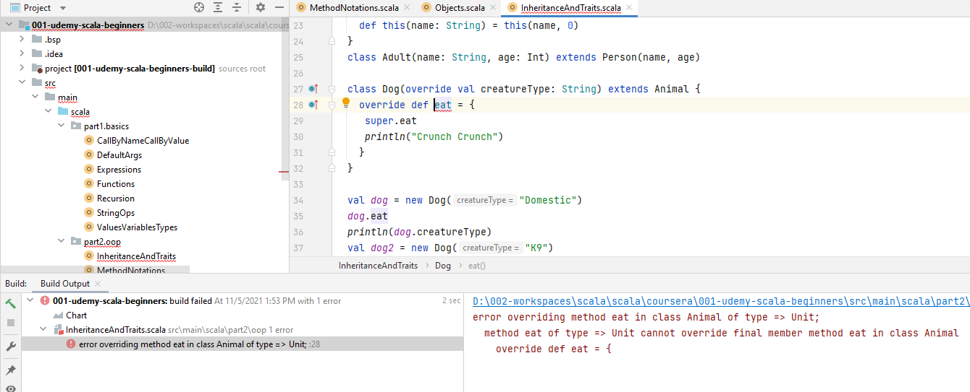

So that was one method used final on member. Now final can be used on the class itself. So if I say. The class animal is final, so I put in a final modifier before the class.

object InheritanceAndTraits extends App {

*// single class inheritance*

final class Animal {

val *creatureType* = "wild"

def eat = *println*("nomnom")

}

And I deleted from the member then this prevents the entire class from being extended, so the extension for Cat and for dog is illegal when you use the key word final on the superclass. So illegal inheritance from final class animal. The numerical classes in Scala are, for example, final string type is also final. OK, so this is another way to do it. So use final on the entire class.

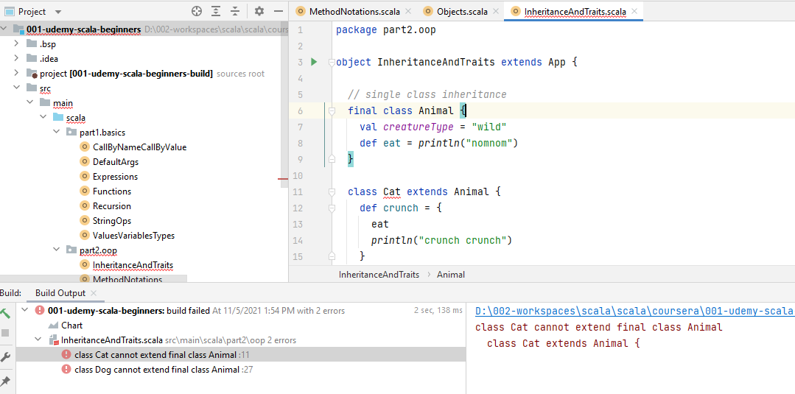

And the third option and this is new is to seal the class now sealing the class is a softer restriction in that you can extend classes in this file. So in this file only, but prevent extension in other files.

object InheritanceAndTraits extends App {

*// single class inheritance*

sealed class Animal {

val *creatureType* = "wild"

def eat = *println*("nomnom")

}

So if I see all the class animal by using the keyword sealed, then the extension of class animal with the subclasses, cat and dog in this file are valid. But if I try to extend animal in another file, then that would be illegal. The sealed keyword is often used when you want to be exhaustive in your type hierarchy. So if, for example, the only two possible animals in this world would be cats and dogs, then you would normally use a sealed class animal and extend cat and dog in this file and prevent animal from being extended in other files because cats and dogs are the only types that you can have.

object Inheritance extends App {

// single class inheritance

sealed class Animal {

val creatureType = "wild"

def eat = println("nomnom")

}

class Cat extends Animal {

def crunch = {

eat

println("crunch crunch")

}

}

val cat = new Cat

cat.crunch

// constructors

class Person(name: String, age: Int) {

def this(name: String) = this(name, 0)

}

class Adult(name: String, age: Int, idCard: String) extends Person(name)

// overriding

class Dog(override val creatureType: String) extends Animal {

// override val creatureType = "domestic" // can override in the body or directly in the constructor arguments

override def eat = {

super.eat

println("crunch, crunch")

}

}

val dog = new Dog("K9")

dog.eat

println(dog.creatureType)

// type substitution (broad: polymorphism)

val unknownAnimal: Animal = new Dog("K9")

unknownAnimal.eat

// overRIDING vs overLOADING

// super

// preventing overrides

// 1 - use final on member

// 2 - use final on the entire class

// 3 - seal the class = extend classes in THIS FILE, prevent extension in other files

}

All right. So we talked about a lot of things, but most are pretty basic and you've probably seen the concepts in other languages.

### Inhertiance Contd: Abstract Classes & Traits

We're going to talk about abstract data types in this column. This goes hand-in-hand with the previous video with inheritance. All right. So in my IDE, I'm actually going to create an entirely new Scala application just for this video because we're going to make heavy modifications. So I'm actually going to rename this inheritance and traits thing to be only inheritance. I'm going to create an entirely new Scala application called Abstract Data Types. And, I'm going to make this an object, of course extends App. So we have a fresh application just for this video, of course. Or there are situations where you need to leave some fields or methods blank or unimplemented. These are called abstract members. Classes which contain unimplemented or abstract fields or methods are called abstract classes, and they are defined by the keyword abstract so abstract class. And let's define an abstract class animal with two fields of all creature type, which is a string. And notice I'm not defining it. I'm not supplying a value here. On the right hand side, that means this value is abstract and the supply method eat, which returns unit and is also unimplemented. So this method is also abstract. Cool. So this is an example of an abstract class where you do not supply values for this value and for this method specifically because you want the subclasses to do that for you. So this is an example of an abstract class.

package part2.oop

object InheritanceContd extends App {

*// abstract*

abstract class Animal {

val creatureType: String

def eat: Unit

}

}

Now, one thing to note that abstract classes cannot be instantiated. It should make sense because an instance of a class has to have all these methods implemented. Otherwise, how would the runtime know what to execute when you call, for example, the method? So, for example, if I declare an animal to be a new animal, then the compiler will complain, say in class animal is a struct cannot be instantiated and object creation impossible because these two guys are not implemented. So let's delete that.

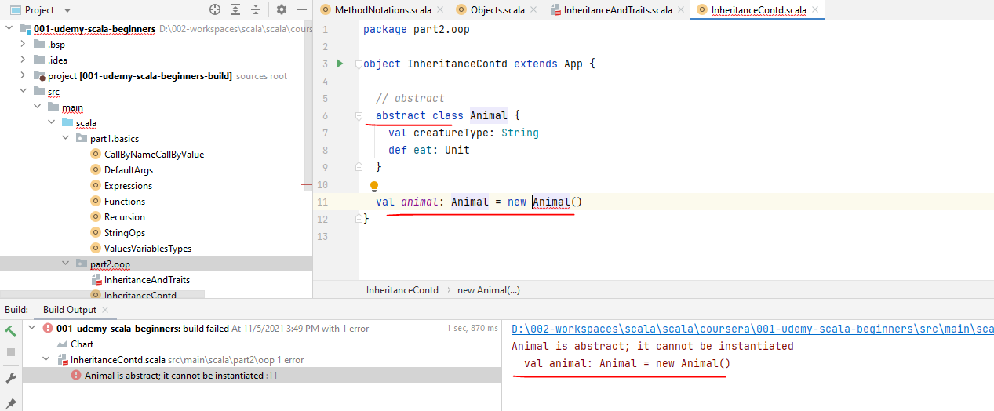

Basically, abstract classes and abstract data types are means to be extended later. So let's extend it with a class dog. Now, at this point, the compiler complains and saying class dog must either be declared, obstruct or implement, obstruct members, eat and creature type, so the correct way to define dog is to simply provide an implementation on the abstract fields. So say override valve creature type string equals, let's say, K9 and override def eat Unit and just prints "crunch crunch".

package part2.oop

object InheritanceContd extends App {

*// abstract*

abstract class Animal {

val creatureType: String

def eat: Unit

}

class Dog extends Animal {

override val *creatureType*: String = "Canine"

~~override~~ def eat: Unit = *println*("Crunch Crunch") // override not mandatory

}

}

Now, these implementations qualify as overriding, but the override key word is not really mandatory for abstract members, so if I deleted the compiler, it will still figure out that there is that this method actually overrides an abstract number from the superclass, so there's no prior implementation to replace. So the compiler is happy.

All right. You've learned about abstract classes. Let's talk about traints, which are the ultimate abstract data types in Scala. Traits are created by using the keyword trait and then the name of the trait. Much like the name of an abstract class, let's call this carnivore, and this treat describes things which can eat animals. So let's apply in method called eat with a parameter animal of type animal. Let's just assume this guy returns Unit. We don't really care about the return type. So notice that this method is also abstract and traits by default, like abstract classes have abstract fields and methods. But what's special about traits is that unlike abstract classes, they can be inherited along classes.

object InheritanceContd extends App {

*// abstract*

abstract class Animal {

val creatureType: String

def eat: Unit

}

class Dog extends Animal {

override val *creatureType*: String = "Canine"

override def eat: Unit = *println*("Crunch Crunch")

}

trait Carnivore {

def eat(animal: Animal): Unit

}

}

Let me show you what I mean. So if I define a classical crocodile which extends animal, I can also inject a trade here with carnivore. And this basically means that this class crocodile inherits members from both animal and carnivore.

package part2.oop

object InheritanceContd extends App {

*// abstract*

abstract class Animal {

val creatureType: String

def eat: Unit

}

class Dog extends Animal {

override val *creatureType*: String = "Canine"

override def eat: Unit = *println*("Crunch Crunch")

}

trait Carnivore {

def eat(animal: Animal): Unit

}

class Crocodile extends Animal with Carnivore {

}

}

So let's give some implementation here in the class crocodile. Let's supply a Val creatureType which is string, and let's say the creature type is croc, for example. Now let's define the two abstract methods eat, which returns Unit. Let's say this is num num num for brevity and the def eat method from the carnivore treat. This also returns Unit. And let's just do an s interpolated string with saying "I'm a Croc and I'm eating" and I'm injecting here. Let's say animal.creatureType. All right. So if I'm eating a dog, the crocodile will say, "I'm a croc and I'm eating a dog". All right. So just to prove an example, if I clear a dog, which is a new dog and a crocodile, no crocodile and croc eat dog, then this guy will print. "I'm a croc and I'm eating animal.creatureType, which in this case is canine. All right, so Crock eat Dog will print, I'm a Croc and I'm eating a Canine. So if I click and run here, let's see what this prints out. Says I'm a crook and I'm eating canine, right?

package part2.oop

object InheritanceContd extends App {

*// abstract*

abstract class Animal {

val creatureType: String

def eat: Unit

}

class Dog extends Animal {

override val *creatureType*: String = "Canine"

override def eat: Unit = *println*("Crunch Crunch")

}

trait Carnivore {

def eat(animal: Animal): Unit

}

class Crocodile extends Animal with Carnivore {

val *creatureType*: String = "Croc"

def eat: Unit = *println*("nomnom")

def eat(animal: Animal): Unit = *println*(s"I'm a Croc and

I'm eating a **$**{animal.creatureType}")

}

val *dog* = new Dog

val *croc* = new Crocodile

*croc*.eat(*dog*)

*croc* eat *dog*

}

So you've seen here how we extend a class with a trait. We can actually mix in multiple traits here. So if you have another trade saying, let's say cold blooded, then you can actually mix it here with cold blooded. OK, you can mix in as many traits as you want.

package part2.oop

object InheritanceContd extends App {

*// abstract*

abstract class Animal {

val creatureType: String

def eat: Unit

}

class Dog extends Animal {

override val *creatureType*: String = "Canine"

override def eat: Unit = *println*("Crunch Crunch")

}

trait Carnivore {

def eat(animal: Animal): Unit

}

trait ColdBlooded

class Crocodile extends Animal with Carnivore with ColdBlooded {

val *creatureType*: String = "Croc"

def eat: Unit = *println*("nomnom")

def eat(animal: Animal): Unit = *println*(s"I'm a Croc and I'm eating

a **$**{animal.creatureType}")

}

val *dog* = new Dog

val *croc* = new Crocodile

*croc*.eat(*dog*)

*croc* eat *dog*

}

OK, now, I want to talk about the difference between traits versus abstract classes. Abstract classes can have abstract and non abstract types. So let's just say, for example, this guy is wild. OK, now. Of course, this needs the override modifier now that creature type is not abstract, so abstract classes can have both abstract and non abstract members, but so can Traits. So if I define a val, let's say, preferred meal, which is a String. Let's just say the value here is meat. Fresh meat. Right? This is a non abstract member. So both abstract classes and Traits have both abstract and non abstract members.

So this begs the question how are traits actually different from abstract classes? Well, for one, traits cannot have constructor parameters. So Traits do not have constructor parameters. This is a hard practical difference if I go to the trade Carnivore and try to pass in a name. This will not compile because the compiler is confused. It doesn't even expect an identifier here for the Trait. Right. So Traits do not have constructor parameters.

Note: this actually worked when I created a parameter and passed value when applying trait

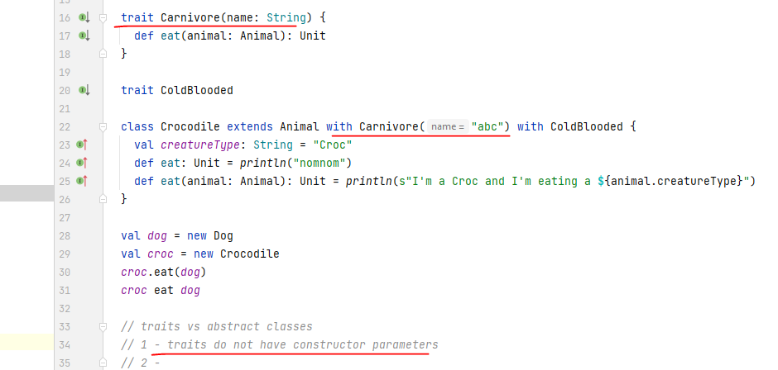

Second, you can only extend one class, but you can mix in multiple traits. Right? So two multiple traits may be inherited by the same class. At the beginning, I said Scala has single class inheritance, but I didn't say that it has multiple traits inheritance, so this is how you implement multiple inheritance in Scala. All right.

abstract class Animal {

val creatureType: String

def eat: Unit

}

trait Carnivore {

def eat(animal: Animal): Unit

}

trait ColdBlooded

class Crocodile extends Animal with Carnivore with ColdBlooded {

val *creatureType*: String = "Croc"

def eat: Unit = *println*("nomnom")

def eat(animal: Animal): Unit = *println*(s"I'm a Croc and I'm

eating a **$**{animal.creatureType}")

}

And the third thing and this is a little more subtle. And this is a more subtle matter of choice, actually. So we choose a trait versus an abstract class if it describes a type of behavior. So traits or behavior. Notice that I named the straight carnivore because it describes the type of things that eat animals, but an abstract class. Is a type of thing, right, so animals describe animals, but traits describe what they do.

package part2.oop

object InheritanceContd extends App {

*// abstract*

abstract class Animal {

val creatureType: String

def eat: Unit

}

class Dog extends Animal {

override val *creatureType*: String = "Canine"

override def eat: Unit = *println*("Crunch Crunch")

}

trait Carnivore {

def eat(animal: Animal): Unit

}

trait ColdBlooded

class Crocodile extends Animal with Carnivore with ColdBlooded {

val *creatureType*: String = "Croc"

def eat: Unit = *println*("nomnom")

def eat(animal: Animal): Unit = *println*(s"I'm a Croc and I'm eating

a **$**{animal.creatureType}")

}

val *dog* = new Dog

val *croc* = new Crocodile

*croc*.eat(*dog*)

*croc* eat *dog*

*// traits vs abstract classes*

*// 1 - traits do not have constructor parameters*

*// 2 - multiple traits may be inherited by the same class*

*// 3 - traits = behavior, abstract class = type of thing*

}

Cool. So now that you know how Scala does inheritance, let's talk a little bit about Scalars giant type hierarchy. This starts with the type any, which is basically the mother of all types now derived from any. We have any riff which is mapped to java's object type. All classes you will use will derive from any riff unless you explicitly say the extent some other class. So all the classes that we use, like string lists set and all user derived classes will extend any riff, even though you don't explicitly say so. If you define the playing class like person, it implicitly extends any riff. Now derived from all of these is the Scalar dot nor type, which is very special. It's only instance is the null reference, which basically means no reference. This type hierarchy works this way, so null extends basically everything in the sense that you can replace anything. For example, a person with null with null reference. All right.

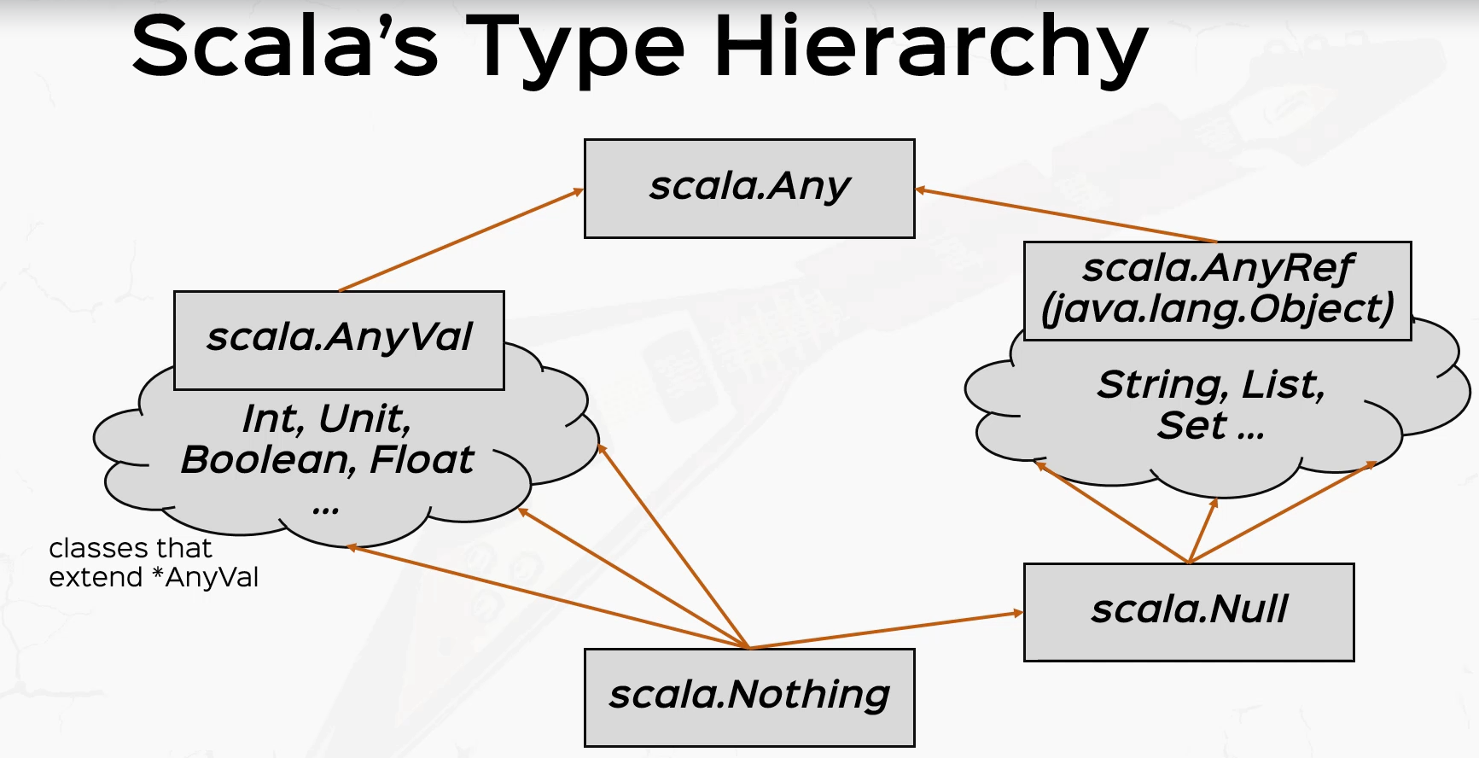

On the left hand side, we have any val which contain all the primitive values of Scala like Int or Boolean or float. And some other classes that extend any val. It's very rarely used in practice, and you very rarely need to extend any val. Maybe for some memory optimizations, but any val normally contains just the primitive types in skull and derived from all of them is called nothing. In the sense that, again, nothing can replace everything. This will make sense a little bit later when we talk about throwing exceptions and expressions returning nothing but nothing just so you know, in there is a subtype of every single thing in Scala. Nothing means no instance of anything at all. Not even null not even Unit, not even anything. It's the type of nothingness, if you will. There are expressions returning nothing, and we'll talk about them later in the section.

### Inheritance Exercises: Implementing our own Collection

We are going to go to the exercises package and I'm going to create a new skull, a class called MyList. And here we're going to create an abstract class, which describes a list of integers. So here, my friends, you are going to implement your own collection. This exercise is pretty simple but very challenging to think about in the first iteration. So I'm going to give you some indications. This list will be a singly linked list, which holds integers, and it will have the following methods the method head will return and end, which is going to be the first element of this list. Another method is going to be teal, which is the remainder of the list. I'm pretty sure you've implemented your own lists in other languages and you've implemented singly linked list, so this will hold the pointer, if you will, of the remainder of the list. OK. Some small methods like is empty, which returns a bullion and returns. Is this list empty? Then we are going to have a method called Add, which receives an integer and will return a new list with this element added. OK. And I also want you to override a special method called two string, which returns a string representation. Of the list. Right. So I want you to add these methods in two or more or however many you decide subclasses or subtypes of this my list abstract class. But first, decide on the method signatures for each of these methods and then implement them in their subtypes now positive video and give it a good think and try to implement this. And I will see you in a couple of seconds where I'll show you how to do it. All right, so I hope you did the exercise. This is very important that you give it your own shot first before jumping into a solution. But right now, I'm going to show you how to do it and you'll be surprised of how easy it is. So let's decide on the method signatures first. So Def Head will return an inch because it will return the first element of the list. Now the tail will return the remainder, which is of type. My list now is empty, will return a bullet and of course. We'll return a Boolean the add method. Let's call this element, which is of type internal return on my list. All right. Because this will return the new list with the element at it. Now if you remember the concept, this is an immutable list because as you see, we're not modifying this instance, we're we'll return a new instance whenever we want to modify it and to string, I'm going to implement later, but let's focus on these four first. OK.

package part2.oop.exercises

abstract class MyList {

/*

Assignment is as below

head = first element of this list

tail = remainder of the list ( hold the pointer of the remainder of the list )

isEmpty = is this list empty

add(Int) = returns a new list with this element added

toString = returns a String representation of the list ( override this method )

*/

def head: Int

def tail: MyList

def isEmpty: boolean

def add(Int element): MyList

def toString(): String

}

So my list is an abstract class, and I want to extend it by two subclasses, the empty list and the non empty list. The interest is going to be an object, so object empty extends my list. OK, so objects can actually extend classes, but of course, we need to supply the appropriate methods, so let's actually copy this and paste them here and let's implement them. For now, I'm going to give it an implementation of watch when I'm writing. Question, question, question. This is an expression returning nothing. If you pay attention to the last couple of minutes, this guy returns nothing.

abstract class MyList {

/*

head = first element of this list

tail = remainder of the list ( hold the pointer of the remainder of the list )

isEmpty = is this list empty

add(Int) = returns a new list with this element added

toString = returns a String representation of the list ( override this method )

*/

def head: Int

def tail: MyList

def isEmpty: boolean

def add(Int element): MyList

// def toString(): String

}

object Empty extends MyList {

def head: Int = ???

def tail: MyList = ???

def isEmpty: Boolean = ???

def add(element: Int): MyList = ???

}

And when this method is called, this guy will throw and not implement an error because we'll implement them later. All right. So I'm going to supply question, question for all of these. OK, so we have the empty list. I also want a non empty list, so I'm going to define a class called con's, which extends my list. Now the cons class will have two parameters will have the head, which is an end and a tail, which isn't it? So con's will actually compose a value with some other list. This is what a linked list actually means. It's composed of an element and the rest of the list. OK. So let's paste the method definitions here, and let's give them the default implementations with question, question question. So that we actually implement them in a minute. All right.

package part2.oop.exercises

abstract class MyList {

/*

head = first element of this list

tail = remainder of the list ( hold the pointer of the remainder of the list )

isEmpty = is this list empty

add(Int) = returns a new list with this element added

toString = returns a String representation of the list ( override this method )

*/

def head: Int

def tail: MyList

def isEmpty: boolean

def add(Int element): MyList

// def toString(): String

}

object Empty extends MyList {

def head: Int = ???

def tail: MyList = ???

def isEmpty: Boolean = ???

def add(element: Int): MyList = ???

}

class Cons(h: Int, t: Int) extends MyList {

def head: Int = ???

def tail: MyList = ???

def isEmpty: Boolean = ???

def add(element: Int): MyList = ???

}

Let's move to the empty object, which is the easiest to implement. Now, the head and tail method for the empty object don't really make sense, so there's no head until to return. Now, if in your implementation, you return some kind of negative one or not a number or mean value or something like that, and nor fertil, that's also an acceptable implementation. But in this case, let's just crash the program with an exception. So let's throw new and let's just say NoSuchElementException. Throw expressions are expressions which return nothing if you paid attention to the last few minutes when I discussed the nothing type and we're going to discuss throwing and catching exceptions later in the section, but just to for the long story short version, if you call the head method on the empty list, this will crash a program with this exception. So I'm going to copy this implementation and I'm going to paste it here in the tail implementation because tail does not make sense either for the empty list. Now the isEmpty method is very simple, it will return true because this is the empty list and the add element will turn the empty list into a ConsList. So this is going to return the Cons with the elements as the head and the tail is going to be this object, the empty list. Oh, the compiler complains, because, of course, the cons takes on my list as a tale. So I said one thing and wrote another. OK. So the empty list is already implemented.

Object Empty extends MyList {

def head: Int = throw new NoSuchElementException

def tail: MyList = throw new NoSuchElementException

def isEmpty: Boolean = true

def add(element: Int): MyList = new Cons(element, Empty)

}

class Cons(h: Int, t: MyList) extends MyList {

def head: Int = *???*

def tail: MyList = *???*

def isEmpty: Boolean = *???*

def add(element: Int): MyList = *???*

}

Now the cons list is also pretty simple because the head is going to be the head parameter. The tail is going to be the tail parameter that I used. When constructing cons is empty method returns false? Because by definition, it's not empty because it contains at least one element. And add also creates a new course with this element that I receive as a parameter and this object as the tail. So this is basically it, folks. In just two minutes, we have a fully functional linked list.

Object Empty extends MyList {

def head: Int = throw new NoSuchElementException

def tail: MyList = throw new NoSuchElementException

def isEmpty: Boolean = true

def add(element: Int): MyList = new Cons(element, Empty)

}

class Cons(h: Int, t: MyList) extends MyList {

def head: Int = h

def tail: MyList = t

def isEmpty: Boolean = false

def add(element: Int): MyList = new Cons(element, this)

}

Let's just test it. So I'm going to create an object called the ListTest, which extends app. This is a Scala application, and let's just create a val, let's say List, which is a Cons or a Cons with 1 and empty. And let's just try to print list and not head. All right. So if I right click and run this, I should see the value one in the console.

object ListTests extends App {

val *list* = new Cons(1, Empty)

*println*(*list*.head)

}

*Output*

*1*

Of course, because the head method is this guy, which is this guy, the parameter that I used when constructing cons. Now, of course, I can actually have lists with many elements. So if I instead of to use another console with two and then another console with three and empty. This is a linked list with elements one two three. So if I see list.tail.head, then this will print the number two here because the list detail is this guy right over here. All right. Now let's test the add method, for example. So if I tried to print line, let's not add the Element 4 and then print its head, then I should see the elements 4 because adding an element actually adds it to the head. So if I right click and run this, I should see the value 4 here, of course, to the console. All right.

object ListTests extends App {

val *list* = new Cons( 1, new Cons(2, new Cons(3, Empty) ) )

*println*( *list*.head )

}

So all our methods basically work. I'm not going to test is empty because they are actually let's do that just for the sake of it. So the list is empty. This will return false because it's, um by definition, a non empty list. Right now, let's go ahead and implement the two string method first.

object Empty extends MyList {

def head: Int = throw new NoSuchElementException

def tail: MyList = throw new NoSuchElementException

def isEmpty: Boolean = true

def add(element: Int): MyList = new Cons(element, Empty)

}

class Cons(h: Int, t: MyList) extends MyList {

def head: Int = h

def tail: MyList = t

def isEmpty: Boolean = false

def add(element: Int): MyList = new Cons(element, this)

}

object ListTests extends App {

val *list* = new Cons( 1, new Cons(2, new Cons(3, Empty) ) )

*println*( *list*.head )

*println*( *list*.add(4).head )

println( list.isEmpty )

}

*Output*

*1*

*4*

*false*

I'm going to define a protected method. Print elements, which just prints the elements in order with a space in between them. And this will return a string. And the two string method, I'm going to say override death to string this returns a string and the default implementation in the mylist trick directly is going to be, let's say, a square bracket plus another square bracket for closing. And in between, we're going to print elements, print elements plus. OK, so open square bracket, then print elements, then closed brackets. Why I chose this implementation is because print elements will actually delegates to the subclasses implementation when printing out the elements. So if I define a list and then I call the two string method on it. The print elements method will then call the appropriate print elements method in the appropriate subclass for it.

abstract class MyList {

def head: Int

def tail: MyList

def isEmpty: Boolean

def add(element: Int): MyList

protected def printElements: String

override def toString: String = "[ " + printElements + " ]"

}

So let me show you what I mean by that. So if I define the printElements method which returns a String and then the implementations should be the empty string for the empty list, but for the cons, the implementation is going to be slightly different. So def printElements, which returns a String and in this case, let's say that if the tail is empty, then we just return the the head. OK. Otherwise, just the head plus a space plus tail.printElements. So this is a recursive method which lists every single element in this non member list by calling print elements recursively on the tail.

package part2.oop.exercises

abstract class MyList {

def head: Int

def tail: MyList

def isEmpty: Boolean

def add(element: Int): MyList

protected def printElements: String

override def toString: String = "[ " + printElements + " ]"

}

object Empty extends MyList {

def head: Int = throw new NoSuchElementException

def tail: MyList = throw new NoSuchElementException

def isEmpty: Boolean = true

def add(element: Int): MyList = new Cons(element, Empty)

override def printElements: String = ""

}

class Cons(h: Int, t: MyList) extends MyList {

def head: Int = h

def tail: MyList = t

def isEmpty: Boolean = false

def add(element: Int): MyList = new Cons(element, this)

override def printElements: String =

if (tail.isEmpty) "" + head

else h + " " + t.printElements

}

Then if I print the list.toString, then this toString will go to the toString method, the trait which caused the printElements method, which is then derived by these two implementations. Right.

object ListTests extends App {

val *list* = new Cons( 1, Empty )

*println*( *list*.head )

*println*( *list*.add(4).head )

*println*( *list*.isEmpty )

// will call the toString method from the abstract class MyList

*println*( *list*.toString )

}

So the appropriate elements method will be called later, which is a polymorphic call. I should actually paste this here because I'm printElements is a polymorphic call. Then if I print list.toString, then to string will call print elements, which in turn will call the print elements from the cons class because list is a concern, right? So if I print list to string, then I should see the elements one, two and three in order. So if I right click and run this, the compiler complains because the method print elements cannot be accessed in exercises.myList. Well, why is that? Well, that's because I'm accessing the print elements method on an external object, but not on this object, right? So I actually need to kill the protected modifier here.

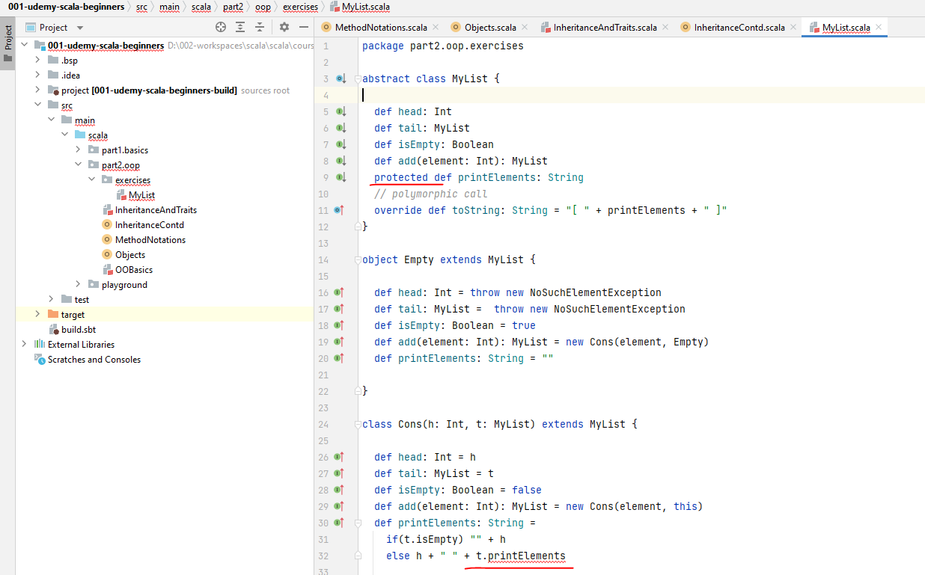

So if I right click and run this. Then it should be fine. All right, so we have the string representation one, two three. So again, why does this work?

*Output:*

*1*

*4*

*false*

*[ 1 2 3 ]*

Well, that's because the two string method is actually called in the abstract class and this calls printElements, which is then overridden in the class Cons. So print elements will be called from Cons class and the recursive call, actually returns this string 1 2 3, which is then concatenated with the square brackets in the toString method. Now you may wonder why the override key word here in the two string method. Well, toString and equals and hashCode are methods that are present in the Any ref class, so I need to override it. All right, people. This is a fully functional list and we're going to expand it in the rest of the section and possibly beyond it. So keep this exercise handy. All right.

So let's recap. We've gone through a lot of things. So we started with the fact that Scala offers class based inheritance with the simple extends keyword, and we also discussed about axis modifiers, private, protected and no modifier, which by default means public. We also discussed about constructors and the fact that we need to pass in constructor arguments to parent classes whenever we need them. We discussed about overriding members and methods we discussed about super, about reusing values and methods from parent classes. We discussed about preventing overrides with final on members or classes and about sealed classes. And we also discussed about abstract classes and traits. We also discussed how classes and traits are different and about multiple inheritance by mixing in multiple traits in the same extension scheme.

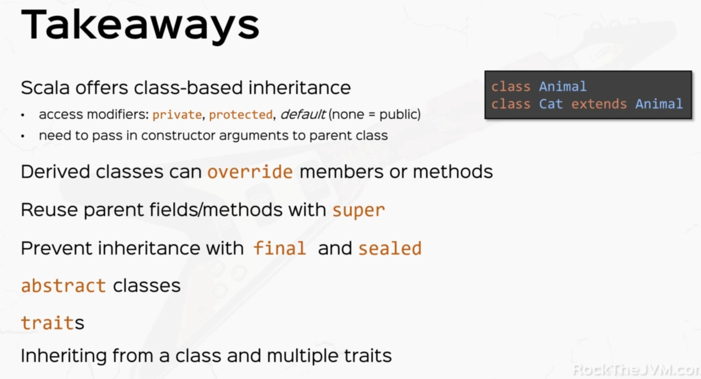

### Generics

in this video, we're going to introduce the concept of generics and skull, which is an incredibly powerful tool in the scarlet type system arsenal. So let's create a new Scala application in the part2oop package. Call this generics. As always, make this an object and extends App. In previous video we implemented a very cute linked list for integers. The trouble with that is that it's very limited to integers. What if we wanted to create a String linked list instead with the tools that we currently have? We wouldn't be able to do that and we would need to duplicate the entire code and put in string instead of Int. So collections are a powerful use case where we would want a collection that could store elements of a certain type. So the way that we do that in the Scala generics world would be to define a class MyList parameterized with a type A, like I wrote here. So the type A here in between square brackets denotes a generic type. And once you define that, you can use the type A inside the class definition.

package part2.oop

object Generics extends App {

class MyList[A] {

// use the type A

}

val listOfIntegers = new MyList[Int]

val listOfStrings = new MyList[String]

}

When you then later use this my list type, you can just say the list of integers is a new my list typed with int in between square brackets. So the type int in between square brackets will then replace the generic type A for this instance of list of integers. Of course you can define a list of strings. Is my list parameterized with a type string instead? So notice how this code innocently gets reusable for every single possible type that we can store inside our generic list. So this what we define here class my list parameter with a is called a generic class in the type A. Here is the name of a type of parameter. You can give it whatever name you want. You can also have multiple type parameters. For example, if I define a class called my map, which maps, keys and values, I can have two type parameters here in between square brackets. So in between square brackets, key, that is one generic type and value also another generic type. You can have as many type parameters as you want. This also works for Traits. So if, for example, I turned this my list into a trait, this also works fine, although the trade cannot be instantiated here because, well, MyList is an abstract type, so I'm going to revert this to a class. But I just want you to know that trait's can also be type parameterized like this. All right.

package part2.oop

object Generics extends App {

class MyList[A] {

*// use the type A*

}

class MyMap[Key, Value] {

}

val *listOfIntegers* = new MyList[Int]

val *listOfStrings* = new MyList[String]

}

*Error:*

*MyList is a trait; it cannot be instantiated*

*val listOfIntegers = new MyList[Int]*

Now I want to talk about generic methods. So let's say I define a small companion object for the class. My list, so object my list. Just so you know, objects cannot be type parameterized. And let's define a method here in the Bilis companion object that given a type parameter, would construct an empty my list parameterized with that type. So the way that we write this is def let's call this empty and we'll put in a type parameter here. So this is the method called empty type parameterized with A and this will return a myList parameterized with A. So once you declare the type parameter here, you can later use it in the function definition. So just assume for now that this function doesn't actually do anything, doesn't return anything. So this thing will return nothing. What I wanted to show you is how you define a method signature type parameterized with a generic type parameter. So the object MyList, which is a companion for the class MyClass defined above, has a generic method called empty, which takes in a type parameter A and returns a MyList of A and you can use the type A here inside the function implementation.

package part2.oop

object Generics extends App {

class MyList[A] {

*// use the type A*

def empty[A]: MyList[A] = *???*

}

class MyMap[Key, Value]

val *listOfIntegers* = new MyList[Int]

val *listOfStrings* = new MyList[String]

object MyList {

def empty[A]: MyList[A] = *???*

}

val *emptyListOfIntegers* = MyList.*empty*[Int]

}

But right now we don't have a function implementation. I just wanted you to see how a generic method looks like and of course, the way that you would use this method is, let's say, val, emptyList of Integers. So empty list of integers would be to say MyList the object.empty with the type parameter Int and this will return my list of Int, if you hover over empty list of integers, it will say generics dot myList of Int. All right. So now we know how to define and use generic classes and treats and how to define and use generic methods. OK, so this was easy enough. What's hard is what comes after.

If you run this now – it would complain as below

Exception in thread "main" scala.NotImplementedError: an implementation is missing

at scala.Predef$.$qmark$qmark$qmark(Predef.scala:344)

at part2.oop.Generics$MyList$.empty(Generics.scala:17)

at part2.oop.Generics$.<clinit>(Generics.scala:20)

at part2.oop.Generics.main(Generics.scala)

Now that we know generics, there are some hard questions that we need to answer and this is called the variance problem. Let's define a little class hierarchy with a class animal and two subclasses, cat and dog. So class cat extends animal and class. Dog extends animal, of course. All right. So a small class hierarchy. Now, the good question is, if cat extends animal, does a list of cat also extend the list of animal? Now, there are three possible answers to this question. The first answer is yes. List of cat extends list of animal.

package part2.oop

object Generics extends App {

class MyList[A] {

*// use the type A*

def empty[A]: MyList[A] = *???*

}

class MyMap[Key, Value]

val *listOfIntegers* = new MyList[Int]

val *listOfStrings* = new MyList[String]

*// generic methods*

object MyList {

def empty[A]: MyList[A] = *???*

}

val *emptyListOfIntegers* = MyList.*empty*[Int]

*// variance problem*

class Animal

class Cat extends Animal

class Dog extends Animal

This behavior is called Covariance. And the way that you declare a covariance list is to say class. Let's call this covariate list. And in the type parameter here in between square brackets, you put in a little plus a SO plus A means that this is a covariance list. Now, the way that you would use a covariance list is in the same style that you would use cats for animals. So in the same style that you would save animal type two with the type animal equals new cat. The way that we did with the polymorphic type substitution earlier in the section. The same way would apply with an animal list. So we say animal list, which is a covariate list of animal and instead of a coherent list of animal, I just put an. New Covariant list of cat, and this would work well now an even harder question now, once I declare an animal is to be a coherent list of animal and its actual value, I don't really care about it. Can I actually add any animal to it? So if I say animal list dot add a new dog, would that be OK? That's not a trivial question because animal list is defined to be a list of animals. So in theory, I should be able to add any animal. But adding a new dog to an animal list, which is in fact a list of cats, would actually pollute the list of animals here. So this is a hard question. This was the first option.

// yes, List[Cat] extends List[Animal] - Covariance

class CovariantList[+A]

val *animal*: Animal = new Cat

val animalList: CovariantList[Animal] = new CovariantList[Cat]

// animalList.add(new Dog) ??? <--HARD QUESTION

}

Second option. Let's count this one. Yes. List of cat extends list of animal. The second option is no list of cats and list of animals are two separate things. So this would be an Invariant list. This is called Invariants. In the way that you would write a Invariant list, so I'm defining an Invariant list class here, simply specify the type parameter without any signs before or after it. So the mildest type that we defined at the beginning of the lecture is actually an invariant my list. Invariant classes are each in its own world and you cannot substitute one for another. So if I say val, then invariant animal list, which is defined as an invariant list of animal, you cannot substitute that with a new invariant list of cat or invariant list of anything else for that matter.

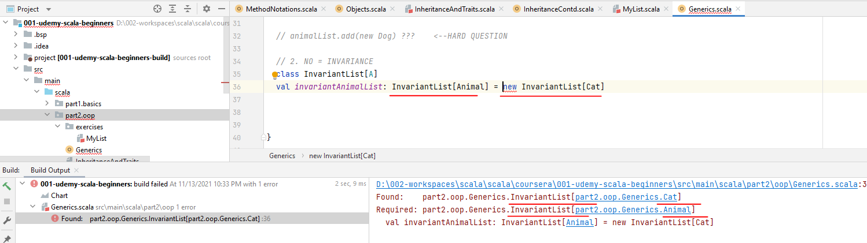

package part2.oop

object Generics extends App {

class MyList[A] {

*// use the type A*

def empty[A]: MyList[A] = *???*

}

class MyMap[Key, Value]

val *listOfIntegers* = new MyList[Int]

val *listOfStrings* = new MyList[String]

*// generic methods*

object MyList {

def empty[A]: MyList[A] = *???*

}

val *emptyListOfIntegers* = MyList.*empty*[Int]

*// variance problem*

class Animal

class Cat extends Animal

class Dog extends Animal

*// 1. Yes, List[Cat] extends List[Animal] - Covariance*

class CovariantList[+A]

val *animal*: Animal = new Cat

val *animalList*: CovariantList[Animal] = new CovariantList[Cat]

*// animalList.add(new Dog) ???* <-- HARD QUESTION

*// 2. NO = INVARIANCE*

class InvariantList[A]

val *invariantAnimalList*: InvariantList[Animal] = new InvariantList[Cat]

}

So if you define something to be a list of animal in this case, you make sure you put an animal on the right hand side here because otherwise the compiler will throw errors in your face. Now, this option was very easy.

*// 2. NO = INVARIANCE*

class InvariantList[A]

// WONT WORK

// val invariantAnimalList: InvariantList[Animal] = new InvariantList[Cat]

// Works like this only

val invariantAnimalList: InvariantList[Animal] = new InvariantList[Animal]

The third option is very counterintuitive and it's basically the opposite relationship. I'm going to call this hell no. And the relationship is called contra variance. Contra variant classes I'm going to define a contra variant class here in contra variant list are defined with a type parameter with a little minus sign before it. So if I say contra variant list of minus eight, that means it's a contra variant list. And the way that you would use a control variant list is to say, Val, let's call this contra variant. List, which is of type in this time, I'm going to use that derived class here. So contra variant list of cat here equals and on the right hand side, I'm going to put in a new contra variant list of animal.

// 3. Hell, no! CONTRAVARIANCE

class ContraVariantList[-A]

val *contraVariantList*: ContraVariantList[Cat] = new ContraVariantList[Animal]

Now, look at the type relationships. If you take a look at the covariate version, the first one we can replace a list of animals with a list of cats because cats are animals. Right in the controversy, in case I'm replacing a list of cats with a list of animals, even though CAT is a subtype of animals. So the relationship is exactly opposite and it doesn't really make sense. How can you replace a list of cats with a list of animals? Because animals can also be dogs and dinosaurs and all that kind of stuff. So it's not intuitive, at least not for lists. But watch what happens. Let's say instead of a Covariant list, I actually create a class called Trainer, which basically trains animals. So I'm going to replace these with this new class. And instead of covering this, I'm going to name this value trainer.

class Trainer[-A]

val *trainer*: Trainer[Cat] = new Trainer[Animal]

Now, the semantics of it will change this time, because if I say that I want a trainer of CAT, but I'm supplying a trainer of animal, this guy on the right hand side is better because it's a trainer of animal. So it can also train a cat. It can also train a dog. It can also train a Dinosaur. And in particular, it trains a cat, which is what I want. So I can use a trainer of animal to be a trainer of cat, which is more particular. So these are the basic variants options that we have. We have Covariance. We have Invariance, which means every type is in its own world and we have ContraVariance, which is the opposite relation to Covariance.

Bounded Types

Now let's talk about bounded types. Bounded types allow you to use your generic classes only for certain types that are either a subclass of a different type or a super class of a different type. Let me show you what I mean. So let's say I define, for example, a class cage, which can also only hold an animal. So in between square brackets, I'm going to write a type parameter A and I'm going to add a restriction in the form of <: So this is an operator and I'm going to put in the animal type here. So basically I'm saying Class Cage only accepts type parameters A which are subtypes of animal. So this is how you read this generic type definition. And let's say this class receives a parameter, let's say animal, which is of type A. All right, and if I declare a value called Cage, I can actually use the cage generic class to put in a Dog, say new dog. OK, so this expression evaluates to something which is an animal.

*// Bounded Types*

class Cage[A **<:** Animal](animal: A)

val *cage* = new Cage(new Dog)

class Car

val *newCage* = new Cage[new Car]

So this is an acceptable type for the cage. If I define a class car, for example, I can't write the new cage equals new cage of a new car. That's because car does not class animal. So even though intelligence has not underlined my code in red, I will not be able to run this because a new car does not conform to the expected type. So let's prove this. So if I click and run, of course I get a compiler error saying infrared type arguments do not conform to Class Cage's type parameter bounds. All right. So this is bounded types and this is an upper bound to type in animal

Lower Bounded Types

We have lower bounded types as well. And the lower bound to type sign is instead of less than Colon, we have greater than column. And this is saying that Cage only accepts something which is a super type of animal. All right. So I'm going to leave the subtype here for now.

*// Bounded Types*

class Cage[A **>:** Animal](animal: A)

val *cage* = new Cage(new Dog)

class Car

val *newCage* = new Cage[new Car]

Bounded Types of Variance

Now bounded types of variance problem, which is very, very annoying when we want to write covariance collections. So let's go to our little my list and let's just say that my list is Covariant of the type A.. So lists should, in theory, be Covariant.

object Generics extends App {

class MyList[**+**A] {

*// use the type A*

def empty[A]: MyList[A] = *???*

}

Now, a natural method to add in a mildest type would be an ADD method. So if I try to add an ADD method, which receives an element of Type A. and returns a MyList of type A and let's just provide an empty implementation for now because we don't really care about the implementation. I want to show you that this function signature, this method signature does not work, even though MyList is covariant and it's generic. And the error that the compiler tells me is Covariant Type A occurs in Contra Variant position in type A value element. And you might be wondering what the hell is that?

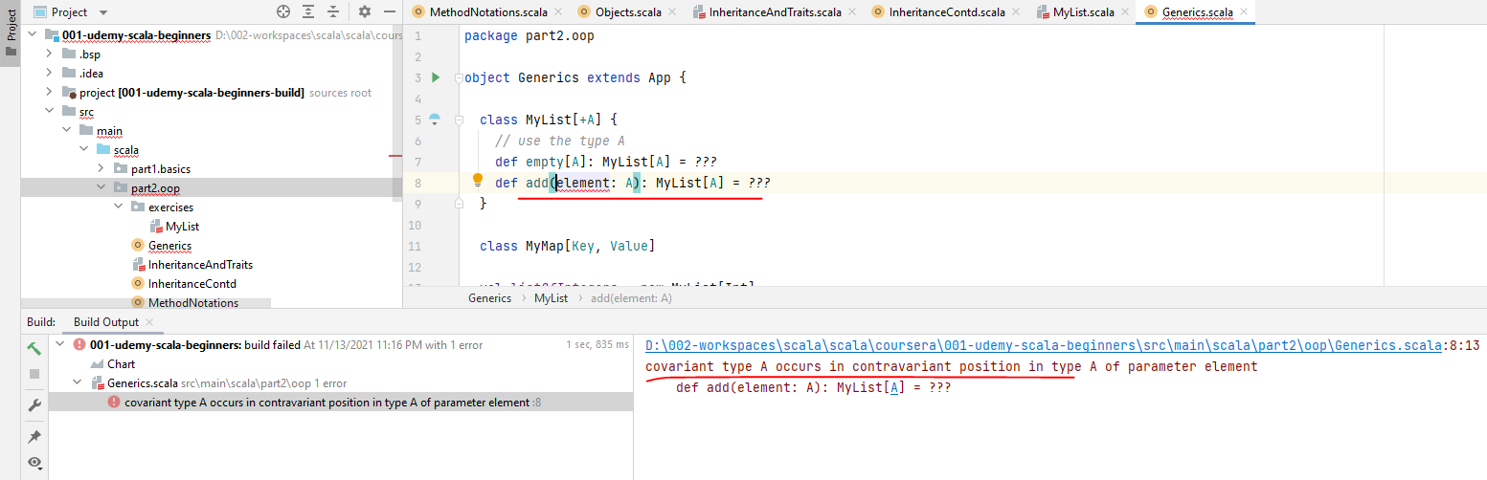

Now, this cryptic error that the compiler threw in our face is actually the technical version of the hard question that we asked in version one here when we talked about Covariant lists. So if we want to define a Covariant List, we need to be able to answer this question, which is if I have a list of animals, which in fact is a list of cats, what if I add a new dog to it? Well, the answer is that if to a list of cats, I add the new dog that will turn this new list into a list of Animals, basically. Right, because I have cats and then a dog, which makes the whole list a list of generic animals. Right. So adding a dog to a list of cats would actually turn it into something more generic. So a list of cats, by adding a new dog to it, will turn it into a list of animals.

object Generics extends App {

class MyList[+A] {

*// use the type A*

def empty[A]: MyList[A] = *???*

def add(element: A): MyList[A] = *???*

}

. . .

Now, the technical implementation of this into the add method right over here is something like the following. And I want you to be very careful about what I'm about to write. So the add method will take another parameter when another type parameter, type B, which will be a super type of A, and the element here will have the type B instead not A and at the end will return a MyList of B. So what this says is that if to a list of A I put in a B, which is a super type of A, then this list will turn into A MyList of B, not into MyList of A.

object Generics extends App {

class MyList[+A] {

*// use the type A*

def empty[A]: MyList[A] = *???*

def add[B >: A](element: B): MyList[B] = *???*

/*

A = Cat

B = Dog = Animal

*/

}

So in the example with cats and dogs, let's just say that A equals cat. So I have a list of cats and then I add a dog. So B is a dog, which in particular is an animal. All right. So B is basically an animal. If I add an animal to a list of cats, then that will turn into on MyList of Animals because there are cats and dogs now. So this is how we technically solve this hard question. The answer to the hard question is we return a list of Animals. And the technical transcription of this is this method definition. So add with a new type parameter B, which is a super type of A, the parameter is of type B and the type of result is also a type B.

Now, I want you to not stress too much on this heart problem. This is an advanced topic and we're going to discuss type system mastery in the advanced course. But this is an important problem to solve. And I wanted to give you a solution because we do want Covariant collections, so don't stress too much. But this is a small taste of the Variance problems that you get into when designing generic frameworks. Cool.

package part2.oop

object Generics extends App {

class MyList[+A] {

*// use the type A*

def empty[A]: MyList[A] = *???*

def add(element: A): MyList[A] = *???*

}

class MyMap[Key, Value]

val *listOfIntegers* = new MyList[Int]

val *listOfStrings* = new MyList[String]

*// generic methods*

object MyList {

def empty[A]: MyList[A] = *???*

}

val *emptyListOfIntegers* = MyList.*empty*[Int]

*// variance problem*

class Animal

class Cat extends Animal

class Dog extends Animal

*// 1. Yes, List[Cat] extends List[Animal] - COVARIANCE*

class CovariantList[+A]

val *animal*: Animal = new Cat

val *animalList*: CovariantList[Animal] = new CovariantList[Cat]

*// animalList.add(new Dog) ??? <-- HARD QUESTION*

*// 2. NO = INVARIANCE*

class InvariantList[A]

*// val invariantAnimalList: InvariantList[Animal] = new InvariantList[Cat] // WONT WORK*

val *invariantAnimalList*: InvariantList[Animal] = new InvariantList[Animal] *// Works like this only*

*// 3. Hell, no! CONTRAVARIANCE*

class ContraVariantList[-A]

val *contraVariantList*: ContraVariantList[Cat] = new ContraVariantList[Animal]

class Trainer[-A]

val *trainer*: Trainer[Cat] = new Trainer[Animal]

*// Bounded Types*

class Cage[A <: Animal](animal: A)

val *cage* = new Cage(new Dog)

class Car

val *newCage* = new Cage(new Cat)

}

Now, as an exercise, I want you to go ahead and expand my list to be generic. This is the only exercise that I'm going to ask of you in this lecture, and I actually want you to do it or at least do it with me in the solution, because we'll expand the list as we go. Support the video now and try to do the exercise. All right. I'm in the middle class and let's make this generic and covariate. So first thing that I'm going to do is add a Covariant type parameter, which will start to break a lot of things. Especially if I start to replace the Int type with the A type, so MyList will now hold elements of Type A. So the head will be a type A head and tail will be a MyList of A, isEmpty is going to be a Boolean, add is going to receive a type parameter A which will break our method signature and printElements and toString are going to stay the same.

package part2.oop.exercises

abstract class MyGenericList[+A] {

/*

head = first element of this list

tail = remainder of the list ( hold the pointer of the remainder of the list )

isEmpty = is this list empty

add(Int) = returns a new list with this element added

toString = returns a String representation of the list ( override this method )

*/

def head: A

def tail: MyGenericList[A]

def isEmpty: Boolean

def add(element: A): MyList

def printElements: String

// polymorphic call

override def toString: String = "[ " + printElements + " ]"

}

But now let's modify the signature for the add method. And as we've learned, we need a super type of A, so type parameter B, which is a super type of A element of type B and the return type is on my list of B

package part2.oop.exercises

abstract class MyGenericList[+A] {

/*

head = first element of this list

tail = remainder of the list ( hold the pointer of the remainder of the list )

isEmpty = is this list empty

add(Int) = returns a new list with this element added

toString = returns a String representation of the list ( override this method )

*/

def head: A

def tail: MyGenericList[A]

def isEmpty: Boolean

def add[B >: A](element: B): MyList[B]

def printElements: String

// polymorphic call

override def toString: String = "[ " + printElements + " ]"

}

So this is the abstract class that we are going to implement in EmptyList and ConsList. Now let's start with ConsList because it's a little bit easier to think about. So my list is called variant, so that means ConsList must be Covariant as well. So ConsList[+A] the head instead of inde will make it a and the tail is on my list of A and finally extends my list of a. All right. Head and tails are going to be changed so head will return A and the tail will be on. My list of the implementations are still the same. Now the add method of course needs the new type parameter being just a super type of a, the element is of type B and the result is my list of being an implementation is going to stay the same. So basically ConsList is done.

class ConsList[+A](h: A, t: MyGenericList[A]) extends MyGenericList[A] {

def head: A = h

def tail: MyGenericList[A] = t

def isEmpty: Boolean = false

def add[B >: A](element: A): MyGenericList[A] = new ConsList(element, this)

def printElements: String =

if(t.isEmpty) "" + h

else h + " " + t.printElements

}

The interesting thing now happens with EmptyList. So let's think about this. EmptyList should be a proper replacement of MyList of anything. Let's me show you what I mean. So if I see a val List of integers, which is on MyList of Int, I should be able to see EmptyList here. But I should also be able to see empty if I have a list of something else. So say a list of strings, which is also on my list of string. This time around. And I should also be able to say that. Empty is a proper value for an empty list of strings.

object GenericListTests extends App {

val *listOfIntegers*: MyGenericList[Int] = EmptyList

val *listOfStrings*: MyGenericList[String] = EmptyList

}

So how do we do that? Well, my list is Covariant, right? We added the little plus sign.

abstract class MyGenericList[+A] {

. . .

}

Complete code so far . . .

package part2.oop.exercises

abstract class MyGenericList[+A] {

*/\**

*head = first element of this list*

*tail = remainder of the list ( hold the pointer of the remainder of the list )*

*isEmpty = is this list empty*

*add(Int) = returns a new list with this element added*

*toString = returns a String representation of the list ( override this method )*

*\*/*

def head: A

def tail: MyGenericList[A]

def isEmpty: Boolean

def add[B >: A](element: B): MyGenericList[B]

def printElements: String

*// polymorphic call*

override def toString: String = "[ " + printElements + " ]"

}

object EmptyList extends MyGenericList {

def head: Int = throw new NoSuchElementException

def tail: MyGenericList = throw new NoSuchElementException

def isEmpty: Boolean = true

def add(element: Int): MyGenericList = new Cons(element, EmptyList)

def printElements: String = ""

}

class ConsList[+A](h: A, t: MyGenericList[A]) extends MyGenericList[A] {

def head: A = h

def tail: MyGenericList[A] = t

def isEmpty: Boolean = false

def add[B >: A](element: A): MyGenericList[A] = new ConsList(element, this)

def printElements: String =

if(t.isEmpty) "" + h

else h + " " + t.printElements

}

object GenericListTests extends App {

val *listOfIntegers*: MyGenericList[Int] = EmptyList

val *listOfStrings*: MyGenericList[String] = EmptyList

}

Now, if you remember, the nothing type is a proper substitute for any type. So if you say, for example, this guy, this guy says it returns an end, but instead returns nothing, nothing is a proper substitute for any type in much the same way as nothing is a proper substitute for any type. The object empty here should be a proper substitute of a my list of any type. So a natural way to think about it is to make empty, extend the list of nothing. So right now we need to supply the proper method implementations here and to change the types so the head and tail should return Nothing. And my list of nothing respectively. OK, the expressions will still hold. All right isEmpty. It will be unchanged in the add method we will need a type parameter B, so the type parameter B this time will be a super type of Nothing, not of A because this nothing type is concrete. This time it's not a generic type. OK, so B should be a super type of nothing, which in this particular case is always true. And the elements of Type B and the result is a list of type B and the implementation is going to be unchanged because a new cause of element and empty will return a new cause of B, which is a list of B. All right, so everything seems to match.

object EmptyList extends MyGenericList[Nothing] {

def head: Nothing = throw new NoSuchElementException

def tail: MyGenericList[Nothing] = throw new NoSuchElementException

def isEmpty: Boolean = true

def add[B >: Nothing](element: B): MyGenericList[B] = new ConsList(element, EmptyList)

def printElements: String = ""

}

Now let's test our code to make sure it runs well. So instead of a list of integers, let's say Yukon's of one and Yukon's with two and new cons of three and empty and the list of strings, let's just say we have new cons with a with string. Hello and new coins with the word Scala and empty. OK, so this is now a list of integers and the list of strings. All right. Now if we print line the list of integers to string and print line list of strings that two string, then that will should print the list. One, two, three in the list. Hello Scala. Oh, the code does not compile because I have this little cage problem, let's just like delete this or comment this out and say generic type needs, proper bounded type. All right. So back to list. Let's make it click and run. And yes, I see the strings, one, two, three, the string, one, two, three, and the string. Oh, Scott. All right. So our lists work. Well, this is how you genericized an API or a framework. This is quite a bit of work and needs some careful thinking.

package part2.oop.exercises

abstract class MyGenericList[+A] {

/*

head = first element of this list

tail = remainder of the list ( hold the pointer of the remainder of the list )

isEmpty = is this list empty

add(Int) = returns a new list with this element added

toString = returns a String representation of the list ( override this method )

*/

def head: A

def tail: MyGenericList[A]

def isEmpty: Boolean

def add[B >: A](element: B): MyGenericList[B]

def printElements: String

// polymorphic call

override def toString: String = "[ " + printElements + " ]"

}

object EmptyList extends MyGenericList[Nothing] {

def head: Nothing = throw new NoSuchElementException

def tail: MyGenericList[Nothing] = throw new NoSuchElementException

def isEmpty: Boolean = true

def add[B >: Nothing](element: B): MyGenericList[B] = new ConsList(element, EmptyList)

def printElements: String = ""

}

class ConsList[+A](h: A, t: MyGenericList[A]) extends MyGenericList[A] {

def head: A = h

def tail: MyGenericList[A] = t

def isEmpty: Boolean = false

def add[B >: A](element: B): MyGenericList[B] = new ConsList(element, this)

def printElements: String =

if(t.isEmpty) "" + h

else s"**$**h **$**{t.printElements}"

}

object GenericListTests extends App {

val listOfIntegers: MyGenericList[Int] = EmptyList

val listOfStrings: MyGenericList[String] = EmptyList

val listOfIntegersTwo: MyGenericList[Int] =

new ConsList(1, new ConsList(2, new ConsList(3, EmptyList)))

val listOfStringsTwo: MyGenericList[String] =

new ConsList("Hello", new ConsList("Scala", EmptyList))

println(listOfIntegers.toString)

println(listOfIntegers.toString)

println(listOfIntegersTwo.toString)

println(listOfStringsTwo.toString)

}

All right. So let's wrap this up. You've learned how to use generics, which are a method to use the same code on potentially unrelated types. So the way that you declare a generic is to define a type parameter in between square brackets. This works for classes and for traits. You've also learned how to use generic methods, which means adding a type parameter in between square brackets at the method definition, which allows you to use the type parameter for the rest of the method signature. You've also learned that you can define types with multiple type parameters and you can name type parameters with whatever you want. Usually in practice we use single letters.

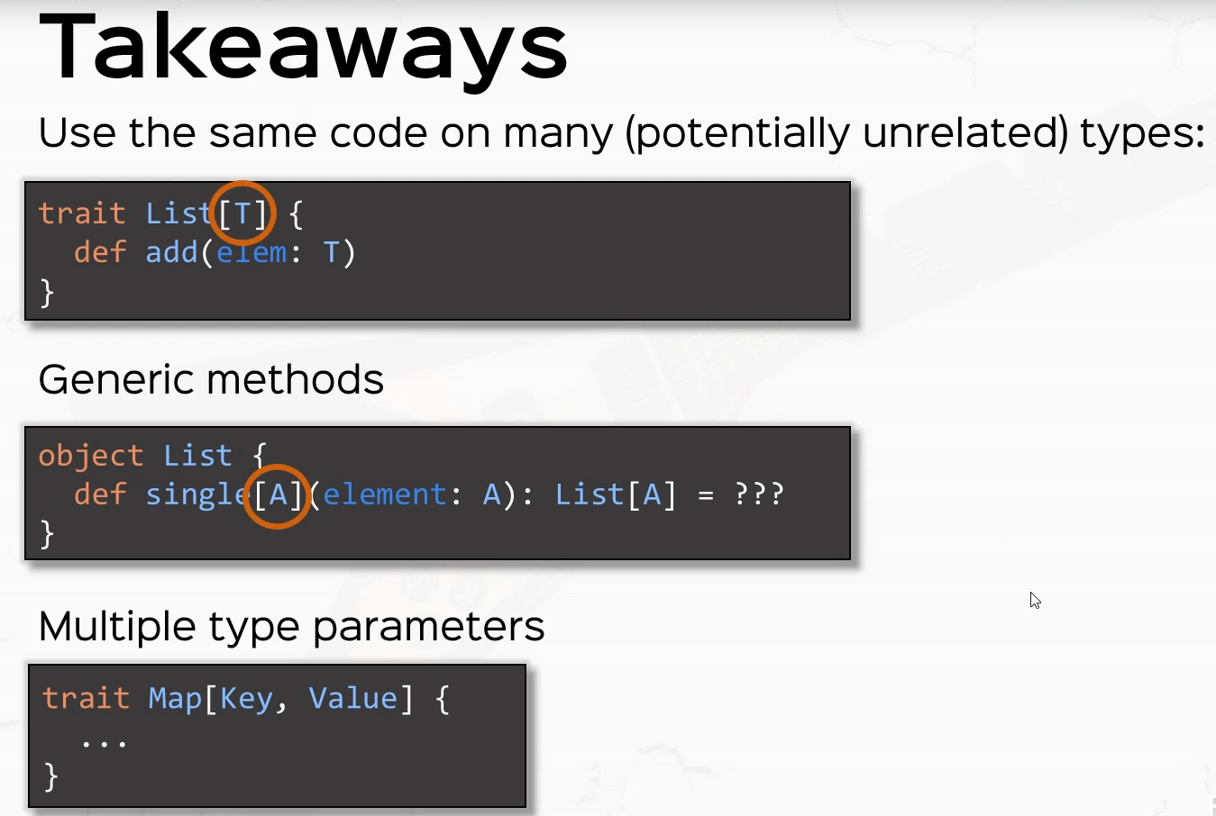

You've also learned an important problem in type systems, which is the variance problem, which basically says that if B extends A should list of B extend list of eight and you've learned the three possible options, covariance, invariants and contre variants and you've learned about when we use each you've learned about bounded types, which is defined by this little funky symbol less than or equal. This is for upper bounds. There is a symmetrical sign for lower bounded types as well. And you've also tested the PIN in defining generic methods with an annoying variance problem that we solve with bounded types.

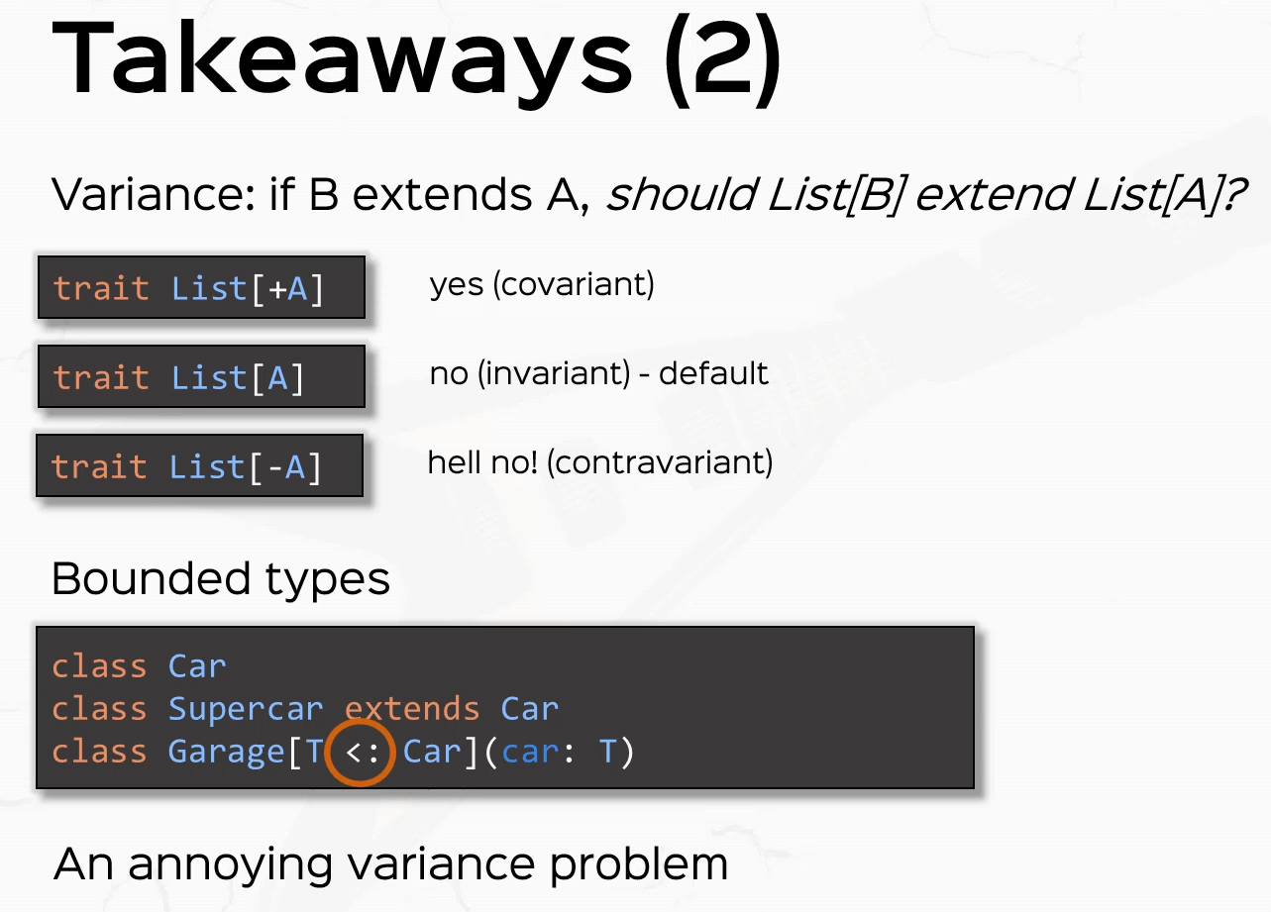

### Anonymous Classes

We're going to talk about anonymous classes. I am going to start this lecture with a bit of a shock. So I'm going to define a Trait called Animal and with a method def eat which returns unit or let's just say this is an abstract class. It doesn't really matter all that much. And only we only care. That animal is an abstract data type. And here I'm going to define a value called funny animal, which is an animal. And watch what I'm writing. I'm going to say new animal. And inside I'm going to override def eat. And inside I'm going to print line a hahahahahahaha.

package part2.oop

object AnonymousClasses extends App {

abstract class Animal {

def eat: Unit

}

val *funnyAnimal*: Animal = new Animal {

def eat: Unit = *println*("Hahahahahahahaha")

}

*funnyAnimal*.eat

}

*Its going to print that only when we call the method on the funnyAnimal val*

So what we did here is exactly what it looks like. We instantiated an abstract class shocker, only that it's not an actual abstract class that we instantiated it. We instantiated a real class. So let's prove that. So if I try to print funnyAnimal.getClass, this guy will print something. So it will say class lectures, part two of anonymous classes, dollar, dollar a non, dollar one. So what actually happened when we wrote this is that the compiler took this part right here, the animal with the curly braces and actually created a class with a funny name like lectures.part2oop.AnonymousClasses$$anon$1 and actually instantiated that later and assigned that to funny animal. This is called an anonymous class.

package part2.oop

object AnonymousClasses extends App {

abstract class Animal {

def eat: Unit

}

val *funnyAnimal*: Animal = new Animal {

def eat: Unit = *println*("Hahahahahahahaha")

}

*funnyAnimal*.eat

*println*(*funnyAnimal*.getClass)

}

*Output:*

*Hahahahahahahaha*

*class part2.oop.AnonymousClasses$$anon$1*

So when we write new animal with a on the spot implementation with a compiler actually does is basically cutting this out, saying class AnonymousClasses$$anon$1 extends animal and then with that little implementation that I provided and when I use it, the compiler actually instantiate that class instead. So this is what actually happens when I instantiate an anonymous class.

val funnyAnimal: Animal = new AnonymousClasses$$anon$1

So when we said. Funny animal equals new animal with that on the spot implementation, what actually happens is I'm going to put this in the comment section so that it's easier to refer to. So equivalent with class anonymous classes$1 extends animal and then val funnyAnimal, which is an animal, is in fact a knew this guy. So the compiler does this behind the scenes.

package part2.oop

object AnonymousClasses extends App {

abstract class Animal {

def eat: Unit

}

val *funnyAnimal*: Animal = new Animal {

def eat: Unit = *println*("Hahahahahahahaha")

}

/*

equivalent with

class AnonymousClasses$$anon$1 extends Animal {

override def eat: Unit = println("Hahahahahahaha")

}

val funnyAnimal: Animal = new AnonymousClasses$$anon$1

*/

*funnyAnimal*.eat

*println*(*funnyAnimal*.getClass)

}

Now, if I define let's consider a class person with a name, OK? And with a method called CIHI, which returns unit and just prints something to the console saying, for example, with an X interpolate a string, hi, my name is name. How can I help? Something like that. Now, if you wanted to use an anonymous class for person and pass that to a value, say, gym is a new person and following the scheme from animal supply, some on the spot implementations like for example, to say hi, if I copy this around in all varieties and saying Hi, my name is Jim. How can I be of service? All right, this thing would work fine if it weren't for the parameters for the person class.

class Person(name: String) {

def sayHi: Unit = *println*(s"Hi, my name is **$**name, How can i help?")

}

val *jim* = new Person {

override def sayHi: Unit = *println*(s"Hi, my name is Jim, How can i be of service?")

}

So just as it was illegal to extend the class person without supplying the proper parameters, it is as illegal here to instantiate an anonymous class here because the derivation or the extension of the class already happens under the code. So make sure you pass in the proper parameters. So let's say we have the person with a parameter, Jim, so be a good student and pass in the proper parameters for the super classes that you are extending, even anonymously.

class Person(name: String) {

def sayHi: Unit = *println*(s"Hi, my name is **$**name, How can i help?")

}

val *jim* = new Person("Jim") {

override def sayHi: Unit = *println*(s"Hi, my name is Jim, How can i be of service?")

}

jim.sayHi

*Output:*

*Hahahahahahahaha*

*class part2.oop.AnonymousClasses$$anon$1*

*Hi, my name is Jim, How can i be of service?*

Another rule that I didn't really mention, but I think it's common sense, is to make sure you provide implementations for all the abstract fields or methods in the abstract types or traits that you instantiate anonymously. Otherwise, the compiler wouldn't be able to create a non abstract class in the back for you. But notice here that this anonymous class works for the class person, even though a person is not abstract in any way. So anonymous classes work for abstract and non abstract data types just as well.

All right. So let's wrap this up. We learned that we can instantiate types and override methods or fields on the spot. So if, for example, I have a trade with an abstract method definition, I can actually instantiate that trade and provide a definition on the spot. There are only two things that you need to take into account. So first of all, you need to pass in the required constructor arguments if you're extending a class and if you need to. The second is that if you are instantiating an anonymous class which descends from an abstract data type, like an abstract class or a trade, you need to implement all abstract methods or fields. Also, just to know, anonymous classes work for trades and classes, whether they're abstract or not. All right. So this was a shorter one, but I'm waiting for you in the next video where we are going to expand my list with some generic predicates and transformers and also anonymous classes.

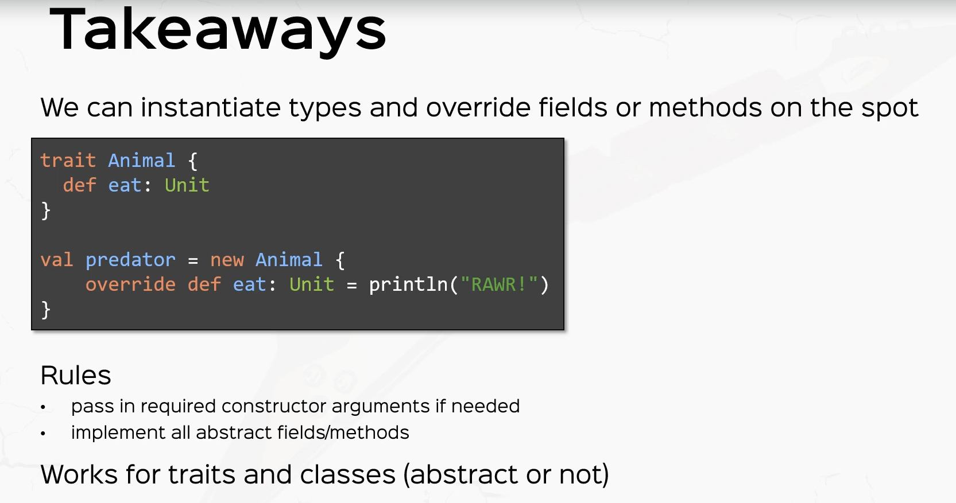

### Object-Oriented Exercises: Expanding Our Collection

So we're going to expand the MyList functionality, the first thing that I want you to do is create a generic trait called MyPredicate of T, and it will have a small method to test whether a value of type T passes a condition, so every subclass of my predicate T will actually have a different implementation of that little method, which tests whether the tea passes that condition. All right. Second, exercise, a generic trait called MyTransformer. It will take two parameters in B and it will have a small method to convert a value of Type A into a value of Type B, every subclass of MyTransformer will have a different implementation of that method. Now, I want you to implement the following functions on my list. I want you to implement a function called map, which takes some of my transformer and it returns a new my list of a different type. filter - which takes a myPredicate and it returns on my list and flat map, which takes a transformer from A to MyList of B and it returns on MyList of B.

So here's how these things will work. So MyPredicate of T will have a little method, say, test which receives a value of type T and returns a Boolean. And let's say, for example, we have a concrete class which extends the predicate to trade. So, for example, if I have the class even predicate, which extends my predicate of into that little test method and even predicate, we'll take an end as a parameter and it will return whether that end is even or not. Right. In the same way that my transformer, let's say it returns a string to an end, let's say string to end transformer. That will extend my transformer from strength to end and the method inside, let's say that the method is called transform. Which receives a parameter of type A in return, a value of Type B, then for the case of the string to transformer, the implementation of the method transformer will just turn that string, which is received as a parameter to an end. So if you've implemented my predicate in my transformer correctly, then map, filter and flood map should work as follows. Let's say you have a list, say one, two, three. All right. And if you map one, two, three with a transformer, which, for example, doubles an Int, then you will get the list 2, 4, 6.

/*

Exercises:

1. Generic trait MyPredicate[-T] with a little method test(T) => Boolean

2. Generic trait MyTransformer[-A, B] with a method transform(A) => B

3. MyList:

- map(transformer) => MyList

- filter(predicate) => MyList

- flatMap(transformer from A to MyList[B]) => MyList[B]

class EvenPredicate extends MyPredicate[Int]

class StringToIntTransformer extends MyTransformer[String, Int]

[1,2,3].map(n * 2) = [2,4,6]

[1,2,3,4].filter(n % 2) = [2,4]

[1,2,3].flatMap(n => [n, n+1]) => [1,2,2,3,3,4]

*/

Of course, this is pseudocode, if you will, you need to pass in the correct arguments here, right? Also the filter, if you have the list one, two, three, four, which filters that a number is even should give you the list to four and flat map is a little bit special. So if you have the list, one, two, three, four, or let's say one, two, three, flatMap and four each and you'll get the list and and plus one. All right. This will return the concatenation of all these little sub lists for every element. So, for example, the sublist for one is going to be one to the sublist for the number two, with this little argument, it's going to be two, three. Then the sublist for the element three is going to be three, four. So this is the result that I want you to get after flatMap.

Now, a hint so that you don't get into frustration's while solving this exercise. This is very important. I want you to define your my pretty good trade with a minus sign for T and MyTransformer with a minus sign for a. So basically I want you to define my predicate ContraVariant in the type T and my transformer ContraVariant in the type A.. This is very important. Without it your code will not compile. Now I won't go into detail why this happens. This is a deep rabbit hole and we're going to deal with it in the advanced course. But please accept this very, very tiny little hack right here. If you're curious, I can answer this in the course form. But for now, just accept this as is and will use my predicate in my transformer with these signatures. Now, if this exercise seems a little bit too abstract, don't stress too much and try to give it a good thought and even rewind the video if there are parts of it that you don't understand. But give it a good thought and I'm going to give a solution in a couple of seconds. But for now, just pause the video. All right, so I'm here in the mildest file and let's define our two traits here. So like I said, trade my predicate with the type parameter T with the little minus sign. And we're going to have a little method called, let's say, test, which receives an element of type T and returns of Boolean.

All right. So this is the entire definition of the predicate trait. All right. And the trait my transformer receives to type parameters, a which is contra variant and B, and it will have, again, a very small method. Let's call this transform, which receives an element of type A. and returns an element of Type B.

package part2.oop.exercises

abstract class MyAdvancedList[+A] {

/*

head = first element of this list

tail = remainder of the list ( hold the pointer of the remainder of the list )

isEmpty = is this list empty

add(Int) = returns a new list with this element added

toString = returns a String representation of the list ( override this method )

*/

def head: A

def tail: MyAdvancedList[A]

def isEmpty: Boolean

def add[B >: A](element: B): MyAdvancedList[B]

def printElements: String

// polymorphic call

override def toString: String = "[ " + printElements + " ]"

}

object EmptyAdvancedList extends MyAdvancedList[Nothing] {

def head: Nothing = throw new NoSuchElementException

def tail: MyAdvancedList[Nothing] = throw new NoSuchElementException

def isEmpty: Boolean = true

def add[B >: Nothing](element: B): MyAdvancedList[B] =

new ConsAdvancedList(element, EmptyAdvancedList)

def printElements: String = ""

}

class ConsAdvancedList[+A](h: A, t: MyAdvancedList[A]) extends MyAdvancedList[A] {

def head: A = h

def tail: MyAdvancedList[A] = t

def isEmpty: Boolean = false

def add[B >: A](element: B): MyAdvancedList[B] = new ConsAdvancedList(element, this)

def printElements: String =

if(t.isEmpty) "" + h

else s"**$**h **$**{t.printElements}"

}

trait MyPredicate[-T] {

def test(elem: T): Boolean

}

trait MyTransformer[-A, B] {

def transform(elem: A): B

}

object AdvancedListTests extends App {

val listOfIntegers: MyAdvancedList[Int] = EmptyAdvancedList

val listOfStrings: MyAdvancedList[String] = EmptyAdvancedList

val listOfIntegersTwo: MyAdvancedList[Int] =

new ConsAdvancedList(1, new ConsAdvancedList(2,

new ConsAdvancedList(3, EmptyAdvancedList)))

val listOfStringsTwo: MyAdvancedList[String] =

new ConsAdvancedList("Hello", new ConsAdvancedList("Scala", EmptyAdvancedList))

println(listOfIntegers.toString)

println(listOfIntegers.toString)

println(listOfIntegersTwo.toString)

println(listOfStringsTwo.toString)

}

Now, given MyPredicate and MyTransformer, the function signatures for a map flatMap and filter in my list will look like these. So def map, which receives A type parameter B because we'll turn on my list of into my list of B, so we need to be aware of the new type parameter B and we'll receive a transformer. So the transformer is a transformer from A to B and it will return on my list of B. So this is the function signature for map.

package part2.oop.exercises

abstract class MyAdvancedList[+A] {

/*

head = first element of this list

tail = remainder of the list ( hold the pointer of the remainder of the list )

isEmpty = is this list empty

add(Int) = returns a new list with this element added

toString = returns a String representation of the list ( override this method )

*/

def head: A

def tail: MyAdvancedList[A]

def isEmpty: Boolean

def add[B >: A](element: B): MyAdvancedList[B]

def printElements: String

// polymorphic call

override def toString: String = "[ " + printElements + " ]"

def map[B](transformer: MyTransformer[A, B]): MyAdvancedList[B]

}

Notice that if I. Don't put in the minus sign here, your code, that is the function signature for a map will not compile because of this cryptic Covariant type occurs in Invariant position. Right. So I want you to go ahead and put this minus back here.

trait MyTransformer[**-**A, B] {

def transform(elem: A): B

}

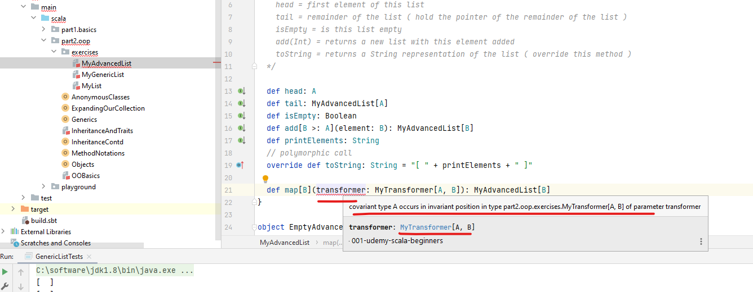

All right, then, flatMap, which again receives a type parameter B, because the return type is again on MyList of B, so we need to be made aware of the new type parameter here. And the transformer is a transformer from a to on MyList of B and the return type is on MyList of B and filter is the easiest of all, which receives no type parameters and only receives a predicate which is a predicate. My predicate of A and the end result is going to be on MyList of A. OK, so this is the first step, deciding on the function signatures for map, flat map and filter.

abstract class MyAdvancedList[+A] {

. . .

def map[B](transformer: MyTransformer[A, B]): MyAdvancedList[B]

def filter(predicate: MyPredicate[A]): MyAdvancedList[A]

def flatMap[B](transformer: MyTransformer[A, MyAdvancedList[B]]): MyAdvancedList[B]

}

Now let's go ahead and implement them. So let's start with the Empty singleton object. I'm just going to copy the function definitions and just replace them here and replace A with nothing. And I'm just going to copy this around where I see a I'm going to replace nothing. All right, now the implementations here are going to be extremely straightforward because mapping flat mapping and filtering an empty list are all going to return an empty list. So the implementation for all these methods is going to be empty. All right.

abstract class MyAdvancedList[+A] {

def head: A

def tail: MyAdvancedList[A]

def isEmpty: Boolean

def add[B >: A](element: B): MyAdvancedList[B]

def printElements: String

*// polymorphic call*

override def toString: String = "[ " + printElements + " ]"

def map[B](transformer: MyTransformer[A, B]): MyAdvancedList[B]

def filter(predicate: MyPredicate[A]): MyAdvancedList[A]

def flatMap[B](transformer: MyTransformer[A, MyAdvancedList[B]]): MyAdvancedList[B]

}

object **EmptyAdvancedList** extends MyAdvancedList[Nothing] {

def head: Nothing = throw new NoSuchElementException

def tail: MyAdvancedList[Nothing] = throw new NoSuchElementException

def isEmpty: Boolean = true

def add[B >: Nothing](element: B): MyAdvancedList[B] =

new ConsAdvancedList(element, EmptyAdvancedList)

def printElements: String = ""

def map[B](transformer: MyTransformer[A, B]): MyAdvancedList[B] = EmptyAdvancedList

def filter(predicate: MyPredicate[A]): MyAdvancedList[A] = EmptyAdvancedList

def flatMap[B](transformer: MyTransformer[A, MyAdvancedList[B]]): MyAdvancedList[B]

= EmptyAdvancedList

}

Now for Cons, this is going to get a little bit complicated. I'm going to start with filter which receives a predicate which is a mere predicate of A and returns MyList of A. Now, what does this do, I have a Cons with a head and a tail right. Now, filtering with a predicate means filtering the head and then filtering the tail. This is a singly linked list. So basically what I first need to do is to test if head satisfies the Predicate, that is if the predicate.test with the head passes. So if predicate.test with head, right, then head will be included in the result, so I'm going to say new Cons with head and the tail filtered with the predicate so the tail needs to be filtered and then needs to be passed in here as the result. So t.filter(predicate). Otherwise, predicate.test with the head does not pass. So that means the head will not be included in the result. So I'm just going to return t.filter(Predicate). Does that make sense?

class ConsAdvancedList[+A](h: A, t: MyAdvancedList[A]) extends MyAdvancedList[A] {

def head: A = h

def tail: MyAdvancedList[A] = t

def isEmpty: Boolean = false

def add[B >: A](element: B): MyAdvancedList[B] = new ConsAdvancedList(element, this)

def printElements: String =

if(t.isEmpty) "" + h

else s"**$**h **$**{t.printElements}"

def filter(predicate: MyPredicate[A]): MyAdvancedList[A] =

if (predicate.test(h)) new ConsAdvancedList(h, t.filter(predicate))

else t.filter(predicate)

}

So if head passes the predicate, it will be included in the result. So the result is certainly going to be a concern with the head. The tail is going to be filtered with a predicate. So we don't really know what that will return. It might return an empty list, but we'll just delegate to the recursive call with filter and it will take care of itself. Otherwise, the head does not pass the predicate, so it will not be included in the result. So the result will be a tail filter predicate. All right.

Now, let's move on to map. I'm going to copy the function signatures here, so I'm going to copy the map signature from MyList. And in this case, we are not concerned with the structure of the result because the structure will be identical to this list in the sense that if this list has three elements, then the result will also have three elements. So the implementation is going to be a new ConsAdvanceList, because if this is a non-empty list, then so is the result. So we'll create a new ConsAdvancedList and the head is going to be transformed by the transformer. So the head of the result is going to be transformer.transform(head). So this is going to be the head of the result and the tail of the result is going to be t.map with the same transformer.

class ConsAdvancedList[+A](h: A, t: MyAdvancedList[A]) extends MyAdvancedList[A] {

def head: A = h

def tail: MyAdvancedList[A] = t

def isEmpty: Boolean = false

def add[B >: A](element: B): MyAdvancedList[B] = new ConsAdvancedList(element, this)

def printElements: String =

if(t.isEmpty) "" + h

else s"**$**h **$**{t.printElements}"

def filter(predicate: MyPredicate[A]): MyAdvancedList[A] =

if (predicate.test(h)) new ConsAdvancedList(h, t.filter(predicate))

else t.filter(predicate)

def map[B](transformer: MyTransformer[A, B]): MyAdvancedList[B] =

new ConsAdvancedList( transformer.transform(h), t.map(transformer) )

}

So just a recursive call, let's just comment out flatMap for a second, so I'm commenting out flatMap just to make sure that our code runs well so far. So if I printLn list of integers.map with a new MyTransformer from Int to Int where the override def transform for an Int returns an Int and say 11 times 2. All right, this is basically the example that I gave you at the beginning of the exercise, and this, by the way, is an anonymous class. This was the whole purpose of the exercise.

package part2.oop.exercises

abstract class MyAdvancedList[+A] {

def head: A

def tail: MyAdvancedList[A]

def isEmpty: Boolean

def add[B >: A](element: B): MyAdvancedList[B]

def printElements: String

// polymorphic call

override def toString: String = "[ " + printElements + " ]"

def map[B](transformer: MyTransformer[A, B]): MyAdvancedList[B]

def filter(predicate: MyPredicate[A]): MyAdvancedList[A]

// def flatMap[B](transformer: MyTransformer[A, MyAdvancedList[B]]): MyAdvancedList[B]

}

object EmptyAdvancedList extends MyAdvancedList[Nothing] {

def head: Nothing = throw new NoSuchElementException

def tail: MyAdvancedList[Nothing] = throw new NoSuchElementException

def isEmpty: Boolean = true

def add[B >: Nothing](element: B): MyAdvancedList[B] =

new ConsAdvancedList(element, EmptyAdvancedList)

def printElements: String = ""

def map[B](transformer: MyTransformer[Nothing, B]): MyAdvancedList[B] = EmptyAdvancedList

def filter(predicate: MyPredicate[Nothing]): MyAdvancedList[Nothing] = EmptyAdvancedList

def flatMap[B](transformer: MyTransformer[Nothing, MyAdvancedList[B]]): MyAdvancedList[B]

= EmptyAdvancedList

}

class ConsAdvancedList[+A](h: A, t: MyAdvancedList[A]) extends MyAdvancedList[A] {

def head: A = h

def tail: MyAdvancedList[A] = t

def isEmpty: Boolean = false

def add[B >: A](element: B): MyAdvancedList[B] = new ConsAdvancedList(element, this)

def printElements: String =

if(t.isEmpty) "" + h

else s"**$**h **$**{t.printElements}"

def filter(predicate: MyPredicate[A]): MyAdvancedList[A] =

if (predicate.test(h)) new ConsAdvancedList(h, t.filter(predicate))

else t.filter(predicate)

def map[B](transformer: MyTransformer[A, B]): MyAdvancedList[B] =

new ConsAdvancedList(transformer.transform(h), t.map(transformer));

}

trait MyPredicate[-T] {

def test(elem: T): Boolean

}

trait MyTransformer[-A, B] {

def transform(elem: A): B

}

object AdvancedListTests extends App {

val listOfIntegers: MyAdvancedList[Int] = EmptyAdvancedList

val listOfStrings: MyAdvancedList[String] = EmptyAdvancedList

val listOfIntegersTwo: MyAdvancedList[Int] =

new ConsAdvancedList(1, new ConsAdvancedList(2, new ConsAdvancedList(3, EmptyAdvancedList)))

val listOfStringsTwo: MyAdvancedList[String] =

new ConsAdvancedList("Hello", new ConsAdvancedList("Scala", EmptyAdvancedList))

println( listOfIntegers.toString )

println( listOfIntegers.toString )

println( listOfIntegersTwo.toString )

println( listOfStringsTwo.toString )

println( listOfIntegersTwo.map(new MyTransformer[Int, Int] {

override def transform(elem: Int): Int = elem * 2

}).toString)

}

*Output:*

*[ ]*

*[ ]*

*[ 1 2 3 ]*

*[ Hello Scala ]*

*[ 2 4 6 ]*

If I print line this guy that to string, then I should receive the value 2 4 6. So if I right, click and run. I get the values two, four, six now, I think this might be overwhelming to some of you, so I'm going to break it down. So how does Map actually work? Let's break this down. Let's say I have the list. One, two, three. Right. So 1, 2, 3, .map. And for shorthand, I'm going to pass in the pseudo syntax and multiply by two in in which the actual syntax is a new transformer with the override def transform here on the spot. Right. OK, so this is what it is. So it has a new Cons with transform and transform with a head and the head is one transformer to transform of one is 1 times 2, which means the value of 2 in the tail is going to be the tail[2, 3].map with the same transformer. Right. And this is later going to be a new concept for the same head. And this expression here is again a new concept with transform and transform this guy's head and and multiply it by 2 with the head being 2 is going to be the value 4 and the list with the only n1 3 map with the same transformer. Which in turn is going to be a new concern to new calls for and this guy is going to be a new ConsAdvancedList with transform and transform this lists head, which is 3 times 2 which is 6, and then this list's tail, which is Empty, that map with the same transformer, which in turn is a new concept with two new icons for new concepts and empty.map with a transformer. If you saw the previous implementation is still empty. So empty. So this is your complete result.

/*

[1,2,3].map(n * 2)

= new ConsAdvancedList(2, [2,3].map(n * 2))

= new ConsAdvancedList(2, new ConsAdvancedList(4, [3].map(n * 2)))

= new ConsAdvancedList(2, new ConsAdvancedList(4, new ConsAdvancedList(6,

Empty.map(n * 2))))

= new ConsAdvancedList(2, new ConsAdvancedList(4, new ConsAdvancedList(6, Empty))))

*/

Let's try the filter as well. So if I println list of integers that filter and lets pass an anonymous instance of MyPredicate of Int with the on the spot implementation override def test which receives an element of type Int and returns boolean and the implementation is going to be elem mod 2 is equal to zero ( elem % 2 == 0 ) and .toString at the end then, because I have the list, 1, 2, 3, I'm only going to print the list consisting of the elements 2. Which is exactly what we see in the console.

*println*( *listOfIntegersTwo*.map(new MyTransformer[Int, Int] {

override def transform(elem: Int): Int = elem * 2

}).toString)

*Output:*

*[ 2 ]*

So let's break it down. How does this work? So if we have to filter the list [ 1, 2, 3 ] .filter and just for the sake of space, I'm going to say n mod 2 == 0, then that is going to be well. Pretty good test had. This predicate.test 1 will fail, so it will return the tail, that filter predicate. So this is going to return [2, 3] .filter with the same and n mod 2 == 0 in turn, predicate.test with the head this time passes. So this is going to be a new ConsAdvancedList with [2, and t.filter(Predicate)]. So the list consisting of 3 filter and n mod 2 equals zero. So this is going to be a new ConsAdvancedList of 2 and 3, that filter is going to test the predicate for the head and this is going to fail this time. So it will return till that filter predicate. By tail I mean, this guys tail which is empty.filter and 2 equals zero now empty not filter anything basically returns empty because that's how he implemented this. So this is going to return a new ConsAdvancedList with 2 and Empty. So this is our complete result and it will print just the value to here to the console.

/*

[1,2,3].filter(n % 2 == 0) =

[2,3].filter(n % 2 == 0) =

= new ConsAdvancedList(2, [3].filter(n % 2 == 0))

= new ConsAdvancedList(2, Empty.filter(n % 2 == 0))

= new ConsAdvancedList(2, Empty)

*/

Now for flatMap, this is going to be very interesting because we need a concatenation function. So let's add a little concatenation function. Let's first of all uncommented the flatMap definition and we're going to implement it in ConsAdvancedList very shortly. But first, let's add a concatenation method. I'm going to call this ++.

abstract class MyAdvancedList[+A] {

/*

head = first element of this list

tail = remainder of the list ( hold the pointer of the remainder of the list )

isEmpty = is this list empty

add(Int) = returns a new list with this element added

toString = returns a String representation of the list ( override this method )

*/

def head: A

def tail: MyAdvancedList[A]

def isEmpty: Boolean

def add[B >: A](element: B): MyAdvancedList[B]

def printElements: String

// polymorphic call

override def toString: String = "[ " + printElements + " ]"

def map[B](transformer: MyTransformer[A, B]): MyAdvancedList[B]

def filter(predicate: MyPredicate[A]): MyAdvancedList[A]

def flatMap[B](transformer: MyTransformer[A, MyAdvancedList[B]]): MyAdvancedList[B]

def ++(list: MyAdvancedList[A]): MyAdvancedList[A]

}

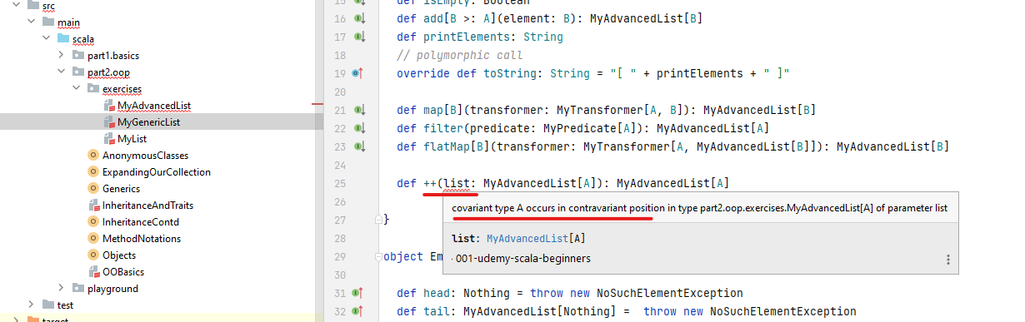

So I'm concatenating a list with MyList of a number returning on MyList of eight, but of course I'm getting this annoying controversy and error here. So like we did with the add method, we're going to expand this by supplying a new parameter B, so be supportive of a list is on MyList of B and the return type is MyList of B. All right. So this is concatenation.

abstract class MyAdvancedList[+A] {

def head: A

def tail: MyAdvancedList[A]

def isEmpty: Boolean

def add[B >: A](element: B): MyAdvancedList[B]

def printElements: String

// polymorphic call

override def toString: String = "[ " + printElements + " ]"

def map[B](transformer: MyTransformer[A, B]): MyAdvancedList[B]

def filter(predicate: MyPredicate[A]): MyAdvancedList[A]

def flatMap[B](transformer: MyTransformer[A, MyAdvancedList[B]]): MyAdvancedList[B]

// concatenation

def ++[B >: A](list: MyAdvancedList[B]): MyAdvancedList[B]

}

All right, let's implement concatenation in empty and ConsAdvancedList so def ++ with the type parameter B super type of nothing and the list is on MyList of being and the return type is MyList of B. This is very simple because it just returns that list.

object EmptyAdvancedList extends MyAdvancedList[Nothing] {

def head: Nothing = throw new NoSuchElementException

def tail: MyAdvancedList[Nothing] = throw new NoSuchElementException

def isEmpty: Boolean = true

def add[B >: Nothing](element: B): MyAdvancedList[B] =

new ConsAdvancedList(element, EmptyAdvancedList)

def printElements: String = ""

def map[B](transformer: MyTransformer[Nothing, B]): MyAdvancedList[B] = EmptyAdvancedList

def filter(predicate: MyPredicate[Nothing]): MyAdvancedList[Nothing] = EmptyAdvancedList

def flatMap[B](transformer: MyTransformer[Nothing, MyAdvancedList[B]]): MyAdvancedList[B] =

EmptyAdvancedList

def ++[B >: Nothing](list: MyAdvancedList[B]): MyAdvancedList[B] = list

}

Empty concatenating with anything will return that thing. This is very simple. For ConsAdvancedList it's a little bit more complicated. So let's copy the function definition from the from the upper class. Sorry, and let's implement it here. The implementation is going to be very simple. It's going to return ConsAdvancedList with the same head and tail + list. This is a little bit of magic, so if I concatenate list 1, 2 with list 3, 4, 5, then this will see a new ConsAdvancedList with 1 and the list 2 ++ [ 3, 4, 5 ] per the function implementation, which in turn is a new ConsAdvancedList with 1 in this because it's a ConsAdvancedList will also return cons with 2 and the tail which is empty this time. ++ 3, 4, 5. and finally, this will return ConsAdvancedList with 1, new ConsAdvancedList 2 and Empty ++ 3, 4, 5 will just return 3, 4, 5, which actually is a new ConsAdvancedList with 3 new ConsAdvancedList 4 new ConsAdvancedList 5. All right. So this is our complete result. So this is a very short but very useful function implementation.

/*

[1,2] ++ [3,4,5]

= new Cons(1, [2] ++ [3,4,5])

= new Cons(1, new Cons(2, Empty ++ [3,4,5]))

= new Cons(1, new Cons(2, new Cons(3, new Cons(4, new Cons(5)))))

*/

def ++[B >: A](list: MyList[B]): MyList[B] = new Cons(h, t ++ list)

So let's move on to flatMap. So let's go ahead and copy the function definition from the abstract class and paste here under the concatenation. And this is going to be, again, a very powerful one liner. So this is going to be transformer.transform the head concatenated with tail, flatMap transformer. One-Liner, super powerful, this is the power of skala, and you're getting a taste of it right now. So let's break it down so if I have the list one, two, which gets a flat map for every end, we get the list and and plus one. Well, this is transformer.transform the head, transformer.transform 1 and 2 in the list, concatenated with tail flatMap. The same transformer, which, again, is [1, 2] concatenated with transformer.transform this guy, of course, [2, 3] concatenated with this guy's empty. OK, so because this is a single list, the tail is going to be empty, Empty.flatMap the same transformer. Right, which basically means [1, 2] concatenated with [2, 3] concatenated with Empty, which of course, is [1,2,2, 3] if we assume that the concatenation method works correctly.

/*

[1,2].flatMap(n => [n, n+1])

= [1,2] ++ [2].flatMap(n => [n, n+1])

= [1,2] ++ [2,3] ++ Empty.flatMap(n => [n, n+1])

= [1,2] ++ [2,3] ++ Empty

= [1,2,2,3]

*/

def flatMap[B](transformer: A => MyList[B]): MyList[B] =

transformer(h) ++ t.flatMap(transformer)

*Complete code so far*

package part2.oop.exercises

abstract class MyAdvancedList[+A] {

/*

head = first element of this list

tail = remainder of the list ( hold the pointer of the remainder of the list )

isEmpty = is this list empty

add(Int) = returns a new list with this element added

toString = returns a String representation of the list ( override this method )

*/

def head: A

def tail: MyAdvancedList[A]

def isEmpty: Boolean

def add[B >: A](element: B): MyAdvancedList[B]

def printElements: String

// polymorphic call

override def toString: String = "[ " + printElements + " ]"

def map[B](transformer: MyTransformer[A, B]): MyAdvancedList[B]

def filter(predicate: MyPredicate[A]): MyAdvancedList[A]

//def flatMap[B](transformer: MyTransformer[A, MyAdvancedList[B]]): MyAdvancedList[B]

// concatenation

def ++[B >: A](list: MyAdvancedList[B]): MyAdvancedList[B]

}

object EmptyAdvancedList extends MyAdvancedList[Nothing] {

def head: Nothing = throw new NoSuchElementException

def tail: MyAdvancedList[Nothing] = throw new NoSuchElementException

def isEmpty: Boolean = true

def add[B >: Nothing](element: B): MyAdvancedList[B]

= new ConsAdvancedList(element, EmptyAdvancedList)

def printElements: String = ""

def map[B](transformer: MyTransformer[Nothing, B]): MyAdvancedList[B] = EmptyAdvancedList

def filter(predicate: MyPredicate[Nothing]): MyAdvancedList[Nothing] = EmptyAdvancedList

def flatMap[B](transformer: MyTransformer[Nothing, MyAdvancedList[B]]): MyAdvancedList[B]

= EmptyAdvancedList

def ++[B >: Nothing](list: MyAdvancedList[B]): MyAdvancedList[B] = list

}

class ConsAdvancedList[+A](h: A, t: MyAdvancedList[A]) extends MyAdvancedList[A] {

def head: A = h

def tail: MyAdvancedList[A] = t

def isEmpty: Boolean = false

def add[B >: A](element: B): MyAdvancedList[B] = new ConsAdvancedList(element, this)

def printElements: String =

if(t.isEmpty) "" + h

else s"**$**h **$**{t.printElements}"

def filter(predicate: MyPredicate[A]): MyAdvancedList[A] =

if (predicate.test(h)) new ConsAdvancedList(h, t.filter(predicate))

else t.filter(predicate)

/*

[1,2,3].map(n * 2)

= new ConsAdvancedList(2, [2,3].map(n * 2))

= new ConsAdvancedList(2, new ConsAdvancedList(4, [3].map(n * 2)))

= new ConsAdvancedList(2, new ConsAdvancedList(4,

new ConsAdvancedList(6, Empty.map(n * 2))))

= new ConsAdvancedList(2, new ConsAdvancedList(4, new ConsAdvancedList(6, Empty))))

*/

def map[B](transformer: MyTransformer[A, B]): MyAdvancedList[B] =

new ConsAdvancedList(transformer.transform(h), t.map(transformer));

/*

[1,2] ++ [3,4,5]

= new Cons(1, [2] ++ [3,4,5])

= new Cons(1, new Cons(2, Empty ++ [3,4,5]))

= new Cons(1, new Cons(2, new Cons(3, new Cons(4, new Cons(5)))))

*/

def ++[B >: A](list: MyAdvancedList[B]): MyAdvancedList[B] =

new ConsAdvancedList(h, t ++ list)

}

trait MyPredicate[-T] {

def test(elem: T): Boolean

}

trait MyTransformer[-A, B] {

def transform(elem: A): B

}

object AdvancedListTests extends App {

val listOfIntegers: MyAdvancedList[Int] = EmptyAdvancedList

val listOfStrings: MyAdvancedList[String] = EmptyAdvancedList

val listOfIntegersTwo: MyAdvancedList[Int] =

new ConsAdvancedList(1, new ConsAdvancedList(2, new ConsAdvancedList(3, EmptyAdvancedList)))

val anotherListOfIntegersTwo: MyAdvancedList[Int]

= new ConsAdvancedList(4, new ConsAdvancedList(5, EmptyAdvancedList))

val listOfStringsTwo: MyAdvancedList[String] =

new ConsAdvancedList("Hello", new ConsAdvancedList("Scala", EmptyAdvancedList))

println(listOfIntegers.toString)

println(listOfIntegers.toString)

println(listOfIntegersTwo.toString)

println(listOfStringsTwo.toString)

println( listOfIntegersTwo.map(new MyTransformer[Int, Int] {

override def transform(elem: Int): Int = elem * 2

}).toString)

println( listOfIntegersTwo.filter(new MyPredicate[Int] {

override def test(elem: Int): Boolean = elem % 2 == 0

}))

println( listOfIntegersTwo ++ anotherListOfIntegersTwo).toString

}

So let's test our methods here. So if I find another list of integers, let's say I copy this guy and let's say another list of integers and say ConsAdvanceList [4 5]. All right, then, if I println list of integers concatenated with another list of integers to string, then they should print [1 2 3 4 5], just to prove that our concatenation method works correctly. Now, let's finally print the flatMap. So if I do a list of integers, flatMap, a new transformer from Int to MyList of Int in which the override def transform takes an element of type Int and returns a MyList of int, which is in this case a new ConsAdvancedList with elements and another ConsAdvancedList with element plus 1 and Empty. This is what basically means the element and element plus 1.

*Complete Code*

package part2.oop.exercises

abstract class MyAdvancedList[+A] {

/*

head = first element of this list

tail = remainder of the list ( hold the pointer of the remainder of the list )

isEmpty = is this list empty

add(Int) = returns a new list with this element added

toString = returns a String representation of the list ( override this method )

*/

def head: A

def tail: MyAdvancedList[A]

def isEmpty: Boolean

def add[B >: A](element: B): MyAdvancedList[B]

def printElements: String

// polymorphic call

override def toString: String = "[ " + printElements + " ]"

def map[B](transformer: MyTransformer[A, B]): MyAdvancedList[B]

def flatMap[B](transformer: MyTransformer[A, MyAdvancedList[B]]): MyAdvancedList[B]

def filter(predicate: MyPredicate[A]): MyAdvancedList[A]

// concatenation

def ++[B >: A](list: MyAdvancedList[B]): MyAdvancedList[B]

}

object EmptyAdvancedList extends MyAdvancedList[Nothing] {

def head: Nothing = throw new NoSuchElementException

def tail: MyAdvancedList[Nothing] = throw new NoSuchElementException

def isEmpty: Boolean = true

def add[B >: Nothing](element: B): MyAdvancedList[B] =

new ConsAdvancedList(element, EmptyAdvancedList)

def printElements: String = ""

def map[B](transformer: MyTransformer[Nothing, B]): MyAdvancedList[B] = EmptyAdvancedList

def filter(predicate: MyPredicate[Nothing]): MyAdvancedList[Nothing] = EmptyAdvancedList

def flatMap[B](transformer: MyTransformer[Nothing, MyAdvancedList[B]]): MyAdvancedList[B]

= EmptyAdvancedList

def ++[B >: Nothing](list: MyAdvancedList[B]): MyAdvancedList[B] = list

}

class ConsAdvancedList[+A](h: A, t: MyAdvancedList[A]) extends MyAdvancedList[A] {

def head: A = h

def tail: MyAdvancedList[A] = t

def isEmpty: Boolean = false

def add[B >: A](element: B): MyAdvancedList[B] = new ConsAdvancedList(element, this)

def printElements: String =

if(t.isEmpty) "" + h

else s"**$**h **$**{t.printElements}"

def filter(predicate: MyPredicate[A]): MyAdvancedList[A] =

if (predicate.test(h)) new ConsAdvancedList(h, t.filter(predicate))

else t.filter(predicate)

/*

[1,2,3].map(n * 2)

= new ConsAdvancedList(2, [2,3].map(n * 2))

= new ConsAdvancedList(2, new ConsAdvancedList(4, [3].map(n * 2)))

= new ConsAdvancedList(2, new ConsAdvancedList(4,

new ConsAdvancedList(6, Empty.map(n * 2))))

= new ConsAdvancedList(2, new ConsAdvancedList(4, new ConsAdvancedList(6, Empty))))

*/

def map[B](transformer: MyTransformer[A, B]): MyAdvancedList[B] =

new ConsAdvancedList(transformer.transform(h), t.map(transformer));

/*

[1,2] ++ [3,4,5]

= new Cons(1, [2] ++ [3,4,5])

= new Cons(1, new Cons(2, Empty ++ [3,4,5]))

= new Cons(1, new Cons(2, new Cons(3, new Cons(4, new Cons(5)))))

*/

def ++[B >: A](list: MyAdvancedList[B]): MyAdvancedList[B] =

new ConsAdvancedList(h, t ++ list)

/*

[1,2].flatMap(n => [n, n+1])

= [1,2] ++ [2].flatMap(n => [n, n+1])

= [1,2] ++ [2,3] ++ Empty.flatMap(n => [n, n+1])

= [1,2] ++ [2,3] ++ Empty

= [1,2,2,3]

*/

def flatMap[B](transformer: MyTransformer[A, MyAdvancedList[B]]): MyAdvancedList[B] =

transformer.transform(h) ++ t.flatMap(transformer)

}

trait MyPredicate[-T] {

def test(elem: T): Boolean

}

trait MyTransformer[-A, B] {

def transform(elem: A): B

}

object AdvancedListTests extends App {

val listOfIntegers: MyAdvancedList[Int] = EmptyAdvancedList

val listOfStrings: MyAdvancedList[String] = EmptyAdvancedList

val listOfIntegersTwo: MyAdvancedList[Int] =

new ConsAdvancedList(1, new ConsAdvancedList(2, new ConsAdvancedList(3, EmptyAdvancedList)))

val anotherListOfIntegersTwo: MyAdvancedList[Int] =

new ConsAdvancedList(4, new ConsAdvancedList(5, EmptyAdvancedList))

val listOfStringsTwo: MyAdvancedList[String] =

new ConsAdvancedList("Hello", new ConsAdvancedList("Scala", EmptyAdvancedList))

println(listOfIntegers.toString)

println(listOfIntegers.toString)

println(listOfIntegersTwo.toString)

println(listOfStringsTwo.toString)

println( listOfIntegersTwo.map(new MyTransformer[Int, Int] {

override def transform(elem: Int): Int = elem * 2

}).toString)

println( listOfIntegersTwo.filter(new MyPredicate[Int] {

override def test(elem: Int): Boolean = elem % 2 == 0

}))

println( listOfIntegersTwo ++ anotherListOfIntegersTwo).toString

println(listOfIntegersTwo.flatMap(new MyTransformer[Int, MyAdvancedList[Int]] {

override def transform(elem: Int): MyAdvancedList[Int] =

new ConsAdvancedList(elem, new ConsAdvancedList(elem + 1, EmptyAdvancedList))

}).toString)

}

*Output:*

*[ ]*

*[ ]*

*[ 1 2 3 ]*

*[ Hello Scala ]*

*[ 2 4 6 ]*

*[ 2 ]*

*[ 1 2 3 4 5 ]*

*[ 1 2 2 3 3 4 ]*

So if I flatMap with this transformer and if I print two string at the end, I should be seeing [1 2 2 3 3 4 ]. And the console, right, so I see [1 2] which is the sublist for 1, [2 3], which is a sublist for 2 and 3, 4, which is a sublist for 3. All right. So quite a lot and quite powerful with, frankly, just a few lines of code. So in just one hundred lines of code, you've defined basically a complete covariance generic list, which is pretty darn cool.

### Case Classes

Now, the problem that we want to solve is that often for lightweight data structures, which is a lot of the time, like for class person, we need to reimplement all sorts of boilerplate, like companion objects, like standard methods for Serializing and for pretty printing like equals and hashCode toString for pretty string representation and so on and so forth. In case classes are an ideal solution to this problem, case classes are an exceptionally useful shorthand for defining a class and the companion object and a lot of sensible defaults in one go. They're really perfect for creating this kind of lightweight data holding classes with really minimum of hassle. So the way that we create a case class in Scala is just write case class and then say person with name as String and age as Int. So the only difference is the keyword case here. But this keyword is so powerful because this declaration does multiple things. First of all, class parameters are promoted to fields. So if I say, val person, let's say jim equals new person with gym and age 34, then if I println jim.name, then that's a valid thing because it's a case class. If I hadn't put in the key word case here, the parameter name would not have been a field. Right. So case classes promote all parameters to fields. Second thing, a sensible toString for ease of debugging. So if I print line jim.string, then watch what happens. It prints person with Jim 34. This is a pretty decent, toString representation, if I hadn't put in a case here, then the two string representation, let's just ignore the name. The two string representation would have been something very cryptic like person at a very weird hash code over here. Right. So the case class have to string representations which are really sane. By the way, I think I forgot to tell you something that Java already does as a syntactic sugar. So if I print line jim.toString, that's one thing. But if I print line, Jim, as is, this will automatically delegate to the toString method. So if I line the object, Jim, then that will turn Jim into its toString method. So a small digression print line object or instance, because object has a very special meaning and Scala as you've found out. So print instance is actually print line instance.toString. This is another form of syntactic sugar. So if I print line Jim, I'm going to get a person with Jim and age 34.

package lectures.part2oop

object CaseClasses extends App {

/*

equals, hashCode, toString

*/

case class Person(name: String, age: Int)

// 1. class parameters are fields

val jim = new Person("Jim", 34)

println(jim.name)

// 2. sensible toString

// println(instance) = println(instance.toString) // syntactic sugar

println(jim)

// 3. equals and hashCode implemented OOTB

val jim2 = new Person("Jim", 34)

println(jim == jim2)

}

*Output:*

*Jim*

*Person(Jim,34)*

*true*

Third thing that I wanted to tell you is that equals let's call this three equals and hash code implemented out of the box, which make case class is especially important for use in collections. So if I define a new person called Jim, let's say Jim, to the new person with the same parameters, Jim. 34. If I print line, Jim equals Jim2 it will print True. So if I click and run this, I'm actually going to see true here if I hadn't use the keyword case. And just ignoring the name for now, I would have seen false here in the console because Jim and Jim2 are two different instances of class person, but the equals method was not implemented. So the default from AnyRef was picked, which by default, for different references returns false. All right. So let's get back to the case class, speaking of scenarios with duplicates.

Next thing that I want to show you is the fact that case classes have handy copy methods. So instead of defining a new person with the same parameters as jim, I can just say, well, it's a jim.copy. And copy creates a new instance of this case class. What's more, the copy methods also receive named parameters. So if I receive the parameter age equals like 45, this is a valid use of the copy method and it will return another instance of person with the same parameters as Jim except age, which in this case is a different value 45. So if I print line Jim3, this will return a new instance of person with the age 45. Right so person jim 45.

package lectures.part2oop

object CaseClasses extends App {

/*

equals, hashCode, toString

*/

case class Person(name: String, age: Int)

// 1. class parameters are fields

val jim = new Person("Jim", 34)

println(jim.name)

// 2. sensible toString

// println(instance) = println(instance.toString) // syntactic sugar

println(jim)

// 3. equals and hashCode implemented OOTB

val jim2 = new Person("Jim", 34)

println(jim == jim2)

// 4. CCs have handy copy method

val jim3 = jim.copy(age = 45)

println(jim3)

}

Next super feature case classes have companion objects. So if I say well the person equals person then this is a valid definition. Person is the companion object of this case class. Just because I use the keyword case makes the compiler automatically create companion objects for this class. Now, companion objects also have some handy factory methods, so if, for example, I create a new person called Mary, I can actually call this companion objects apply method. So remember, the apply method makes the companion object callable like a function. And I can just use parameters Mary and 23. So I've just constructed a person this actually delegates to the person's apply method. So the companion objects apply method does the same thing as the constructor. So in practice, we don't really use the keyword new when instantiating a case class, we only use this form. All right.

package lectures.part2oop

object CaseClasses extends App {

/*

equals, hashCode, toString

*/

case class Person(name: String, age: Int)

// 1. class parameters are fields

val jim = new Person("Jim", 34)

println(jim.name)

// 2. sensible toString

// println(instance) = println(instance.toString) // syntactic sugar

println(jim)

// 3. equals and hashCode implemented OOTB

val jim2 = new Person("Jim", 34)

println(jim == jim2)

// 4. CCs have handy copy method

val jim3 = jim.copy(age = 45)

println(jim3)

// 5. CCs have companion objects

val thePerson = Person

val mary = Person("Mary", 23)

}

Next super feature. Yeah, I know. Case classes are a gold mine, so case classes are serializable, which makes classes especially useful when dealing with distributed systems. You can send instances of case classes through the network and in between. JVM says this is especially important when dealing, for example, in the Akka framework. Akka deals with sending serializable messages through the network and our messages are in general in practice case classes. Finally, and this is particularly important in practice and in this course is that case classes have Extractor patterns. What this means is that keast classes can be used in pattern matching, which is one of the most powerful Scala features. And we're going to talk about pattern matching later in this course. I also want you to know that there is such a thing as a case object, right? So this acts like a case class, except it's an object.

package lectures.part2oop

object CaseClasses extends App {

/*

equals, hashCode, toString

*/

case class Person(name: String, age: Int)

// 1. class parameters are fields

val jim = new Person("Jim", 34)

println(jim.name)

// 2. sensible toString

// println(instance) = println(instance.toString) // syntactic sugar

println(jim)

// 3. equals and hashCode implemented OOTB

val jim2 = new Person("Jim", 34)

println(jim == jim2)

// 4. CCs have handy copy method

val jim3 = jim.copy(age = 45)

println(jim3)

// 5. CCs have companion objects

val thePerson = Person

val mary = Person("Mary", 23)

// 6. CCs are serializable

// Akka

// 7. CCs have extractor patterns = CCs can be used in PATTERN MATCHING

case object UnitedKingdom {

def name: String = "The UK of GB and NI"

}

/*

Expand MyList - use case classes and case objects

*/

}

So if, for example, I have case object United Kingdom. Which has, for example, a deaf name, which is a string and say the United Kingdom of Great Britain and Northern Ireland, then this is a case object case objects have the same property as case clauses, except they don't get companion objects because they are their own companion objects. Cool. Now, the exercise for this lecture is going to be to expand my list, to use case classes and case objects whenever you see fit. So simple as that. So positive video now for a minute or two and go through my list and see what you can convert to case classes and case objects. So I just switch to my list and I will convert the empty object to a case object and the cons close to a case class and that my focus is it. But with this keyword case, I've made my list extremely powerful. I've basically implemented equals and hash code out of the box so I can use the list in collections as well. And I've made my list serializable, which makes it extremely powerful to use in distributed networks.

package part2.oop.exercises

abstract class MyAdvancedList[+A] {

/*

head = first element of this list

tail = remainder of the list ( hold the pointer of the remainder of the list )

isEmpty = is this list empty

add(Int) = returns a new list with this element added

toString = returns a String representation of the list ( override this method )

*/

def head: A

def tail: MyAdvancedList[A]

def isEmpty: Boolean

def add[B >: A](element: B): MyAdvancedList[B]

def printElements: String

// polymorphic call

override def toString: String = "[ " + printElements + " ]"

def map[B](transformer: MyTransformer[A, B]): MyAdvancedList[B]

def flatMap[B](transformer: MyTransformer[A, MyAdvancedList[B]]): MyAdvancedList[B]

def filter(predicate: MyPredicate[A]): MyAdvancedList[A]

// concatenation

def ++[B >: A](list: MyAdvancedList[B]): MyAdvancedList[B]

}

case object EmptyAdvancedList extends MyAdvancedList[Nothing] {

def head: Nothing = throw new NoSuchElementException

def tail: MyAdvancedList[Nothing] = throw new NoSuchElementException

def isEmpty: Boolean = true

def add[B >: Nothing](element: B): MyAdvancedList[B] =

new ConsAdvancedList(element, EmptyAdvancedList)

def printElements: String = ""

def map[B](transformer: MyTransformer[Nothing, B]): MyAdvancedList[B] = EmptyAdvancedList

def filter(predicate: MyPredicate[Nothing]): MyAdvancedList[Nothing] = EmptyAdvancedList

def flatMap[B](transformer: MyTransformer[Nothing, MyAdvancedList[B]]): MyAdvancedList[B]

= EmptyAdvancedList

def ++[B >: Nothing](list: MyAdvancedList[B]): MyAdvancedList[B] = list

}

class ConsAdvancedList[+A](h: A, t: MyAdvancedList[A]) extends MyAdvancedList[A] {

def head: A = h

def tail: MyAdvancedList[A] = t

def isEmpty: Boolean = false

def add[B >: A](element: B): MyAdvancedList[B] = new ConsAdvancedList(element, this)

def printElements: String =

if(t.isEmpty) "" + h

else s"**$**h **$**{t.printElements}"

def filter(predicate: MyPredicate[A]): MyAdvancedList[A] =

if (predicate.test(h)) new ConsAdvancedList(h, t.filter(predicate))

else t.filter(predicate)

/*

[1,2,3].map(n * 2)

= new ConsAdvancedList(2, [2,3].map(n * 2))

= new ConsAdvancedList(2, new ConsAdvancedList(4, [3].map(n * 2)))

= new ConsAdvancedList(2, new ConsAdvancedList(4,

new ConsAdvancedList(6, Empty.map(n * 2))))

= new ConsAdvancedList(2, new ConsAdvancedList(4, new ConsAdvancedList(6, Empty))))

*/

def map[B](transformer: MyTransformer[A, B]): MyAdvancedList[B] =

new ConsAdvancedList(transformer.transform(h), t.map(transformer));

/*

[1,2] ++ [3,4,5]

= new Cons(1, [2] ++ [3,4,5])

= new Cons(1, new Cons(2, Empty ++ [3,4,5]))

= new Cons(1, new Cons(2, new Cons(3, new Cons(4, new Cons(5)))))

*/

def ++[B >: A](list: MyAdvancedList[B]): MyAdvancedList[B] =

new ConsAdvancedList(h, t ++ list)

/*

[1,2].flatMap(n => [n, n+1])

= [1,2] ++ [2].flatMap(n => [n, n+1])

= [1,2] ++ [2,3] ++ Empty.flatMap(n => [n, n+1])

= [1,2] ++ [2,3] ++ Empty

= [1,2,2,3]

*/

def flatMap[B](transformer: MyTransformer[A, MyAdvancedList[B]]): MyAdvancedList[B] =

transformer.transform(h) ++ t.flatMap(transformer)

}

trait MyPredicate[-T] {

def test(elem: T): Boolean

}

trait MyTransformer[-A, B] {

def transform(elem: A): B

}

object AdvancedListTests extends App {

val listOfIntegers: MyAdvancedList[Int] = EmptyAdvancedList

val listOfStrings: MyAdvancedList[String] = EmptyAdvancedList

val listOfIntegersTwo: MyAdvancedList[Int] =

new ConsAdvancedList(1, new ConsAdvancedList(2, new ConsAdvancedList(3, EmptyAdvancedList)))

val anotherListOfIntegersTwo: MyAdvancedList[Int] =

new ConsAdvancedList(4, new ConsAdvancedList(5, EmptyAdvancedList))

val listOfStringsTwo: MyAdvancedList[String] =

new ConsAdvancedList("Hello", new ConsAdvancedList("Scala", EmptyAdvancedList))

println(listOfIntegers.toString)

println(listOfIntegers.toString)

println(listOfIntegersTwo.toString)

println(listOfStringsTwo.toString)

println( listOfIntegersTwo.map(new MyTransformer[Int, Int] {

override def transform(elem: Int): Int = elem * 2

}).toString)

println( listOfIntegersTwo.filter(new MyPredicate[Int] {

override def test(elem: Int): Boolean = elem % 2 == 0

}))

println( listOfIntegersTwo ++ anotherListOfIntegersTwo).toString

println(listOfIntegersTwo.flatMap(new MyTransformer[Int, MyAdvancedList[Int]] {

override def transform(elem: Int): MyAdvancedList[Int] =

new ConsAdvancedList(elem, new ConsAdvancedList(elem + 1, EmptyAdvancedList))

}).toString)

}

So if I go down here with a list of integers and if I clone this, for example, I create a clone of list of integers with the same values. If I println clone list of integers equals list of integers, integers, yes. Then that will return True, just because I've used the keyword case, if I didn't use the keyword case, then I would need to and define a recursive equals method, which would have been a great headache for a list, because I would need to compare all the elements recursively. So this is just one of the features that I've added with not even a line of code with a simple word. All right.

So another example of the power of the Scala language. All right. So let's wrap this up. A small but powerful scale feature case classes are a fast way of defining light data structures with as little boilerplate as possible and with quite a lot of features.

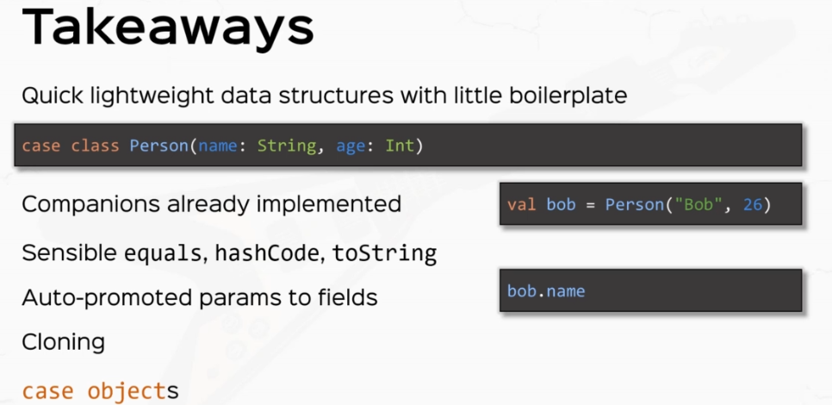

So if I have to find a case class, then I get a number of things out of the box. For one, we already have companion objects already implemented with Hendee Apply methods. We have a lot of sensible methods implemented. Out of the box, for example, equals hash code and two string. We ought to promote parameters to field so that we can use them as if they are values and any other methods like cloning. Case classes are also serializable and they're also extractable in pattern matching, which is something that we are going to talk about later. We also discussed case objects which act in the same way as case classes only that they are objects. Cool. Another weapon in your arsenal.

### Enums

Enums, which were a very late addition to the Scala programming language. So you may know the concept of an enum from some other programming language that you've worked with. Java, for example, has the concept of an Enum baked into the language and prior to Scala 3 enums were a headache to create. But thankfully in Scala 3, we also have first class support for Enums, and Enums are a data type that you can define much like a class. So I'm going to create an example here. You know, I'm going to call this permissions, and this is a data type that will only have a bunch of instances that we create in the class or in this case, in our body. And the way that we create the only possible instances of this type is with a keyword case. And then I'm going to write the actual instances, for example, read, write, execute and none.

package part2.oop

object Enums {

enum Permissions {

case READ, WRITE, EXECUTE, NONE

}

}

So Enums are used as a data type where you can already enumerate that's what they're called enum. You can enumerate all the possible cases, all the possible instances of that type. And by this, you've already created a sealed data type that cannot be extended, and the only possible instances of this type is read, write, execute and not so you cannot really instantiate permissions on your own. You can only use these constants. So the way that you would use those would be something like some permissions. Assuming I can type properly and the data type is permissions, much like you would for a class or a trade or a case class or whatever, and the way that you would refer to one of these constants would be like permissions. and then you would use, for example, READ – permissions.READ. So this is basically it. That's all you need to know in order to work with apps. You can define that as a data type, and this is how you can use the concerns that you placed in the permissions in them. And then once you have a permissions instance, you can pass it around. You can do whatever you want with it.

package part2.oop

object Enums {

enum Permissions {

case READ, WRITE, EXECUTE, NONE

}

val *somePermission*: Permissions = Permissions.READ

}

And, you know, because it's a data type, you can add fields or methods. So, for example, I can add a open document. Method, which returns units and as an implementation, I don't really care what the implementation is. For example, I can say if this is equal to read, then I will print line opening document. Otherwise, I'm going to print line reading, not aloud or something like that. And in Main, you can type in some permissions, that open document, so you can call methods on permissions instances, so if I run this application, we're going to see opening document because the consent was the right one.

package part2.oop

object Enums {

enum Permissions {

case READ, WRITE, EXECUTE, NONE

*// add fields, methods*

def openDocument(): Unit = {

if (this == READ) *println*("Opening document...")

else *println*("Not allowed to open ...")

}

}

val *somePermission*: Permissions = Permissions.READ

def main(args: Array[String]): Unit = {

*somePermission*.openDocument()

}

}

*Output:*

*Opening document . . .*

So you can add fields or methods like you would on any other class or treat. So Enums can pretty much work like any class, except you already have the constants of that class already specified in. Those can also take constructor arguments. So, for example, I can define an enum called permissions with bits, so we'll take an integer as an argument specifying the Bitwise representation of some permissions and inside, you can define the constants like, READ, WRITE, EXECUTE and NONE. But those constants need to already have the right argument specified inside because the cases that is the constants need to be initialized early. So I'm going to define a case called READ, which extends permissions with bits with the argument, let's say 4 that is 100. You can define a case, right, which extends permissions with bits, with the argument to that's 010. And Case Execute. Which extends permissions with bits, with one that is the wires representations zero zero one in case none extends permissions with bits with 0, so that's 000.

package part2.oop

object Enums {

enum Permissions {

case READ, WRITE, EXECUTE, NONE

*// add fields, methods*

def openDocument(): Unit = {

if (this == READ) *println*("Opening document...")

else *println*("Not allowed to open ...")

}

}

val *somePermission*: Permissions = Permissions.WRITE

*// constructor args*

enum PermissionsWithBits(bits: Int) {

case READ extends PermissionsWithBits(4) *// 100*

case WRITE extends PermissionsWithBits(2) *// 010*

case EXECUTE extends PermissionsWithBits(1) *// 001*

case NONE extends PermissionsWithBits(0) *// 000*

}

def main(args: Array[String]): Unit = {

*somePermission*.openDocument()

}

}

So this is how you can define constants inside an enum by specifying the right constructor argument. Now I get it that this particular structure is quite boilerplate for the Scala language, which being so compact in Java, you can do something like Enum thing and then you can have Case A with the constructor 2, B with constructor 3 and so on and so forth, so you can specify that in other languages in a much more compact way. But I'll take it as it is. I'll take Enums any day rather than the Scala 2 way of defining Enums, which was a bend over backwards. So this is how you can define Enums with constructor arguments. And you can also have Companion objects for an enum, much like you can for any other class. So I'm going to define an object called permissions with bits. And inside you can obviously have methods or fields. For example, I can define a method that returns a permissions with bits instance. So I'm going to have fromBits, for example, which I'm going to have bits Int. Permissions with bits, and here I can check the bits inside this number and return one of these constants so that I don't really need to check them myself, so I can do whatever here, I can just return permissions None. So you can use the Companion object for an enum as a source for factory methods. Factory methods, given some arguments will return one possible instance of your enum and depending on your arguments, you will receive one constant or another. All right.

package part2.oop

object Enums {

enum Permissions {

case READ, WRITE, EXECUTE, NONE

*// add fields, methods*

def openDocument(): Unit = {

if (this == READ) *println*("Opening document...")

else *println*("Not allowed to open ...")

}

}

val *somePermission*: Permissions = Permissions.READ

*// constructor args*

enum PermissionsWithBits(bits: Int) {

case READ extends PermissionsWithBits(4) *// 100*

case WRITE extends PermissionsWithBits(2) *// 010*

case EXECUTE extends PermissionsWithBits(1) *// 001*

case NONE extends PermissionsWithBits(0) *// 000*

}

object PermissionsWithBits {

def fromBits(bits: Int): PermissionsWithBits = *// whatever*

PermissionsWithBits.NONE

}

*// standard API*

val *somePermissionsOrdinal* = *somePermission*.ordinal

*println*(*somePermissionsOrdinal*)

def main(args: Array[String]): Unit = {

*somePermission*.openDocument()

}

}

*Output:*

*Not allowed to open ...*

*0*

Now let me talk to you about the standard API of Enums that come baked in to every single enum. One such functionality is the ability to inspect the index or ordinal, at which that particular permissions or enum instance was defined. So, for example, some permissions ordinal is zero because the permissions read consent was defined first in the permissions in definition. So I can say, well, let's call this some permissions ordinal as. Some permissions that ordinal and ordinal returns and. That is the index in which this particular instance occurs in the enum definition. So if I do, for example, print line some permissions, ordinal, we'll see the index at which that thing was defined. So you have the index zero, that is because indices start as 0, so this will be 0 than 1, then 2 and so on and so forth. All right.

Another useful functionality of Enums is the ability to iterate or get a hold of all the possible values of an Enum. For example, if you're accessing an enum from an external library, you might want to see how many and what instances you can access. So I can say, for example, all permissions as permissionsWithBits.values, and this returns an array of all possible values of the Enum, so this is quite useful as well if you want to see what values you can access, you can also create an instance of an enum from a string. So you can say, for example, let's call this read permission of type permissions, and this is quite important because this can only be accessed on Enums with no constructor arguments. So I can say Permissions.valueOf and value of takes a string as an argument, and the string will be passed and turned into one of these permissions instances. For example, I'm going to say read written just like that. And this string will be parsed and matched with either one of the names of the Enum. And in case of this example, this is going to be permissions.read.

package part2.oop

object Enums {

enum Permissions {

case READ, WRITE, EXECUTE, NONE

*// add fields, methods*

def openDocument(): Unit = {

if (this == READ) *println*("Opening document...")

else *println*("Not allowed to open ...")

}

}

val *somePermission*: Permissions = Permissions.WRITE

*// constructor args*

enum PermissionsWithBits(bits: Int) {

case READ extends PermissionsWithBits(4) *// 100*

case WRITE extends PermissionsWithBits(2) *// 010*

case EXECUTE extends PermissionsWithBits(1) *// 001*

case NONE extends PermissionsWithBits(0) *// 000*

}

object PermissionsWithBits {

def fromBits(bits: Int): PermissionsWithBits = *// whatever*

PermissionsWithBits.NONE

}

*// standard API*

val *somePermissionsOrdinal* = *somePermission*.ordinal

val *allPermissions* = PermissionsWithBits.values

val *readPermission*: Permissions = Permissions.*valueOf*("READ")

def main(args: Array[String]): Unit = {

*somePermission*.openDocument()

*println*(*somePermissionsOrdinal*)

*println*(*allPermissions*)

*println*(*readPermission*)

}

}

Output:

*Not allowed to open ...*

*1*

*[Lpart2.oop.Enums$PermissionsWithBits;@282ba1e*

*READ*

All right, so that was a quick lesson and introduction to Enums in Sky, you can now write Enums, much like you can in any other languages, starting in Scala 3.

### Exceptions

So exceptions are a technical and very sweet name for the miserable situation where your program crashes. So, for example, if I create val x, which is, say, a string, we don't really care, but from some method or from some other piece of code returns null. And if I try to print line x.length or something, then that will crash my program. So if I. Right. Click and run this, this will crash my program with the famed NullPointer Exception. Now the technical translation for this absolutely crappy situation is that this method length when accessed or when called, throws the new pointer exception and nobody's there to catch it. And so the JVM will crash. So the technical terms are throwing and catching exceptions. So before continuing, let's comment this out and say this will crash with no pointer exception, so let's find out how to throw exceptions, you can throw an exception by using the keyword, throw new NullPointer exception. This is an expression that throws an exception. So if I click and run this. I'm going to crash my program this time intentionally, so this is an expression that throws an exception, and because there's nobody there to catch it, this will crash the program.

package part2.oop

object Exceptions extends App {

*// println(x.length)*

*// the above println will crash with a NPE*

*// throwing and catching Exceptions*

throw new NullPointerException

}

Exception in thread "main" java.lang.ExceptionInInitializerError

at part2.oop.Exceptions.main(Exceptions.scala)

Caused by: java.lang.NullPointerException

at part2.oop.Exceptions$.<clinit>(Exceptions.scala:7)

... 1 more

Like everything else in Scala, throwing an exception is an expression. All right. So this can be assigned to things. If I say val aWeirdValue equals throw new NullPointerException. This is a valid value for a real value, except that this expression returns nothing. So if I hover over aWeirdValue, it says a word value is Nothing. So this doesn't actually hold a value but can be assigned to things. So if a weird value is of some other kind let's say a string, this is also a valid substitute because nothing is a valid substitute for any other type. Now, if you've never dealt with Java or the JVM before, you may wonder why the new thing here? Well, the thing is that exceptions are actually instances of classes, nothing more. So NPE is actually a class. I'm instantiating it and I'm throwing an instance of null pointer exception. Now, the property of a class to be throwable is restricted by that class, extending or deriving from the Throwable type. So throwable classes, extend the Throwable class. The reason from throwable are exceptions, so the type of Exceptions and Error are the major throwable sometimes.

package lectures.part2oop

object Exceptions extends App {

val x: String = null

// println(x.length)

// this ^^ will crash with a NPE

// 1. throwing exceptions

// val aWeirdValue: String = throw new NullPointerException // also crashes

// throwable classes extend the Throwable class.

// Exception and Error are the major Throwable subtypes

}

Both exceptions and Errors will crash your JVM, but exceptions and errors are different in their semantics. So exceptions denotes something that went wrong with the program, for example NPE, exception errors know it's something that happened wrong with the system. For example, a stack overflow error that you've probably seen in the recursion lecture. That is something that went wrong with the JVM because you exceeded the memory of the JVM stack. Right. So, you know, no about exceptions, what they are, how to throw them. Let's discuss about how to catch exceptions. So you now know how to throw exceptions. I'm going to call this 1. throwing exceptions and here we'll discuss about how to catch exceptions. All right. So let's define a small method. Let's call this actually, I'm going to write this on this line. So def getInt and this receives a parameter, let's say, with exceptions, which is a boolean.

All right. We want to trigger whether this method throws exceptions or not and this returns an Int. And the implementation is going to be if with exceptions, then throw an exception, throw new, let's say, RuntimeException and RuntimeExceptions usually also get a message as a parameter, let's say No Int for you, otherwise, let's just return the value of 42. The way that you would guard against an exception from this method is to use a try catch expression, so the way that you would do that is to write, to try and then open and close curly brace. And inside you write your code that might fail. Let's say getInt with the parameter True and after the curly brace, the keyword catch and then another curly brace. And in here, we are going to try to match what kind of exception might be thrown in here, so we're going to say case, let's give this a name, So e: RuntimeException and then an error sign and then let's print something to the console "Caught a runtime exception". All right, and finally, notice that finally is also keyword, and here we have a code that will get executed, will get executed no matter what. OK, so let's print line the string finally, all right, so this is the whole syntax for a try catch finally expressions. So inside the try block you put in your code that might throw an exception in the catch block. You try to match against all exceptions that you might have. And finally, you will put in your code that will get executed no matter what. So let's try to run this program.

package part2.oop

object Exceptions extends App {

val x: String = null

// println(x.length)

// this ^^ will crash with a NPE

// 1. throwing exceptions

// val aWeirdValue: String = throw new NullPointerException // also crashes

// throwable classes extend the Throwable class.

// Exception and Error are the major Throwable subtypes

// 2. how to catch exceptions

def getInt(withExceptions: Boolean): Int =

if (withExceptions) throw new RuntimeException("No int for you!")

else 42

val potentialFail = try {

// code that might throw

getInt(false)

} catch {

case e: RuntimeException => 43

} finally {

// code that will get executed NO MATTER WHAT

// optional

// does not influence the return type of this expression

// use finally only for side effects

println("finally")

}

println(potentialFail)

}

*Output:*

*finally*

*42*

Now let's run this again. Good. So we have caught a one time exception and finally, so get into with the perimeter, true tries to throw a runtime exception. Right, but it got caught in the catch block right over here and it got smashed against this pattern. So the case e: RuntimeException is a good pattern for the exception that got thrown. So this on the right hand side, this expression got evaluated, which had the side effect of printing things to the console. And then finally we printed the string finally to the console because this will get executed whether or not the exception is or is not caught. Let's try to change the pattern instead of random exception, let's call it, let's try to catch a NullPointerException and see what happens now, because we're matching against and NPE, the runtime exception that actually gets thrown in here will not get caught. So this will crash our program. So if we. Right. Click and run this, this should crash, of course. So with java.lang.RuntimeException, with "No Int for you", this is the message. But finally, the string was printed out no matter what. Now, if you've paid very close attention to this error message right over here, you saw probably the fully qualified name for the RuntimeException, which is java.lang.RuntimeException. So if you saw that, then your suspicions or true exceptions come from the Java language. And they are a JVM specific thing, not a Scala specific thing. Cool.

package part2.oop

object Exceptions extends App {

val x: String = null

// println(x.length)

// this ^^ will crash with a NPE

// 1. throwing exceptions

// val aWeirdValue: String = throw new NullPointerException // also crashes

// throwable classes extend the Throwable class.

// Exception and Error are the major Throwable subtypes

// 2. how to catch exceptions

def getInt(withExceptions: Boolean): Int =

if (withExceptions) throw new RuntimeException("No int for you!")

else 42

val potentialFail = try {

// code that might throw

getInt(true)

} catch {

case e: NullPointerException => println("Caught a runtime exception")

} finally {

// code that will get executed NO MATTER WHAT

// optional

// does not influence the return type of this expression

// use finally only for side effects

println("finally")

}

println(potentialFail)

}

*Output:*

*finally*

*Exception in thread "main" java.lang.ExceptionInInitializerError*

*at part2.oop.Exceptions.main(Exceptions.scala)*

*Caused by: java.lang.RuntimeException: No int for you!*

*at part2.oop.Exceptions$.getInt(Exceptions.scala:17)*

*at part2.oop.Exceptions$.liftedTree1$1(Exceptions.scala:22)*

*at part2.oop.Exceptions$.<clinit>(Exceptions.scala:31)*

*... 1 more*

Now, let's talk a little bit more about this track, which finally expression because it's a little bit more complicated. So like everything else in Scala, the try catch finally is an expression. Now, what is the value of this try catch finally, you may wonder, well, let's try to assign this to a val, let's call this potentialFail = and the value of the potential failure is this whole try catch finally. So potential fail is drums rolling any val? Well, that's because the try catch block tries to return an Int. So the value returned by getInt is an Int, but the value returned from catching another pointer exception, which is this println statement is Unit. So when the compiler tries to unify Int and unit, it gets any Val.

// 2. how to catch exceptions

def getInt(withExceptions: Boolean): Int =

if (withExceptions) throw new RuntimeException("No int for you!")

else 42

val potentialFail = try {

// code that might throw

getInt(true)

} catch {

case e: RuntimeException => println("Caught a runtime exception")

} finally {

// code that will get executed NO MATTER WHAT

println("finally")

}

If, for example, while on catching the little pointer exception, I return the value say 43. And let's change this back to RuntimeException. Then the type of potential fail will be an Int because the try block returns an Int and all the catch blocks or the catch cases return Int, so the compiler unifies Int with Int and just figures out that potential fail is an Int. All right. So if I actually print line potential fail, I'm actually going to see the value 43.

package part2.oop

object Exceptions extends App {

val x: String = null

// println(x.length)

// this ^^ will crash with a NPE

// 1. throwing exceptions

// val aWeirdValue: String = throw new NullPointerException // also crashes

// throwable classes extend the Throwable class.

// Exception and Error are the major Throwable subtypes

// 2. how to catch exceptions

def getInt(withExceptions: Boolean): Int =

if (withExceptions) throw new RuntimeException("No int for you!")

else 42

val potentialFail = try {

// code that might throw

getInt(true)

} catch {

case e: RuntimeException => 43

} finally {

// code that will get executed NO MATTER WHAT

println("finally")

}

println(potentialFail)

}

*Output:*

*finally*

*43*

Right, if we could get into the value as false, which means that this guy does not throw exceptions, then I'm going to see the value of 42 to the console. Of course, but the finally string was printed regardless. Which brings me to the important idea that the finally block is optional and also finally does not influence the return type of this expression, so use finally only for side effects, for example, logging something to a file when you write to distribute applications, you might want to do that.

val potentialFail = try {

// code that might throw

getInt(false)

} catch {

case e: RuntimeException => 43

} finally {

// code that will get executed NO MATTER WHAT

// optional

// does not influence the return type of this expression

// use finally only for side effects

println("finally")

}

println(potentialFail)

*Output:*

*finally*

*42*

All right. So you now know what exceptions are, how to throw them and how to catch them. Now, let's talk about how to define your own exceptions. So, like I said at the beginning, exceptions are instances of special classes that derive from exception or error. You rarely need in practice to derive a class from error. You most usually need exception. So if I declare a class called MyException, which extends Exception, then I can actually create a new Exception. Of course, as I would of any other class and then I could just throw it, throw exception. So if I right click and run this, this will crash my program with MyException. And your custom exceptions, because there are classes like any other classes, they can have class parameters, they can have fields, they can have methods, they can have whatever you expect from a regular class, although you rarely need that in practice. At most, you usually need a name or a print stack trace utility method, but that's probably 99 percent of the use cases. You really need anything else. All right. So let's practice.

// 3. how to define your own exceptions

class MyException extends Exception

val exception = new MyException

// throw exception

I want you to do some small exercises. First, I want you to crash your program with a with an out of memory error, out of memory. errors happen when you want to allocate more memory than the JVM has. All right. I want you to crash with a stack overflow error. You have seen this before and this is probably easier to do. And now I want to define a little pocket calculator. So this will be a class with a couple of methods that basically adds two numbers. These are all in for simplicity multiply and divide. Also, let's add the subtract method, so subtract, so add, subtract, multiply and divide. So these methods are going to be extremely simple, with the exception that these methods will throw a custom exception if something wrong happens. So per case, we'll throw an overflow exception that you are going to implement if you add x, y exceeds. So if add X, Y exceeds in that max value overflow exception. If subtract X Y and also add X and Y are negative, so exceeds in mean value, right. And MathCalculation exception. For division by zero.

/*

1. Crash your program with an OutOfMemoryError

2. Crash with SOError

3. PocketCalculator

- add(x,y)

- subtract(x,y)

- multiply(x,y)

- divide(x,y)

Throw

- OverflowException if add(x,y) exceeds Int.MAX_VALUE

- UnderflowException if subtract(x,y) exceeds Int.MIN_VALUE

- MathCalculationException for division by 0

*/

So how to crash your program without a memory error? Basically, you need to allocate more memory that the JVM has available. So if I define an array that has too many elements, I can use a red dot of them to allocate an array with as many elements as I want. So let's say I allocate Int.maxValue, elements of type, whatever I want. This will crash the JVM. All right, so this will create an OutOfMemory error, requested a size exceeds virtual memory limit. All right. So this is how you crash your JVM with an out of memory error. This is also called colloquially and quite affectionately.

/*

1. Crash your program with an OutOfMemoryError

2. Crash with SOError

3. PocketCalculator

- add(x,y)

- subtract(x,y)

- multiply(x,y)

- divide(x,y)

Throw

- OverflowException if add(x,y) exceeds Int.MAX_VALUE

- UnderflowException if subtract(x,y) exceeds Int.MIN_VALUE

- MathCalculationException for division by 0

*/

// OOM

// val array = Array.ofDim(Int.MaxValue)

// SO

// def infinite: Int = 1 + infinite

// val noLimit = infinite

And now I think the stack overflow error is easier to solve, and it's by defining an infinite recursive method. So if I define infinity, which say, returns and ends and it turns one plus infinite, then this will create a stack recursion. And if I assign this to a value, let's call this no limit and infinite. Then running this will crash the program with a stack overflow and the stacktrace is extremely big because we've exceeded the Java stack limit. All right, so this is how you crash your JVM with the beloved stack overflow.

Now for the pocket calculator. This is going to be pretty easy. So let's call this pocket calculator pocket calculator and actually let's make this an object. It's not it's not really relevant or important, but I don't want to instantiate pocket calculator every time I actually call its methods. So let's define the ad method, which receives two parameters, X and Y, both integers and normally this returns X plus Y because this is what adding does. Right. But if X plus Y actually exceeds the Integer representation, then we should throw an OverflowException or Underflow if both X and Y are negative and X plus Y is actually less than Integer min value. Now there's a problem with that because we can't really compare, say, X plus Y versus Int Max value. So what I mean by that is that let's say the result is X plus Y, we can't really compare if result bigger than that max value, because this is basically false all the time. This is the max value that the integer type can have. So result will never be greater than Int.MaxValue. What we actually need to test is that if X plus Y is bigger than max value than this result will suddenly turn -ve. So watch what happens. Say I actually delete this and return result just for the sake of example and I just print line, pocketCcalculator.add and I add Int.MaxValue and say the value 10. Right. So I'm adding two billion something and ten. Watch what the result is going to be. Negative two billion something.

object PocketCalculator {

def add(x: Int, y: Int) = x + y

}

*println*(PocketCalculator.*add*(Int.*MaxValue*, 10))

*Output:*

*-2147483639*

All right. So a positive value plus a positive value giving a negative value means that I've overflown integer. So basically if X bigger than zero and Y bigger than zero and result less than zero, then I'm going to throw a new OverflowException. That I haven't actually defined, let's define the class OverflowException extends RuntimeException, for example, you can use any exception type that you want. Also, let's define the UnderflowException that we're on the subject. This extends RuntimeException as well. All right, so if two positive values added result in a negative value, then we throw an OverflowException if or otherwise If both elements are negative and the result is positive, then a symmetrical event happens. That's called an Underflow. So we are going to throw a new UnderflowException. All right, otherwise, we'll just return result. Let's put this in an else clause. All right. So the code flow will not complete. OK, if the Overflow or Underflow happen, then we're going to throw these exceptions and the program will crash. A symmetrical thing will happen with subtract, let's say X is an Int, Y is an Int, and we have a symmetrical implementation, so the result is X minus Y, we're going to be very careful with the conditions here. So if X is bigger than zero and Y is less than zero this time around, then that means subtracting X from Y means adding to positive numbers and the result is less than zero, then we're going to Overflow otherwise, if X is less than zero and Y is bigger than zero, then that means I'm adding to negative numbers. And if in this case result is positive, then I'm going to throw an UnderflowException else result. OK, so very, very similar.

class OverflowException extends RuntimeException

class UnderflowException extends RuntimeException

object PocketCalculator {

def add(x: Int, y: Int) = {

val result = x + y

if (x > 0 && y > 0 && result < 0) throw new OverflowException

else if (x < 0 && y < 0 && result > 0) throw new UnderflowException

else result

}

def subtract(x: Int, y: Int) = {

val result = x - y

if (x > 0 && y < 0 && result < 0) throw new OverflowException

else if (x < 0 && y > 0 && result > 0) throw new UnderflowException

else result

}

}

OK, let's multiply. And again, this is also something that we're going to deal with in terms of conditions, so let's say the result is X times Y, so if X is bigger than zero and Y is bigger than zero, and all of a sudden the result is less than zero, then overflow. But this also happen if I have two negative numbers yielding a negative number, because normally in two negative numbers multiply, it should result in a positive number. Now, if the signs are inversed and yet the result is positive, then we are dealing with Underflow. So let's put some else statements here, else, and I'm going to paste the conditions and we're going to change them right now. So if X is bigger than zero and Y is less than zero, so the signs are inversed and the result is not negative, it's positive, then we're dealing with underflow and underflow and vice versa. So if X is less than zero and Y is less than zero and the result is positive, then again we're dealing with underflow, otherwise a result. OK, so this is how we would do an exception savvy pocket calculator. And the divide is pretty simple. So if divide X is an Int, Y is an Int and implementation is going to be - if Y is equal to zero, then throw new division by zero, which we called MathCalculationException. So class MathCalculationException extends runtime exception. And let's for the sake of it, for the sake of variation, let's call this division by zero. And pass it to runtime exception. Division by zero, right, because runtime exception also has a constructor that has a string as a parameter. OK, so we are going to throw math calculation exception otherwise it's divided by. OK, so let's print this out.

class OverflowException extends RuntimeException

class UnderflowException extends RuntimeException

class MathCalculationException extends RuntimeException("Division by 0")

object PocketCalculator {

def add(x: Int, y: Int) = {

val result = x + y

if (x > 0 && y > 0 && result < 0) throw new OverflowException

else if (x < 0 && y < 0 && result > 0) throw new UnderflowException

else result

}

def subtract(x: Int, y: Int) = {

val result = x - y

if (x > 0 && y < 0 && result < 0) throw new OverflowException

else if (x < 0 && y > 0 && result > 0) throw new UnderflowException

else result

}

def multiply(x: Int, y: Int) = {

val result = x * y

if (x > 0 && y > 0 && result < 0) throw new OverflowException

else if (x < 0 && y < 0 && result < 0) throw new OverflowException

else if (x > 0 && y < 0 && result > 0) throw new UnderflowException

else if (x < 0 && y > 0 && result > 0) throw new UnderflowException

else result

}

def divide(x: Int, y: Int) = {

if (y == 0) throw new MathCalculationException

else x / y

}

}

println(PocketCalculator.add(Int.MaxValue, 10))

println(PocketCalculator.divide(2, 0))

*Output:*

*finally*

*42*

*Exception in thread "main" java.lang.ExceptionInInitializerError*

*at part2.oop.Exceptions.main(Exceptions.scala)*

*Caused by: part2.oop.Exceptions$OverflowException*

*at part2.oop.Exceptions$PocketCalculator$.add(Exceptions.scala:70)*

*at part2.oop.Exceptions$.<clinit>(Exceptions.scala:98)*

*... 1 more*

So if I try to print pocketCalculator.divide and I try to divide the numbers two and zero, I'm going to get this super MathCalculationException that we defined. Oh, so what am I seeing? Oh, I'm seeing the OverflowException because the ADD method is no exception. Savvy. So this comment this out and let's run divide now. OK, so we have MathCalculationException and the message division by zero, so our methods work correctly.

// println(PocketCalculator.add(Int.MaxValue, 10))

println(PocketCalculator.divide(2, 0))

*Output:*

*finally*

*42*

*Exception in thread "main" java.lang.ExceptionInInitializerError*

*at part2.oop.Exceptions.main(Exceptions.scala)*

*Caused by: part2.oop.Exceptions$MathCalculationException: Division by 0*

*at part2.oop.Exceptions$PocketCalculator$.divide(Exceptions.scala:92)*

*at part2.oop.Exceptions$.<clinit>(Exceptions.scala:99)*

*... 1 more*

OK, quick recap. You now know that exceptions are these miserable little things that crash your program. You now know how to throw exceptions and the fact that throwing an exception returns nothing. You now know how to catch exceptions with try catch finally expressions and you know, how to define your own exception by deriving exception or error or the throwable types from Java. Cool. So you now know how to intentionally crash your program.

### Packaging and Imports

We're going to talk about packaging and imports and how you can organize your color code. All right, let's create a new Scala application in the party or B package. So. Right, click new and call class and let's call this packaging and imports. And this will be an object and of course, extends app. So in this lecture, we're going to talk about packages a lot. So what's a package now? A package is basically just a bunch of definitions grouped under the same name in 99 percent of the time this matches directory structure. So take a look at this guy at the top level package definition. This is one of the few exceptions in the so-called Scala world. This is not an expression. So the package definition says package lectures.part2oop. So this basically says that whatever definitions we write in this file will be part of the lectures.part2oop.

package lectures.part2oop

object PackagingAndImports extends App {

}

Now, members within a package are visible by using their simple name. So if, for example, I collapse the basics dot skyline, I access, for example, the writer class, I can actually use it by name.

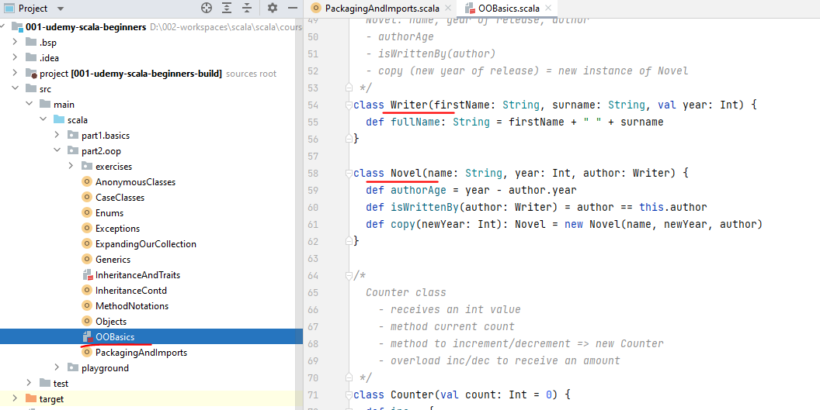

So if I say val Writer is new writer and let's just say for the sake of it, that I give it some parameters. "Rock the JVM" and the year 2018, well, I can actually use the Writer class, as is so package members are accessible by their simple name.

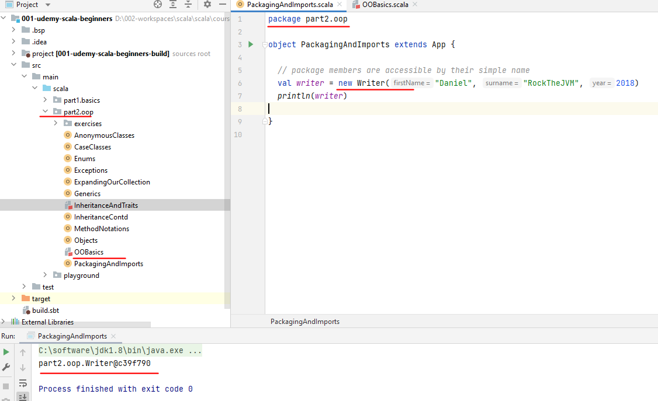

All right, if you're not in the proper package, you need to import the package. If, for example, let's say in the playground package, I. right click and create a new Scala class and I'm going to call this, say, Cinderella, just for the sake of it. All right. And I'm going to close it because I don't really need it now in order to use the Cinderella class - new Cinderella, notice that the idea suggesting that I import the package, so if I double click here, the import statement is automatically added. If I don't do the import, then the compiler will not find the Cinderella name. OK, so in order for you to be able to use a class or a trade or a top level definition by their simple name, you either need to be in the same package with them or you need to import them from their proper package.

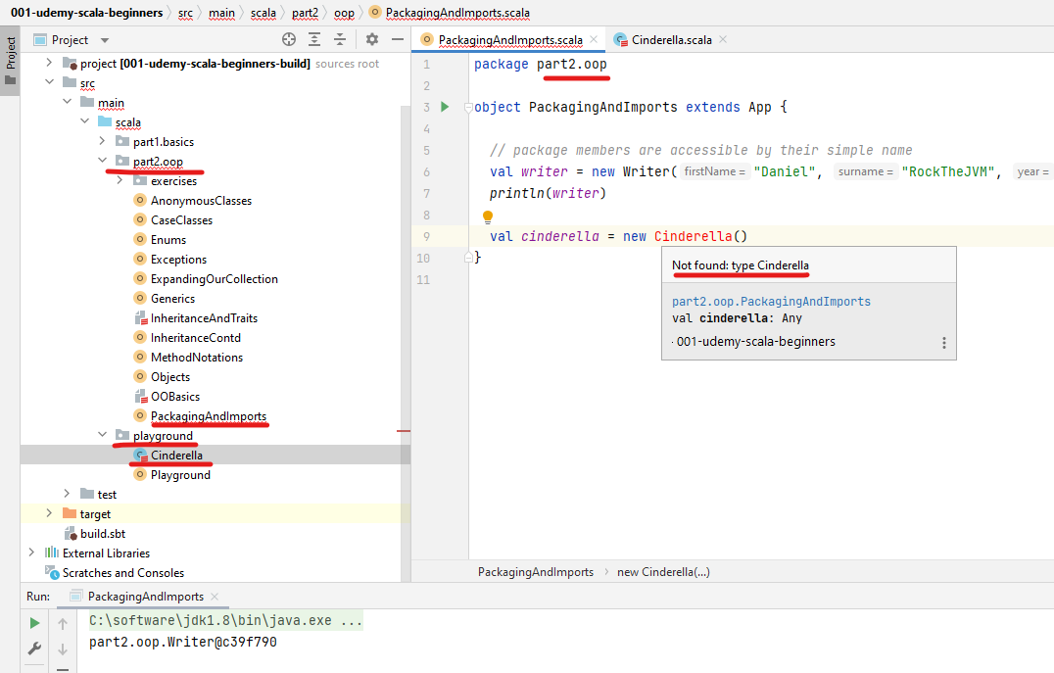

If you still don't want to import the package and you still want to access the central class. There is another way to do it, and that is by using the fully qualified name. So you can say playground dot Cinderella. And this tells the compiler where to look for the Cinderella class and that is in the package playground. So this is called a fully qualified class name. So playground that Cinderella is fully qualified name. All right, so let's just import the package back. And used in Iraq by her simple name, now a little bit about packages, so packages are ordered hierarchically. And the hierarchy is given by this dot notation, so the part to OP package, for example, is a sub package of the lectures package and this maps the folder structure in the file system. So on the filesystem under the source folder, we have the letters folder in the part to folder. This is the best practice and is very rarely broken yds like until you do this by default. So we don't even need to care about this too much. All right.

package part2.oop

import playground.Cinderella

object PackagingAndImports extends App {

*// package members are accessible by their simple name*

val *writer* = new Writer("Daniel", "RockTheJVM", 2018)

*println*(*writer*)

*// import the package*

val *cinderalla* = new Cinderella *// playground.Cinderella = fully qualified name*

*// packages are in hierarchy*

*// matching folder structure.*

}

So you've learned about packages and you've learned about imports, how they are ordered and how to use them. And now I want to talk about a very Scala specific code organizing structure, which is called a package object. This originated from the problem that sometimes we may want to write methods or constants outside of basically everything else. We can now only write classes and trades and objects, and we can only access values or methods or constants from them. But we might need to have some kind of universal constants or universal methods that reside outside classes so we don't need to resort to classes to access them. So package objects were created for this purpose. The way that we create a package object is to right click on the package that we would like this to sit in and right click and create a new package object.

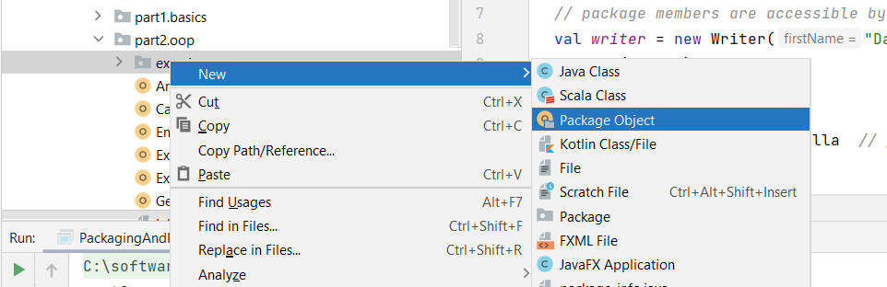

package part2

package object oop {

}

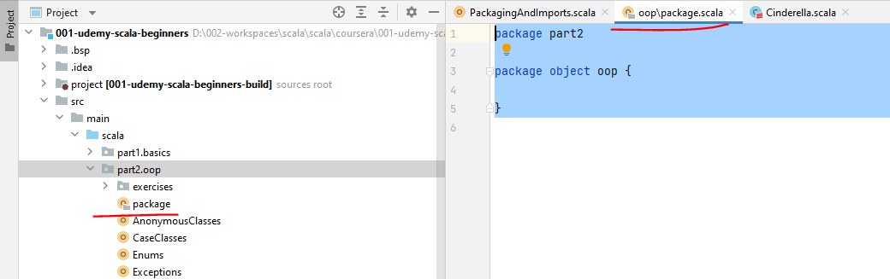

Notice that the ID didn't really ask for anything else about what name should it have or where should it sit. And that is because package objects can only be one per package. The name of this package object is part2oop, the same as the package that this resides in. And the file that this package is going to sit in is called package.scott. This is a naming convention and is like the packaging hierarchy, very, very rarely broken. So a package can only contain one package object with the same name in a file called package.scala, and inside this package object, we can actually define methods or constants and use them by their simple name throughout the entire rest of the package. So say, for example, that we have a universal method called sayHello, which returns Unit and just prints something to the console and say Hello Scala, and a value called Speed of light. Which is 299792458, that's meters per second.

package part2

package object oop {

def sayHello(): Unit = *println*("Hello Scala")

val *SPEED_OF_LIGHT* = 299792458

}

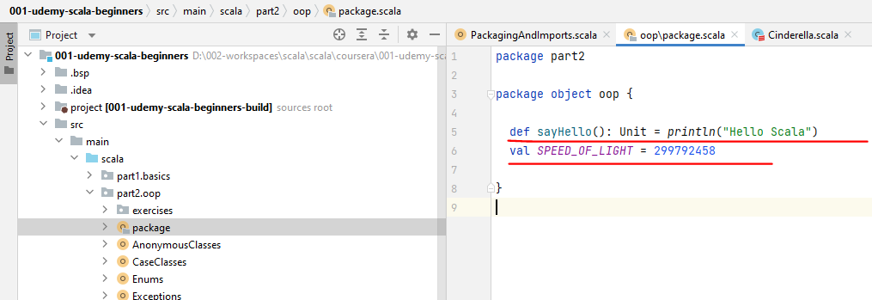

So in throughout the entire package, now I can access these methods. So, for example, I can call or say hello just like that by their simple name, because this package object makes these things the method and the value visible throughout the entire package. All right, so just like that now, package objects are pretty rarely used in practice, but I wanted you to know that they exist and they're quite handy if you do need them.

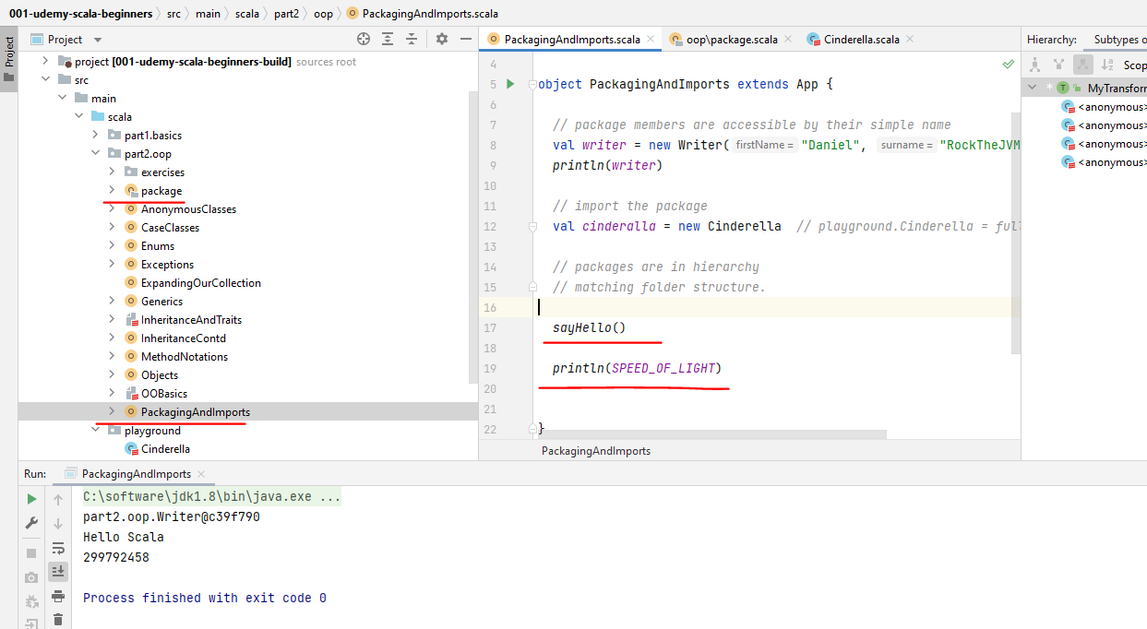

So let's dive a little bit deeper into imports now. So let's go to the playground here and let's create a new Scala class, let's call this Prince Charming. This time around, we're living a freakin fairy tale. OK, so we have Cinderella and Prince Charming, right? So if I want to use Prince Charming and assign it to a valuable prince, you Prince Charming. Notice how the IDE grouped the two imports together and saying import playground dot curly brace.

package part2.oop

import playground.{Cinderella, PrinceCharming}

object PackagingAndImports extends App {

*// package members are accessible by their simple name*

val *writer* = new Writer("Daniel", "RockTheJVM", 2018)

*println*(*writer*)

*// import the package*

val *cinderalla* = new Cinderella *// playground.Cinderella = fully qualified name*

*// packages are in hierarchy*

*// matching folder structure.*

*sayHello*()

*println*(*SPEED_OF_LIGHT*)

*// imports*

val *prince* = new PrinceCharming

}

And then the two types that I want to use by their simple name. Now, if the list gets too long, you can always say import playground dot underscore, which basically makes everything in the package playground imported by their simple name as best practice only use underscore if you actually need it. In most cases, this kind of importing will do. There's also the possibility of doing name aliasing, add imports. So watch what I'm writing. I'm going here to the Cinderella import and I'm going to use a little ursine and I'm going to call Cinderella a princess. Even though Cinderella is not a princess, you get the picture. So instead of Cinderella, I'm using the name Princess to refer to the playground Cinderella class. This feature is useful if for some reason you need to import more than one class with the same name from different packages and this aliasing will solve your naming conflicts.

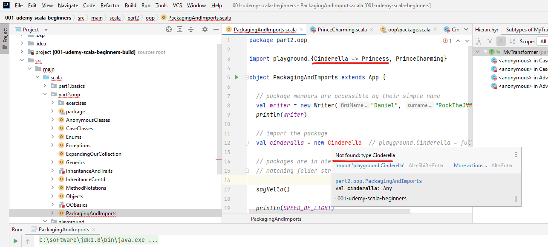

So, for example, if you have import java, java.util.Date pretty popular and import java.sql.date, which are two different dates. Then if you say val d was new date, then the compiler will assume that this is the first import. So this will say. That d is a java.util.date, if for some reason you need both of these in your program, then you have two options. So say, for example, you want a java.util.date and a java.sql.date. One option is to use fully qualified names.

package part2.oop

import playground.{PrinceCharming, Cinderella as Princess}

import java.util.Date

import java.sql.Date

object PackagingAndImports extends App {

*// package members are accessible by their simple name*

val *writer* = new Writer("Daniel", "RockTheJVM", 2018)

*println*(*writer*)

*// import the package*

val *cinderalla* = new Princess *// playground.Cinderella = fully qualified name*

*// packages are in hierarchy*

*// matching folder structure.*

*sayHello*()

*println*(*SPEED_OF_LIGHT*)

*// imports*

val *prince* = new PrinceCharming

val *d* = new java.util.Date()

val *d1* = new java.sql.Date(2018, 5, 4)

*println*(*d*)

*println*(*d1*)

}

*Output:*

*part2.oop.Writer@c39f790*

*Hello Scala*

*299792458*

*Wed Nov 17 13:52:04 IST 2021*

*3918-06-04*

The other option is to use aliasing, so the way that you would do that is for one of the imports that you would like to rename to use curly braces and actually put in some erro after the name of the class that you want to import and give it another name. So date will be imported under the name SqlDate, for example, and you can simply use the name SqlDate here.

package part2.oop

import playground.{PrinceCharming, Cinderella as Princess}

import java.util.Date

import java.sql.{Date => SqlDate}

object PackagingAndImports extends App {

*// package members are accessible by their simple name*

val *writer* = new Writer("Daniel", "RockTheJVM", 2018)

*println*(*writer*)

*// import the package*

val *cinderalla* = new Princess *// playground.Cinderella = fully qualified name*

*// packages are in hierarchy*

*// matching folder structure.*

*sayHello*()

*println*(*SPEED_OF_LIGHT*)

*// imports*

val *prince* = new PrinceCharming

val *d* = new java.util.Date()

val *d1* = new SqlDate(2018, 5, 4)

*println*(*d*)

*println*(*d1*)

}

All right. So option number two is to use aliasing or so, you know, quite a lot already. Finally, I want to talk about default imports. Default imports are packages that are automatically imported without any intentional import from your side. So some examples include Java Langue, which contains the string object exception or that kind of good stuff. Also, the top level Scala package, which contains and nothing function and all the basic stuff in Scala and also scala.Predef. For example, the print line function and the question question, question expression is important from Scala Predef, you rarely, if ever need to worry about this stuff. All right.

package part2.oop

import playground.{PrinceCharming, Cinderella as Princess}

import java.util.Date

import java.sql.{Date => SqlDate}

object PackagingAndImports extends App {

*// package members are accessible by their simple name*

val *writer* = new Writer("Daniel", "RockTheJVM", 2018)

*println*(*writer*)

*// import the package*

val *cinderalla* = new Princess *// playground.Cinderella = fully qualified name*

*// packages are in hierarchy*

*// matching folder structure.*

*sayHello*()

*println*(*SPEED_OF_LIGHT*)

*// imports*

val *prince* = new PrinceCharming

*// 1. use FQ names*

val *d1* = new java.util.Date()

val *d2* = new java.sql.Date(2018, 5, 4)

*// 2. use aliasing*

val *d3* = new Date

val *d4* = new SqlDate(2018, 5, 4)

*// default imports*

*// java.lang - String, Object, Exception*

*// scala - Int, Nothing, Function*

*// scala.Predef - println, ???*

*println*(*d1*)

*println*(*d2*)

*println*(*d3*)

*println*(*d4*)

}

So let's recap. You've learned that a package is basically a bunch of definitions under the same name. And the top level package definition allows members to use each other with their simple name to use a definition by their simple name. You need to either be in the same package with them or import their package. You've also learned that packages mirror the file structure. This is best practice and is very rarely broken. You've also learned about fully qualified name and also learned about package objects which hold standalone methods or constants. In a package package. Objects can be one per package in a file called package.scala. Finally, you've learned about the various ways of doing imports and about name aliasing.

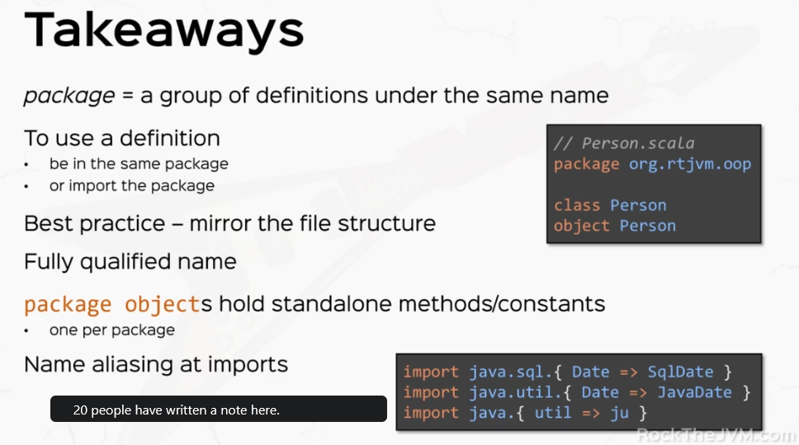

## Functional Programming with Scala

### Whats a Function really?

Create a new package and let's just call this part3.fp functional programming. Create a Scala class called Function. And make this an object, of course, and extends App. The whole purpose of the functional programming section is to use and work with functions as first class elements. What that means is that we want to work with functions like we would with plain values. That's the dream. The problem is that we come from an object oriented world. And when you come from an object oriented world, basically everything is an object. That means it's an instance of some kind of class. This is how the JVM was originally designed for Java for instances of classes and nothing else. So the only way that you could simulate functional programming was to use classes and instances of those classes. So in Java and also in object oriented Scala, we would write a class called something, something like an action with a method called, say, execute, which for example, takes an Int and returns a string or something else.

package lectures.part3fp

object WhatsAFunction extends App {

// DREAM: use functions as first class elements

// problem: oop

}

class Action {

def execute(element: Int) String = ???

}

So we would write something like this, we would write classes and methods and the way that you would use these things as quote unquote functions, would be to instantiate this class either anonymously or not anonymously. So if you remember what we did with my list, if we go to MyPredicate here right.

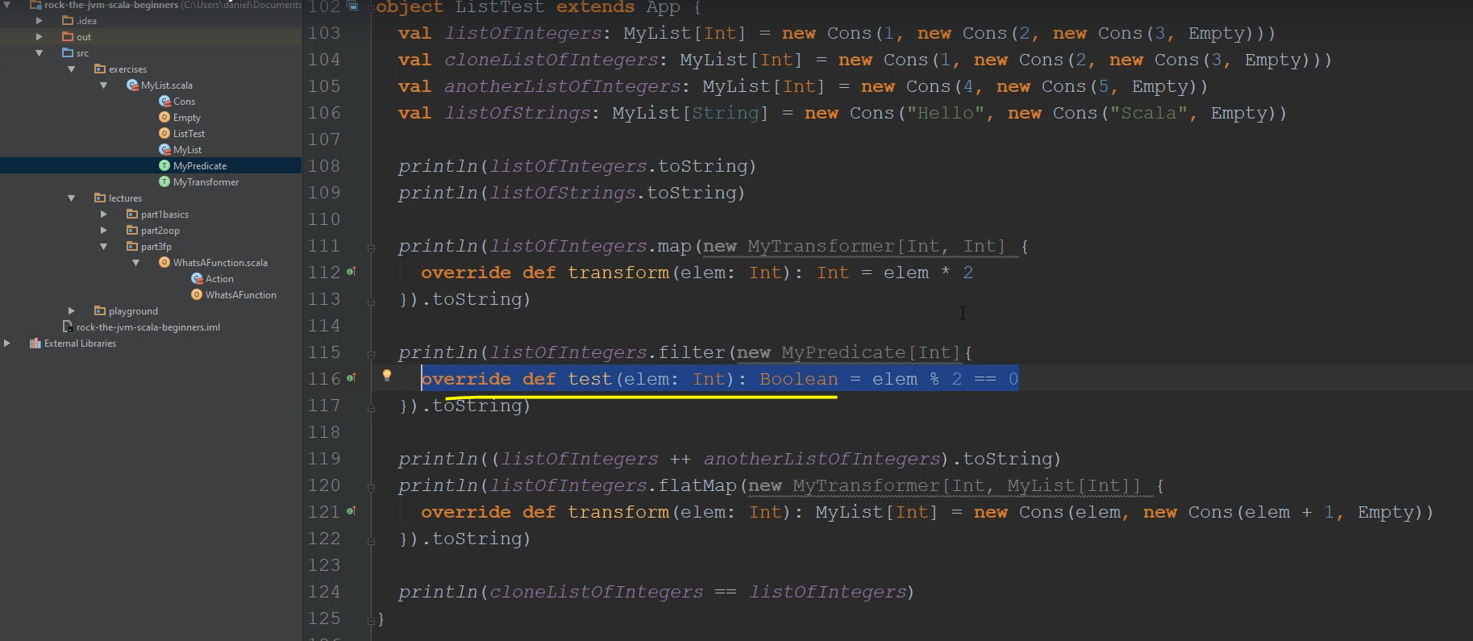

At the end, we are using predicates and transformer's like "functions". But there are actually instances of these classes with on the spot override method definitions. So this is how you would work with these functions, so to speak. You would actually work with these function simulations, right.

trait MyPredicate[-T] {

def test(elem: T): Boolean

}

trait MyTransformer[-A, B] {

def transform(elem: A): B

}

*println*( *listOfIntegersTwo*.map(new MyTransformer[Int, Int] {

override def transform(elem: Int): Int = elem * 2

}).toString)

*println*( *listOfIntegersTwo*.filter(new MyPredicate[Int] {

override def test(elem: Int): Boolean = elem % 2 == 0

}))

At most, what you would do would be to genericized, an abstract away most of the boilerplate so that you could use generic types. So our action here would be some kind of Abstract type, like a trait and action would take parameters, type parameters. And we would say that this action execute takes an element of type A and returns an element of Type B. So this is at most what an object oriented language would be able to do. Again, this is how the JVM is naturally constructed. So Scala had to resort to some clever tricks to make it look like a truly functional language. So a better design would be to just rename this to let's call MyFunction and instead of this execute, rename this to apply, which by now, you know, that has a special meaning in Scala.

object WhatsAFunction extends App {

// DREAM: use functions as first class elements

// problem: oop

}

trait MyFunction[A, B] {

def apply(element: A): B

}

So if we have a little my function, let's say new super function, well let's say Doubler, which is a new MyFunction, let's say this double's an Int. So this is my function from Int to Int and the override def apply takes an Int element of type Int and returns an Int and lets just say returns 11 times two. This is an instance of this little function like class. But the advantage of Scala as opposed to Java is that we can actually call Doubler of two like it were a function. So Doubler acts like a function.

package part3.fp

object WhatsAFunction extends App {

*// DREAM: use functions as first class elements*

*// problem: oop*

val *doubler* = new MyFunction[Int, Int] {

override def apply(element: Int): Int = element * 2

}

*println*(*doubler*(2))

}

trait MyFunction[A, B] {

def apply(element: A): B

}

So if I can run this doubler actually calls the apply method and this is going to print the number 4 to the console.

All right, so for now, Doubler, which is an instance of a function like class, can be called like a function. Now, the interesting thing is that Scala supports these function types out of the box and the function types are a function1 or function2 or function3 up to function22. But for function with 1 parameter and one result, this is function1 with A and B..

So this is a function type which is by default supported in scale. So if for example, I create a val, let's call this a stringToIntConvertor. All right. And this will be a new function1 and look at the IDE. So the IDE already suggests the function types for me. So new function one with say stringToInt and they work in the same way. So override def apply with string which is of type string and returns and end and then just say the implementation is stringToInt. So just as a simple implementation and now I can actually call this string to end converter and let's just say I call it "", call it with the string say 3 plus 4. So this thing returns and seven at the console.

package part3.fp

object WhatsAFunction extends App {

*// DREAM: use functions as first class elements*

*// problem: oop*

val *doubler* = new MyFunction[Int, Int] {

override def apply(element: Int): Int = element * 2

}

val *stringToIntConverter* = new Function[String, Int] {

override def apply(str: String): Int = str.toInt

}

*println*(*stringToIntConverter*("3") + 4)

}

trait MyFunction[A, B] {

def apply(element: A): B

}

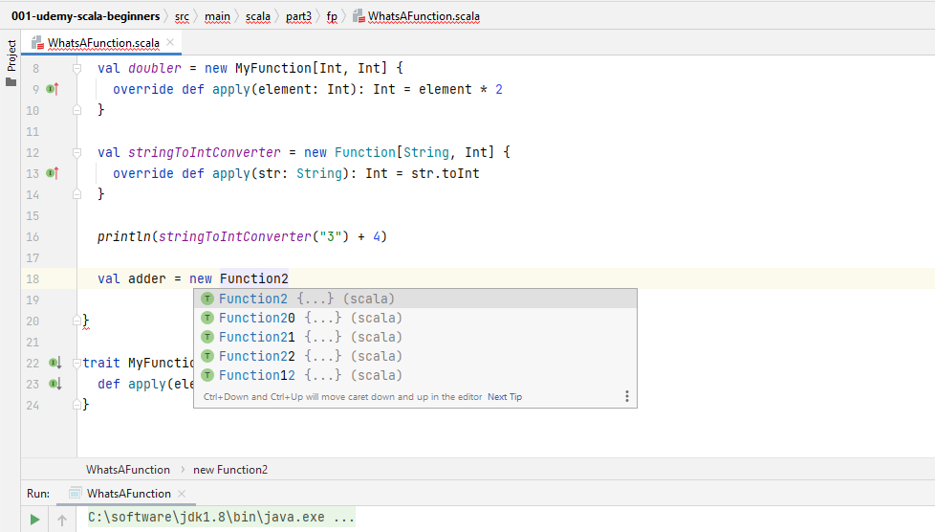

All right, now, by default, Scala supports these function types up to 22 parameters, so, for example, if I have a function that takes and Int and returns an Int, let's say adder, that would be a new function, too, with Int and Int.

So these are the parameter types and this is the result type. And the override def apply takes two parameters, A and B both Int and the return type is Int. And let's just say it returns A plus B for a simple implementation. OK, so this is a proper function. Now the type of atter is. If I hover, it's this guy isn't in error int, which is syntactic sugar for Function2.

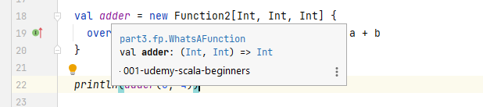

So if I say adder is a function2 with Int and Int, this is the correct type. Right. But a syntactic sugar for this type is Int and in parentheses these signify the parameters and error int. This is a syntactic sugar for Function2. So this is getting closer to functional programming. So we have function types, for example, Function2 with two type parameters and the result type parameter we write this as. A, B => R. We're going to start using these a lot more as we go through the functional programming section, but the elephant in the room in this lecture is the major takeaway, which is and I'm writing this in all caps, all Scala functions are objects or instances of classes deriving from Function1, Function2, etc..

package part3.fp

object WhatsAFunction extends App {

*// DREAM: use functions as first class elements*

*// problem: oop*

val *doubler* = new MyFunction[Int, Int] {

override def apply(element: Int): Int = element * 2

}

// function types = Function[A,B]

val *stringToIntConverter* = new Function[String, Int] {

override def apply(str: String): Int = str.toInt

}

*println*(*stringToIntConverter*("3") + 4)

val *adder* = new Function2[Int, Int, Int] {

override def apply(a: Int, b: Int): Int = a + b

}

*println*(*adder*(3, 4))

*// Function types Function2[A, B, R] === (A,B) => R*

*// ALL SCALA FUNCTIONS ARE OBJECTS*

}

trait MyFunction[A, B] {

def apply(element: A): B

}

So we're laying the groundwork here for Scala as a functional programming language based on the Java Virtual Machine, which was never originally designed with functional programming in mind. The JVM was designed with object orientation in mind and as we'll see throughout the section, through a series of syntactic features, we'll get to Scala as a truly functional language. All right. So let's practice what we've learned. I want you to go through a series of very simple exercises. First, I want you to define a function which takes two strings and concatenate them. So this is dead simple. I just want you to use this function type. All right, second, I want you to go ahead and go to the my list implementation and transform the MyPredicate. And MyTransformer into function types and see what you find. Third, I want you to go ahead and define a function which takes an argument an Int and returns another function which takes an Int and returns an Int. First of all, I want you to pay for this exercise, define what's the type of the function and how do you do it? How to actually implement this special function, so to speak. So as always, pause the video and think through these exercises and then a couple of seconds I'll jump in with solutions.

/*

1. a function which takes 2 strings and concatenates them

2. transform the MyPredicate and MyTransformer into function types

3. define a function which takes an int and returns another function which takes

an int and returns an int

- what's the type of this function

- how to do it

*/

All right. So I hope you do it. Let's take them in turn. So a function which takes two strings and needs. This is dead simple. So let's call this concatenator, which is of type string, string => string. All right, and the value for that is going to be a new function to do with String, String, String, and the implementation of the apply method is going to be override def apply. This takes two strings, A and B, for example and returns a string and it just concat needs them together. Of course, if I name the parameters differently. So this is the concatenator and if I print concatenate her applied with "Hello" and "Scala". Then I should receive the String "Hello Scala" at the council, which is exactly what we expected now for them my pretty good in my transformer. Let's go back to my list. So switching let's go and investigate how these guys look like. So MyPredicate and MyTransformer are basically function types if you take a closer look. So MyPredicate is basically a function type from T => Boolean and MyTransformer is a function type from A => B right now.

package lectures.part3fp

object WhatsAFunction extends App {

// DREAM: use functions as first class elements

// problem: oop

val doubler = new MyFunction[Int, Int] {

override def apply(element: Int): Int = element * 2

}

println(doubler(2))

// function types = Function1[A, B]

val stringToIntConverter = new Function1[String, Int] {

override def apply(string: String): Int = string.toInt

}

println(stringToIntConverter("3") + 4)

val adder: ((Int, Int) => Int) = new Function2[Int, Int, Int] {

override def apply(a: Int, b: Int): Int = a + b

}

// Function types Function2[A, B, R] === (A,B) => R

// ALL SCALA FUNCTIONS ARE OBJECTS

/*

1. a function which takes 2 strings and concatenates them

2. transform the MyPredicate and MyTransformer into function types

3. define a function which takes an int and returns another function which takes

an int and returns an int

- what's the type of this function

- how to do it

*/

def concatenator: (String, String) => String = new Function2[String, String, String] {

override def apply(a: String, b: String): String = a + b

}

println(concatenator("Hello ", "Scala"))

// Function1[Int, Function1[Int, Int]]

val superAdder: Function1[Int, Function1[Int, Int]] =

new Function1[Int, Function1[Int, Int]] {

override def apply(x: Int): Function1[Int, Int] = new Function1[Int, Int] {

override def apply(y: Int): Int = x + y

}

}

val adder3 = superAdder(3)

println(adder3(4))

println(superAdder(3)(4)) // curried function

}

trait MyFunction[A, B] {

def apply(element: A): B

}

|  |  |
| --- | --- |
| package part2.oop.exercises  abstract class MyHOFList[+A] {  /*  head = first element of this list  tail = remainder of the list ( hold the pointer of the remainder of the list )  isEmpty = is this list empty  add(Int) = returns a new list with this element added  toString = returns a String representation of the list ( override this method )  */  def head: A  def tail: MyHOFList[A]  def isEmpty: Boolean  def add[B >: A](element: B): MyHOFList[B]  def printElements: String  // polymorphic call  override def toString: String = "[ " + printElements + " ]"  // def map[B](transformer: MyHOFTransformer[A, B]): MyHOFList[B]  def map[B](transformer: A => B): MyHOFList[B] 🄌  // def flatMap[B](transformer: MyHOFTransformer[A, MyHOFList[B]]): MyHOFList[B]  def flatMap[B](transformer: A => MyHOFList[B]): MyHOFList[B] ➊  // def filter(predicate: MyHOFPredicate[A]): MyHOFList[A]  def filter(predicate: A => Boolean): MyHOFList[A] ➋  // concatenation  def ++[B >: A](list: MyHOFList[B]): MyHOFList[B]  }  case object EmptyHOFList extends MyHOFList[Nothing] {  def head: Nothing = throw new NoSuchElementException  def tail: MyHOFList[Nothing] = throw new NoSuchElementException  def isEmpty: Boolean = true  def add[B >: Nothing](element: B): MyHOFList[B] =  new ConsHOFList(element, EmptyHOFList)  def printElements: String = ""  **// Higher Order Functions**  // def map[B](transformer: MyHOFTransformer[Nothing, B]): MyHOFList[B] = EmptyHOFList  def map[B](transformer: Nothing => B): MyHOFList[B] = EmptyHOFList  // def filter(predicate: MyHOFPredicate[Nothing]): MyHOFList[Nothing] = EmptyHOFList  def filter(predicate: Nothing => Boolean): MyHOFList[Nothing] = EmptyHOFList  // def flatMap[B](transformer: MyHOFTransformer[Nothing, MyHOFList[B]]): MyHOFList[B]  def flatMap[B](transformer: Nothing => MyHOFList[B]): MyHOFList[B] = EmptyHOFList  def ++[B >: Nothing](list: MyHOFList[B]): MyHOFList[B] = list  }  class ConsHOFList[+A](h: A, t: MyHOFList[A]) extends MyHOFList[A] {  def head: A = h  def tail: MyHOFList[A] = t  def isEmpty: Boolean = false  def add[B >: A](element: B): MyHOFList[B] = new ConsHOFList(element, this)  def printElements: String =  if(t.isEmpty) "" + h  else s"**$**h **$**{t.printElements}"  // def filter(predicate: MyHOFPredicate[A]): MyHOFList[A] =  def filter(predicate: A => Boolean): MyHOFList[A] =  // if (predicate.test(h)) new ConsHOFList(h, t.filter(predicate)) ➍  // if (predicate.apply(h)) new ConsHOFList(h, t.filter(predicate)) ➍  if (predicate(h)) new ConsHOFList(h, t.filter(predicate))  else t.filter(predicate)  /*  [1,2,3].map(n * 2)  = new ConsAdvancedList(2, [2,3].map(n * 2))  = new ConsAdvancedList(2, new ConsAdvancedList(4, [3].map(n * 2)))  = new ConsAdvancedList(2, new ConsAdvancedList(4,  new ConsAdvancedList(6, Empty.map(n * 2))))  = new ConsAdvancedList(2, new ConsAdvancedList(4,  new ConsAdvancedList(6, Empty))))  */  // def map[B](transformer: MyHOFTransformer[A, B]): MyHOFList[B] =  def map[B](transformer: A => B): MyHOFList[B] = ➎  // new ConsHOFList(transformer.transform(h), t.map(transformer));  new ConsHOFList(transformer.apply(h), t.map(transformer)); ➎  /*  [1,2] ++ [3,4,5]  = new Cons(1, [2] ++ [3,4,5])  = new Cons(1, new Cons(2, Empty ++ [3,4,5]))  = new Cons(1, new Cons(2, new Cons(3, new Cons(4, new Cons(5)))))  */  def ++[B >: A](list: MyHOFList[B]): MyHOFList[B] =  new ConsHOFList(h, t ++ list)  /*  [1,2].flatMap(n => [n, n+1])  = [1,2] ++ [2].flatMap(n => [n, n+1])  = [1,2] ++ [2,3] ++ Empty.flatMap(n => [n, n+1])  = [1,2] ++ [2,3] ++ Empty  = [1,2,2,3]  */  // def flatMap[B](transformer: MyHOFTransformer[A, MyHOFList[B]]): MyHOFList[B] =  def flatMap[B](transformer: A => MyHOFList[B]): MyHOFList[B] = ➏  // transformer.transform(h) ++ t.flatMap(transformer)  transformer(h) ++ t.flatMap(transformer)  }  //trait MyHOFPredicate[-T] { // T => Boolean  // def test(elem: T): Boolean  //}  //  //trait MyHOFTransformer[-A, B] { // A => B  // def transform(elem: A): B  //}  object AdvacedHOFListTest extends App {  val listOfIntegers: MyHOFList[Int] = EmptyHOFList  val listOfStrings: MyHOFList[String] = EmptyHOFList  val listOfIntegersTwo: MyHOFList[Int] =  new ConsHOFList(1, new ConsHOFList(2, new ConsHOFList(3, EmptyHOFList)))  val anotherListOfIntegersTwo: MyHOFList[Int] =  new ConsHOFList(4, new ConsHOFList(5, EmptyHOFList))  val listOfStringsTwo: MyHOFList[String] =  new ConsHOFList("Hello", new ConsHOFList("Scala", EmptyHOFList))  println(listOfIntegers.toString)  println(listOfIntegers.toString)  println(listOfIntegersTwo.toString)  println(listOfStringsTwo.toString)  // println( listOfIntegersTwo.map(new MyHOFTransformer[Int, Int] { ➐  println( listOfIntegersTwo.map(new Function1[Int, Int] {  // override def transform(elem: Int): Int = elem * 2  override def apply(elem: Int): Int = elem * 2 ➐  }).toString)  // println( listOfIntegersTwo.filter(new MyHOFPredicate[Int] {  println( listOfIntegersTwo.filter(new Function1[Int, Boolean] { ➐  // override def test(elem: Int): Boolean = elem % 2 == 0  override def apply(elem: Int): Boolean = elem % 2 == 0  }))  println( listOfIntegersTwo ++ anotherListOfIntegersTwo).toString  // println(listOfIntegersTwo.flatMap(new MyHOFTransformer[Int, MyHOFList[Int]] {  println(listOfIntegersTwo.flatMap(new Function1[Int, MyHOFList[Int]] { ➐  // override def transform(elem: Int): MyHOFList[Int] =  override def apply(elem: Int): MyHOFList[Int] = ➐  new ConsHOFList(elem, new ConsHOFList(elem + 1, EmptyHOFList))  }).toString)  } | The revelation that I wanted you to reach was that the predicate and transformer types that we wrote in the object oriented section don't make sense here anymore because we already have function types so we can safely delete them altogether.  And a bunch of things will now not compile, but we can fix them and here we can fix the mildest abstract class by changing the transformer to a Function1. Or to A => B type. And the transformer here is going to be an A => MyList of B type 🄌, and the predicate, as we discussed, is an A => Boolean type ➊, OK? And suddenly all the things now seem more functional programming like. So let's change the function signatures throughout the code.  So my transformer is a nothing to be. All right, transformer, here is a nothing arrow. MyList of B. Predicate is of type Nothing => Boolean. Below, we have filter with MyPredicate, which is of type arrow => Boolean ➋.  ➑  OK, now, predicate.test, it doesn't really make sense anymore, so we can either call predicate.apply ➍, which would make sense or simply predicate, because we can now call it like a function  Again, below transformer is an A => B type ➎. And the transform method, of course, does not exist ➎. We can call apply or we can simply call transformer ➎.  All right. And on flatMap, transformer of A => MyList[B] is just a arrow, MyList[B] ➏. So instead of transform, we can simply leave the apply method,  OK, and now the transformer MyPredicate MyTransformer, don't really make sense and we can replace them with Function1 ➐. OK, and Predicate is a new Function1, one from Int => Boolean. |

All right, and transformer, here is a Function1 from Int to MyList, and these methods are not called transform() and test(), but they are simply called apply(). OK, so we've suddenly turned my list into a more functional collection because it now uses functions as first class values, especially when it comes to map, flatMap and filter. These in particular are called higher order functions ➑. Higher order functions either receive functions as parameters or return other functions. As a result, higher order functions are critical concept to functional programming because it now uses functions as first class values, especially when it comes to map, flatMap and filter. These in particular are called higher order functions. Higher order functions either. Receive functions as parameters or return other functions as a result, higher order functions are critical concept to functional programming. So that was the exercise.

**// Higher Order Functions**

// def map[B](transformer: MyHOFTransformer[Nothing, B]): MyHOFList[B] = EmptyHOFList

def map[B](transformer: Nothing => B): MyHOFList[B] = EmptyHOFList

// def filter(predicate: MyHOFPredicate[Nothing]): MyHOFList[Nothing] = EmptyHOFList

def filter(predicate: Nothing => Boolean): MyHOFList[Nothing] = EmptyHOFList

// def flatMap[B](transformer: MyHOFTransformer[Nothing, MyHOFList[B]]): MyHOFList[B]

def flatMap[B](transformer: Nothing => MyHOFList[B]): MyHOFList[B] = EmptyHOFList

Number two, let's switch back to WhatsAFunction.scala and actually go to exercise number three, which is a special kind of function which returns another function as a result. This is also a **Higher Order Function**. So first of all, we need to decide what type this function is going to take. Well, the type is going to be a Function1 because first it takes an Int as a parameter ➒. So this is the only parameter that this Function receives. So Function1 and the parameters are going to be Int. And the return type is another function which takes an Int and returns an Int. So the return type is going to be Function1 of Int and Int. So this is going to be the final type of our special function. Let's use it. So val, let's call this special function which is of type this guy copied and pasted, so is it's going to be a new Function of this type and the override def apply takes an Int, let's say X and returns Function1 with Int and int. So because it returns a function, one with Int and Int, and it will return a new Function1, with Int and Int, and so it will have to return an instance of Function1, right.

// Function1[Int, Function1[Int, Int]]

val **superAdder**: Function1[Int, Function1[Int, Int]] = new Function1[Int, Function1[Int, Int]] { ➒

override def apply(**x**: Int): Function1[Int, Int] = new Function1[Int, Int] {

override def apply(y: Int): Int = **x** + y

}

}

OK, and the override def apply here will take another value y, which is Int and returns an Int. OK, now we are free to supply an implementation here, because I didn't really give it to you in the exercise, so let's just say that this just adds to two numbers, X plus Y. OK, so because X is defined in the upper function over here. X is visible inside the function implementation, which starts here, so X is also visible inside the result value. Let's rename this special function, let's call this super atter because it's more suggestive of its implementation. All right. And let's create a little value val adder let's call this adder3. That's because I'm going to call superAdder with parameter 3. Now, adder3 here is a new function. So the type of adder3 is Int => Int, which is a Fucntion1 from Int to Int. Now if I println adder3, adder3 with parameter 4 for example, then this will return 7 because the implementation of adder3 is this guy which adds X, which in this case is 3 passed to superAdder before, and Y which is the actual parameter. So if I click and run. I'm going to see the value 7 here in the console.

package part3.fp

object WhatsAFunction extends App {

*// DREAM: use functions as first class elements*

*// problem: oop*

val *doubler* = new MyFunction[Int, Int] {

override def apply(element: Int): Int = element * 2

}

val *stringToIntConverter* = new Function[String, Int] {

override def apply(str: String): Int = str.toInt

}

*println*(*stringToIntConverter*("3") + 4)

val *adder* = new Function2[Int, Int, Int] {

override def apply(a: Int, b: Int): Int = a + b

}

*println*(*adder*(3, 4))

*// Function types Function2[A, B, R] === (A,B) => R*

*/\**

*1. a function which takes 2 strings and concatenates them*

*2. transform the MyPredicate and MyTransformer into function types*

*3. define a function which takes an int and returns another function which takes an int*

*and returns an int*

*- what's the type of this function*

*- how to do it*

*\*/*

def concatenator: (String, String) => String = new Function2[String, String, String] {

override def apply(a: String, b: String): String = a + b

}

*println*(*concatenator*("Hello ", "Scala"))

*// Function1[Int, Function1[Int, Int]]* ➊

val superAdder: Function1[Int, Function1[Int, Int]] = new Function1[Int, Function1[Int, Int]] {

override def apply(x: Int): Function1[Int, Int] = new Function1[Int, Int] {

override def apply(y: Int): Int = x + y

}

}

val *adder3* = *superAdder*(3)

*println*(*adder3*(4))

println( superAdder(3)(4) ) 🄌

}

*Output:*

*7*

In the same fashion, I can actually write print line superAdder, applied with parameter 3 and parameter 4 🄌. Notice how weird this is so super adder applied with 3 returns, a Function1 and then I can call that with parameter 4. So if I run this guy I'm also going to see the value of 7. This special function, so to speak, is called a **Curried Function** ➊.

Curried functions have the property that they can be called with multiple parameter lists just by their mere definition. So a Curried function actually receives some kind of parameter and returns another function which receives parameters 🄌 and ➊. So basically super error can be called with multiple parameter lists. To get to the final result. We are going to talk about higher order functions and curried functions in the next videos. But I wanted you to get a taste of what occurred. Function looks like.

So let's recap our main motivation when starting the functional programming section was that we wanted to use functions as first class programming elements. That is, we want to be able to pass functions as parameters or return functions as a result. So we basically want to be able to work with functions like we are able to work with any other kind of values. But the problem is that Scala works on top of the Java virtual machine, which was never designed for functional programming in the first place. It was designed for Java, for which the first class programming elements are instances of classes. Now the only solution that would work for a functional programming language is to turn all Skoller functions into instances of special kind of function like types. And in Scala, we have function treats of up to twenty two parameters and a function trade looks like this. Ignore the variance modifiers. For now we also have syntactic sugar for function types.

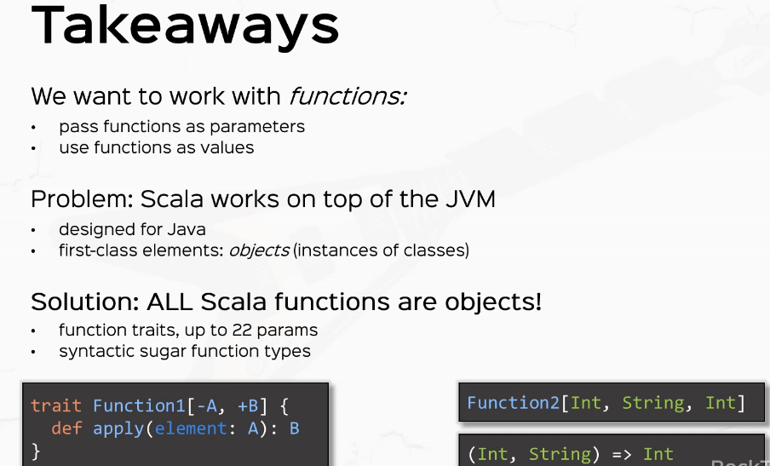

For example, if we have a function to which receives two parameters indenturing and the return type is an end. This function to type has the sugar in string error int and we're going to use these sugars from now on. All right. So quite a promising start in this journey towards a truly functional language.

### Anonymous Functions

Let's continue the journey towards functional programming with anonymous functions. So you now know about function types. Now, the problem is that instantiating a function is still very much tied to the object oriented way. So if I define a value doubler, which doubles an end, for example, I would need to create a new function, one with intent and and then override def apply with an X, which is an end, and then return X times two. So this is basically the still object oriented way of defining an anonymous function and instantiating it on the spot.

package lectures.part3fp

object AnonymousFunctions extends App {

val doubler = new Function1[Int, Int] {

override def apply(x: Int) = x * 2

}

}

Now in Scala, the way that we do that is by just deleting all this crap and just say X and Arrow X times two. So this is basically the exact equivalent expression.

package lectures.part3fp

object AnonymousFunctions extends App {

// anonymous function (LAMBDA)

val doubler = (x: Int) => x * 2

}

So what this does it instantiates a new function, one with the override def apply, which takes an X, which is an end and returns X times to this is syntactic sugar for all that crap, and it's called an anonymous function or a lambda. Now the name Lambda comes from the term lambda calculus, which is the mathematical representation of functional programming. This was formalized by Alonzo Church sometime in the 1930s for quite a long time ago, roughly at the same time as Alan Turing formalized the computing machines that we use today. But now in just an abuse of terminology, so to speak, this in our context will be called a lambda. So we will equate anonymous function with a lambda. Now some syntax rules. So this lambda thing - (x: Int) => x * 2 - is a value, which is basically an instance of function1. Now, what is a type of doubler? Well, it's the type Int => Int so we can actually declare it as such. So we can declare that as Int => Int and then equals this guy.

// anonymous function (LAMBDA)

val doubler: Int => Int = (x: Int) => x * 2

OK, now given the fact that I've declared Doubler to be an integer Int, I can actually remove this type and let it be matched by the compiler just for a shorthand of notation.

// anonymous function (LAMBDA)

// val doubler: Int => Int = ~~(~~x~~:~~ ~~Int)~~ => x * 2

val doubler: Int => Int = x => x * 2

So if the compiler already knows that this value should be an Int => Int, then it will assume that the expression here will match its type's. So x will be an Int and the return value is going to be x * 2 and all the types will match. So the compiler will help you get shorter code.

// anonymous function (LAMBDA)

val doubler: (x: Int) => x * 2

So it will either do that or it will help you with type inference. So again, if I emit the type, then the compiler will not know what kind of expression this will be in.

val doubler: x => x * 2

So you need to specify the correct types here.

// anonymous function (LAMBDA)

val doubler: (x: Int) => x * 2

All right, now, syntax rules of what happens if you have multiple parameters in. Let's say we have a vowel called atter, which is a function that adds to numbers. So in that case, we'll have a hint and B, end arrow A plus B.

// multiple params in a lambda

val adder: (Int, Int) => Int = (a: Int, b: Int) => a + b

If I do want to supply the type for this function, I must put in the arguments in between parentheses. So I'm going to say Int, Int in between parentheses and then => Int. Notice in the previous case, I wouldn't need to do that so I could just simply say Int. Right. But if you have multiple parameters, you have to put them in between parentheses. Cool. Now what happens if you don't have any parameters? So let's say we have a value which says just do something. Then the syntax for a no parameter Lambda is parenthesis, parentheses, arrow, and the value that I want to return, say 3.

// no params

val justDoSomething: () => Int = () => 3

All right, so parentheses error three is a no parameter lambda that just returns the value of three and the type four, that is parentheses error int. Now, I want you to pay very close attention to something, so if I print line, just do something versus print lining, just do something parentheses.

// careful

println( justDoSomething ) // function itself

println( justDoSomething() ) // call

What do you think? Will happen. Well, let's go ahead and find out what's right, click and run. So the first in line prince, this guy, which clearly is an instance of something, so basically Prince the function itself and just do something called actually Prince the value returned by that function. Now, you've probably gotten used to this style of calling methods, but when it comes to lambdas, you must call them with parentheses. So be very careful.

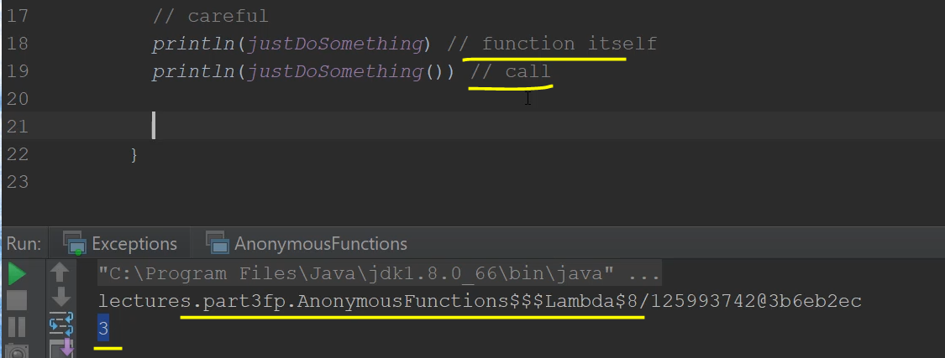

This is the function itself. And this is the actual call, careful now, another way of writing lambdas is to use curly braces. This is commonly used syntax and style in practice, so, for example, if I declare a val, let's say string to it, this is a a common example. And in practice, we often use curly braces. And at the level of the open curly brace, we say string, which is a string arrow. And right below we write the implementation. So this is common style, it's not always loved, but this style is sometimes used.

// curly braces with lambdas

val stringToInt = { (str: String) =>

str.toInt

}

All right. All right. Let's fill in the pile of syntactic sugar with more syntactic sugar. Watch what I'm writing, let's say I have a well called nice incremental year, which which is a function of type and Arin's, which just increments the parameter. And normally I would write something like X and Arrow X plus one. All right. But a shorter way to write this is what's this underscore plus one?

// MOAR syntactic sugar

val niceIncrementer: Int => Int = _ + 1 // equivalent to x => x + 1

This is equivalent to x => x + 1 to further shorthand the notation. If, for example, I have two parameter function, let's call this nice atter, which is of type and end int Arin's instead of saying a B or A plus B, we could just simply say. Underscore plus underscore where each underscore is a different parameter. So this is equivalent to a B or A plus B.

val niceAdder: (Int, Int) => Int = _ + _ // equivalent to (a,b) => a + b

Each underscore stands for a different parameter. This notation is extremely useful in practice when you want to change a higher order, function calls. But please note that the underscore notation is extremely contextual. If you miss the type, the compiler won't know what each underscore means.

val niceAdder~~: (Int, Int) => Int~~ = _ + _ // equivalent to (a,b) => a + b

So if I delete this type. If I delete this guy, the compiler won't know which underscore means what and not even how many parameters this guy has. So the compiler has to be 100 percent sure of the function definitions so that it can safely replace each underscore with each parameter of the proper type.

val niceAdder: (Int, Int) => Int = _ + _ // equivalent to (a,b) => a + b

All right. Now let's practice what we've learned. So I want you to do a couple of exercises. First, I want you to go to my list and I want you to replace all function X calls with lambdas. OK, second exercise, I want you to define or rewrite the special atter that we wrote in the previous video, the curried one as an anonymous function. So two very simple exercises

package lectures.part3fp

object AnonymousFunctions extends App {

// anonymous function (LAMBDA)

val doubler: Int => Int = (x: Int) => x * 2

// multiple params in a lambda

val adder: (Int, Int) => Int = (a: Int, b: Int) => a + b

// no params

val justDoSomething: () => Int = () => 3

// careful

println( justDoSomething ) // function itself

println( justDoSomething() ) // call

// curly braces with lambdas

val stringToInt = { (str: String) =>

str.toInt

}

// MOAR syntactic sugar

val niceIncrementer: Int => Int = _ + 1 // equivalent to x => x + 1

val niceAdder: (Int, Int) => Int = _ + _ // equivalent to (a,b) => a + b

/*

1. MyList: replace all FunctionX calls with lambdas

2. Rewrite the "special" adder as an anonymous function

*/

val superAdd = (x: Int) => (y: Int) => x + y

println(superAdd(3)(4))

}

|  |  |
| --- | --- |
| object ListTest extends App {  val *listOfIntegers*: MyList[Int] = new Cons(1, new Cons(2, new Cons(3, Empty)))  val *cloneListOfIntegers*: MyList[Int] = new Cons(1, new Cons(2, new Cons(3, Empty)))  val *anotherListOfIntegers*: MyList[Int] = new Cons(4, new Cons(5, Empty))  val *listOfStrings*: MyList[String] = new Cons("Hello", new Cons("Scala", Empty))  *println*(*listOfIntegers*.toString)  *println*(*listOfStrings*.toString)  // println( listOfIntegers.map( new Function1[Int, Int] { 🄌  // override def apply(elem: Int): Int = elem * 2  // })  *println*(*listOfIntegers*.map(elem => elem * 2).toString) 🄌  // println( listOfIntegers.filter( new Function1[Int, Int] { ➊  // override def apply(elem: Int): Boolean = elem % 2 == 0  // })  *println*(*listOfIntegers*.filter(elem => elem % 2 == 0).toString) ➊  *println*((*listOfIntegers* ++ *anotherListOfIntegers*).toString)  // *println*(*listOfIntegers*.flatMap( elem => ➋  // new Cons(elem, new Cons(elem + 1, Empty))).toString )  println(listOfIntegers.flatMap( elem => ➋  new Cons(elem, new Cons(elem + 1, Empty))).toString )  *println*(*cloneListOfIntegers* == *listOfIntegers*) | First exercise, we switch to my list and let's kill all these function calls, so first function this one we call just elem => elem multiplied an element 2. So instead of this guy, I'm just going to say elem => elem * 2. And that is it. 🄌  ➊ This guy, new function one which says elem % 2 == zero. So this is are a little predicate. So I'm going to say elem => elem % 2 == 0  ➋ Now with a flatMap, this function elem from each element, it returns a new Cons. So basically, we have an element of type Int. And from this element, I create a new Cons and let's clean up this code. |

Now, if you want an even shorter notation, we could simply say underscore times two and underscore mod two is equal to zero.

println(listOfIntegers.map(**_** * 2).toString) 🄌

println(listOfIntegers.filter(**_** % 2 == 0).toString) ➊

But the underscore notation doesn't work for this lambda because we use the element two times in the implementation.

println(listOfIntegers.flatMap( elem => ➋

new Cons(elem, new Cons(elem + 1, Empty))).toString )

And as we saw earlier, each underscore stands for a different parameter. So basically you can't use an underscore multiple times. Now, switching back to anonymous functions, let's rewrite the special order as an anonymous function. This is very simple to write, and when I write it, it will seem very obvious, but it's sometimes hard to think about this. So I'm going to define it right now. I'm going to call it a superAdd.

val superAdd = (x: Int) => (y: Int) => x + y

println( superAdd(3)(4) )

And this will be. X: Int and this will return another function, y: Int => x + y? So this is the lamda version of the curried function that we wrote earlier. If you remember, we had all these nested new function, one with overrides in place. So this is a much more elegant and shorter way to write it. Of course, it works the same way. So if I had superAdd called with arguments 3 and then with the argument 4 this would work the same way and it would print the number 7.

We're going to discuss currient functions very shortly, but for now, these are the solutions to these two very simple exercises.

All right, recap time. So our problem was that instead of passing anonymous function x instances every time, which is 1. cumbersome and very hard to test and still object oriented, we can use lambdas. Now, the anatomy of a lambda looks like this parameters in which each parameter has a name and a type. Then the implementation, which is a single expression, the return type is always inferred and parentheses are mandatory from one there, one parameter as we've seen in the code. So this is heavy syntactic sugar for instantiating anonymous function X types.

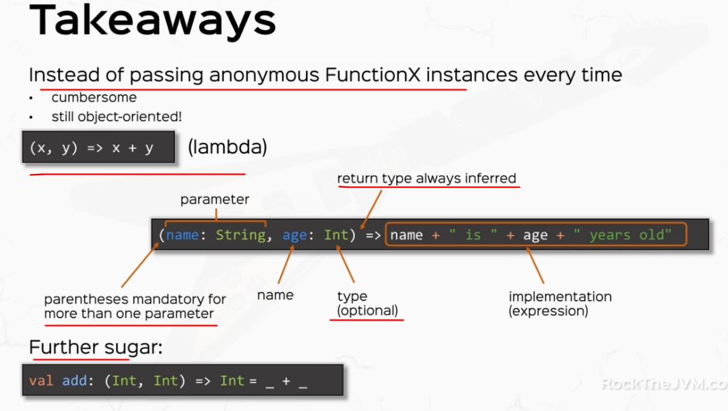

But we also seen further sugar with underscores. All right. So now you've learned lambdas which are foundational to functional programming.

### Higher Order Functions and Curries

We're going to put another solid brick into our functional programming fundamentals. We're going to talk about higher order functions and curried functions. We touched upon these concepts very briefly in the last videos, but here we'll discuss them in depth. All right. So in our development environment, let's just create a new color application in the Part three functional programming package. And let's call this HOFsAndCurrys, of course, make this an object and and extends app. All right, so in the last videos you saw function types, my question for you is what keeps us from defining a super function with a type? And I'm not going to have any limits here. Let's say I have the super complex function type like Int arrow parentheses, string, comma, inseparable boolean error in here, which at the end has an arrow and the return type is Int => Int.

So what keeps us from defining such a function? Well, nothing. But how do you read this kind of function? Now try to pause the video for one second and try to read this function type. So what kind of parameters does this function have and what is the return type of this function? So first, let's look at the return type of this super function. The return type is at the right hand side of this arrow here. So the return type of the super function is another function which takes an Int and returns an Int.

package lectures.part3fp

object HOFsCurries extends App {

val *superFunction*: (Int, (String, (Int => Boolean)) => Int) => (Int => Int) = null

}

Now, the parameters here are one is an Int and the second is this whole guy over here. And this guy is another function which takes an String and the function Int to Boolean and the return type is int.

So the super function takes two parameters, an Int and a function and returns another function. Now, as we touched upon in the last videos, such a function that either takes function as parameters or returns functions as a result is called a higher order function or affectionately a HOF. Now examples of higher order functions that we've already written our map, flatMap and filter that we wrote in my list.

val superFunction: (Int, (String, (Int => Boolean)) => Int) => (Int => Int) = null

// higher order function (HOF)

// map, flatMap, filter in MyList

So all of these are higher order functions because each of them have a function as a parameter. Now, as you might expect, higher order functions are all the rage and functional programmers are in love, their head over heels about higher order functions. And we'll start to think in terms of higher order functions throughout the rest of the course. Now, let's see an example. Let's say we have, um, we want to define a function that applies a function, another function in times over a given value. So this special function, let's call this n times we'll take three parameters, the function F the number in and the value X F is a function that will be applied and is the number of applications of this function. And X is the subject of the applications of this function. So if I call and times, for example, with any function f and say the value 3 and any value X, then this will be 3 times the applications of f over x. So that will be f applied to x but 3 times. So f applied to this guy and then another f applied to this guy. So f applied to f apply to f of X.. So this is a classical example of a higher order function. It takes a function as a parameter and just applies it a number of times.

So let's think about how we would implement this. So let's define the method nTimes and this will take a function f let's say the function is Int to Int for simplicity. And n is a no and x is a value and the final return type is going to be Int. So let's think about this. What if n is less than or equal to zero then in that case, there is no applications of f to consider. So if N is less than or equal to zero, then I'm just going to return the plane value because I'm not going to apply F to it. All right. Otherwise and let's think about this.

|  |  |
| --- | --- |
| // function applies a function n times over a value x  // nTimes(f, n, x)  // nTimes(f, 3, x) = f(f(f(x))) =  nTimes(f, 2, f(x)) = f(f(f(x))) ➊  // nTimes(f, n, x) = f(f(...f(x))) = ➋  nTimes(f, n-1, f(x))  def nTimes(f: Int => Int, n: Int, x: Int): Int =  if (n <= 0) x  else nTimes(f, n-1, f(x)) ➌  val plusOne = (x: Int) => x + 1 ➍  println(nTimes(plusOne, 10, 1)) ➎  *Output: 11* | So I put in an example here with n times, with f, 3 and X, which applies the f 3 times over the value x, but what is, for example, this guy right over here, so f applied to f is basically n times with the same function f but 2 and the value inside instead of x is f of x. Think about this. So n times of f, 2 and f of x applies f 2 times ➊. And inside the value here is f of x, so this is very mathematically tricky. So in general, n times with a ➋ function f a number and a value, x is f applied to f apply to n times over the value x which is the same call n times with the same function, but n - 1 times and the value inside. Will be recursive, so this is the recursion ➌ that we are going to apply. Think about this & look at example to see how it makes sense. All right. So the implementation is going to be end times with the same function F and minus one. And the value here is going to be f apply to x. |

And here we are, some good programming students seeing functional programming suddenly turning into abstract math, and that's because it is functional programming is a direct mapping over a number of branches of mathematics ➌. Now, let's define a little function that just increments a value by 1 in let's call nTimes on that function. ➍ So let's call this plusOne, which takes an Int and returns that Int + 1. So this is a basic incremental function ➍. And let's try to see what happens if I call nTimes with this plusOne function and ➎ let's call this 10 times over the value one, what do you think this is going to happen? Well, we'll call plusOne on the value 1 10 times. So basically we'll increment one 10 times. So we should expect to see the value 11 printed to the console.

So let's compiler code and we get not implemented error, oh, of course, because we've put in the ??? here. Let's replace this with the null or something like that, because we are not actually using the super function. So let's right click and run this time all faster. And yes, we see the value 11 in the console. All right.

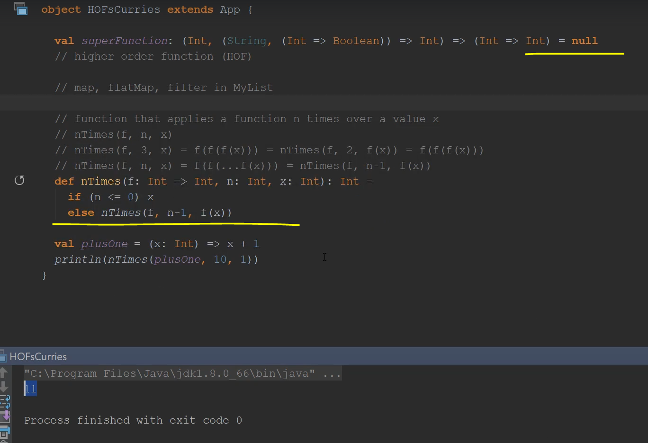

So this example was pretty simple, although if you ask me, it's quite a convoluted way of incrementing a value 10 times. But it serves as an example of how you can use higher order functions to compute something. And as you will get to more complex APIs in your programs, you'll start to need this kind of stuff. Now, speaking of APIs, there is a better way to implement this n times function. And the option is to, instead of passing all parameters at once, like f and Int the value X, we can simply say that the function nTimesBetter takes a function and takes a number and returns another function, which is basically the application of this function n times that you can then use on any value you want. So here's what I mean. So I have a function called, let's say nTimesBetter. And this takes the function f as a parameter and the number n as a parameter. But instead of taking the value X as a parameter as well, we can save that for later and say that this guy returns a function from Int to Int.

// ntb(f,n) = x => f(f(f...(x)))

// increment10 = nTimesBetter(plusOne, 10) = x => plusOne(plusOne....(x))

// val y = increment10(1)

def nTimesBetter(f: Int => Int, n: Int): (Int => Int) =

Now, the difference here is that in the nTimesBetter case, instead of applying f n times to the value x, we save that for later in the sense that if I say nTimesBetter with f and n is basically x => f of f of f of n times with x. So instead of actually applying f n times to x, I return a lambda that you can then use later however many times you want and apply it to various values. So if I have, let's say increment10, which is in times better of this increment, plus one that we called and 10, this will return basically a lambda that applies plus one ten times to x. So you can then use later and say, val y equals increment10 of 1, so you can use incrementing as if it were a function that you computed earlier by calling nTimesBetter with plusOne and 10.

Now, this is a subtle distinction and it might not make too much sense or it might not be too intuitive at this point. And that is because you haven't gotten into the problems that require you to think in terms of higher order functions in this fashion. But trust me, this style of thinking will come natural to you. As you write more code. You might be wondering why the hell do I want all this higher order function stuff just to incremental value 10 times? This seems overkill. Don't worry too much. This style of thinking will come natural to you. It will just take some time and practice. All right. So this is what we're doing in this course. So let's get back to the implementation.

The logic is going to be fairly similar. So if and is less than or equal to zero, then instead of x, I just returned the identity function, which is a lambda, which takes an Int and returns that value. Otherwise it will return a lambda. Let's put in the full definition, it will return a lambda whose implementation is going to be basically the same as this guy right over here. So n times better, but with the proper parameters in place. So f and n - 1 applied to f of x i.e. f(x). All right, so this syntax is a little bit tricky, so in terms better, as you see from the function definition returns a function and that will be applied to f of x. All right.

val plusOne = (x: Int) => x + 1

println( nTimes(plusOne, 10, 1) )

// ntb(f,n) = x => f(f(f...(x)))

// increment10 = ntb(plusOne, 10) = x => plusOne(plusOne....(x))

// val y = increment10(1)

def nTimesBetter(f: Int => Int, n: Int): (Int => Int) =

if (n <= 0) (x: Int) => x

else (x: Int) => nTimesBetter(f, n-1)(f(x))

val plus10 = nTimesBetter( plusOne, 100000 )

println( plus10(1) )

So let's try to test it. So let's create a simple value like incrementing, let's call this plus 10 to be consistent in notations. So this will be in times better with N and plus one or plus one and. Which is 10, right, and let's print plus 10, apply it to the value one, we should expect to see the same value 11 printed to the console.

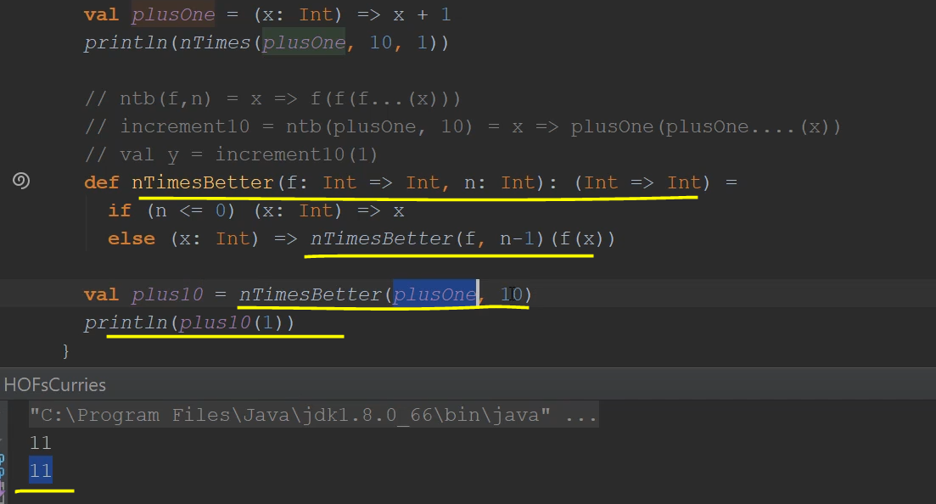

Of course, because plus10 is actually nTimesBetter applied to plus1(10), which is a function that applies plus one 10 times to whatever value we pass in here in this case, one. All right. So this is not really easy to think about. If this was too hard or too abstract for you, feel free to rewind this video or try to run these functions by yourself. Functional programming is not easy. Whoever tells you otherwise is either a master of functional programming or they're lying or they have no idea what the hell they're talking about. So take some time to get these concepts right if you get them right. You're ahead of 99 percent of Scala programmers who basically write imperative code with Scala syntax. So we've gone quite a long way from dealing with expression's and while loops and actually dealing with abstract higher order functions. I'm really proud of you. All right.

Now let's move. If you've noticed this style of writing, we encountered that in the previous videos as well. And we talked about a new concept which we didn't really get into depth, and it's called curried functions. So we wrote that little superAdder function, which I'm going to write here again, which is x => y and => x plus y with the proper spacing here in place.

Now, what is the type of superAdder? Well, it's Int => Int => Int with the notes that the => sign here is a right associative

// curried functions

val superAdder: Int => Int => Int = (x: Int) => (y: Int) => x + y

so this function receives an Int and returns another function. So basically our type for superAdder is actually this guy with parentheses implied by the compiler. So we can then call super atter by creating some additional helper functions. If I say add 3, this is superAdder with parameter 3 and this is actually a lambda from y to 3 + y, right. So we can actually print line, for example, add three code with ten and this will print 13 to the console.

// curried functions

val superAdder: Int => (Int => Int) = (x: Int) => (y: Int) => x + y

println( add3(10) )

So these curried functions are very useful if you want to define the helper functions that you want to use later on, various values. Now you see that if you actually want to call super atter with all the parameter lists, like superAdder with 3 and 10, you can actually do that.

// curried functions

val superAdder: Int => (Int => Int) = (x: Int) => (y: Int) => x + y

println( add3(10) )

println( superAdder(3)(10) )

So we supply two parameter lists now Scala supports another almost another kind of curried functions by specifying functions with multiple parameter lists and the way that we do that is, for example, if I want to write a curried formatter which wants to turn a double into a string according to some kind of format, I would write something like curriedFormatter and I would receive a format. And a double x just like that, with two parameter lists and return a string as a result and the implementation is going to be c.format(x) just for a simple implementation. There is a format function in the String class, but the implementation here is beyond the point. The point is that I can define a function with multiple parameter lists to act like curried functions so I can then later create various formatting. So if I, for example, say standard format, which is of type doubleToString and the value of this is curriedFormatter with, say, %4.2f, then this is a valid function.

// functions with multiple parameter lists

def curriedFormatter(c: String)(x: Double): String = c.format(x)

val standardFormat: (Double => String) = curriedFormatter("%4.2f")

Standard format is a function from double to string that applies curriedFormatter with this format later to whatever value I pass to it, I can create as many formats as I want. Let's say I create the value preciseFormatter, which is also a function from double to string. And the value of this is going to be curriedFormatter.

val preciseFormat: (Double => String) = curriedFormatter("%10.8f")

And let's say I pass some more precise format, say %10.8f and let's see what happens if I print line standard format with math.pi and print line precise.format with Math.pi. So notice that curriedFormatter acts like a curried function because I can then later create some functions that apply curried formatter with fewer parameter lists, and then I could then use them with whatever value I want later. All right. So if I right click and run this. Look, I see 3.14 because the curried formatter is applied with 4.2f and the precise format applies with more decimals.

// curried functions

val superAdder: Int => (Int => Int) = (x: Int) => (y: Int) => x + y

val add3 = superAdder(3) // y => 3 + y

println(add3(10))

println(superAdder(3)(10))

// functions with multiple parameter lists

def curriedFormatter(c: String)(x: Double): String = c.format(x)

val standardFormat: (Double => String) = curriedFormatter("%4.2f")

val preciseFormat: (Double => String) = curriedFormatter("%10.8f")

println(standardFormat(Math.PI))

println(preciseFormat(Math.PI))

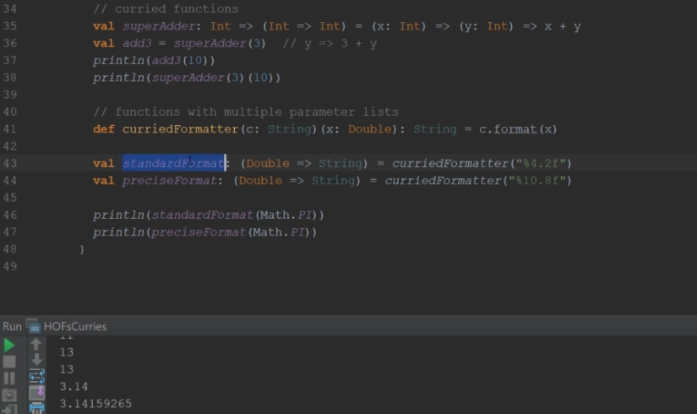

Now curried functions like these can have as many parameter lists as you want.

Now, one thing to note, for functions with multiple parameter lists

// functions with multiple parameter lists

def **curriedFormatter**(c: String)(x: Double): String = c.format(x)

if you want to define smaller functions later, you have to specify their type.

val standardFormat: (Double => String) = curriedFormatter("%4.2f")

val preciseFormat: (Double => String) = curriedFormatter("%10.8f")

Otherwise your code will not compile.

So if I right click and run this trial, run this, the compiler will complain because it will not know what type the standard format function will have. The proper way to do that is to use partial function applications, which is an advanced subject. We're going to talk about that in the advanced course. But for now, just be sure to specify the types for your smaller functions. All right. So an important topic.

Let's recap. So we've learned that functional programming is all about working with functions. So we need to pass functions as parameters or return functions as a result. So basically, we want to work with functions as we work with any other kind of values. So this introduces the concept of higher order functions.

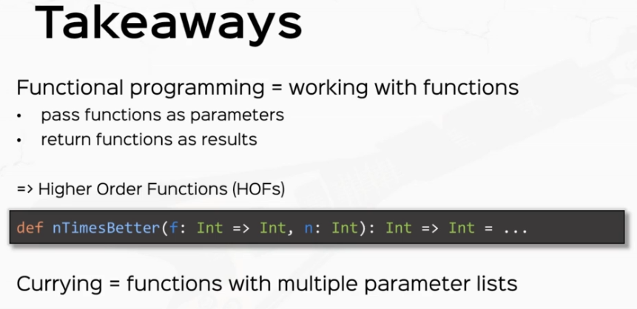

And we've seen some examples. And then we dealt with currying, which is a byproduct of our need of dealing with higher order functions and curring deals with functions with multiple parameter lists.

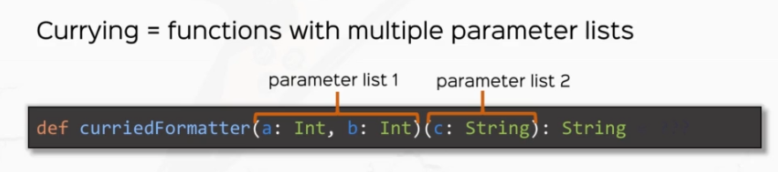

And we've seen examples where CurriedFormatter can take multiple parameter lists. You can have as many parameter lists as you want and you can define smaller functions to use later. This was a crucial topic. So make sure you get this right.

### HOFs and Curries – Exercises

Let's practice higher order functions because they're so, so important. All right, we're back in the IDE, so let's do some exercises. First, I want you to go ahead and expand MyList with some methods. I want you to add a for each method, which for each element, does a side effect. So this will receive a function from element unit and this will apply this function to every element of my list.

Then I want you to add a sort function which receives a sorting function, which basically compares two functions. The sorting function will be of type (A, A) to Int, that is negative if this guy is less than this guy and positive otherwise. All right. And this will return another my list. Right. This is going to be very interesting. Then I wanted to add a zip with function, which takes another list and a zip function from two elements to a different element (A, A) => B. And this will return to MyList[B], so I'm going to give you some examples, shortly, so bear with me then.

Then I want you to add a fold method. This will be a Curried function. Let me give you some examples of how these things should work. So if I have the Lit[1, 2, 3], if I call for each printLn(x). Then this will print each element on a new line.

/*

1. Expand MyList

- foreach method A => Unit

[1,2,3].foreach(x => println(x))

*/

OK, so it functions are fairly simple. If I have the List[1,2,3] and I call this guy with sort and saying, if I receive two elements, x and y, I return y minus x, saying that x is quote unquote less than Y, if it's actually bigger than y than this will sort this list descending. So this will return three to one.

/*

- sort function ((A, A) => Int) => MyList

[1,2,3].sort((x, y) => y - x) => [3,2,1]

*/

Zip with function is very interesting, so if I receive, for example, for list one, two, three, I zipWith with another list, say I don't know, four or five, six, and the function x multiplied by y, then I should receive, as a result, the multiplication of each corresponding element with each corresponding element in the argument list. So this will be the list one times for two times five and five and three times six. Right.

/*

- zipWith (list, (A, A) => B) => MyList[B]

[1,2,3].zipWith([4,5,6], x * y) => [1 * 4, 2 * 5, 3 * 6] = [4,10,18]

*/

So this is the list for 10, 18, and finally the full function is going to be curried. Let me show you how it's going to work. Like so Foaled will receive two parameter lists. One is going to be a start value and a function, and this will return of value. Let me show you how it's going to work. So if I have the list one, two, three, if I call fold with a start value of zero and with a function that just adds to numbers, this will return the sum of all these numbers. So it returns six. The way that it's going to work is that the list will start to get folded in the sense that you add this element to the start value and then you add the second element to the previous value and then you add the third element to the previous value. And finally, when you have no more elements, you return a final value. All right. So this is how fold is going to work. All right.

/*

- fold(start)(function) => a value

[1,2,3].fold(0)(x + y) = 6

*/

So quite some difficult exercises, but they're very useful in practicing the higher order function mindset, if you will. All right. The other smaller exercises are, first of all, defining methods to turn functions into curried and uncurried versions. Let me show you what I mean. So I want you to define a method. Let's call this toCurry, which takes a function, let's say the function is Int Int and returns Int. We don't really care too much if you want to genericized that, that's bonus point and turns that into a curried version of that function, which returns Int => Int => Int with the same implementation and vice versa fromCurry I want you to get a function which is of this type and turns that into a function with two parameters.

/*

2. toCurry(f: (Int, Int) => Int) => (Int => Int => Int)

fromCurry(f: (Int => Int => Int)) => (Int, Int) => Int

*/

Then I want you to do your abstract math homework by writing some methods which compose two functions and applying one function and then another. So compose with fmg will return a lambda, which applies f(g(x)), so compose f(g(x)) will return a lambda, which for every value of x this will apply g first and then f this is function composition and with the opposite order.

/*

3. compose(f,g) => x => f(g(x))

*/

Let's call this andThen and this also receives two functions and this will return a lambda which for every x will return g apply to f of X. That means it applies f first and then it applies g. All right. So pause the video and work through these exercises three to one.

/*

andThen(f,g) => x => g(f(x))

*/

And let's switch to my list. All right. So we want to add A for each method. Let's create a new section here for HOFs. So we want to add here in the abstract class my list. We want to add A for each method, which takes a function from a two unit, and this will return unit because it will just apply to every element.

package exercises

abstract class MyList[+A] {

/*

head = first element of the list

tail = remainder of the list

isEmpty = is this list empty

add(int) => new list with this element added

toString => a string representation of the list

*/

def head: A

def tail: MyList[A]

def isEmpty: Boolean

def add[B >: A](element: B): MyList[B]

def printElements: String

// polymorphic call

override def toString: String = "[" + printElements + "]"

// higher-order functions

def map[B](transformer: A => B): MyList[B]

def flatMap[B](transformer: A => MyList[B]): MyList[B]

def filter(predicate: A => Boolean): MyList[A]

// concatenation

def ++[B >: A](list: MyList[B]): MyList[B]

// hofs

def foreach(f: A => Unit): Unit

|  |  |
| --- | --- |
| All right. So now we need to implement that later in empty. And let's actually do that and define all the other functions in turn.  So for HOFs def for each f from nothing to Unit this return unit and this won't actually do anything and just return the unit value. | case object Empty extends MyList[Nothing] {  def head: Nothing = throw new NoSuchElementException  def tail: MyList[Nothing] = throw new NoSuchElementException  def isEmpty: Boolean = true  def add[B >: Nothing](element: B): MyList[B] = new Cons(element, Empty)  def printElements: String = ""  def map[B](transformer: Nothing => B): MyList[B] = Empty  def flatMap[B](transformer: Nothing => MyList[B]): MyList[B] = Empty  def filter(predicate: Nothing => Boolean): MyList[Nothing] = Empty  def ++[B >: Nothing](list: MyList[B]): MyList[B] = list  *// hofs*  def foreach(f: Nothing => Unit): Unit = () |
| Remember the unit value is this guy parenthesis. Parentheses. Right. So for empty that's very easy.  Then we have the section for Hoffs here and def for each this will get a function from each Unit, this return Unit and the implementation is going to be fairly simple.  So we'll apply f to the head. So Cons has this head element. Right, and then def for each f. Very simple. | case class Cons[+A](h: A, t: MyList[A]) extends MyList[A] {  def head: A = h  def tail: MyList[A] = t  def isEmpty: Boolean = false  def add[B >: A](element: B): MyList[B] = new Cons(element, this)  def printElements: String =  if(t.isEmpty) "" + h  else s"**$**h **$**{t.printElements}"  */\**  *[1,2,3].filter(n % 2 == 0) =*  *[2,3].filter(n % 2 == 0) =*  *= new Cons(2, [3].filter(n % 2 == 0))*  *= new Cons(2, Empty.filter(n % 2 == 0))*  *= new Cons(2, Empty)*  *\*/*  def filter(predicate: A => Boolean): MyList[A] =  if (predicate(h)) new Cons(h, t.filter(predicate))  else t.filter(predicate)  */\**  *[1,2,3].map(n * 2)*  *= new Cons(2, [2,3].map(n * 2))*  *= new Cons(2, new Cons(4, [3].map(n * 2)))*  *= new Cons(2, new Cons(4, new Cons(6, Empty.map(n * 2))))*  *= new Cons(2, new Cons(4, new Cons(6, Empty))))*  *\*/*  def map[B](transformer: A => B): MyList[B] =  new Cons(transformer(h), t.map(transformer))  */\**  *[1,2] ++ [3,4,5]*  *= new Cons(1, [2] ++ [3,4,5])*  *= new Cons(1, new Cons(2, Empty ++ [3,4,5]))*  *= new Cons(1, new Cons(2, new Cons(3, new Cons(4, new Cons(5)))))*  *\*/*  def ++[B >: A](list: MyList[B]): MyList[B] = new Cons(h, t ++ list)  */\**  *[1,2].flatMap(n => [n, n+1])*  *= [1,2] ++ [2].flatMap(n => [n, n+1])*  *= [1,2] ++ [2,3] ++ Empty.flatMap(n => [n, n+1])*  *= [1,2] ++ [2,3] ++ Empty*  *= [1,2,2,3]*  *\*/*  def flatMap[B](transformer: A => MyList[B]): MyList[B] =  transformer(h) ++ t.flatMap(transformer)  *// hofs*  def foreach(f: A => Unit): Unit = {  f(h)  t.foreach(f)  } |
| All right, so let's test this, so if I println, not actually print line, if I say list of integers for each print line. That means a list of integers, def for each x => print line x, right, but I choose the shorthand notation list of integers for each print line. So I should be seeing one, two, three on separate lines. So if I to click and run this, I should be seeing that. One, two, three. So this was very easy. Good exercise. | object ListTest extends App {  val *listOfIntegers*: MyList[Int] = new Cons(1, new Cons(2, new Cons(3, Empty)))  val *cloneListOfIntegers*: MyList[Int] = new Cons(1, new Cons(2, new Cons(3, Empty)))  val *anotherListOfIntegers*: MyList[Int] = new Cons(4, new Cons(5, Empty))  val *listOfStrings*: MyList[String] = new Cons("Hello", new Cons("Scala", Empty))  // listOfIntegers.foreach(x = > println(x))  listOfIntegers.foreach(println)  *Output:* |

|  |  |
| --- | --- |
| Number two was sorting. So if I add a function, it receives a comparison. Let's call this compare, which is of type A to end.  So basically this says that for every two elements, this will return a negative value if the first is less quote unquote, less than second and positive otherwise. So this will return on my list of. All right. | package exercises  abstract class MyList[+A] {  /*  head = first element of the list  tail = remainder of the list  isEmpty = is this list empty  add(int) => new list with this element added  toString => a string representation of the list  */  def head: A  def tail: MyList[A]  def isEmpty: Boolean  def add[B >: A](element: B): MyList[B]  def printElements: String  // polymorphic call  override def toString: String = "[" + printElements + "]"  // higher-order functions  def map[B](transformer: A => B): MyList[B]  def flatMap[B](transformer: A => MyList[B]): MyList[B]  def filter(predicate: A => Boolean): MyList[A]  // concatenation  def ++[B >: A](list: MyList[B]): MyList[B]  // hofs  def foreach(f: A => Unit): Unit  def sort(compare: (A, A) => Int): MyList[A] |
| Now, the sort method for Empty is going to be, of course, very easy. So if I get sort with a compare function from Nothing, Nothing to an Int, then this will return the Empty list because empty is already sorted. All right. So this was easy. | case object Empty extends MyList[Nothing] {  def head: Nothing = throw new NoSuchElementException  def tail: MyList[Nothing] = throw new NoSuchElementException  def isEmpty: Boolean = true  def add[B >: Nothing](element: B): MyList[B] = new Cons(element, Empty)  def printElements: String = ""  def map[B](transformer: Nothing => B): MyList[B] = Empty  def flatMap[B](transformer: Nothing => MyList[B]): MyList[B] = Empty  def filter(predicate: Nothing => Boolean): MyList[Nothing] = Empty  def ++[B >: Nothing](list: MyList[B]): MyList[B] = list  *// hofs*  def foreach(f: Nothing => Unit): Unit = ()  def sort(compare: (Nothing, Nothing) => Int) = Empty |
|  |  |

|  |  |
| --- | --- |
| For Cons not so much. Let's call it a sort of compare and the function type is a => int and this will return MyList[A] = and I am going to open and close some curly braces because I'm going to need some auxiliary functions. So let's use the insertion sort method because it's easier to implement here. So what I want to do is to tail.sort, let's call this sortedTail which is still that sort with the same compar function. All right, and then I will return insert, which is a function that I'm going to write inside, and I'm going to insert the head into this sortedTail so this auxiliary function will do assorted insertion of a value inside an already sorted list. All right. So let's write this insert. Let's call this a value or just call it x, which is an A and a sorted list, which is MyList[A]. So this function will assume that this list here is already sorted and it will return on MyList[A]. | def sort(compare: (A, A) => Int): MyList[A] = {  def insert(x: A, sortedList: MyList[A]): MyList[A] =  val sortedTail = t.sort(compare)  insert(h, sortedTail)  } |
| OK, and implementation is going to be fairly simple, so if sorted list is empty, then I'll just return a new Cons with x and empty. This is very simple. Otherwise, if x is less, then quote unquote less than, but we are actually called compare x and the sortedList.head. and this list is, quote unquote, <= the already smallest element of this sortedList. So I'm just going to return Cons. Oh, and let's just put it on the list than or equal to zero here condition because compare returns and end and the result is going to be a new Cons with this X value and the already sorted list. That means x is the smallest element in the result. Otherwise, I mean just going to return Cons with sortedLists head and whatever comes after the sorting of, or after the insertion of x into the sortedLists tail. All right, so again, if sorted list is empty, then I'm just going to return a list of only one element. Otherwise then if X is less than the already smallest element of the sorted list, then that means x will be the new smallest element of the result. So I'm just going to turn the new cons with x and sorted this. Otherwise, the heads element of the sorted list is the smallest element of the result. So I'm going to return to new Cons with that. And whatever comes after the insertion of x into the rest of the list. This function is not recursive. If you want to do tail recursion, feel free to pause the video and do this for bonus points. | def sort(compare: (A, A) => Int): MyList[A] = {  def insert(x: A, sortedList: MyList[A]): MyList[A] =  if (sortedList.isEmpty) new Cons(x, Empty)  else if (compare(x, sortedList.head) <= 0)  new Cons(x, sortedList)  else new Cons(sortedList.head, insert(x, sortedList.tail))  val sortedTail = t.sort(compare)  insert(h, sortedTail)  } |
| All right. So let's test this. So if I say print line listOfIntegers.sort and like I said, I put in x, y, => y - x, which basically inverts the order of the elements. If I click and run this, I should be seeing the list 3 to 1 here in the console. So our sort method works fine. | object ListTest extends App {  val *listOfIntegers*: MyList[Int] =  new Cons(1, new Cons(2, new Cons(3, Empty)))  val *cloneListOfIntegers*: MyList[Int] =  new Cons(1, new Cons(2, new Cons(3, Empty)))  val *anotherListOfIntegers*: MyList[Int] =  new Cons(4, new Cons(5, Empty))  val *listOfStrings*: MyList[String] =  new Cons("Hello", new Cons("Scala", Empty))  *. . .*  *listOfIntegers*.foreach(*println*)  *println*(*listOfIntegers*.sort((x, y) => y - x)) |

**Complete code so far.**

abstract class MyList[+A] {

/*

head = first element of the list

tail = remainder of the list

isEmpty = is this list empty

add(int) => new list with this element added

toString => a string representation of the list

*/

def head: A

def tail: MyList[A]

def isEmpty: Boolean

def add[B >: A](element: B): MyList[B]

def printElements: String

// polymorphic call

override def toString: String = "[" + printElements + "]"

// higher-order functions

def map[B](transformer: A => B): MyList[B]

def flatMap[B](transformer: A => MyList[B]): MyList[B]

def filter(predicate: A => Boolean): MyList[A]

// concatenation

def ++[B >: A](list: MyList[B]): MyList[B]

// hofs

def foreach(f: A => Unit): Unit

def sort(compare: (A, A) => Int): MyList[A]

def zipWith[B, C](list: MyList[B], zip:(A, B) => C): MyList[C]

def fold[B](start: B)(operator: (B, A) => B): B

def reverse: MyList[A] = {

def reverseTailrec(input: MyList[A], result: MyList[A]): MyList[A] =

if (input.isEmpty) result

else reverseTailrec(input.tail, Cons(input.head, result))

reverseTailrec(this, Empty)

}

}

case object Empty extends MyList[Nothing] {

def head: Nothing = throw new NoSuchElementException

def tail: MyList[Nothing] = throw new NoSuchElementException

def isEmpty: Boolean = true

def add[B >: Nothing](element: B): MyList[B] = new Cons(element, Empty)

def printElements: String = ""

def map[B](transformer: Nothing => B): MyList[B] = Empty

def flatMap[B](transformer: Nothing => MyList[B]): MyList[B] = Empty

def filter(predicate: Nothing => Boolean): MyList[Nothing] = Empty

def ++[B >: Nothing](list: MyList[B]): MyList[B] = list

// hofs

def foreach(f: Nothing => Unit): Unit = ()

def sort(compare: (Nothing, Nothing) => Int) = Empty

}

case class Cons[+A](h: A, t: MyList[A]) extends MyList[A] {

def head: A = h

def tail: MyList[A] = t

def isEmpty: Boolean = false

def add[B >: A](element: B): MyList[B] = new Cons(element, this)

def printElements: String =

if(t.isEmpty) "" + h

else s"**$**h **$**{t.printElements}"

/*

[1,2,3].filter(n % 2 == 0) =

[2,3].filter(n % 2 == 0) =

= new Cons(2, [3].filter(n % 2 == 0))

= new Cons(2, Empty.filter(n % 2 == 0))

= new Cons(2, Empty)

*/

def filter(predicate: A => Boolean): MyList[A] =

if (predicate(h)) new Cons(h, t.filter(predicate))

else t.filter(predicate)

/*

[1,2,3].map(n * 2)

= new Cons(2, [2,3].map(n * 2))

= new Cons(2, new Cons(4, [3].map(n * 2)))

= new Cons(2, new Cons(4, new Cons(6, Empty.map(n * 2))))

= new Cons(2, new Cons(4, new Cons(6, Empty))))

*/

def map[B](transformer: A => B): MyList[B] =

new Cons(transformer(h), t.map(transformer))

/*

[1,2] ++ [3,4,5]

= new Cons(1, [2] ++ [3,4,5])

= new Cons(1, new Cons(2, Empty ++ [3,4,5]))

= new Cons(1, new Cons(2, new Cons(3, new Cons(4, new Cons(5)))))

*/

def ++[B >: A](list: MyList[B]): MyList[B] = new Cons(h, t ++ list)

/*

[1,2].flatMap(n => [n, n+1])

= [1,2] ++ [2].flatMap(n => [n, n+1])

= [1,2] ++ [2,3] ++ Empty.flatMap(n => [n, n+1])

= [1,2] ++ [2,3] ++ Empty

= [1,2,2,3]

*/

def flatMap[B](transformer: A => MyList[B]): MyList[B] =

transformer(h) ++ t.flatMap(transformer)

// hofs

def foreach(f: A => Unit): Unit = {

f(h)

t.foreach(f)

}

def sort(compare: (A, A) => Int): MyList[A] = {

def insert(x: A, sortedList: MyList[A]): MyList[A] =

if (sortedList.isEmpty) new Cons(x, Empty)

else if (compare(x, sortedList.head) <= 0) new Cons(x, sortedList)

else new Cons(sortedList.head, insert(x, sortedList.tail))

val sortedTail = t.sort(compare)

insert(h, sortedTail)

}

|  |  |
| --- | --- |
| Next, we have a zip with function. Let's go back to the top and add a zipWith function. This function will receive some type parameters, but let's write the actual parameters first so we'll zip with a list which is of type myList of some other type.  Let's say MyList[B] and the zip function is going to be and A B => some other type C right. So if I zip a list of integers with a list of strings, I should be able to get a list of some other type because the zip function is so very generic. Right. And the end is going to be on my list of C, so we're going to add some type parameters, B and C here. All right.  Now this zip function, will throw an exception if the lists have different lengths because zipping a list with two elements with a zip with a list of three elements doesn't really make sense. All right. So we'll need to take that into account as well. | abstract class MyList[+A] {  def head: A  def tail: MyList[A]  def isEmpty: Boolean  def add[B >: A](element: B): MyList[B]  def printElements: String  // polymorphic call  override def toString: String = "[" + printElements + "]"  // higher-order functions  def map[B](transformer: A => B): MyList[B]  def flatMap[B](transformer: A => MyList[B]): MyList[B]  def filter(predicate: A => Boolean): MyList[A]  // concatenation  def ++[B >: A](list: MyList[B]): MyList[B]  // hofs  def foreach(f: A => Unit): Unit  def sort(compare: (A, A) => Int): MyList[A]  def zipWith[B, C](list: MyList[B], zip:(A, B) => C): MyList[C] |
|  |  |

So let's go to the empty object and define zip with, and this will get some type parameters B and C and this will get a list which is of MyList[B] and a zip function, which is of type Nothing and B to a value of type C and the return type is on MyList[C] and implementation here is going to be if list is not empty, then I'm going to throw an exception. Let's say RuntimeException with lists do not have the same length. This is important. If I'm trying to zip an empty with a non-empty list, then the zipWith function doesn't make sense. Otherwise I'm just gonna return empty because an empty zip with an empty will return an empty list. All right, cool.

case object Empty extends MyList[Nothing] {

def head: Nothing = throw new NoSuchElementException

def tail: MyList[Nothing] = throw new NoSuchElementException

def isEmpty: Boolean = true

def add[B >: Nothing](element: B): MyList[B] = new Cons(element, Empty)

def printElements: String = ""

def map[B](transformer: Nothing => B): MyList[B] = Empty

def flatMap[B](transformer: Nothing => MyList[B]): MyList[B] = Empty

def filter(predicate: Nothing => Boolean): MyList[Nothing] = Empty

def ++[B >: Nothing](list: MyList[B]): MyList[B] = list

*// hofs*

def foreach(f: Nothing => Unit): Unit = ()

def sort(compare: (Nothing, Nothing) => Int) = Empty

def zipWith[B, C](list: MyList[B], zip: (Nothing, B) => C): MyList[C] =

if (!list.isEmpty) throw new RuntimeException("Lists do not have the same length")

else Empty

}

Now in Cons if I go ahead and do zipWith with type parameters B and C, you can actually paste the function definition if you want. So list is MyList[B] and the zip function is of type A, B => C and the return type is of MyList[C]. Well if the list is empty this time around, then I'm going to throw this guy the same exception. The new RuntimeException that lists do not have the same length. OK, this makes sure that the lists have the same length. Otherwise, I'm going to return to Cons and the head of the element is going to be the zip function applied to the heads of this element of this list and the list received as a parameter. So zip applied to head and list.head and tail.zipWith list.tail and the function zip.

val anotherListOfIntegers: MyList[Int] = new Cons(4, new Cons(5, Empty))

val listOfStrings: MyList[String] = new Cons("Hello", new Cons("Scala", Empty))

def zipWith[B, C](list: MyList[B], zip: (A, B) => C): MyList[C] =

if (list.isEmpty) throw new RuntimeException("Lists do not have the same length")

else new Cons(zip(h, list.head), t.zipWith(list.tail, zip))

All right, so let's test this, so if I print well, let's say we have so we have another list of integers with 2 elements, so 4 and 5 and the list of strings. "Hello" "Scala", this is a good example to zip, let's say another list of strings, zip with a list of strings and a zip function, which basically, let's say concatenates the integer and the string.

println(anotherListOfIntegers.zipWith[String, String](listOfStrings, _ + "-" + _))

So underscore plus space plus underscore. Right. So this is a very short hand lambda notation, so we're going to say 4 space, hello, 5 space Scala. All right, we're probably not going to see we're in the result string here. We're probably going to see 4 elements here because because of the space. So it's actually print. A different separator instead of space, let's say we use a dash instead so that we make sure that we have 2 elements, not 4. All right, so right, click and run. This is what happened. Missing type parameter for expanded function. Well, yes, because the underscores, like we said in the previous videos, are extremely contextual. And Scala doesn't know which underscores means what? So we'll need to pass in the type parameters here, string and string at the end. Right. And this time it should work well. All right, so we have a list of two elements here, which is obtained by zipping the list 4, 5 with the list of Hello, Scala by appending by putting a little dash in between them. Now, Zipping is an extremely powerful utility and spark programmers and data scientists use zipping quite a lot. So quite a useful function.

And now the icing on the cake lets go and implement fold. So fold takes a type parameter B because we want to make this extremely generic and as actual parameters, you got two parameter lists with a start value of type B and an operator which is of type B, A => B and the final return type is A B value.

abstract class MyList[+A] {

/*

head = first element of the list

tail = remainder of the list

isEmpty = is this list empty

add(int) => new list with this element added

toString => a string representation of the list

*/

def head: A

def tail: MyList[A]

def isEmpty: Boolean

def add[B >: A](element: B): MyList[B]

def printElements: String

// polymorphic call

override def toString: String = "[" + printElements + "]"

// higher-order functions

def map[B](transformer: A => B): MyList[B]

def flatMap[B](transformer: A => MyList[B]): MyList[B]

def filter(predicate: A => Boolean): MyList[A]

// concatenation

def ++[B >: A](list: MyList[B]): MyList[B]

// hofs

def foreach(f: A => Unit): Unit

def sort(compare: (A, A) => Int): MyList[A]

def zipWith[B, C](list: MyList[B], zip:(A, B) => C): MyList[C]

def fold[B](start: B)(operator: (B, A) => B): B

So this is the complete type signature for fold, so let's go to the Empty and lets define fold with the type parameter B and the start value, which is of type B and the operator, which is of type (B, Nothing) => B, and the return type is B, and because this is an empty list, we don't really get to apply the operator to anything. So we'll just return the start value. OK, so quite a simple implementation, but for Cons. We actually need to do something so death fold with a type parameter, be the start value of type B and an operator, which is of type (B, A) => B, and the final return type is B.

def fold[B](start: B)(operator: (B, A) => B): B

All right, so because this is a non-empty list, I have to compose the start value with my head, let's call this newStart, which is operator applied to start and the head. And then later, I'm just going to call tail.fold with a new start because I've already applied to the operator between start and my head, so my head is already gone.

def fold[B](start: B)(operator: (B, A) => B): B = {

val newStart = operator(start, h)

t.fold.(newStart)(operator)

}

So I'm just going to apply fold with newStart and the same operator. Now we can actually let go of the value newStart and actually use this expression literally here, and we end up with the complete function implementation.

t.fold.( operator(start, h) )(operator)

So let's break it down, how it works. If I have the list, 1,2,3, and if I fold with a start value of 0 and the operator + right, this will be tail.fold. So that will be the list 2, 3 dot fold with the start value, which is the operator between start and head. So plus between zero and one and the same operator which is again the tail three. Fold, the start value is the operator between this guy and the head so plus between 1 and 3 into that's 3 in the same operator plus which is empty list that fold with the operator between this value and the head which is 6 and the same operator plus and empty.fold with the start value and any operator just returns the start value which is six. All right. So this is how fold works.

/*

[1,2,3].fold(0)(+) =

= [2,3].fold(1)(+) =

= [3].fold(3)(+) =

= [].fold(6)(+)

= 6

*/

def fold[B](start: B)(operator: (B, A) => B): B = {

t.fold.( operator(start, h) )(operator)

}

Let's actually test it. So if I do listOfIntegers.fold with the value 0 and the plus operator. OK, then let's print this out, I should be seeing the value 6, because I have the list. [1,2,3]. So I'm seeing the value 6 here, folding is also very important when you want to collapse all your data into one single value. This is often called reduce and fold is one of the forms that reduce can have. All right. So quite heavy functional programming here with MyList.

package exercises

**abstract class MyList[+A] {**

/*

head = first element of the list

tail = remainder of the list

isEmpty = is this list empty

add(int) => new list with this element added

toString => a string representation of the list

*/

def head: A

def tail: MyList[A]

def isEmpty: Boolean

def add[B >: A](element: B): MyList[B]

def printElements: String

// polymorphic call

override def toString: String = "[" + printElements + "]"

// higher-order functions

def map[B](transformer: A => B): MyList[B]

def flatMap[B](transformer: A => MyList[B]): MyList[B]

def filter(predicate: A => Boolean): MyList[A]

// concatenation

def ++[B >: A](list: MyList[B]): MyList[B]

// hofs

def foreach(f: A => Unit): Unit

def sort(compare: (A, A) => Int): MyList[A]

def zipWith[B, C](list: MyList[B], zip:(A, B) => C): MyList[C]

def fold[B](start: B)(operator: (B, A) => B): B

def reverse: MyList[A] = {

def reverseTailrec(input: MyList[A], result: MyList[A]): MyList[A] =

if (input.isEmpty) result

else reverseTailrec(input.tail, Cons(input.head, result))

reverseTailrec(this, Empty)

}

}

**case object Empty extends MyList[Nothing] {**

def head: Nothing = throw new NoSuchElementException

def tail: MyList[Nothing] = throw new NoSuchElementException

def isEmpty: Boolean = true

def add[B >: Nothing](element: B): MyList[B] = new Cons(element, Empty)

def printElements: String = ""

def map[B](transformer: Nothing => B): MyList[B] = Empty

def flatMap[B](transformer: Nothing => MyList[B]): MyList[B] = Empty

def filter(predicate: Nothing => Boolean): MyList[Nothing] = Empty

def ++[B >: Nothing](list: MyList[B]): MyList[B] = list

// hofs

def foreach(f: Nothing => Unit): Unit = ()

def sort(compare: (Nothing, Nothing) => Int) = Empty

def zipWith[B, C](list: MyList[B], zip: (Nothing, B) => C): MyList[C] =

if (!list.isEmpty) throw new RuntimeException("Lists do not have the same length")

else Empty

def fold[B](start: B)(operator: (B, Nothing) => B): B = start

}

**case class Cons[+A](h: A, t: MyList[A]) extends MyList[A] {**

def head: A = h

def tail: MyList[A] = t

def isEmpty: Boolean = false

def add[B >: A](element: B): MyList[B] = new Cons(element, this)

def printElements: String =

if(t.isEmpty) "" + h

else s"**$**h **$**{t.printElements}"

/*

[1,2,3].filter(n % 2 == 0) =

[2,3].filter(n % 2 == 0) =

= new Cons(2, [3].filter(n % 2 == 0))

= new Cons(2, Empty.filter(n % 2 == 0))

= new Cons(2, Empty)

*/

def filter(predicate: A => Boolean): MyList[A] =

if (predicate(h)) new Cons(h, t.filter(predicate))

else t.filter(predicate)

/*

[1,2,3].map(n * 2)

= new Cons(2, [2,3].map(n * 2))

= new Cons(2, new Cons(4, [3].map(n * 2)))

= new Cons(2, new Cons(4, new Cons(6, Empty.map(n * 2))))

= new Cons(2, new Cons(4, new Cons(6, Empty))))

*/

def map[B](transformer: A => B): MyList[B] =

new Cons(transformer(h), t.map(transformer))

/*

[1,2] ++ [3,4,5]

= new Cons(1, [2] ++ [3,4,5])

= new Cons(1, new Cons(2, Empty ++ [3,4,5]))

= new Cons(1, new Cons(2, new Cons(3, new Cons(4, new Cons(5)))))

*/

def ++[B >: A](list: MyList[B]): MyList[B] = new Cons(h, t ++ list)

/*

[1,2].flatMap(n => [n, n+1])

= [1,2] ++ [2].flatMap(n => [n, n+1])

= [1,2] ++ [2,3] ++ Empty.flatMap(n => [n, n+1])

= [1,2] ++ [2,3] ++ Empty

= [1,2,2,3]

*/

def flatMap[B](transformer: A => MyList[B]): MyList[B] =

transformer(h) ++ t.flatMap(transformer)

// hofs

def foreach(f: A => Unit): Unit = {

f(h)

t.foreach(f)

}

def sort(compare: (A, A) => Int): MyList[A] = {

def insert(x: A, sortedList: MyList[A]): MyList[A] =

if (sortedList.isEmpty) new Cons(x, Empty)

else if (compare(x, sortedList.head) <= 0) new Cons(x, sortedList)

else new Cons(sortedList.head, insert(x, sortedList.tail))

val sortedTail = t.sort(compare)

insert(h, sortedTail)

}

def zipWith[B, C](list: MyList[B], zip: (A, B) => C): MyList[C] =

if (list.isEmpty) throw new RuntimeException("Lists do not have the same length")

else new Cons(zip(h, list.head), t.zipWith(list.tail, zip))

/*

[1,2,3].fold(0)(+) =

= [2,3].fold(1)(+) =

= [3].fold(3)(+) =

= [].fold(6)(+)

= 6

*/

def fold[B](start: B)(operator: (B, A) => B): B =

t.fold(operator(start, h))(operator)

}

**object ListTest extends App {**

val listOfIntegers: MyList[Int] = new Cons(1, new Cons(2, new Cons(3, Empty)))

val cloneListOfIntegers: MyList[Int] = new Cons(1, new Cons(2, new Cons(3, Empty)))

val anotherListOfIntegers: MyList[Int] = new Cons(4, new Cons(5, Empty))

val listOfStrings: MyList[String] = new Cons("Hello", new Cons("Scala", Empty))

println(listOfIntegers.toString)

println(listOfStrings.toString)

println(listOfIntegers.map(_ * 2).toString)

println(listOfIntegers.filter(_ % 2 == 0).toString)

println((listOfIntegers ++ anotherListOfIntegers).toString)

println(listOfIntegers.flatMap(elem => new Cons(elem, new Cons(elem + 1, Empty))).toString)

println(cloneListOfIntegers == listOfIntegers)

listOfIntegers.foreach(println)

println(listOfIntegers.sort((x, y) => y - x))

println(anotherListOfIntegers.zipWith[String, String](listOfStrings, _ + "-" + _))

println(listOfIntegers.fold(0)(_ + _))

}

This is some advanced functionality already. Let's switch back to HOFs and Currys and let's solve the other two exercises. So toCurry. I've already given you the function definition.

**The full class code**

object HOFsCurries extends App {

val superFunction: (Int, (String, (Int => Boolean)) => Int) => (Int => Int) = null

// higher order function (HOF)

// map, flatMap, filter in MyList

// function that applies a function n times over a value x

// nTimes(f, n, x)

// nTimes(f, 3, x) = f(f(f(x))) = nTimes(f, 2, f(x)) = f(f(f(x)))

// nTimes(f, n, x) = f(f(...f(x))) = nTimes(f, n-1, f(x))

def nTimes(f: Int => Int, n: Int, x: Int): Int =

if (n <= 0) x

else nTimes(f, n-1, f(x))

val plusOne = (x: Int) => x + 1

println(nTimes(plusOne, 10, 1))

// ntb(f,n) = x => f(f(f...(x)))

// increment10 = ntb(plusOne, 10) = x => plusOne(plusOne....(x))

// val y = increment10(1)

def nTimesBetter(f: Int => Int, n: Int): (Int => Int) =

if (n <= 0) (x: Int) => x

else (x: Int) => nTimesBetter(f, n-1)(f(x))

val plus10 = nTimesBetter(plusOne, 100000)

println(plus10(1))

// curried functions

val superAdder: Int => (Int => Int) = (x: Int) => (y: Int) => x + y

val add3 = superAdder(3) // y => 3 + y

println(add3(10))

println(superAdder(3)(10))

// functions with multiple parameter lists

def curriedFormatter(c: String)(x: Double): String = c.format(x)

val standardFormat: (Double => String) = curriedFormatter("%4.2f")

val preciseFormat: (Double => String) = curriedFormatter("%10.8f")

println(standardFormat(Math.PI))

println(preciseFormat(Math.PI))

/*

1. Expand MyList

- foreach method A => Unit

[1,2,3].foreach(x => println(x))

- sort function ((A, A) => Int) => MyList

[1,2,3].sort((x, y) => y - x) => [3,2,1]

- zipWith (list, (A, A) => B) => MyList[B]

[1,2,3].zipWith([4,5,6], x * y) => [1 * 4, 2 * 5, 3 * 6] = [4,10,18]

- fold(start)(function) => a value

[1,2,3].fold(0)(x + y) = 6

2. toCurry(f: (Int, Int) => Int) => (Int => Int => Int)

fromCurry(f: (Int => Int => Int)) => (Int, Int) => Int

3. compose(f,g) => x => f(g(x))

andThen(f,g) => x => g(f(x))

*/

|  |  |
| --- | --- |
| So toCurry receives a function which takes to arguments and returns a value, and this will return a curried version and the implementation of that is going to be a Lambda taking a value x, which returns, a lambda, taking a value y, and the result is going to be f(x)(y). Very simple, but pretty hard to think about if you are thinking about this the first time. So this is a very similar shape to what the superAdder had earlier. | def toCurry(f: (Int, Int) => Int): (Int => Int => Int) =  x => y => f(x, y) |
| OK, now fromCurry takes a function from which is a curried version Int => Int, Int and returns function with two arguments and returns a Int so we have (Int, Int) => Int and implementation is going to be a lambda with two arguments because the return type here is a function with two arguments, so lambda with two arguments and the implementation is f applied to x apply to y so f(x)(y). Again, easier to write, not easy to think about. So these are non-trivial solutions. All right. | def fromCurry(f: (Int => Int => Int)): (Int, Int) => Int =  (x, y) => f(x)(y) |
| Now let's move to compose and andThen so def compose will take two functions f: Int => Int for simplicity for now. And g is also an Int => Int function and this guy will return an Int => Int function. | def compose(f: Int => Int, g: Int => Int ): Int => Int =  x => f(g(x)) |
| And of course for andThen I'm going to copy this. But instead, I'm going to put g applied to f applied to x so we have g(f(x)). | def andThen(f: Int => Int, g: Int => Int): Int => Int =  x => g(f(x)) |
| The compose and andThen are two very useful functions in the function library. So if you have a look at the documentation for function x compose and andThen are available there. Now let's try to genericized them a little bit. So if I have a function from A => B. Then the return type of guy has to be an A, so that can be applied to it.  So lets say G is a T => A function and let's add this the proper type parameters in place. So [A, B, T]. Then the return type of this guy is going to be g of x, so x is of type T, g(x) is of type A and f => A (i.e. f(g(x)) ) is of type B. So this guy will return a function from T all the way to B so T, A, B. | // FunctionX  def compose[A,B,T](f: A => B, g: T => A): T => B =  x => f(g(x)) |
| Again If I have a function say A to be here in the andThen implementation and G has a function from B to C, then the final return type is A to C, so if I have A, B, C as type parameters here then F of A will return a B, G of B will return a C and the final function will be A all the way to C. Right. So again, abstract math homework. | def andThen[A,B,C](f: A => B, g: B => C): A => C =  x => g(f(x)) |

The complete implementation so far.

package lectures.part3fp

object HOFsCurries extends App {

val superFunction: (Int, (String, (Int => Boolean)) => Int) => (Int => Int) = null

// higher order function (HOF)

// map, flatMap, filter in MyList

// function that applies a function n times over a value x

// nTimes(f, n, x)

// nTimes(f, 3, x) = f(f(f(x))) = nTimes(f, 2, f(x)) = f(f(f(x)))

// nTimes(f, n, x) = f(f(...f(x))) = nTimes(f, n-1, f(x))

def nTimes(f: Int => Int, n: Int, x: Int): Int =

if (n <= 0) x

else nTimes(f, n-1, f(x))

val plusOne = (x: Int) => x + 1

println(nTimes(plusOne, 10, 1))

// ntb(f,n) = x => f(f(f...(x)))

// increment10 = ntb(plusOne, 10) = x => plusOne(plusOne....(x))

// val y = increment10(1)

def nTimesBetter(f: Int => Int, n: Int): (Int => Int) =

if (n <= 0) (x: Int) => x

else (x: Int) => nTimesBetter(f, n-1)(f(x))

val plus10 = nTimesBetter(plusOne, 100000)

println(plus10(1))

// curried functions

val superAdder: Int => (Int => Int) = (x: Int) => (y: Int) => x + y

val add3 = superAdder(3) // y => 3 + y

println(add3(10))

println(superAdder(3)(10))

// functions with multiple parameter lists

def curriedFormatter(c: String)(x: Double): String = c.format(x)

val standardFormat: (Double => String) = curriedFormatter("%4.2f")

val preciseFormat: (Double => String) = curriedFormatter("%10.8f")

println(standardFormat(Math.PI))

println(preciseFormat(Math.PI))

/*

1. Expand MyList

- foreach method A => Unit

[1,2,3].foreach(x => println(x))

- sort function ((A, A) => Int) => MyList

[1,2,3].sort((x, y) => y - x) => [3,2,1]

- zipWith (list, (A, A) => B) => MyList[B]

[1,2,3].zipWith([4,5,6], x * y) => [1 * 4, 2 * 5, 3 * 6] = [4,10,18]

- fold(start)(function) => a value

[1,2,3].fold(0)(x + y) = 6

2. toCurry(f: (Int, Int) => Int) => (Int => Int => Int)

fromCurry(f: (Int => Int => Int)) => (Int, Int) => Int

3. compose(f,g) => x => f(g(x))

andThen(f,g) => x => g(f(x))

*/

def toCurry(f: (Int, Int) => Int): (Int => Int => Int) =

x => y => f(x, y)

def fromCurry(f: (Int => Int => Int)): (Int, Int) => Int =

(x, y) => f(x)(y)

// FunctionX

def compose[A,B,T](f: A => B, g: T => A): T => B =

x => f(g(x))

def andThen[A,B,C](f: A => B, g: B => C): A => C =

x => g(f(x))

So now let's use some dummy examples to prove that our functions work. So let's just have our superAdder. I think we define it earlier. Yes, we have superAdder here, let's say superAdder2, and that will be the function. The addition function to curry, so let's define this guy to be a curried Int, Int, Int function. And as for the value, I'm just going to say _ plus _ dot toCurry or actually call toCurry of this lambda. Parentheses here are too many.

// def superAdder2: (Int => Int => Int) = (_ + _).toCurry

// def superAdder2: (Int => Int => Int) = toCurry((_ + _))

def superAdder2: (Int => Int => Int) = toCurry(_ + _)

So I'm just going to write this guy, so if I define, for example, at four, I can actually call super atter two with the parameter four. And if I print line four with parameter or say, I don't know, 17, then this will add four to 17 because add four to 17 is actually superAddder two with four with 17, which is this guy, 4 plus 17. All right. So I should print twenty one.

def add4 = superAdder2(4)

println(add4(17))

Yes, now fromCurry works backwards. So if I define a function called, let's say simpleAdder which is fromCurry superAdder all right then this will be a lambda that will take just two parameters. So if I print line simpleAdder with 4 and 17, then I print the same 21 to the console.

val simpleAdder = fromCurry(superAdder)

println(simpleAdder(4,17))

All right, so now let's quickly test to the compose and andThen function, let's create a little value called, let's say addTwo, which is x => x + 2, very simple and then multiply by 3 for example so times3, x: IntArrow => x * 3 and let's see what happens when we compose Int and then these two functions.

So let's say val composed is composed with add2 and times3 and well let's say ordered is andThen with the same functions add2 and times3.

val composed = compose(add2, times3)

val ordered = andThen(add2, times3)

Let's see what happens if I print line composed with value say four and print line ordered with the same value for let's see what happens.

println( composed(4) )

println( ordered(4) )

So I click run. So I see the value 14 and the value 18, well, why that why that? Well, because we had composed with add2 and times3, which means that we apply times 3 first, which is 4 times 3, which is 12 and then add2 which gives 14

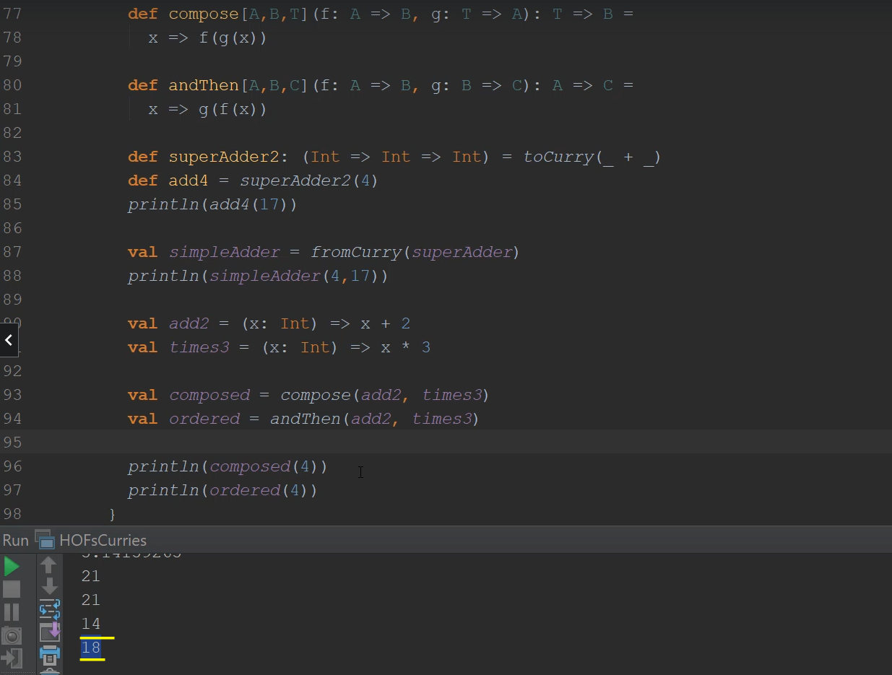

But ordered actually applies these functions in order. So we have 4 + 2 which is 6 and then times 3, that's 18, so composed and ordered, which is composed and then actually yield different results. All right. So quite a lot of exercises and heavy functional programming. I hope you got value out of this video and I can't wait to see you in the next.

### map, flatMap, filter and for-comprehensions

So now that you have more experience with higher order functions, let's talk a little bit more in depth about map, flapMap and filter on actual color collections from the standard library and also introduce for comprehensions, which I promised I would do way, way back in the expressions lecture. So in the I will make a new school applications in the Part three functional programming package as usual.

|  |  |
| --- | --- |
|  | So Right click creates Scala class and let's make a name this map flat map filter four, make this an object. And finally, of course, extends app. All right, so you've now implemented your own map, flat map and filter in your mind list implementations, they are extremely used in school and throughout functional programming in general in the standard library. So I will now introduce the official versions of Map and Filter along with the official list collection. All right. So having implemented your own list, these guys shouldn't be too sci fi. So if I create on your list and on the right hand side, I'm going to say simply list with one, two, three. And if I print like this, if I. Right. Click and run. Now, just wait for the code to compile and we'll get this guy list with one, two, three. |

This is the standard library list implementation and notice that I'm creating a list by calling the apply method on the list companion object. Now, the list standard library implementation also has the kind of methods that we implemented in our my list implementations, for example, the head and tail methods plus the functions that I'm going to introduce here, the map flatMap and filters, of course, head is one until is a list of two or three. And if you're curious to see how the map function is implemented, you can simply search list here on this scalalang.org and look for the map which has the same signature that we used in our mildest implementation, so this was map, filter is also very straightforward and it has the same behavior. So if I have a list filter and say I filter and only want to keep the even numbers and I say _ % 2 is equal to zero, then that will print the list with only the element 2 because other elements do not pass the condition.

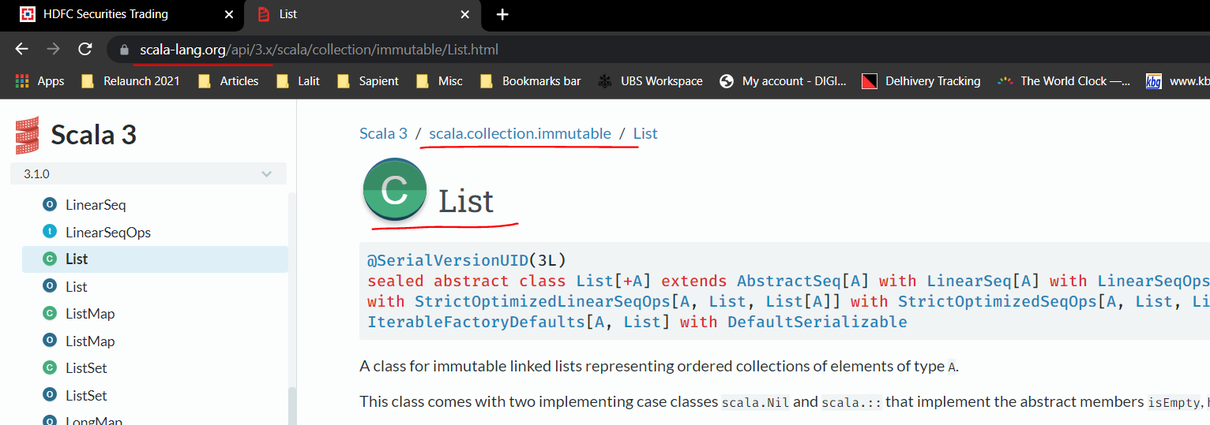

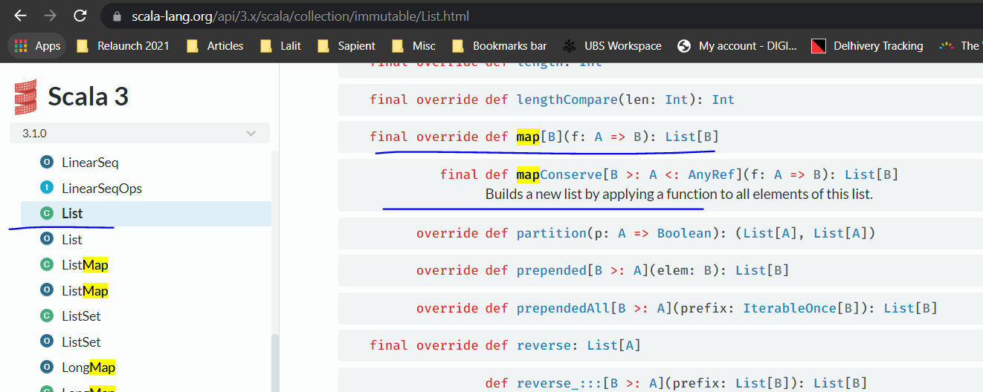

All right, flatMap also act in the same way, so flatMap says, if I have a function that turns in an element into a list, so let's say twoPair is a lambda that turns an x, which is an Int into a list of things that say x and x + 1, which was the example that we used way back in my list.

// flatMap

val toPair = (x: Int) => List(x, x+1)

So if I print line, list.flatMap( toPair ), then I should be seeing the concatenation of the application of two pair on each element of the list. So two pair of one will return the list, 1 to 2 pair of 2 will return the 2 to 3 and likewise the list 3, 4. So I should be seeing the concatenation of all so I should be seeing the list. 1, 2, 2, 3, 3, 4. All right, so this is exactly what is printed out to the console. So this mirrors exactly what we implemented in MyList. So this was why implementing MyList throughout the course was so important. You're probably seeing a map, flatMap and filter as something not extraordinary right now.

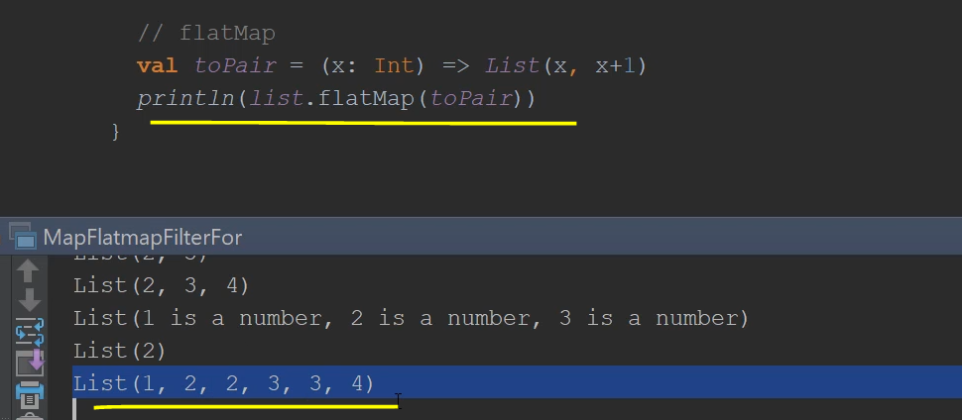

Lets do a small exercise. So try to print out all combinations between two lists. So if I have, let's say, numbers, which is a list and I have the list 1,2,3,4, for example, and a list called characters, which is a list of, say, a, b, c, d. I want you to print all possible combinations of them, like you would print all possible chess squares. So I want you to print a list of a 1, a 2 and so on and so forth until 4.

// print all combinations between two lists

val numbers = List(1,2,3,4)

val chars = List('a','b','c','d')

// List("a1", "a2"... "d4")

|  |  |
| --- | --- |
| Now, this exercise is a test in thinking style because in more conventional programming languages we would use simply used to lose and be done with it, right. You would solve this without breaking a sweat. But in functional programming, I said that instead of loops, we use functional and recursive functions. And in this case we're going to use map and flatMap which traverses the entire collection. So the solution to this would be something like let's call this combination's is numbers.flatMap, because for each element in numbers, I'm going to generate a list. So for each number in numbers that I'm going to traverse characters now. So characters.map and for every character I'm going to return the string composed from the character and the number.  // "iterating"  val combinations =  numbers.filter(_ % 2 == 0)  .flatMap(n => chars.flatMap(c => colors.map(  color => "" + c + n + "-" + color)  ))  println(combinations) |  |
| So string plus the character. Plus the number. All right, let's print this out. So, right, click and run. So, of course, we print all the possible combinations, even be once you want, do you want all the way to defore? So this is how you would transform loops in more conventional languages into functional code. So if you have two loops, you would do a map and a flat map. If you had three loops, for example, if I had callers, which is a list of, say, black and white, then if I wanted all the possible combinations of numbers, characters and colors, then I would do characters that flood map this time around. And for every character I would do colors that map, and for every color I would get an empty string plus the character plus the number, plus the color. And I think I need to close one more parenthesis, so if I were to click and run this, I should be seeing a one black and one white, be one black, one white and all the possible combinations to the end. Notice that this blows up quite a bit. Let's put a dash here. So that's a little bit prettier at print. All right, so you get all the possible combinations between lists of numbers, a list of characters and a list of colors. So this is basically a three way loop, which is composed in functional code of two flat maps and a final map at the end. So this is how we do, "iterations", right? OK.  // print all combinations between two lists  val numbers = List(1,2,3,4)  val chars = List('a','b','c','d')  val colors = List("black", "white")  // List("a1", "a2"... "d4")  // "iterating"  val combinations = numbers.filter(_ % 2 == 0)  .flatMap(n => chars.flatMap(c => colors.map(color => "" + c + n + "-" + color)))  println(combinations)   |  |  | | --- | --- | | // foreach  list.foreach(println)  // for-comprehensions  val forCombinations = for {  n <- numbers if n % 2 == 0  c <- chars  color <- colors  } yield "" + c + n + "-" + color  println(forCombinations)  for {  n <- numbers  } println(n) | Next thing I want to talk about is for each, which is similar to map only that it receives a function returning units. So if I do list that for each line, then this will print all the numbers. 1, 2, 3 on a separate line. This is exactly the same as we implemented in my list, so we now know how to process multiple lists with map, flatMap and filter. But in practice, all these chains will get increasingly hard to read, especially for other people. So if you write this line, it's understandable for you, but other people will take quite some time to understand what you meant.  So in Scala, we have a shorthand for all these chains in their called for comprehensions, so watch how I would rewrite combination's as a for comprehension. So I'm going to say, val, forCombination's equals and I'm going to put in the key word for and I'm going to open a for and some curly braces. And inside I'm going to say n <- left arrow numbers, c <- left arrow characters on a separate line and color <- left arrow colors. And at the end I'm going to say yield. This is a keyword and I'm going to put in this expression. This is exactly equivalent to the map and flat map chain that we wrote above, this expression is rewritten by the compiler to change of maps and flatMaps. But I think you will agree that this way of writing it is much more readable. So if I print line for Combination's, I would get the same result. Yes, so if I collapse this, you'll see that the result here and with four combinations are identical. Now, if I want to filter out some of the, for example, numbers I would put in what we call a guard. So I would say if an mod two is equal to zero, so I'm just filtering to keep only even numbers. And if I print this out. I'm going to get all the combinations between characters and even numbers and all colors, these are translated into a filter call for numbers. So before flood mapping it, the compiler would write something like filter. This guy, so this is what happens when you put in an effort in for comprehension    but right now this chain right over here doesn't even fit into the whole screen. So for comprehensions are much more readable and are preferred in practice.  Now, if you want to do side effects like the for each thing, you can still use for comprehension. So if I say for n in numbers print line and then this is equivalent to numbers.forEach( printLn ). I'm seeing equivalent, but it's actually identical because the compiler takes care to rewrite this for comprehension into an actual functional call. | | |
| Output after applying Guard | |

Before I move on to exercises, I'm going to add one more little syntax overload, which is, again, sometimes used in practice. So if I say, for example, list.map and I want to multiply each element by 2, an alternative syntax to that would be to say space and then open a curly brace and say x => and then provide an implementation here x times two.

list.map { x => x * 2

}

So don't be scared if you see this syntax in practice.

The full code so far

package lectures.part3fp

object MapFlatmapFilterFor extends App {

val list = List(1,2,3)

println(list.head)

println(list.tail)

// map

println(list.map(_ + 1))

println(list.map(_ + " is a number"))

// filter

println(list.filter(_ % 2 == 0))

// flatMap

val toPair = (x: Int) => List(x, x+1)

println(list.flatMap(toPair))

// print all combinations between two lists

val numbers = List(1,2,3,4)

val chars = List('a','b','c','d')

val colors = List("black", "white")

// List("a1", "a2"... "d4")

// "iterating"

val combinations = numbers.filter(_ % 2 == 0)

.flatMap(n => chars.flatMap(c => colors.map(

color => "" + c + n + "-" + color)))

println(combinations)

// foreach

list.foreach(println)

// for-comprehensions

val forCombinations = for {

n <- numbers if n % 2 == 0

c <- chars

color <- colors

} yield "" + c + n + "-" + color

println(forCombinations)

for {

n <- numbers

} println(n)

// syntax overload

list.map { x =>

x * 2

}

/*

1. MyList supports for comprehensions?

map(f: A => B) => MyList[B]

filter(p: A => Boolean) => MyList[A]

flatMap(f: A => MyList[B]) => MyList[B]

2. A small collection of at most ONE element - Maybe[+T]

- map, flatMap, filter

*/

}

All right now exercises. First exercise, I want you to try to see if my list supports for comprehensions, given that we said that the compiler rewrites for comprehensions as chains of map, flat map and filter and for each, I think you'll be surprised.

/*

1. MyList supports for comprehensions?

2. A small collection of at most ONE element - Maybe[+T]

*/

}

Second, exercise, I want you to implement a small collection of at most one element. I want you to call this maybe and we'll make this covariance. And the only possible subtypes of this are going to be an empty collection or an element with one element of type T contained. And I want you to implement map, flat map and filter for this collection.

Now, let's go through the exercises, first exercises says myList supports for comprehensions? Well, for comprehensions are rewritten by the compiler into change of map, flatback and filter. But for that to work, we need a map, flood map and filter to have a special kind of function signature. So map needs to have, map needs to receive a function from A => B. And this guy should return MyList[B]. Filter should receive a predicate which is from A => Boolean and should return MyList[A] and flat map, should receive a function from A => MyList[B], so just in the same style as list. And this should return to my MyList[B]. Now let's check our function signatures.

/*

1. MyList supports for comprehensions?

map(f: A => B) => MyList[B]

filter(p: A => Boolean) => MyList[A]

flatMap(f: A => MyList[B]) => MyList[B]

2. A small collection of at most ONE element - Maybe[+T]

- map, flatMap, filter

*/

So let's see. So MAP receives a type parameter B which receives a transformer from A to B, which is a function from A to B flat map receives a transformer which is of type A to my list of B and filter receives a predicate which is a boolean. So this is exactly what we need to be able to use for comprehensions.

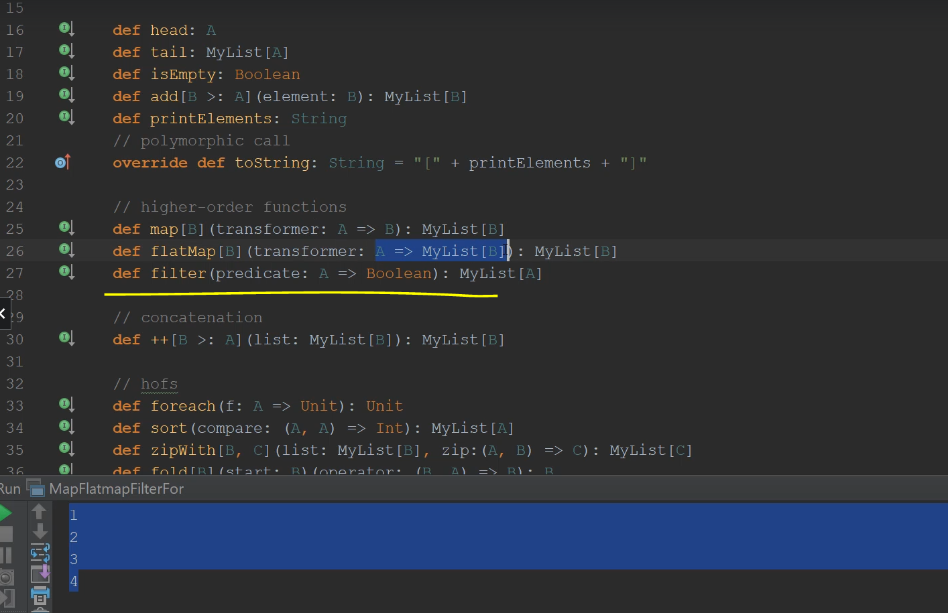

I'm going to switch back to MyList because I want to test for comprehensions here in the MyList file here. So if I say for a no air left list of integers and say. List of strings that say a string in list of strings. I say yield and let's just yield in plus a dash plus the string. Notice that this expression actually works, but that's because our definitions for a map, flatMap and filter have these exact function signatures.

**MyList.scala**

// higher-order functions

def map[B](transformer: A => B): MyList[B]

def flatMap[B](transformer: A => MyList[B]): MyList[B]

def filter(predicate: A => Boolean): MyList[A]

So this was an intentional design so that we could get to this point.

// for comprehensions

val combinations = for {

n <- listOfIntegers

string <- listOfStrings

} yield n + "-" + string

println(combinations)

If you have any other kind of function definitions for math or filter, the for comprehension will not work. So if I say a val combinations = for { whatever and I print this out combinations that I should be seeing, all the combinations from 1 to 3, and Hello Scala all changed with a dash, right? So 1 Hello 1 Scala, 2 Hello 2 Scala and 3 Hello 3 Scala

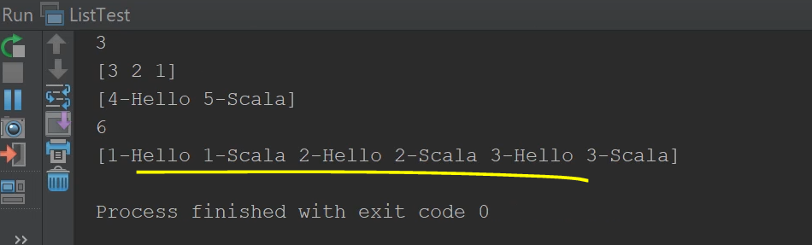

So the combinations work now for comprehensions of course are expressions so I can simply paste them into the print line statement. Just to prove that for comprehensions, like everything else in Scala are expressions that evaluate to a value. I'm just going to undo this one because I've proven my point.

|  |  |
| --- | --- |
| // for comprehensions  val combinations = for {  n <- listOfIntegers  string <- listOfStrings  } yield n + "-" + string  println( for {  n <- listOfIntegers  string <- listOfStrings  } yield n + "-" + string  ) | // for comprehensions  val combinations = for {  n <- listOfIntegers  string <- listOfStrings  } yield n + "-" + string  println(combinations) |

So it seems that as a bonus, our mileage implementation has the nice feature that is compatible with four comprehensions. This is pretty darn cool. And this is something to bear in mind if you want to implement your own collections, if you want to make them compatible with for comprehensions, all you need to do is provide map, flatMap and filter functions that look like these.

abstract class MyList[+A] {

. . .

// higher-order functions

def map[B](transformer: A => B): MyList[B]

def flatMap[B](transformer: A => MyList[B]): MyList[B]

def filter(predicate: A => Boolean): MyList[A]

All right. So let's switch back to map, flatMap and filtering for and implement exercise number two with a Maybe collection. Maybe is often used in functional programming to denote Optional values and where we're going to discuss about the actual option type in Scala but I wanted you to get a sense of how this single element collection looks like.

|  |  |
| --- | --- |
| So we would create a little abstract class, let's actually write this in its own file. So if I go ahead to the exercise package and I create a new class, I'm going to name this Maybe. And I'm going to make this an abstract class, just like the List.  Now, this abstract class, Maybe will take a type parameter, which I'm going to make Covariant.  And just like the List will be extended by two case subtypes by case object, let's call this MaybeNot, which will not contain anything, but it will denote the absence of a value. And this extends Maybe[Nothing]. And then we have a case class, let's call this Just and this will contain a value with the type T again, Covariant and extends Maybe[T]. | abstract class Maybe {  }  case object MaybeNot extends Maybe[Nothing] {  }  case class Just[+T](value: T) extends Maybe[T] {  }  object MaybeTest extends App {  } |
| So in just the same fashion as we did with List, we have an Empty quote unquote "collection" and a full quote unquote "collection", and this guy holds just one value. Now, we said that this abstract class Maybe wanted to have Map that Map and Filter. So let's define a Map, map with type parameter let's call this B and a function which takes a T and returns a B and this will return a Maybe[B], just like we did with List. Now flatMap also take a type parameter B and then will take a transformer from T to a => Maybe[B], and this will return a Maybe[B] and filter doesn't receive any type parameters, but receives a Predicate from T to => Boolean and it will return a Maybe[T] of the same type as the original, so let's go ahead and implement these in the subtypes below. | abstract class Maybe[+T] {  def map[B](f: T => B): Maybe[B]  def flatMap[B](f: T => Maybe[B]): Maybe[B]  def filter(p: T => Boolean): Maybe[T]  } |
| So for MaybeNot, map is going to be what's called def map with a type B, and it receives a function Nothing => B and in just the same style as list this return A, Maybe[B] and it will return, MaybeNot. So basically empty.map something, some function, it will still return an empty quote unquote list. All right. Now, flatMap receives a type parameter B and a transformer from Nothing => Maybe[B] this returns a Maybe[B] and again, empty.flatMap a function returns empty. So MaybeNot. OK, now Filter doesn't receive any type parameters, but it receives a predicate from Nothing => Boolean and then returns Maybe[Nothing]. And of course will return, MaybeNot. Again, empty collection.filter with some predicate it will still return an empty collection. | case object MaybeNot extends Maybe[Nothing] {  def map[B](f: Nothing => B): Maybe[B] = MaybeNot  def flatMap[B](f: Nothing => Maybe[B]): Maybe[B] = MaybeNot  def filter(p: Nothing => Boolean): Maybe[Nothing] = MaybeNot  } |

|  |  |
| --- | --- |
| Now in the case of Just we will actually need to provide some proper implementations. So I'm going to copy them over. For map, if I have a collection with only one element, then I will still return a collection with 1 element and the value will be the result of applying f to the value that I currently have. So this will return just with the value f apply to value.  flatMap - flatMap is easier than you might think, so in the case of List, we can cut needed the application of f to the head and then concatenated that with whatever flatMap did for the tail. But we have no tail here, so we'll just return as a value. And for filter, then we need an if condition, so if p applied to value is true, then I'm going to return this same object. Otherwise from a collection with 1 element, I'm going to end up with a collection of no elements. So maybe not. | case class Just[+T](value: T) extends Maybe[T] {  def map[B](f: T => B): Maybe[B] = *Just*(f(value))  def flatMap[B](f: T => Maybe[B]): Maybe[B] = f(value)  def filter(p: T => Boolean): Maybe[T] =  if (p(value)) this  else MaybeNot  } |
| All right, so this is the implementation that we wanted, let's write a simple application to test our code, so object, let's call this MaybeTest extends app, which will make our code Runnable. Now, MaybeNot is not so interesting. Maybe it's not interesting because map, flatpMap, filter will simply return, MaybeNot. So there's nothing really to test. So let's say we have a val called just3, and we'll just construct a Just object with a value 3. And let's print first this guy and then let's try to play around with it. Let's say just3.map and let's multiply the value inside by 2. Then let's write a flatMap. So just3.flatMap. And from the value inside, we're just going to return just with _ % 2 equals zero. Actually, underscore here is not really known, so I'm going to write in a proper lamda and that's right, just3.filter with the same lambda. OK, so just3 will print, just3, just3.map with this lambda, which multiplies by 2. This is going to end up with just 6 and this guy just3.flatMap where I'm creating a new Just object with a boolean inside. This is going to be a just false and this guy is going to return. MaybeNot, because just through that filter and the predicate is not going to pass for the value three. So from a just object, I'm going to end up with a MaybeNot object. So let's see if our assumptions hold. So we have just3, which is the original object, just six, which is the mapped with the multiply by two, just false with the result of the predicate here inside. And maybe not because I've just filtered a collection with at most one element by a predicate which does not pass for that value. | object MaybeTest extends App {  val *just3* = *Just*(3)  *println*(*just3*)  *println*(*just3*.map(_ * 2))  *println*(*just3*.flatMap(x => *Just*(x % 2 == 0)))  *println*(*just3*.filter(_ % 2 == 0))  } |

Now, at this point, you might be wondering, Daniel, like, wait a minute, what what the hell are you doing? Why on earth would I want to create a collection without most one element? But I'm here to tell you that this may be thing that you wrote here is extremely important. And it's not that it's a collection with at most one element, because if you used it as a collection, then, yes, it will probably be useless. But the philosophy of the may be class here is to denote the possible absence of a value. This is extremely important and we'll deal with it in the options lecture later in the course.

### Collections Overview

We're going to start a small series of videos where we discuss this color collections framework. This short video will serve as an introduction. Now, Scala in the Standard Collections Library offers both mutable and immutable collections. By now, I think you know what mutable and immutable means. Mutable collections can be changed in place were Immutable collections cannot. So you need to instantiate a new collection every time you need to make a change. Now, the standard library has type definitions or type aliases for immutable collections.

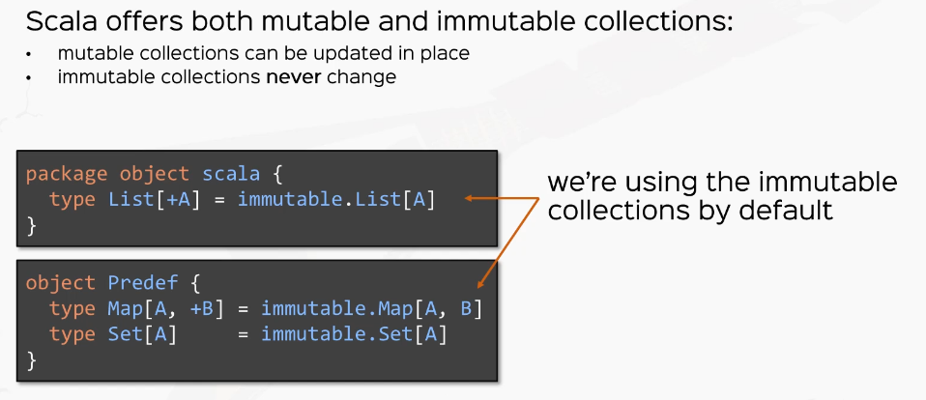

So we're actually using the immutable versions by default. So let's talk about immutable collections. So immutable collections are in a huge hierarchy, starting from Traversable, which is the mother of all collections. These reside in the skull collections immutable package and you'll find them all in there. Now, Traversable is extended by the iterable trade, which in turn is extended by the major collections. Type's sets are the type of collections that do not contain duplicates. For example, has sets and sorted sets. Maps make the associations between keys and values and sequences are the kind of collections that can be traversed in a set order. And the major kinds of sequences are indexed sequences in linear sequences. Indexed sequences have the property that it can be quickly accessed. So Vector's strings and ranges are three examples in which the elements can be accessed in constant time. Linear sequences do not have this property. Linear sequences only guarantee in some form the ordering of elements. So, for example, Stacks and Qs guarantee a certain kind of contract. For example, last in, first out or first in, first out. Right. So this is the basic hierarchy. We're going to discuss about all major collections, starting with the next video. Now, multiple collections can be found in the so-called collections mutable package, and the hierarchy mirrors the immutable hierarchy very closely.

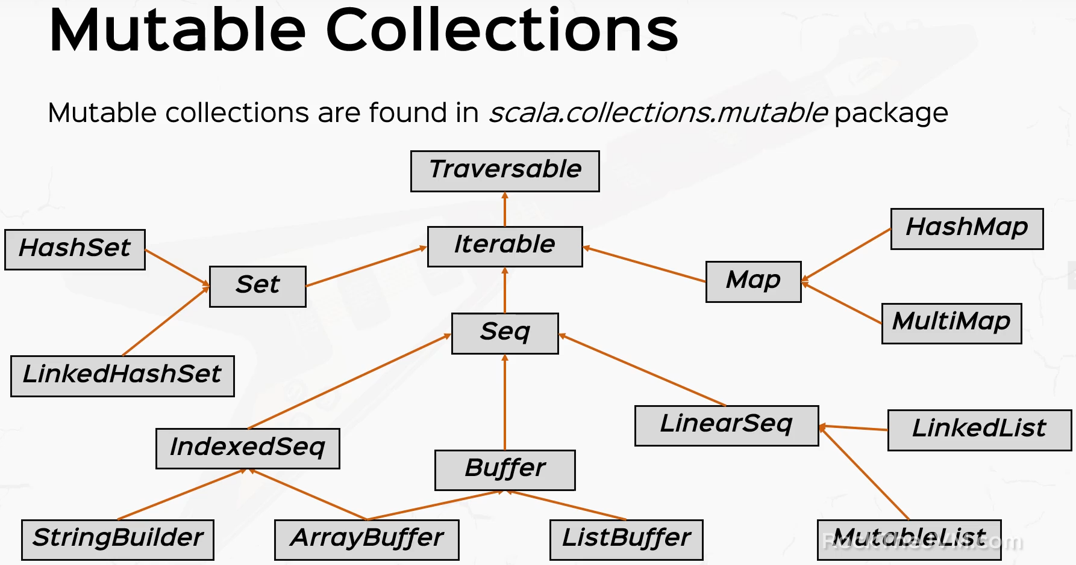

So we have the traversable trade in the iterable trade and then we have set sequences and maps, which are the basic trades, but then the actual implementations for multiple collections differ slightly. So four sets, we have HashSets and LinkedHashSets for map, we have HashMap and multi map and for sequences we have these guys index sequences, buffer and linear sequences, and we have lower level implementations of these traits. So, for example, we have string builder and array buffer and less buffer. And you also see array buffer extending multiple traits. And for linear sequences we have linked list and mutable list. We won't get into mutable collections in this course because we will use immutable types. Ha ha ha ha. So you saw the traversable is basically the mother of all our collections and this offers basically everything that we need. It offers map, lab and filter. It has conversions in between collections. It has size information methods like is empty or size. It has tests that it can apply to some or all the elements within. It has folds and reduces. How does the retrieval and indexing it also has string operations for pretty printing.

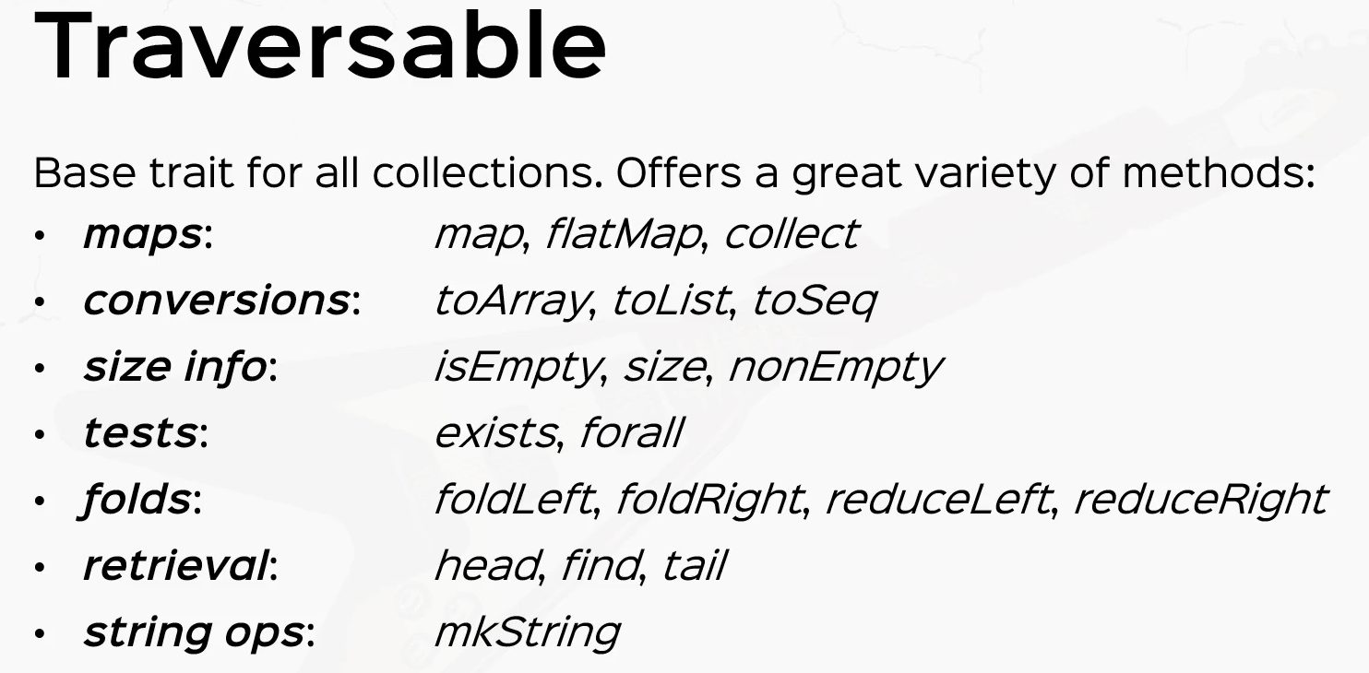

### Sequences, List, Array and Vector

We're going to start seeing collections in practice, starting with sequences. So let's create a new application in the Part three functional programming package and let's call these sequences. Make this an object, of course, and at the end extends extends up. So we're now ready. And the first thing that I want to talk is about sequences which is denoted by the type as Seq.

|  |  |
| --- | --- |
| So sequences are a very general interface for data structures that have two properties that have a well-defined order and they can be indexed sequences, have a lot of operations supported out of the box.  For example, indexing and iterating the appli length and reverse methods are particularly used. We have concatenation and appending and pretending to construct new collections and we have a lot of others besides map up and filter. We have grouping, sorting, searching, slicing and all that kind of stuff. So let's see it in practice in the IDE. |  |

So if I construct a sequence and on the right hand side, I used the apply method from the Seq companion object and I put in a 1, 2, 3, 4 like we did with list. Then if I print line a sequence then I should see the sequence. 1, 2, 3, 4, with a little twist that this sequence is actually a list. So the Seq companion object actually has an applyFactory method that can construct subclasses of Sequence. But the declared type of a Sequence is Sequence of int.

|  |  |
| --- | --- |
| import scala.util.Random  object Sequences extends App {  // Seq  val aSequence = Seq(1,3,2,4)  println(aSequence)  println(aSequence.reverse)  println(aSequence(2))  println(aSequence ++ Seq(7,5,6))  println(aSequence.sorted)  *Output:* | Now let's use some of those utility methods. For example, a sequence that reverse will get the list 4, 3, 2, 1. If we have, for example, a sequence that apply with the number 2, then that means a sequence.get basically at index number 2. So we'll we should see the value 3 here. So the apply method retrieves the value at this particular index, let's use some other methods.  For example, if I tried to do a sequence++ which is the concatenation and put it in another sequence, let's say 5, 6, 7, then I should be seeing the list. 1, 2, 3, 4, 5, 6, 7 here in the console. So this ++ operator is actually very handy. Also some sort methods are often used in practice sorted, especially if sequences are tagged with the type which is a numerical type or something that's comparable.  The sorted method works out of the box. So if I let's say I have 7, 6, 5. Or 7, 5, 6, just to break the ordering. Oh, I see the list, one, two, three, four. Let's break the ordering here. If I say 1, 3 to 4 or something like that, just to see how the sorted method actually works. Right. The sorting method works if the type is by default ordered. |

Now, how this magic actually happens, we're going to discuss in the advanced course. And before we move on to list, I want to talk about ranges, which are also sequences. So if I say save a range, which is a sick of end and on the right hand side, I put in watch what I'm running one space, two space 10. So one to ten is a collection, which is a range. And this can be a sequence here. So if I put in a range that for each print line, then this will print all the numbers 1 to 10. All right, so range is here 1 to 10, like 1 to 100 or 1 until 10, which gets all the numbers with the right and non-inclusive, are extremely used in practice, especially for short script like Scala code. So if you ever wondered how you could apply or print or do something 10 times, you could simply say 1 to 10 .map or for each do something. Right, instead of using recursive function. You could simply do whatever you wanted 10 times.

// Ranges

val aRange: Seq[Int] = 1 until 10

aRange.foreach(println)

(1 to 10).foreach(x => println("Hello"))

All right, ranges are a particularly magical data structure that we are going to explore in the advanced Scala course, because there is some really nice magic with these 2 and until operators on integers which are not supported by default. So I'll leave that to the advanced stuff. But until then, let's move on to lists.

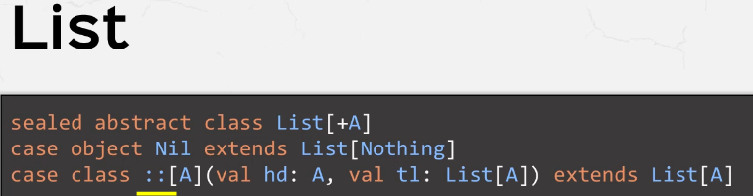

So this is the official signature of the type list, just as my list, it's extended by a Case subject which is called Nil. In our case it was called Empty and a case class, which we called Cons. But in the standard school library, it's called colon colon. So lists are immutable and extend linear sequence. So because they used in linear sequence the head tail and isEmpty, methods are generally fast. They are amortised Constant time. But most other operations, like getting an element of an index, are Linear Time. Lists are sealed and they have, like I said, two subtypes, the object Nil, which denotes an empty list and the class colon colon. Now, I don't need to remind you that the this on naming is so, so permissive.

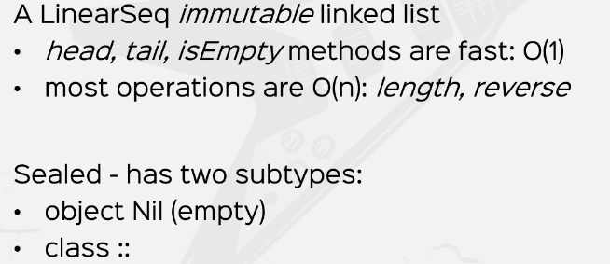

All right. So you've seen list in practice by calling the applyMethod from the companion object. But what I didn't show you was how to prepend or append values to it. Let's call this prepended and let's say I prepared the value 42 to a list. This is how you do it, with :: operator and this is syntactic sugar for :: .apply 42 and a list. So if you print this out preprinted. We're going to see 42 and 1, 2, 3, right, another operator that is often used in practice is +:, +: is also an infix operator between 42 and a list and it does prepending, if you want to do appending, you get the symmetrical :+ operator, let's say 89. If I right, click this and run, I get 42, 1, 2, 3 and 89, so this is for append :+ and this is for prepend +:.

Now if you want to remember them, you just need to know that the colon is always on the side of the list.

// lists

val aList = List(1,2,3)

val prepended = 42 +: aList :+ 89

println(prepended)

*Output:*

*List(42, 1, 2, 3, 89)*

|  |  |
| --- | --- |
| Now, there are a number of other things that I didn't really show you. So say, for example, I want a list of 5 elements with the same value. Let's say 5 apples or apples5 is list dot and here's why I write fill with parameter 5 and then with another parameter list the parameter Apple. So Phil is a curried function that takes in a number and a value and constructs a list with five times or ten times that value. So if I print line this apples5, I should see a list of 5 apples. | val apples5 = List.fill(5)("apple")  println(apples5)  *Output:*  *List(apple, apple, apple, apple, apple)* |
| OK. I also want to show you the make string method, which is pretty handy when you want to pretty print something very quickly. So if I print line, let's say a sequence, a list. I want to print a list that makes string and I want to put a dash between them, make string, actually concatenate all the values and puts in this guy or whatever I want to put it. Let's say I want to put a "-|-" in between all the numbers. Then if I print this, I will have all the elements concatenated with this guy with the separator in between them and the rest is history. | val aList = List(1,2,3)  println( aList.mkString("-|-") )  Output:  1-|-2-|-3 |

|  |  |
| --- | --- |
|  | You already know how to work with lists. So I'm going to move now to Arrays. So still in the context of sequences, we have Arrays which are the equivalent of simple Java Arrays. These can be constructed with predefined lengths. So if I say new array of 3 elements, then that will allocate enough memory for 3 elements without actually needing me to give values to those 3 elements.  Arrays can be mutated. That is, they are Mutable and they are completely interoperable. With Java's native arrays, Indexing is fast in that you can access any element and any position in constant time. But we said that array is a Sequence, but where the hell is the sequence in the definition of the array? |
| Let's see that in practice. All right. Back in the IDE, let's construct an array, say numbers equals array with, say, 1, 2, 3, 4. This is an array. If we wanted to create an array of a given dimension, we can say all three elements is array ofDim with the type end and we can put in number here. And that allocates space for three elements without needing me to actually supply values for those three elements. Let's actually try to print what I actually call this tree elements. That's actually name this correctly. So let's try to print three elements to see what happens. So prints this very obscure string representation. | // arrays  val numbers = Array(1,2,3,4)  val threeElements =  Array.ofDim[String](3)  threeElements.foreach(println)  Output:  [I@379675lb |

|  |  |
| --- | --- |
| But if I try to do instead three elements that for each print line I'm in for a surprise. Because the values are initialized with some default values, so they have default values, if I change this to be a string or some other kind of reference type.  Let's try to see what happens. We have news, so for primitive types like Int and Double's and Booleans, we have different values of zero or false. But for reference types like string or persons or something else, the values are initialized with null. | // arrays  val numbers = Array(1,2,3,4)  val threeElements = Array.ofDim[Int](3)  val threeElementsStr = Array.ofDim[String](3)  threeElements.foreach(println)  threeElementsStr.foreach(println)  Output:  0  0  0  null  null  null |

Now, like I said, arrays can be mutated in place. So if, for example, let's call this mutation, if I say numbers and watch what I write numbers two equals zero, then this will update the value at index two with the value 0. So let's bring the numbers now. So if I print line numbers.mkString and let's put in a space as a separator. I should be seeing one two zero four, so instead of three, I put in a zero. Now, why does the syntax work? Well, this guy is a special syntax sugar for numbers, dot update to zero. So the update method is also special in Schola. It's quite rarely used in practice and it's only used for multiple collections, but this is a syntax shugar that's very similar to apply. So an update is also a special method in school and allows for this kind of syntactic sugar. Now let's make the connection between arrays and sequences. So if I define numbers sequence, which is a sequence of events explicitly described here and on the right hand side, I put in numbers, although numbers is an array which is totally unrelated to the type sequence. Again, Numbers is an array, which is a direct mapping over Java's native arrays. So it has nothing to do with sequences. Despite this, the conversion can be applied. And if I print line numbers sequence. I should be seeing. Wrapped array, so this is a special kind of sequence which wraps over an array. So this equals sign is called an implicit conversion. Implicit conversions are a very advanced topic. And we're going to talk about that. Obviously, in the advanced course, it's a really deep rabbit hole. But I just want you to know that there are such things as implicit conversions so you can convert an array to a sequence via an implicit conversion. The compiler does a lot of magic behind the scenes and we'll explain how that works in the advanced course. This is how arrays actually have access to sequence methods like make string if you pay very, very close attention numbers here and make string or underlined, which is a signal from the ID that implicit conversions happen behind the scenes. Next thing that I want to talk about is Vector's. Now, Victor is basically in its own world, and it's the default implementation for immutable sequences because it's very efficient. It offers effectively constant time for read and write. It's a very slow growing logarithmic. It offers fast element additions for append and prepend, and it's implemented as fixed branch tri with a branch factor of thirty two. So it holds thirty two elements at any one level. That is from memory and cache optimizations. It also offers good performance for very large sizes. So we're actually going to see some examples of using vectors in practice here. And we'll also do a small perf test versus a simple list so vectors can be computed like seeing vector which is a vector event and equals vector one, two, three, just like you would with any other collection. So if you print this out, you will see, uh, the vector, right. So vector one, two, three vectors offer the same functionality as other collections. So I'm not going to bore you too much with them. So let's go to the PERF test with vectors versus lists. So here's what I'm going to do, I'm going to write a small method called Get Right Time. I'm interested in getting the average right time for a collection, so I'm going to pass in a collection, which is a sequence of it. This will return a double. We want to measure it in time and the implementation is going to be the following. I am going to create a new random number generator new and the random number generator in Schola is random. Now, I'm going to attempt to write something to oldest or two of them or to this collection a number of times and then sum up the times required and then divide them by the number of runs. All right. So let's define a number of runs. Let's call this Maxitrans. Let's just say we want a thousand runs or something like that. All right, so like I said before, with Rangers, we want to do something for a thousand times. So how do we do that? Well, we do. We write a small value called the Times. And let's say we do a for comprehension and for every iteration. Which goes from one to max runs, then we yield the following expression, first we need to get the current time of the system. So current time equals, let's say, system that now time then I want to do the operation and then I want to return system that nano time, which is a different time now, minus current time. So the operation here will take this much nanoseconds. Now the operation here is going to be collection dot and there is a method called updated. And we need a person, an index which is going to be randomly generated and we're going to person of value here, let's say zero. So at the random index, which is our dot next end and the limit here is going to be limited by a capacity, let's call this max capacity. Up top, let's call this like a million elements or something like that, so collection updated at random index from zero to max capacity. And at that random index, we were just going to put in a value zero in this collection. And at the end, we are going to measure the time and we are going to return the time difference between this moment in time at the beginning and the moment in time after the collection updated, Cole was completed. All right. So this is the Times. This is a collection of all the measurements of this function. All right, then we need to return the average time, which is basically times that sum, because Times is a collection of numbers. And then we'll just multiply this by one point zero and we'll divide this by Maxitrans. So this is the average time it takes for this collection to be updated at a random index with a random value. The value itself is not that important. So I hope this little benchmark here makes sense. So again, we are instantiate a new random number generator and for one to run. So basically for a thousand times we mark the current time. We try to update the collection at a random index with a random value. We can actually call our next. We don't really care, and then we measure the time after the election that updated was completed and then we returned the time difference. So for a thousand times we measure this time and we return the average. The average is times that sum over Maxitrans. All right. So let's create a list and a vector just to prove how efficient a vector is. So let's call this numbers list, which is, say, one, two max capacity. So that's the range. And then I convert that to a list and a numbers vector. Which is once max capacity not to vector. OK, so I've instantiated two collections here. One is a list and one is a vector. So let's print the test, which is get right time for a numbers list and get right. Time for a numbers vector. And try to see what happens. So before we do that, let's get back to the advantages of each collection. So List has the property that it saves the reference to the tail. So if it tries to update the first element, then the list is incredibly efficient. But if you try to update an element in the middle of the list, it's probably not going to be so efficient, whereas a vector it needs to traverse the whole 30 to branch tree and then replace that entire chunk. So the advantage of list is that it keeps reference to tails. And the advantage of Vector is that. The depth of the tree. Is small, the disadvantage of list is that updating an element in the middle takes a long time, whereas the disadvantage of Vector is that it needs to replace an entire 32 element chunk. We'll see that this is not so much of a disadvantage. All right. So with that in place, let's right click and run this. I have a seven processor and 16 gigs of RAM, this should take a few seconds to run. So the program is running and here we have we have some results. So quite a big of a difference. So for the first number, which is four numbers list, we have the average time it takes to write something to a random index in the list and return a new list is almost nine million nanoseconds or roughly nine milliseconds for a vector. We only have four thousand nanoseconds or four microseconds. So there's three orders of magnitude difference, and that is for a million elements. If we increase the size, the difference is even going to be bigger. So no wonder a vector is the default implementation of sequence. All right.